LIMKOKWING UNIVERSITY OF CREATIVE TECHNOLOGY
SIERRA LEONE
Department of Information and Communication Technology
Semester 01: September 2026 to January 2027
PROG101: PRINCIPLES OF PROGRAMMING LOGIC AND DESIGN
Individual Assignment 1
Designing Logical Solutions for Sierra Leone Community Challenges
Project: Flood Early Warning and Community Alert System for Freetown
Student Name | [Your Full Name]
Student ID | [Your Student ID]
Programme | [Your Programme]
Examiner | Elijah Fullah
Submission | Week 4
GitHub Repository | https://github.com/[username]/PROG101_Assignment1_[StudentName]_[StudentID]

Table of Contents

1. Rationale

1.1 Problem Description
Freetown, the capital of Sierra Leone, floods almost every rainy season. Heavy rainfall between June and September overwhelms blocked drainage channels, swollen streams and rivers, and settlements built on floodplains and steep hillsides. Residents in flood-prone communities such as Kroo Bay, Kissy, Susan's Bay, Culvert, Dwarzark and Regent usually receive little or no organised warning. They learn about danger when water is already entering their homes. The problem this assignment addresses is therefore the absence of a fast, reliable and understandable early-warning process that turns rainfall and river-level readings into clear alerts for the people at risk.

1.2 Background
The scale of the risk is well documented. In August 2017, floods and a landslide at Regent, on the outskirts of Freetown, killed more than one thousand people and left thousands homeless, as recorded in the Government of Sierra Leone's Rapid Damage and Loss Assessment. Flooding has recurred in the years since. The causes are structural: rapid and informal urbanisation, deforestation of the Western Area Peninsula hills, poor solid-waste management that blocks drains, and climate change, which is increasing the intensity of rainfall events in West Africa. Warnings, where they exist, tend to be broadcast generally over the radio and are not tied to a specific neighbourhood or risk level. This leaves communities unable to decide whether to stay, move belongings or evacuate.
Who is affected: residents of flood-prone communities (especially women, children, the elderly and people with disabilities), market traders and small businesses, schools and clinics, and responders such as the National Disaster Management Agency (NDMA), the Red Cross and community leaders.
Why the problem exists: readings are not collected consistently; there is no agreed rule that converts readings into a risk level; alerts are not targeted by zone; and there is no record of past warnings to improve future decisions.

1.3 Proposed Solution
The proposed solution is a logical design for a Flood Early Warning and Community Alert System. For every monitored zone the system reads the 24-hour rainfall (in millimetres) and the river level (in metres) from a sensor or a community volunteer. It validates the readings, classifies the zone as SAFE, WATCH, WARNING or DANGER using decision rules, and sends a plain-language alert by SMS or radio message to each registered resident of that zone. For DANGER it also notifies the disaster-management authorities. Every incident is logged, and a summary report is produced at the end of each monitoring cycle. SMS is chosen as the main channel because it works on basic phones, which are more widely used in Sierra Leone than smartphones, and does not require mobile data. No source code is written in this assignment; the full solution is expressed through algorithms, pseudocode, flowcharts and modular design.

1.4 Computational Thinking Process
Computational thinking (Wing, 2006) was applied through its four pillars:
Decomposition: the big problem "warn people before floods" was broken into smaller problems: collecting readings, validating data, assessing risk, finding the residents, composing the message, sending it, notifying authorities and keeping records. Each became a module or function.
Pattern recognition: flood events follow a repeating pattern. As rainfall and river level rise, danger rises in steps, so the same comparison logic can be reused for each zone and each threshold.
Abstraction: the design ignores details that do not affect the decision (the make of sensor, the telecom network, the terrain of each street) and keeps only what matters: zone name, rainfall, river level, risk level and the resident list.
Algorithm design: the steps are arranged into an ordered, repeatable procedure with decisions (selection) and loops (repetition), described in Section 2 as an algorithm, in Section 3 as pseudocode and in Section 4 as flowcharts.

1.5 Algorithm Design (Summary)
The main algorithm repeats once for every zone: read data, validate, classify risk, alert if the risk is above SAFE, log, and move to the next zone. Risk classification uses Boolean logic. A zone escalates if rainfall OR river level reaches a threshold, and the most severe matching level is chosen first. Alerts are sent with a loop over the resident list, with failed deliveries added to a retry queue.

1.6 SDG Alignment
SDG 11: Sustainable Cities and Communities (primary). Target 11.5 aims to reduce deaths and people affected by disasters, including water-related disasters. The system directly supports this by giving communities time to act.
SDG 13: Climate Action. Target 13.1 strengthens resilience and adaptive capacity to climate-related hazards. SDG 3: Good Health and Well-being. Fewer injuries, drownings and flood-related disease outbreaks such as cholera. SDG 9: Industry, Innovation and Infrastructure (inclusive, low-cost digital infrastructure).

1.7 Open Source Justification
Why open source: a life-saving system should not depend on an expensive licence or one vendor. Open source lets the government, NGOs and universities inspect the rules, verify that thresholds are fair and safe, and adapt them to each district.
Benefits for Sierra Leone: no licence cost for under-resourced agencies; local ownership and skills development for students and developers; transparency and trust; and freedom to localise the alert messages into Krio, Mende and Temne.
Potential community contributions: developers can add new channels (WhatsApp, community radio); meteorologists can refine thresholds; translators can add local languages; students can write tests, documentation and training material; and local councils can contribute zone and evacuation-centre data.

1.8 Digital Public Goods Justification
A Digital Public Good (DPG), as defined by the Digital Public Goods Alliance and the UN Secretary-General's Roadmap for Digital Cooperation, is open-source software, open data or open content that adheres to privacy and other best practices and does no harm, while helping attain the SDGs. The system could qualify by: being released under an approved open licence; publishing its documentation and open flood-risk data; protecting residents' phone numbers through privacy-by-design; and clearly supporting SDGs 11 and 13. It promotes accessibility (works on basic phones, multilingual, free for residents), openness (public code, public thresholds, public documentation) and public benefit (the primary users are communities and public agencies, and no resident pays for alerts).

1.9 Community Impact
Problem being solved: late or missing flood warnings in vulnerable Freetown communities.
Expected impact: earlier evacuation of people and valuables, fewer deaths and injuries, reduced damage to livelihoods, faster response by the NDMA, and a growing data record that helps urban planning.
Beneficiaries: residents of flood-prone zones, schools, clinics, traders, community leaders, the NDMA, Freetown City Council and the Red Cross.
Long-term sustainability: the modular design allows new zones and sensors to be added without redesign; open-source maintenance by a community of contributors keeps costs low; the logic can be hosted by a public agency or university; and community volunteers can supply readings where sensors are unavailable. The same design can later be reused for other hazards such as landslides.

2. Algorithm

2.1 Constants, Variables and Data Types
Name | Data Type | Purpose
WATCH_RAIN = 50 | Constant (Real) | Rainfall (mm in 24 h) at which a WATCH starts
WARNING_RAIN = 100 | Constant (Real) | Rainfall threshold for WARNING
DANGER_RAIN = 150 | Constant (Real) | Rainfall threshold for DANGER
WATCH_RIVER = 2.0 | Constant (Real) | River level (m) for WATCH
WARNING_RIVER = 3.0 | Constant (Real) | River level (m) for WARNING
DANGER_RIVER = 4.0 | Constant (Real) | River level (m) for DANGER
MAX_RAIN = 500, MAX_RIVER = 15 | Constant (Real) | Upper limits used to reject impossible readings
ZONES | Array of String | List of monitored zones (e.g. Kroo Bay, Kissy, Regent)
zoneName | String | Name of the zone being processed
rainfallMM | Real | 24-hour rainfall reading
riverLevelM | Real | River level reading
isValid | Boolean | TRUE if readings pass validation
riskLevel | String | SAFE, WATCH, WARNING or DANGER
residentList | Array of String | Phone numbers registered for the zone
sent, alertsTotal, zoneIndex | Integer | Counters for alerts delivered and loop control
Note: the threshold values are illustrative design values for this assignment. In a real deployment they would be set with the Sierra Leone Meteorological Agency and the NDMA.

2.2 Step-by-Step Algorithm

Main algorithm
- Start.
- Define the constants (thresholds and limits) and the list of ZONES.
- Set zoneIndex to 1 and alertsTotal to 0.
- While zoneIndex is less than or equal to the number of zones, repeat steps 5 to 13.
- Input zoneName, rainfallMM and riverLevelM for the zone.
- Call validateReadings to check that both values are numbers within valid limits. Store the result in isValid.
- If isValid is FALSE, output "Invalid reading - check sensor", log the problem and go to step 13.
- Call calculateRiskLevel with the two readings. Store the result in riskLevel.
- If riskLevel is "SAFE", output "Zone is SAFE" and go to step 13.
- Call sendAlerts with zoneName and riskLevel. Store the number of delivered alerts in sent.
- Add sent to alertsTotal.
- Call logIncident to record the zone, risk level and readings.
- Add 1 to zoneIndex and return to step 4.
- Call generateSummaryReport with alertsTotal.
- Stop.

calculateRiskLevel algorithm
- Receive rainfallMM and riverLevelM.
- If rainfallMM >= DANGER_RAIN OR riverLevelM >= DANGER_RIVER, set riskLevel to "DANGER".
- Otherwise, if rainfallMM >= WARNING_RAIN OR riverLevelM >= WARNING_RIVER, set riskLevel to "WARNING".
- Otherwise, if rainfallMM >= WATCH_RAIN OR riverLevelM >= WATCH_RIVER, set riskLevel to "WATCH".
- Otherwise, set riskLevel to "SAFE".
- Return riskLevel.

sendAlerts algorithm
- Receive zoneName and riskLevel.
- Get residentList for the zone and compose the alert message.
- Set sent to 0 and index to 1.
- While index is less than or equal to the number of residents, send the message to resident[index].
- If delivery succeeds, add 1 to sent; otherwise add the resident to the retry queue.
- Add 1 to index and repeat from step 4.
- If riskLevel is "DANGER", call notifyAuthorities.
- Return sent.

3. Pseudocode
The complete pseudocode is shown below and is also uploaded to GitHub as pseudocode.md. Indentation shows structure; FUNCTION blocks are the modules.
PROGRAM FloodEarlyWarningSystem

// ---------- CONSTANTS ----------
CONSTANT WATCH_RAIN = 50 // mm in 24 hours
CONSTANT WARNING_RAIN = 100
CONSTANT DANGER_RAIN = 150
CONSTANT WATCH_RIVER = 2.0 // metres
CONSTANT WARNING_RIVER = 3.0
CONSTANT DANGER_RIVER = 4.0
CONSTANT MAX_RAIN = 500
CONSTANT MAX_RIVER = 15

// ---------- MAIN MODULE ----------
FUNCTION main()
DECLARE ZONES AS ARRAY OF STRING
DECLARE zoneName, riskLevel AS STRING
DECLARE rainfallMM, riverLevelM AS REAL
DECLARE isValid AS BOOLEAN
DECLARE zoneIndex, sent, alertsTotal AS INTEGER

ZONES <- ["Kroo Bay", "Kissy", "Culvert", "Regent", "Dwarzark", "Susan's Bay"]
zoneIndex <- 1
alertsTotal <- 0

WHILE zoneIndex <= LENGTH(ZONES) DO
zoneName <- ZONES[zoneIndex]
INPUT rainfallMM, riverLevelM

isValid <- validateReadings(rainfallMM, riverLevelM)

IF isValid = FALSE THEN
OUTPUT "Invalid reading - check sensor for ", zoneName
ELSE
riskLevel <- calculateRiskLevel(rainfallMM, riverLevelM)
IF riskLevel = "SAFE" THEN
OUTPUT zoneName, " is SAFE"
ELSE
sent <- sendAlerts(zoneName, riskLevel)
alertsTotal <- alertsTotal + sent
CALL logIncident(zoneName, riskLevel, rainfallMM, riverLevelM)
END IF
END IF

zoneIndex <- zoneIndex + 1
END WHILE

CALL generateSummaryReport(alertsTotal)
END FUNCTION

// ---------- VALIDATION ----------
FUNCTION validateReadings(rainfallMM, riverLevelM) RETURNS BOOLEAN
IF IS_NUMBER(rainfallMM) AND IS_NUMBER(riverLevelM) THEN
IF rainfallMM >= 0 AND rainfallMM <= MAX_RAIN AND
riverLevelM >= 0 AND riverLevelM <= MAX_RIVER THEN
RETURN TRUE
END IF
END IF
RETURN FALSE
END FUNCTION

// ---------- RISK CLASSIFICATION ----------
FUNCTION calculateRiskLevel(rainfallMM, riverLevelM) RETURNS STRING
DECLARE riskLevel AS STRING
IF rainfallMM >= DANGER_RAIN OR riverLevelM >= DANGER_RIVER THEN
riskLevel <- "DANGER"
ELSE IF rainfallMM >= WARNING_RAIN OR riverLevelM >= WARNING_RIVER THEN
riskLevel <- "WARNING"
ELSE IF rainfallMM >= WATCH_RAIN OR riverLevelM >= WATCH_RIVER THEN
riskLevel <- "WATCH"
ELSE
riskLevel <- "SAFE"
END IF
RETURN riskLevel
END FUNCTION

// ---------- ALERTING ----------
FUNCTION sendAlerts(zoneName, riskLevel) RETURNS INTEGER
DECLARE residentList AS ARRAY OF STRING
DECLARE message AS STRING
DECLARE index, sent AS INTEGER
DECLARE delivered AS BOOLEAN

residentList <- getZoneResidents(zoneName)
message <- composeAlert(zoneName, riskLevel)
sent <- 0
index <- 1

WHILE index <= LENGTH(residentList) DO
delivered <- SEND_SMS(residentList[index], message)
IF delivered = TRUE THEN
sent <- sent + 1
ELSE
ADD residentList[index] TO retryQueue
END IF
index <- index + 1
END WHILE

IF riskLevel = "DANGER" THEN
CALL notifyAuthorities(zoneName)
END IF

RETURN sent
END FUNCTION

FUNCTION getZoneResidents(zoneName) RETURNS ARRAY OF STRING
RETURN registered phone numbers for zoneName from the resident register
END FUNCTION

FUNCTION composeAlert(zoneName, riskLevel) RETURNS STRING
IF riskLevel = "DANGER" THEN
RETURN "DANGER " + zoneName + ": Evacuate now to the nearest safe centre."
ELSE IF riskLevel = "WARNING" THEN
RETURN "WARNING " + zoneName + ": Flooding likely. Move valuables and prepare to leave."
ELSE
RETURN "WATCH " + zoneName + ": Heavy rain expected. Clear drains and stay informed."
END IF
END FUNCTION

FUNCTION notifyAuthorities(zoneName)
SEND_MESSAGE TO NDMA_CONTACT, "DANGER level flooding risk in " + zoneName
END FUNCTION

// ---------- RECORDS AND REPORTING ----------
FUNCTION logIncident(zoneName, riskLevel, rainfallMM, riverLevelM)
APPEND (DATE_TIME, zoneName, riskLevel, rainfallMM, riverLevelM) TO incidentLog
END FUNCTION

FUNCTION generateSummaryReport(alertsTotal)
OUTPUT "===== FLOOD MONITORING SUMMARY ====="
OUTPUT "Total alerts sent: ", alertsTotal
OUTPUT "Incidents logged : ", LENGTH(incidentLog)
END FUNCTION

END PROGRAM

4. Flowcharts
The flowcharts were drawn with Graphviz (the same diagram-as-code approach as Mermaid). Symbols: oval = start/end; parallelogram = input/output; rectangle = process; diamond = decision; double-bordered rectangle = call to a function/module.
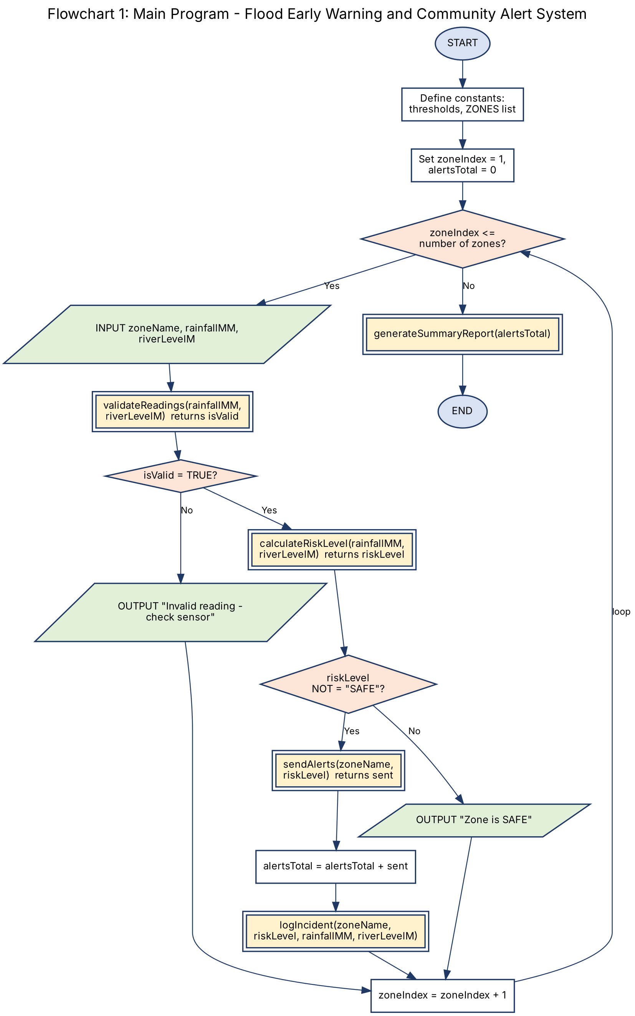

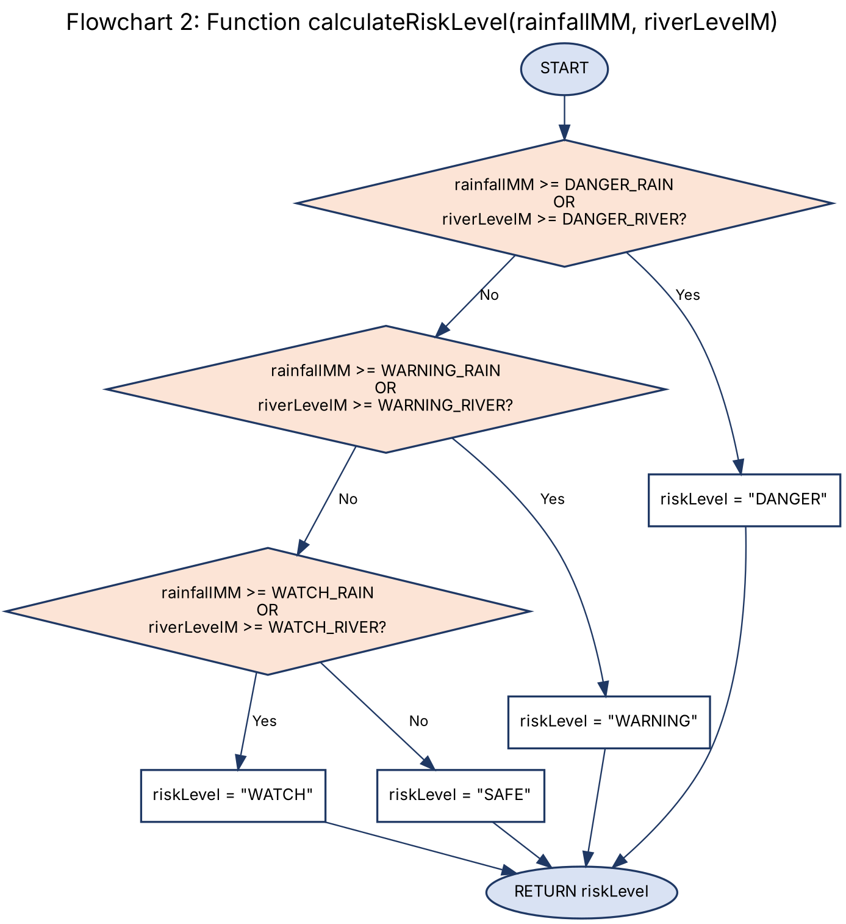

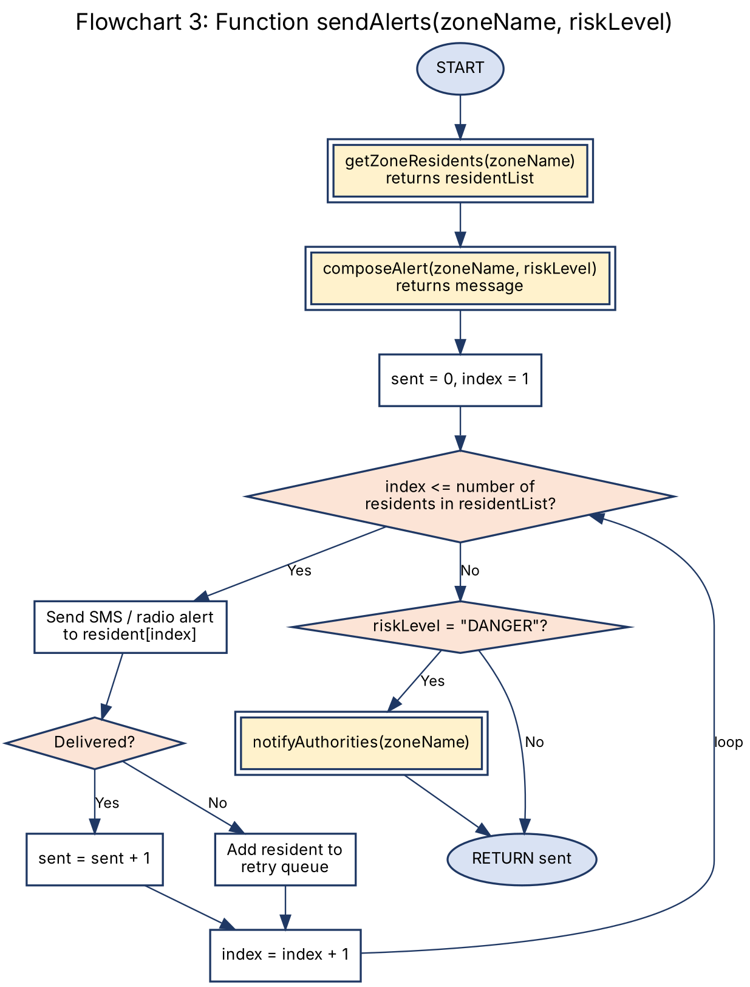

5. Functional Modules
Modular design splits the system into small, single-purpose functions that can be designed, tested and improved independently. This also allows different contributors in an open-source community to work on different modules.
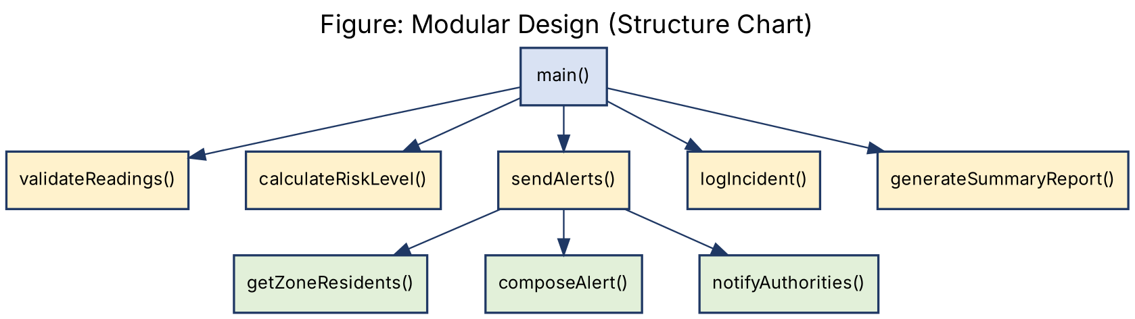
Module | Inputs (parameters) | Output (returns) | Responsibility
main() | none | none | Controls the monitoring loop and calls all other modules
validateReadings() | rainfallMM, riverLevelM | Boolean | Rejects non-numeric, negative or impossible values
calculateRiskLevel() | rainfallMM, riverLevelM | String | Applies decision structures and Boolean logic to classify risk
sendAlerts() | zoneName, riskLevel | Integer | Loops over residents and sends the alert
getZoneResidents() | zoneName | Array | Returns registered phone numbers for the zone
composeAlert() | zoneName, riskLevel | String | Builds a short plain-language message
notifyAuthorities() | zoneName | none | Alerts NDMA/emergency contacts for DANGER
logIncident() | zoneName, riskLevel, readings | none | Records the event for review and reporting
generateSummaryReport() | alertsTotal | none | Displays cycle summary

Programming Logic Coverage
Requirement | Where it appears in the design
Computational thinking / decomposition | Section 1.4, module structure chart
Variables, constants, data types | Section 2.1 table
Decision structures | IF / ELSE IF in calculateRiskLevel; validity and SAFE checks in main
Boolean logic | OR in risk thresholds; AND/NOT in validateReadings
Repetition structures | WHILE loop over zones in main; WHILE loop over residents in sendAlerts
Functions and modular design | Nine modules in Section 5 with parameters and return values

6. Expected Outputs
The scenarios below show how the design behaves. Each is traced through the rules in calculateRiskLevel.
No. | Zone | Rain (mm) | River (m) | Risk Level | Expected Output
1 | Kissy | 20 | 0.8 | SAFE | "Kissy is SAFE". No alerts sent.
2 | Kroo Bay | 65 | 1.5 | WATCH | Alert: "WATCH Kroo Bay: Heavy rain expected. Clear drains and stay informed." SMS sent to all registered residents.
3 | Culvert | 110 | 2.4 | WARNING | Alert: "WARNING Culvert: Flooding likely. Move valuables to higher ground and prepare to leave." SMS to residents.
4 | Regent | 90 | 4.2 | DANGER | River level reaches DANGER threshold even though rain is below it (OR logic). Alert: "DANGER Regent: Evacuate now to the nearest safe centre." SMS to residents and NDMA notified.
5 | Dwarzark | -15 | 1.0 | Invalid | "Invalid reading - check sensor". Error logged and no risk calculated.
6 | Susan's Bay | 155 | 3.2 | DANGER | Rainfall at or above 150 mm triggers DANGER. Evacuation alert and NDMA notification.

Sample Summary Report (end of cycle)
===== FLOOD MONITORING SUMMARY =====
Zones checked : 6
SAFE : 1
WATCH : 1
WARNING : 1
DANGER : 2
Invalid readings : 1
Total alerts sent : [sum of delivered alerts]
Authorities notified : 2
====================================

7. GitHub Evidence
Complete this section with your own evidence after you create the repository. Do not submit placeholders.
Item | Evidence
GitHub Repository | [Insert screenshot of repository home page]
Repository URL | https://github.com/[username]/PROG101_Assignment1_[StudentName]_[StudentID]
Git Commit History | [Insert screenshot of Commits page showing regular commits]
README.md | [Insert screenshot of README.md rendered on GitHub]
Repository Screenshot | [Insert screenshot of file list: report, flowcharts, pseudocode, README.md]

Repository Structure
PROG101_Assignment1_StudentName_StudentID/
README.md
PROG101_Assignment1_Report.docx (or .pdf)
pseudocode.md
flowcharts/
flowchart1_main.png
flowchart2_calculateRiskLevel.png
flowchart3_sendAlerts.png
figure_module_structure.png

8. References
Digital Public Goods Alliance (n.d.) The Digital Public Goods Standard. Available at: https://digitalpublicgoods.net (Accessed: [date]).
Government of Sierra Leone (2017) Sierra Leone: Rapid Damage and Loss Assessment of August 14th, 2017 Landslides and Floods in the Western Area. Freetown: Government of Sierra Leone.
National Disaster Management Agency, Sierra Leone (n.d.) Official website. [Add URL and access date].
Open Source Initiative (n.d.) The Open Source Definition. Available at: https://opensource.org/osd (Accessed: [date]).
United Nations (2015) Transforming our world: the 2030 Agenda for Sustainable Development (A/RES/70/1). Available at: https://sdgs.un.org (Accessed: [date]).
United Nations Secretary-General (2020) Roadmap for Digital Cooperation. New York: United Nations.
Wing, J.M. (2006) 'Computational thinking', Communications of the ACM, 49(3), pp. 33-35.
Please check each reference, add access dates and use the referencing style required by your department.

