**Final practice for certification**

**Part 1. Template design**

Step 1. Use version control system GitHub to create remote code repository for storing your works

Step 2. Create the client application folder structure

Step 3. Make up subject and sitemap for your web project

**Part 2. Mark up web pages**

Step 1. To make the frontend web application cross-browser, cross-platform and adaptive use Bootstrap templates:

* http://www.bentdesignstudio.com/v2/2012/03/twitter-bootstrap-2-photoshop-template-psd/
* <http://bootstrapbay.com/blog/bootstrap-resources/>

Step 2. Create the web-page structure using HTML5 in accordance with page template given on figure 1

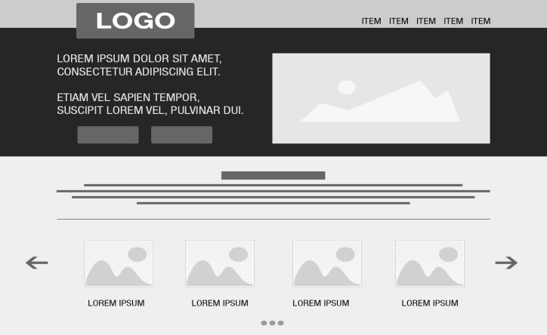

Fig 1. Page template

Step 3. Apply SEO knowledge for your web project pages got from the previous step:

* Use the "title" tag with unique descriptions for each page
* Use the "description", "keyword" meta tag with unique descriptions for each page too
* Make your site easier to navigate
* Make effective use of robots.txt by page including into search results

Step 4. Modify CSS “cascade” styles for your preference, apply sprites from spritesheets for image optimization

Step 5. Apply Normalize and reset.css files

Step 6. Use gradients, 2D and 3D transformation for images on page.

Step 7. Use CSS preprocessor

* Install LESS preprocessor
* Create a style rules with LESS syntax using variables, mixin, color functions and embed them to the web project
* Compile *.less to *.css

**Part 3. Add dynamics to web project**

Step 1. Add a feedback form with combobox, checkbox, textbox, datepicker, button to the frontend web project by using JavaScript

Step 2. Use Bootstrap tools to make a slideshow by applying a touchswipe carousel

**Part 4. JSON-file data getting**

Step 1. Create JSON-file with data according to the chosen subject

Step 2. Pull out JSON-file to webserver (for example <https://www.heroku.com/> )

Step 3. Read data from JSON-file and display them on the page in the table's form using AJAX

**Part 5. JavaScript Plagins applying**

Step 1. Add sorting according to table columns using existing plugins

Step 2. Add the filter to the table data by any field using existing plugins

Step 3. Add paging view possibility (and navigating across pages) for showing table data by parts using existing plugins, for example: http://www.dynatable.com/?utm_source=html5weekly&utm_medium=email&perPage=50&queries[search]=ukraine

Step 4. Use any task manager (such as GRUNT, GULP, Broccoli) for minification, optimizathion the frontend web project