**Gebze Technical University**

**Computer Engineering**

**CSE443- 2019 Fall**

**HOMEWORK 2 REPORT**

**SİMGE SARIÇAYIR**

**151044035**

**Part1**

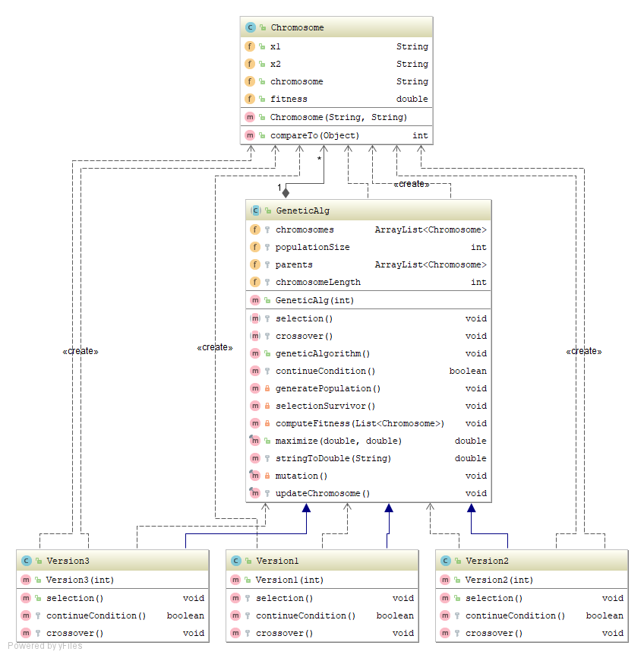

In this part, template method is implemented. According to method there is an abstract class which includes primitive methods and maybe hook methods. In this project geneticAlgorithm method is represents template method and it has some steps. These steps are some abstract method that subclass is decided how it will be implemented but template is precise.

Chromosomes are represented with a class that has fitness value and x1,x2 values.

GeneticAlg class has 2 abstract method. Crossover and Selection methos are abstract because subclasses can have their own manner for it. For example, version1 will use “roulette wheel selection” and 1 point crossover but version 2 will use “rank selection” and 2 point crossover.

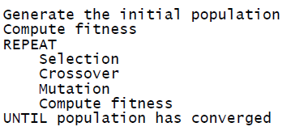

According to genetic algorithm, initial population is initialized with random double values then their fitness values are calculated. When fitness values are calculated maximize function is used. Also, initial population is initialized with random values but there some constraints about it so they are considered too.

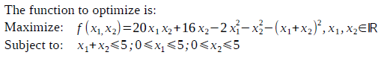

After these operations abstract selection method is implement in the subclasses. There are three types selection methods; roulette wheel selection, rank selection, tournament selection. According to which version has this type they are implemented.

Crossover operation is two type in this project , one point and two point so abstract method is initialized in the subclasses.

Mutation is same for all versions so it is implemented final in the abstract base class. All versions can use that method directly.

These methods are called with order. Then fitness is computed for parent chromosomes which are selected in the selection method previously. These operations are repeated until population is converged.

Loop is repeated with 100 iterations but there is also a termination condition. When a parent could not found 35 times in the selection method while loop is ended.

**Results**

