README
Welcome to PoisedPMS
PoisedPMS is a database management program for a construction company. It allows users to add and edit people such as customers, contractors, architects and project managers as well as projects and their statuses. This will allow the users to easily keep track of complete and incomplete projects and manage their statuses accordingly.
Contents
- Installation Guide
- Database Set-Up
- Usage
- Other Notes
Installation Guide
In order to run PoisedPMS you will need to have a version of Java installed on your machine. The program was built using java version "13.0.2" 2020-01-14 (Java(TM) SE Runtime Environment (build 13.0.2+8)) Therefore it is recommended to install Java 13.0.2 in order to run the program successfully. Here is a guide on installing previous versions for Windows machines: https://service.uoregon.edu/TDClient/2030/Portal/KB/ArticleDet?ID=32227. Alternatively if you would like the newest version of Java (which is recommended by Java) then you can follow the guide here: https://www3.ntu.edu.sg/home/ehchua/programming/howto/JDK_HowTo.html
Next you will need to install MySQL on your machine. You can find an installation guide here: https://dev.mysql.com/doc/mysql-installation-excerpt/5.7/en/. The program was tested using MySQL Server version: 5.7.30-0ubuntu0.18.04.1 (Ubuntu) but any version should work without complications.
You then need to install a Java IDE or alternatively the program can be run from terminal. This program was built using eclipse Version: 2019-12 (4.14.0).
Database Set-Up
- In order to set up your Database you need to create a new user with the username poisedpms@localhost with the password poisedpms.
- Grant all privileges to the newly created user.
- Access the new user and create a new database called PoisedPMS.
- Access the new Database and run the command found in the table_setup.txt file.
- Your Database should now be ready to use.
Usage
Once the program is running a main menu is displayed to the user:
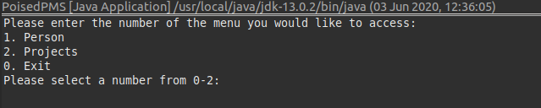
The user can then select a number to view sub menus which allow them to execute tasks in the database. The first menu is the person menu where the user can add people or allocate a project to a person.
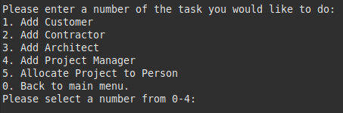

The add customer, add contractor and add architect options use the same method but populates the type field of the person with they type selected. The user is prompted to fill in values and then is presented with the information that has been added to the people table. Below is an example of adding a customer:
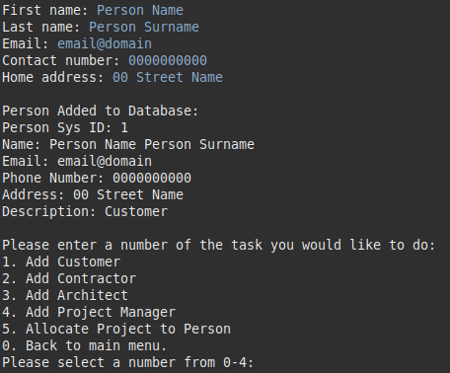

The user is then taken back to the person menu. To allocate a project to a person the user first has to select an available project then choose the person type (Customers do not need projects assigned to them as this happens during project creation). The user then selects the person to assign the project to:
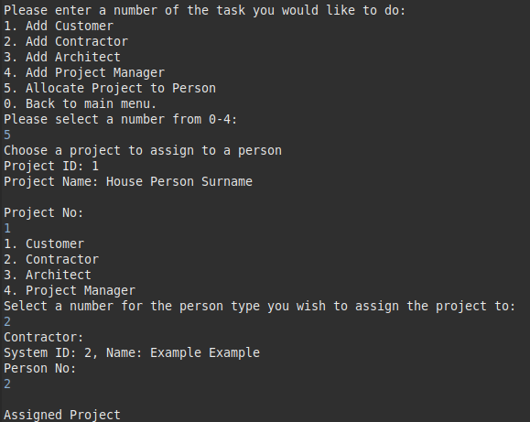

The next menu is the projects menu where the user can create projects, update project statuses, search projects and view lists of specific projects.
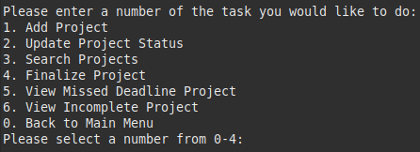

Adding a project is similar to adding a person. The user is prompted to enter specific field values and the information added to the table is printed back to the user. In order to create a project it is preferable to already have customers which you can assign to it during creation:
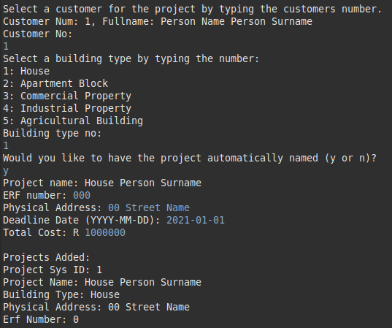

The update project status allows the user to update either the due date, the status or the amount paid. The new value is entered and the table is updated accordingly.
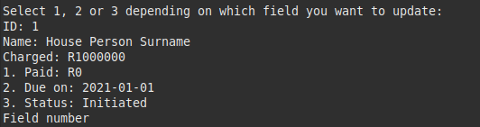

The finalize project option allows the user to enter a completion date, it updates the status to complete and it issues an invoice if the customer has not yet paid the full amount. The invoice can be found in the projects directory as the_project_name.txt.
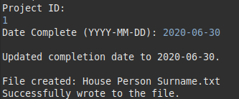

The search projects option uses the same method but allows the user to search fpor a project either using its ID or its name.

The two view options displays lists of projects to the user. The missed deadline option will display all projects that are complete but the deadlines have been missed and the incomplete option will display all projects whose status is not complete.

Other Notes

Created By

Simone Groenewald

For more information on what each method does please refer to the JavaDoc or refer to the in line code comments.

