SWTP 6800 Simulator Usage
27-Mar-2012

COPYRIGHT NOTICES

The following copyright notice applies to the SIMH source, binary, and documentation:

Original code published in 1993-2008, written by Robert M Supnik
Copyright (c) 1993-2008, Robert M Supnik

Permission is hereby granted, free of charge, to any person obtaining a copy of this software and associated documentation files (the "Software"), to deal in the Software without restriction, including without limitation the rights to use, copy, modify, merge, publish, distribute, sublicense, and/or sell copies of the Software, and to permit persons to whom the Software is furnished to do so, subject to the following conditions:

The above copyright notice and this permission notice shall be included in all copies or substantial portions of the Software.

THE SOFTWARE IS PROVIDED "AS IS", WITHOUT WARRANTY OF ANY KIND, EXPRESS OR IMPLIED, INCLUDING BUT NOT LIMITED TO THE WARRANTIES OF MERCHANTABILITY, FITNESS FOR A PARTICULAR PURPOSE AND NONINFRINGEMENT. IN NO EVENT SHALL ROBERT M SUPNIK BE LIABLE FOR ANY CLAIM, DAMAGES OR OTHER LIABILITY, WHETHER IN AN ACTION OF CONTRACT, TORT OR OTHERWISE, ARISING FROM, OUT OF OR IN CONNECTION WITH THE SOFTWARE OR THE USE OR OTHER DEALINGS IN THE SOFTWARE.

Except as contained in this notice, the name of Robert M Supnik shall not be used in advertising or otherwise to promote the sale, use or other dealings in this Software without prior written authorization from Robert M Supnik.

The following copyright notice applies to the SWTP 6800 source, binary, and documentation:

Original code published in 2011, written by William A Beech
Copyright (c) 2011, William A Beech

Permission is hereby granted, free of charge, to any person obtaining a copy of this software and associated documentation files (the "Software"), to deal in the Software without restriction, including without limitation the rights to use, copy, modify, merge, publish, distribute, sublicense, and/or sell copies of the Software, and to permit persons to whom the Software is furnished to do so, subject to the following conditions:

The above copyright notice and this permission notice shall be included in all copies or substantial portions of the Software.

THE SOFTWARE IS PROVIDED "AS IS", WITHOUT WARRANTY OF ANY KIND, EXPRESS OR IMPLIED, INCLUDING BUT NOT LIMITED TO THE WARRANTIES OF MERCHANTABILITY, FITNESS FOR A PARTICULAR PURPOSE AND NONINFRINGEMENT. IN NO EVENT SHALL WILLIAM A BEECH BE LIABLE FOR ANY CLAIM, DAMAGES OR OTHER LIABILITY, WHETHER IN AN ACTION OF CONTRACT, TORT OR OTHERWISE, ARISING FROM, OUT OF OR IN CONNECTION WITH THE SOFTWARE OR THE USE OR OTHER DEALINGS IN THE SOFTWARE.

Except as contained in this notice, the name of William A Beech shall not be used in advertising or otherwise to promote the sale, use or other dealings in this Software without prior written authorization from William A Beech.

1 Simulator Files 4
2 SWTP 6800 Features 4
2.1 Motherboard 5
2.2 MP-A CPU Card 5
2.2.1 BOOTROM Device 6
2.2.2 CPU Device 6
2.2.3 M6800 Registers 7
2.3 MP-A2 CPU Card 7
2.3.1 BOOTROM Device 8
2.3.2 I2716 Device 8
2.3.3 CPU Device 8
2.3.4 M6800 Registers 8
2.4 Programmed I/O Devices 9
2.4.1 MP-S Serial I/O Board 9
2.4.2 DC-4 Dual 5-1/4” Floppy Disk Controller Board 9

This memorandum documents the SWTP 6800 simulator.

Simulator Files

sim/ scp.h
sim_console.h
sim_defs.h
sim_fio.h
sim_rev.h
sim_sock.h
sim_tape.h
sim_timer.h
sim_tmxr.h
scp.c
sim_console.c
sim_fio.c
sim_sock.c
sim_tape.c
sim_timer.c
sim_tmxr.c

sim/swtp6800/common bootrom.c boot ROM simulator
dc-4.c disk controller simulator
i2716.c 2716 ROM simulator d
m6800.c m6800 CPU simulator
m6810.c m6810 RAM simulator
mp-8m.c 8K RAM board simulator
mp-a.c MP-A CPU board simulator
mp-a2.c MP-A2 CPU board simulator mp-b2.c MP-B2 Motherboard board simulator
mp-s.c serial port board simulator

sim/swtp6800/swtp6800 mp-a_sys.c system definitions for MP-A CPU board
mp-a2_sys.c system definitions for MP-A2 CPU board
swtp_defs.h system definitions for the SWTP 6800

Additional files are:

sim/swtp6800/swtp6800 swtbug.bin SWTBUG boot ROM code
swtp6800mp-a.ini Initialization for MP-A CPU
swtp6800mp-a2.ini Initialization for MP-A2 CPU

SWTP 6800 Features

The SWTP 6800 simulator is configured as follows:

device names(s) simulates

m6800+ MP-A CPU with
m6810+ 128B of RAM and
bootrom 1024B of boot ROM
m6800+ MP-A2 CPU with
m6810+ 128B of RAM
bootrom+ 1024B of boot ROM
i2716 4 each 2716 EPROMS and
external RAM above 40K
Motherboard MP-B2 with 8 SS-30 plugs and 7 SS-50 plugs
MP-8M 6 each 8K byte memory board
DC-4 SS-30 5-1/4” Dual Floppy disk controller
MP-S SS-30 Serial I/O Port

The simulator builds as two executable files, SWTP6800MP-A and SWTP6800MP-A2, one for each of the processor boards available.

Most devices can be disabled or enabled, by the commands:

SET <dev> DISABLED
SET <dev> ENABLED

The SWTP 6800 simulator implements several unique stop conditions:

- If an undefined instruction is decoded, a STOP_INST is set
- If an undefined memory or I/O address is selected and MTRAP is enabled, a STOP_INST is set
- If an undefined interrupt occurs and ITRAP is enabled, a STOP_INST is set

The LOAD command supports both S19 format and BIN format tapes. If the file extension is .S19, or the h switch is specified with LOAD, the file is assumed to be S19 format; if the file extension is .BIN, or the -b switch is specified, the file is assumed to be BIN format.

Motherboard
The current simulator supports the MP-B2 motherboard. This board allows for inserting of the selected CPU, up to 6 MP-8M 8K byte memory boards, and one additional SS-50 board. It will allow the addition of up to 6 other SS-50 peripherals with the MP-S and DC-4.

Addresses are fixed for each of the 6 MP-8M boards as shown below:

Device Base address

bd0 0000H
bd1 2000H
bd2 4000H
bd3 6000H
bd4 0A000H
bd5 0C000H

The simulator allows each board to be enabled or disabled individually to simulate the presence or absence of a particular board. This is the standard layout of memory in a SWTP 6800.

MP-A CPU Card
The simulator for the SWTP 6800 MP-A uses several files. The simulator is depicted in Figure 1.

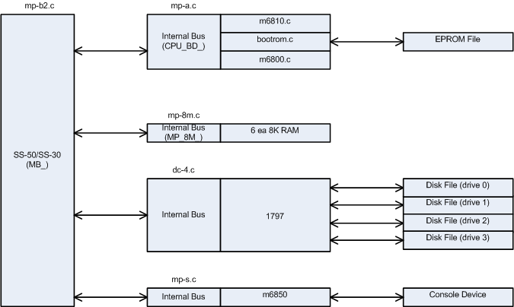

Figure 1. MP-A Simulator

The MP-A CPU has several available options.

BOOTROM Device
The BOOTROM allows selection of the size of the ROM:

SET BOOTROM NONE No Boot PROM
SET BOOTROM 2704 0.5K PROM
SET BOOTROM 2708 1K PROM
SET BOOTROM 2716 2K PROM
SET BOOTROM 2732 4K PROM
SET BOOTROM 2764 8K PROM

The BOOTROM device assigns the base of the ROM image to 0E000H of simulated memory.

The BOOTROM image file is attached to the BOOTROM device as follows:

ATTACH BOOTROM SWTBUG.BIN

CPU Device
The CPU device allows setting the simulated behavior for interrupts and references to unimplemented memory.

SET CPU ITRAP Trap interrupts
SET CPU NOITRAP Don’t trap interrupts
SET CPU MTRAP Trap unimplemented memory
SET CPU NOMTRAP Don’t trap unimplemented memory

M6800 Registers
The CPU registers include the visible state of the processor as well as the control registers for the interrupt system.

name size comments

PC 16 program counter
SP 16 stack pointer
A 8 accumulator a
B 8 accumulator b
IX 16 index register
CCR 8 condition code register

The CPU display radix can be set for octal, decimal or hexadecimal. The commands are as follows:

SET CPU OCT
SET CPU DEC
SET CPU HEX

The current CPU display radix can be found with:

SHOW CPU RADIX

MP-A2 CPU Card
The simulator for the SWTP 6800 MP-A uses several files. The simulator is depicted in Figure 2.

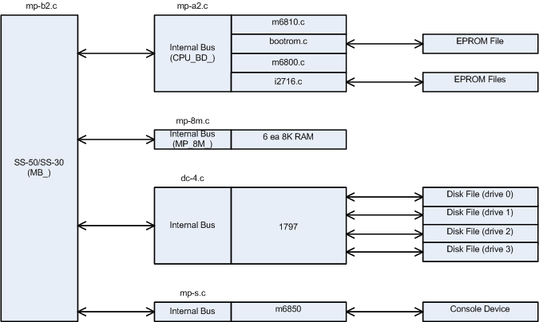

Figure 2. MP-A2 Simulator

The MP-A CPU has several available options.

BOOTROM Device
The BOOTROM allows selection of the size of the ROM:

SET BOOTROM NONE No Boot PROM
SET BOOTROM 2704 0.5K PROM
SET BOOTROM 2708 1K PROM
SET BOOTROM 2716 2K PROM
SET BOOTROM 2732 4K PROM
SET BOOTROM 2764 8K PROM

The BOOTROM device assigns the base of the ROM image to 0E000H of simulated memory.

The BOOTROM image file is attached to the BOOTROM device as follows:

ATTACH BOOTROM SWTBUG.BIN

I2716 Device
The i2716 device provides 4 units to simulate the 4 2716 ROM positions on the MP-A2 CPU board. They are i27160 to i27163.

The i2716 ROM image file is attached to one of the i2716 devices as follows:

ATTACH I27160 FILE0.BIN

CPU Device
The CPU device allows setting the simulated behavior for interrupts and references to unimplemented memory.

SET CPU ITRAP Trap interrupts
SET CPU NOITRAP Don’t trap interrupts
SET CPU MTRAP Trap unimplemented memory
SET CPU NOMTRAP Don’t trap unimplemented memory

M6800 Registers
The CPU registers include the visible state of the processor as well as the control registers for the interrupt system.

name size comments

PC 16 program counter
SP 16 stack pointer
A 8 accumulator a
B 8 accumulator b
IX 16 index register
CCR 8 condition code register

The CPU display radix can be set for octal, decimal or hexadecimal. The commands are as follows:

SET CPU OCT
SET CPU DEC
SET CPU HEX

The current CPU display radix can be found with:

SHOW CPU RADIX

Programmed I/O Devices

MP-S Serial I/O Board
This driver simulates the MP-S serial I/O board for the console connection to the SWTP 6800. The console simulated is either an ANSI terminal or a Teletype Model 33 with paper tape reader and punch. The console functions work correctly but the paper tape functions do not. The simulator simulates the M6850 registers to the extent required to support the console.

Console mode can be set as follows:

SET MP-S ANSI
SET MP-S TTY

Current console status can be shown with the following command:

SHOW MP-S

The MP-S driver simulates the paper tape reader (PTR) and paper tape punch (PTP) devices. These devices need to be attached to files before use. If the file specified is not present, then a new file is created. The attach and detach commands are as follows:

ATTACH PTR TEST
ATTACH PTP TEST1
DETACH PTR
DETACH PTP

Current PTP and PTR status can be shown with the following commands:

SHOW PTP
SHOW PTR

DC-4 Dual 5-1/4” Floppy Disk Controller Board
This driver simulates the DC-4 floppy disk controller board. Normally this board connects to a dual drive DSDD 5-1/4” floppy system. In this emulation, I have provided for 4 drives, the maximum the WD1797 can support and the emulated drive images are also increased in size to 1.44 MB. FLEX can handle this size drive with no problems.

The DC-4 simulator provides for four drive units. The units are DC-40 to DC-43. These devices need to be attached to files before use. If the file specified is not present, then a new file is created. The units can be attached and detached to files as follows:

ATTACH DC-40 BOOT.IMG
DETACH DC-43

Current DC-4 status can be displayed with the following command:

SHOW DC-4

