ProposalForge Pro
AI Assistant for Proposals & Documents
Solution Overview for Leadership
End to end: what it does, how it works, and how it runs in production
Agriculture · Finance · Healthcare
Running live on Microsoft Azure

Contents

1 At a Glance
ProposalForge Pro reads proposals and documents and answers questions about them in plain language — with every answer backed by evidence from the source. It works across three business domains and runs live on Azure with automated delivery, monitoring and safety controls.
The essentials
What it is An AI assistant that answers questions about your documents, with citations.
Who it serves Teams in agriculture, finance and healthcare.
Why it's trusted Answers are grounded in source content; sensitive data is protected.
Where it runs A single service on Microsoft Azure, deployed automatically.
Status Live and tested — 48 automated tests passing, evaluation at 100%.

Proof points
48  tests passing | 100%  answer eval | < 5s  p95 response | 3  domains | 1-click  deploys

2 The Problem & The Value
- Problem: Reading proposals, RFPs and domain documents by hand is slow, inconsistent and costly, and generic AI chatbots invent facts and can leak sensitive data.
- Our answer: A domain-aware assistant that only answers from retrieved source content, cites its evidence, and enforces safety rules per domain.
- Business value: Faster document turnaround, consistent answers, reduced risk in regulated domains, and no lock-in — it runs with or without any single AI vendor.

3 What It Does
- Grounded answers: Every response is built from retrieved source text and shows its citations.
- Automatic routing: It detects whether a question is agriculture, finance or healthcare and uses that domain's knowledge base; if unsure, it asks.
- Multi-document analysis: It can read several documents at once and answer across them.
- Always available: If an AI provider is unavailable, it falls back to another, then to a built-in offline mode — it never goes dark.
- Follow-up suggestions: It proposes relevant next questions to speed the user along.

4 How It's Built
The whole product ships as one container on Azure. A single entry point (nginx) serves both the user interface and the programmatic API, and a coordinator (“orchestrator”) runs the five steps behind every answer. It connects to the AI provider, the knowledge base and Azure monitoring.
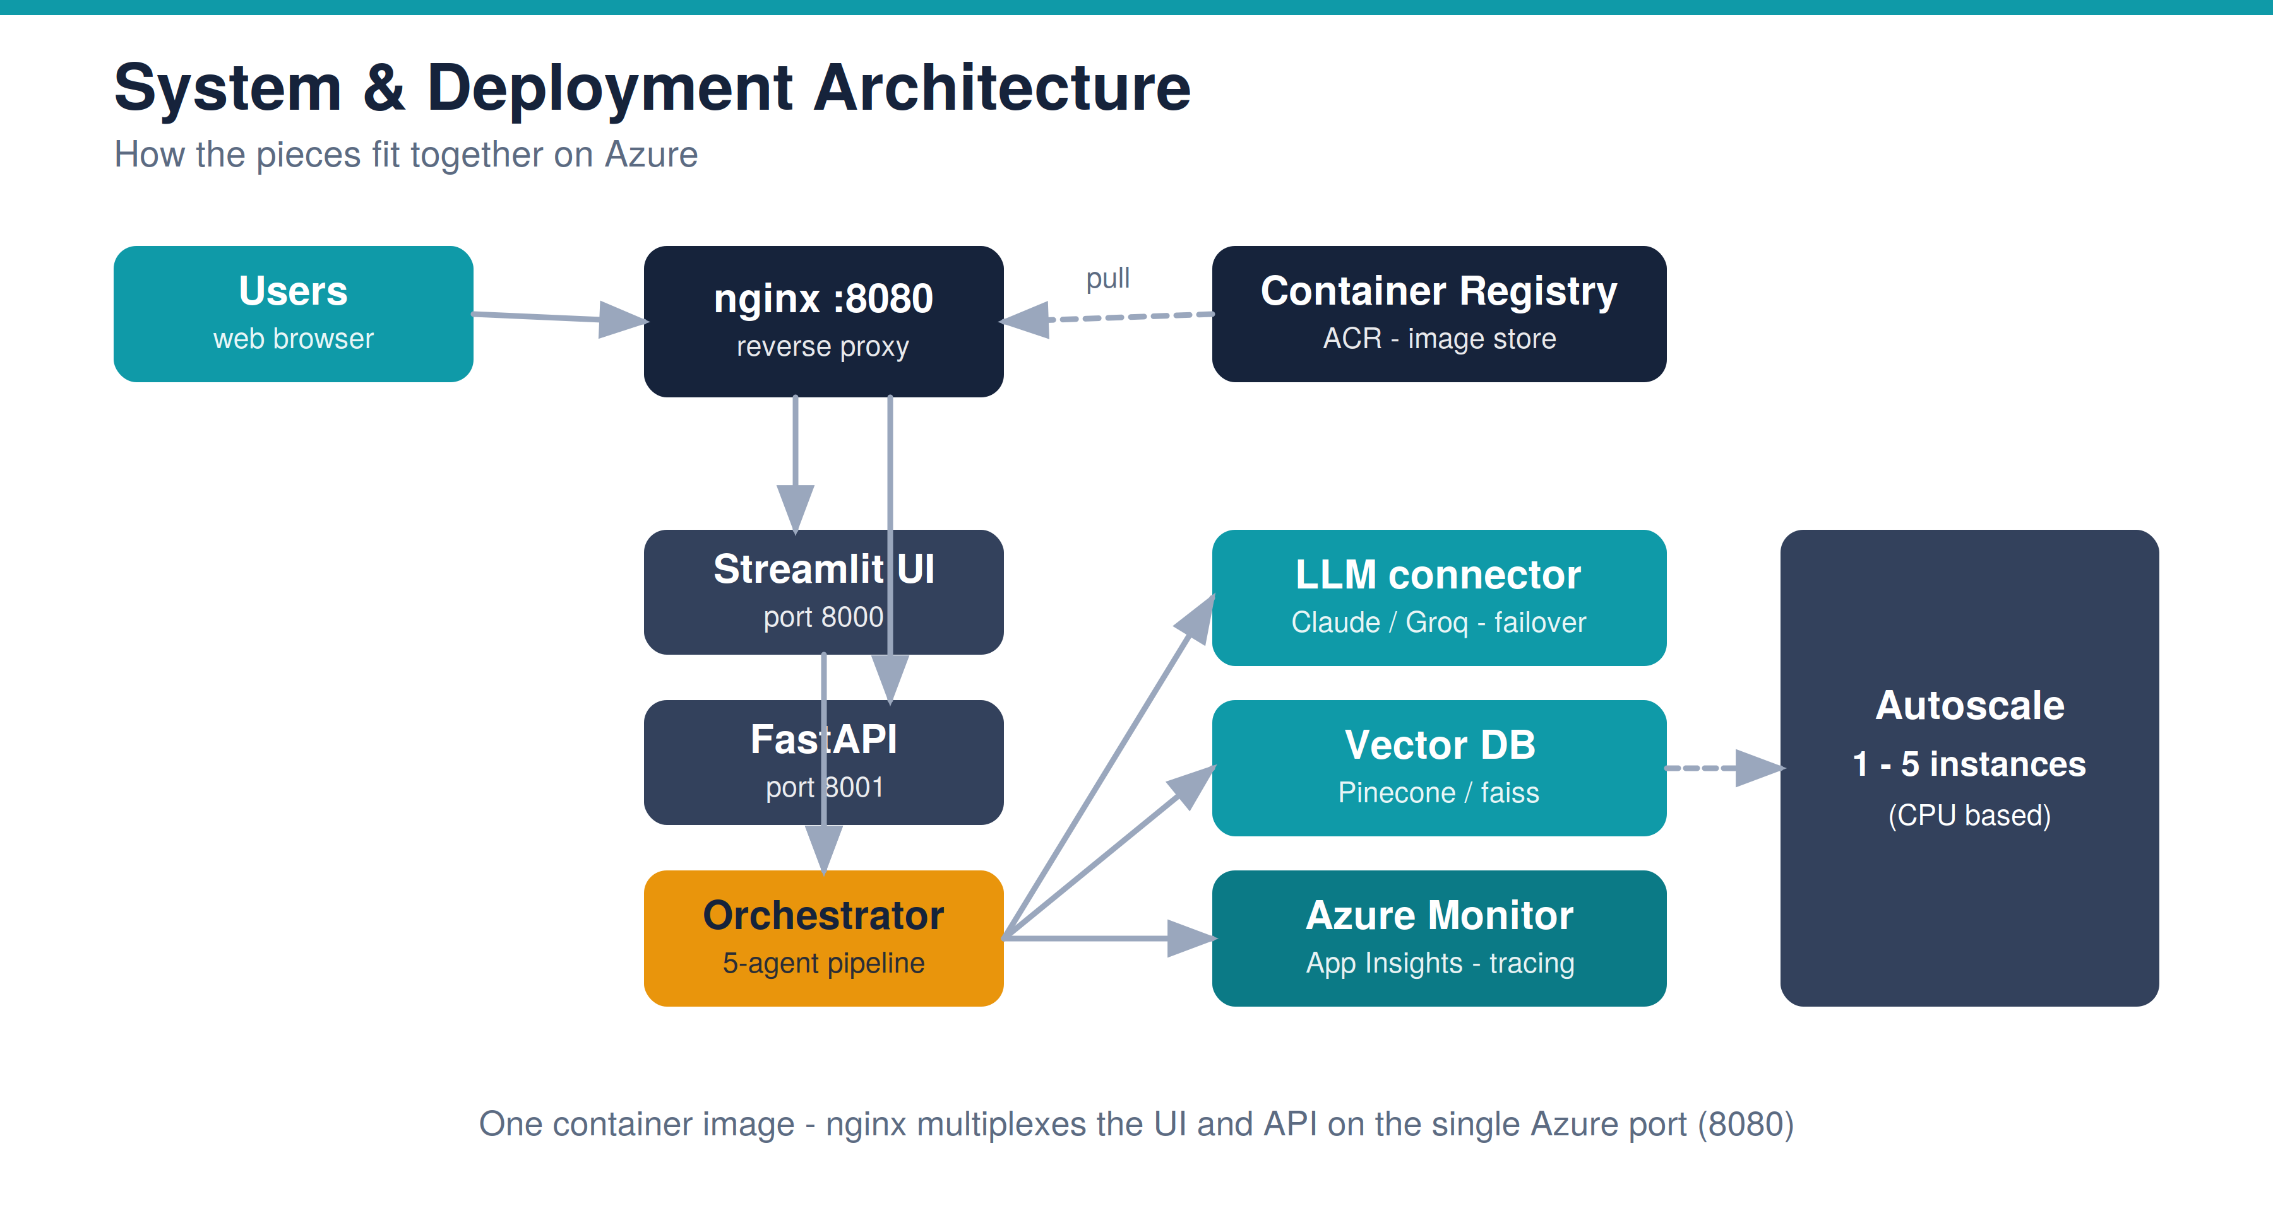
Why it matters: One simple deployable unit that scales automatically from 1 to 5 instances under load.

5 How a Question Is Answered
Behind each answer, the system routes the question to the right domain, runs a safety check, retrieves the most relevant evidence, and composes a cited answer. Each domain is isolated, so information never crosses between them.
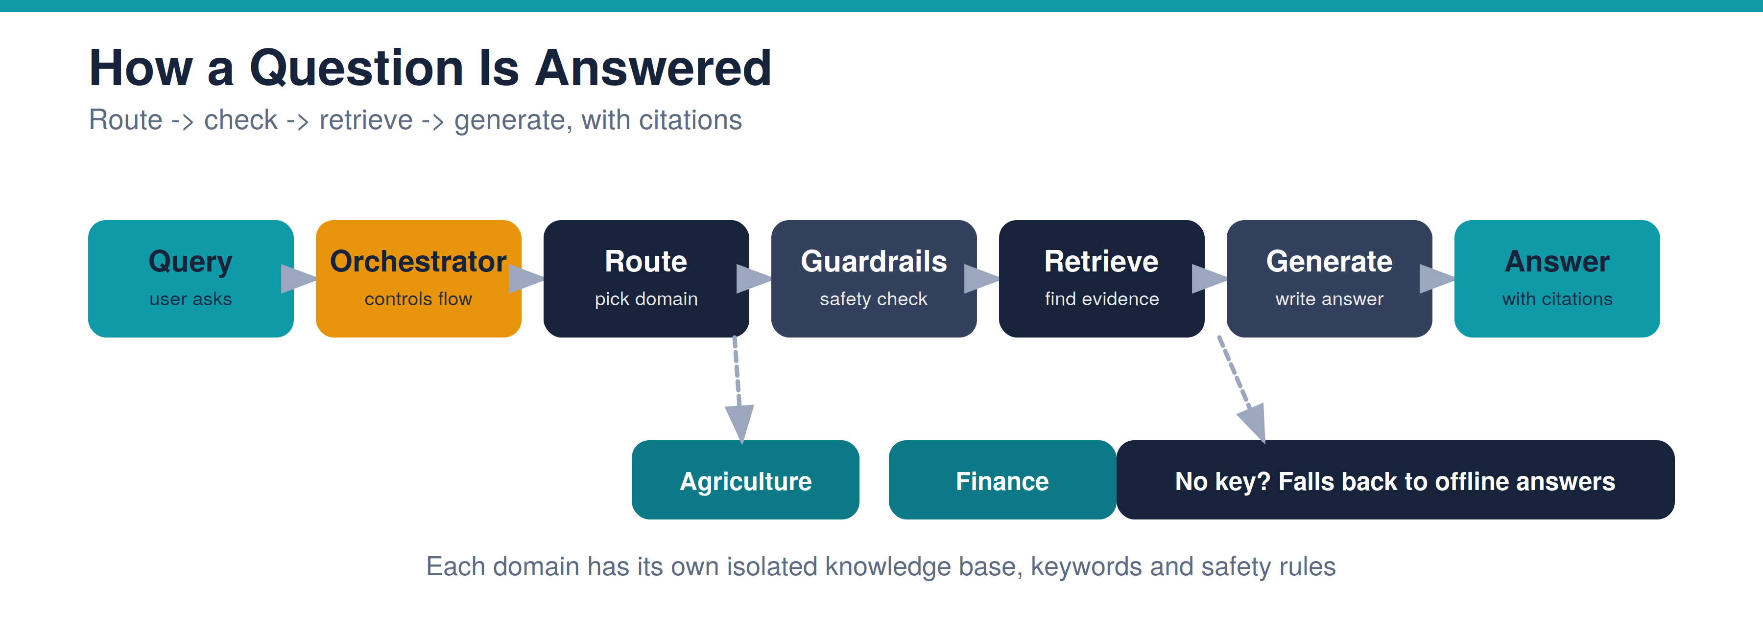
Why it matters: Answers stay accurate, on-topic and safe — and the system always responds, even with no AI key.

6 Why the Answers Are Trustworthy
Documents are indexed once into a searchable knowledge base. Every question then retrieves the closest evidence and the AI composes an answer from it — so responses are grounded, not guessed.
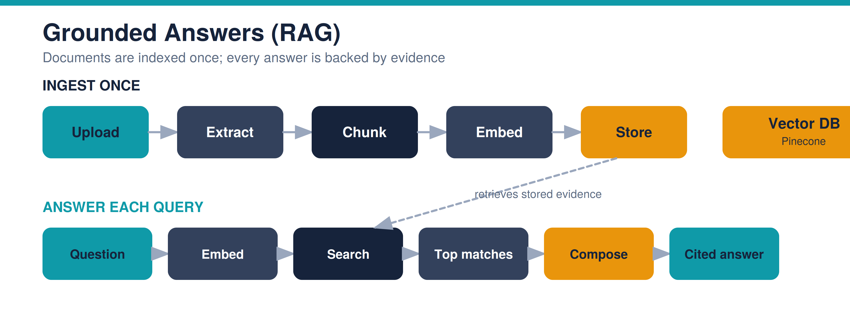
Why it matters: Reduces hallucination: the model answers from your documents, with citations, not from memory.

7 Reliability & Automated Delivery
Every code change is automatically tested, evaluated against a real document, deployed to Azure, and load-tested — with no manual steps. Poor-quality or slow changes are blocked before they reach users.
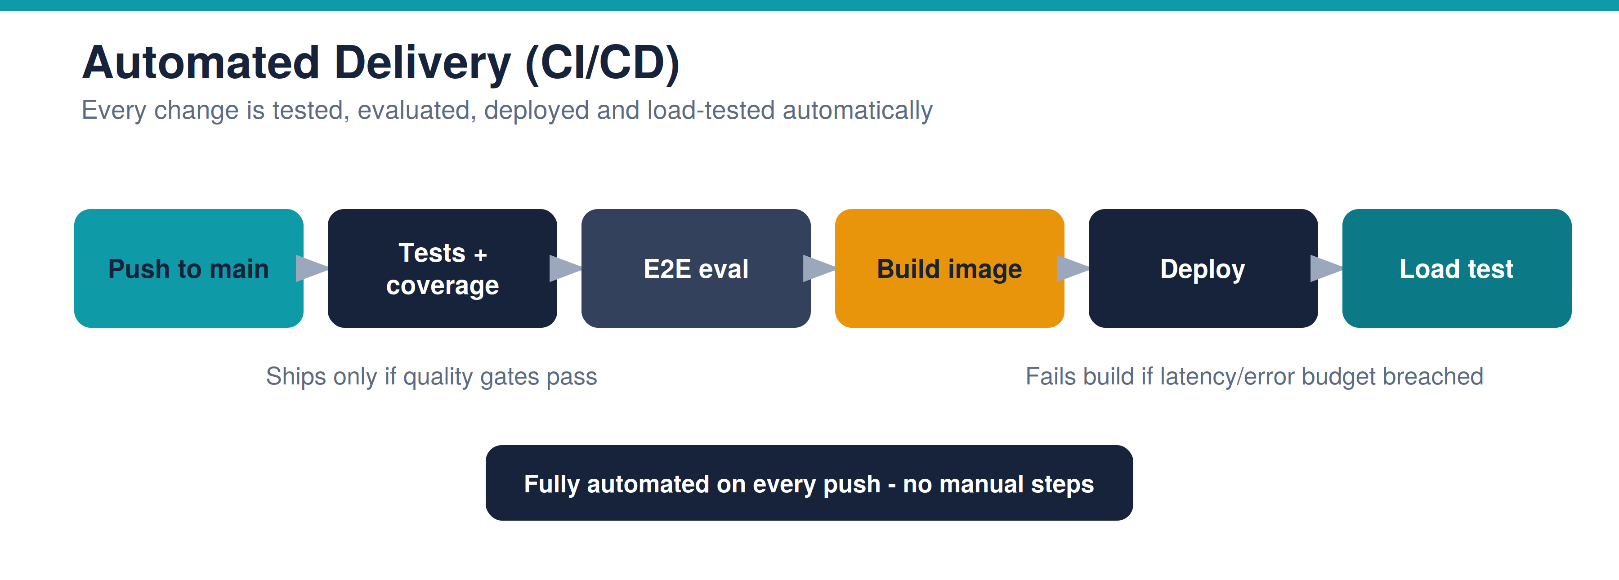
Why it matters: Changes reach production quickly and safely, with quality and speed enforced automatically.

Performance targets (enforced in delivery)
What is measured | Target
Health check response | under 50 ms
Document search (no AI) | under 150 ms
Full answer, 95th percentile | under 5 seconds
Sustained throughput | reported as requests/second
Note: a full AI answer cannot be a few milliseconds — generating language takes time. The sub-second targets apply to health and search; the full-answer target is a 95th-percentile under five seconds, reported alongside throughput.

8 Full Visibility in Production
Operations teams can see exactly what happens inside every request. Azure Monitor records a trace for each answer — its speed, cost (tokens), quality score and any safety blocks — and standard usage and error metrics are captured automatically.
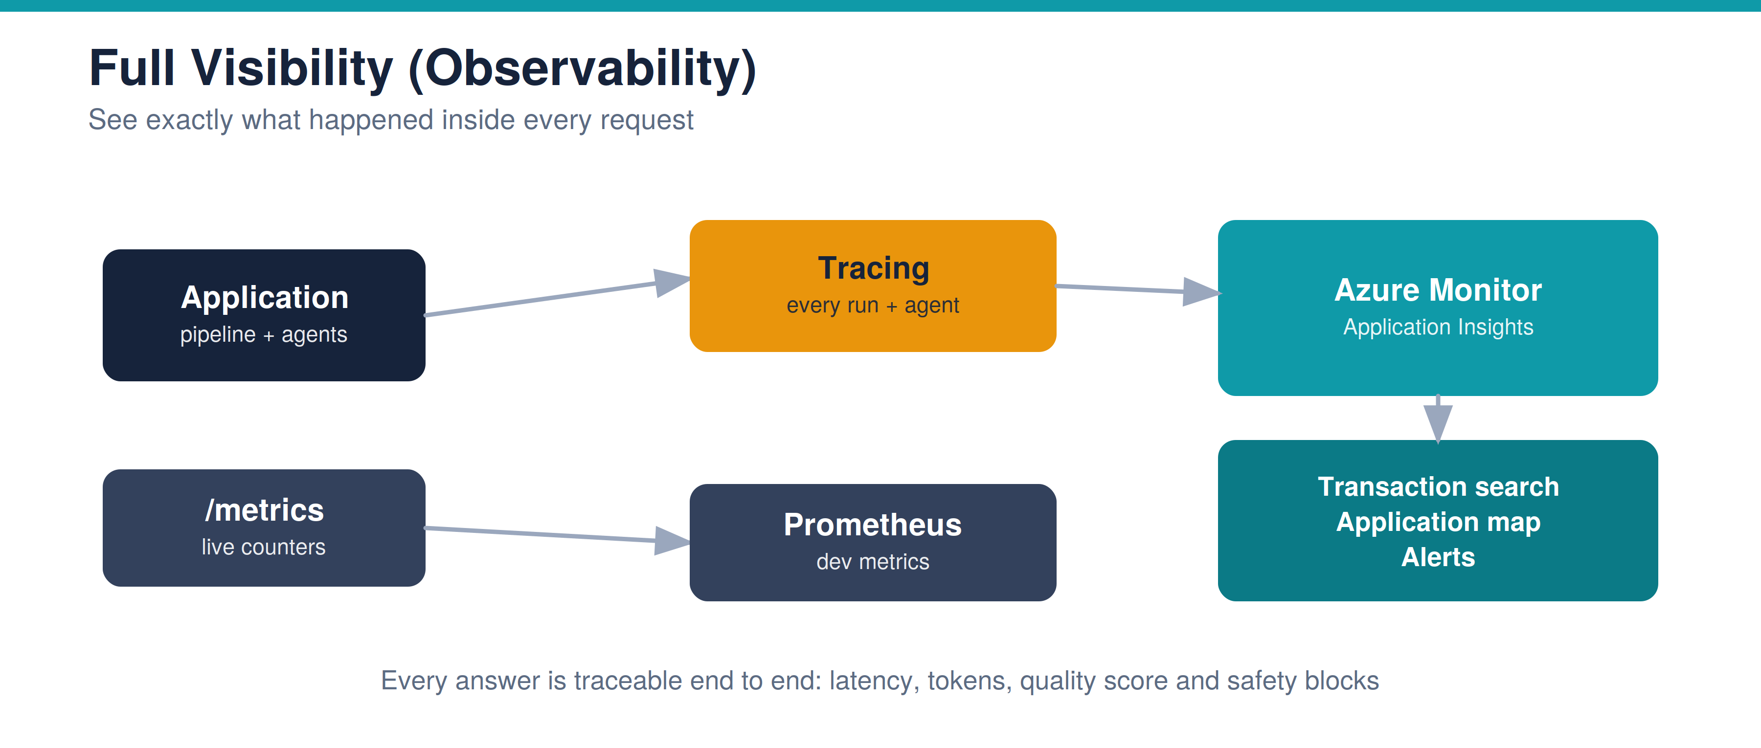
Why it matters: Problems are found and diagnosed fast; performance and cost are visible at all times.

9 Security & Safety
The product protects users, data and answers at every layer. Logins use industry-standard password protection and re-validated sessions; sensitive personal and health information is redacted or refused; each domain enforces its own rules; and every action is logged.
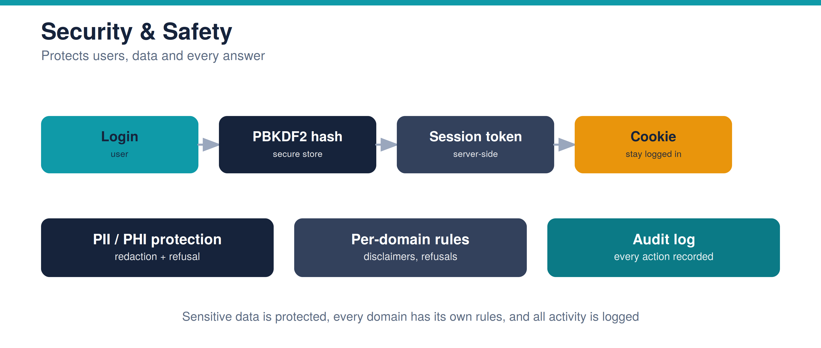
Why it matters: Suitable for regulated domains — protection and a complete audit trail are built in.

10 Outcomes to Date
Area | Result
Automated tests | 48 passing (external-API tests run separately)
Answer evaluation | 100% of grounded-answer checks pass on a real document
Response speed | 95th-percentile under 5 seconds when warm
Search speed | under 150 ms
Availability | automatic failover across AI providers, then offline mode
Visibility | end-to-end tracing live in Azure Monitor

11 What's Next
- Durability: Move user and audit records to managed storage so they persist across restarts.
- Secrets hardening: Hold API keys in Azure Key Vault instead of app settings.
- Proactive alerts: Auto-alert on error-rate or latency breaches.
- New agents: Bid/No-Bid scoring, red-team review, and a compliance traceability matrix.
- Scale testing: Cloud-scale load testing via the provisioned Azure Load Testing service.

A Appendix — Technical Reference

Technology
Layer | Choice
Interface | Streamlit (UI) + FastAPI (API)
AI provider | Claude / Groq, user-selectable with failover; Azure OpenAI supported
Knowledge base | Pinecone vector database (faiss / TF-IDF fallback)
Monitoring | Azure Monitor / Application Insights + Prometheus metrics
Delivery | GitHub Actions + Bicep on Azure Web App for Containers

Key entry points
Endpoint | Purpose
GET /health | Liveness check
GET /api/v1/status | Live status of AI, knowledge base and monitoring
POST /api/v1/retrieve | Search only (no AI)
POST /api/v1/pipeline/run | Full single-document answer
POST /api/v1/analyze/multi | Multi-document analysis

