**Unstructured Resource-ID**

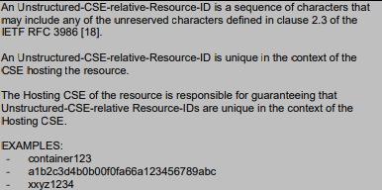

**Blocking Request**

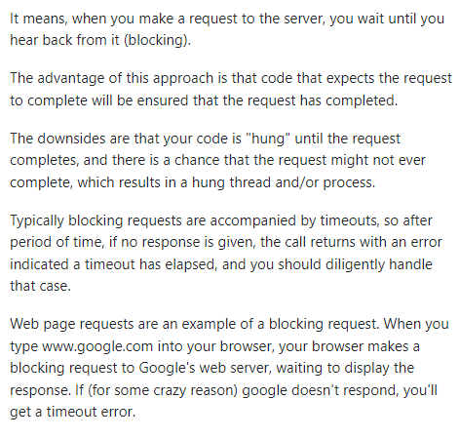

**Result Content**

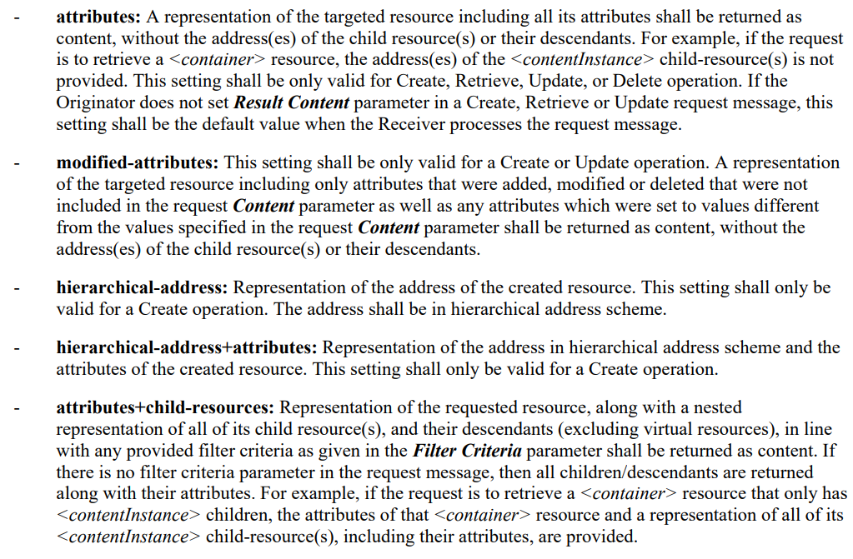

**cseType**

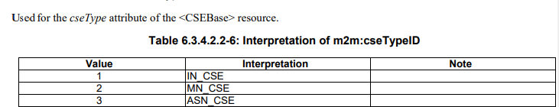

**AE-ID**



**pointOfAccess**

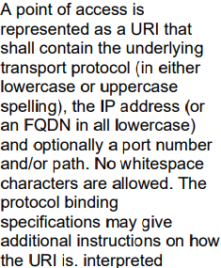

**maxInstanceAge**

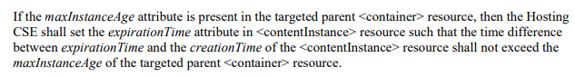

**creator**



**contentInfo**

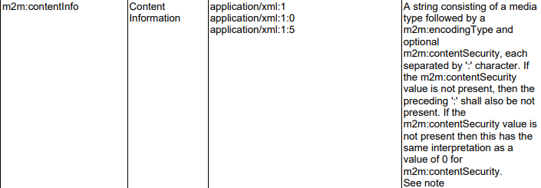

**notificationEvent/representation**

