GIT
Distributed, decentralized, version control system. Many developers can work on a project without being on the same network. Know who made what changes and when. Revert back at any time. Local and remote repositories.

Configure name and email (not to login, but to track who made what changes)
git config --global user.name “Aleksander Berg-Jones"
git config --global user.email "bergjones@gmail.com"

Git and github are separate tools.

Initialize repository = git init
Quickly add a file with gitbash = touch index.html
Status = git status
Add file = git add index.html

try git status again… (says changes to be committed)
Remove file = git rm --cached <file>
Commit file = git commit -m “commit message”
try git status again… (says nothing to commit, working tree clean)
History of commits = git log <# of commits to show>

Add multiple files = git add index.html app.js OR to add all html files git add *.html OR add all with git add . Or
Checkout previous version of code = git checkout HASH (from history of commits in git log)

Branches = git branch (list available branches)
Create a new branch = git branch NEWBRANCHNAME
Switch branches = git checkout BRANCH (master/NAME) then git branch to verify

Merging a branch = how to get something for example onto master from another branch git merge <branch name>. Merges that specified branch onto the current branch you are on.

Push to remote repo (github) = git push (will have to add git username/password)
Pull the latest changes from remote (github) = git pull
Clone a remote (doesnt have to be latest) into a directory = git clone

Ignore files = touch .gitignore
to ignore a single file add <file> to .gitignore
to ignore a directory add </DIRECTORY> to .gitignore

Create remote repo = git remote add origin <URLFROMGITHUB>
then git push -u origin master

TERMINAL / COMMAND PROMPT
Go to a directory = cd
Go back a directory = cd..
Print current directory = pwd (present working directory)
List files in dir = ls with timestamps and file permissions ls -l
Make a dir = mkdir <dirname>
Remove a file = rm <filename>
Remove a directory and all its contents = rm -r <dir>
Copy a file = cp <file> <duplicate>
Move / rename a file = mv <file> <fileNewLocOrNewName>
TAB file name autocompletion

Python
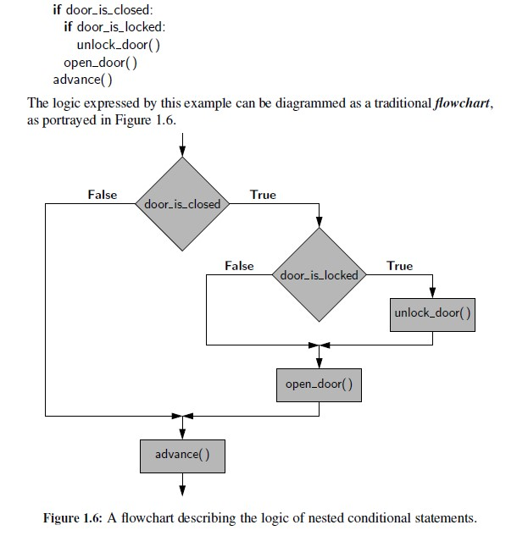
For loop = for iter in iterable:
body

Index based for loop = for j in range(len(data)):
use j

Default parameters for a function = def foo(a, b=15, c=27)….can override with differing values

Files = fp = open(‘sample.txt’) (default second param ‘r’ for reading, ‘w’ for writing)
Read from file = fp.read(‘k)
Writing to a file = fp = open(‘results.txt’, ‘w’)
fp.write(‘Hello World. \n’)

Delimiter = [, ], / , , . , etc

Exceptions

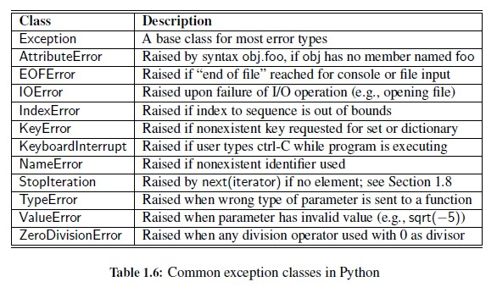

Raising an exception = raise ValueError(‘x cannot be negative’)
raise TypeError(‘x must be numeric’)

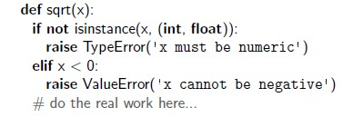
Exception Handling = is especially useful when working with user input or reading from / writing to files because these interactions can be unpredictable. Example: IOError when unable to open file.

try:
ratio = x / y
except ZeroDivisionError:
... do something else …

except IOError as e:

except(ValueError, EOFError):

In this structure, the “try” block

comprehension syntax

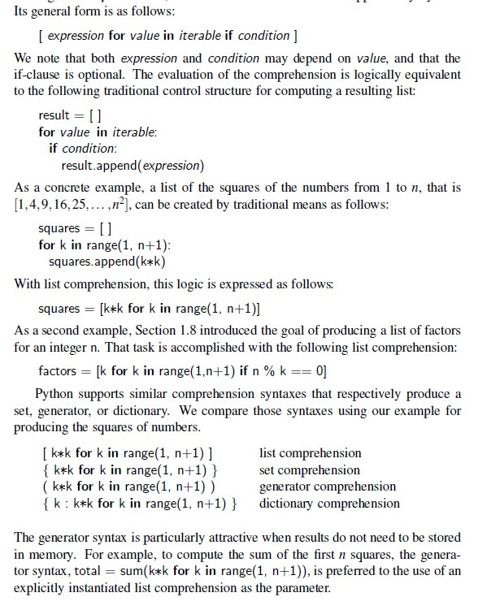

To start an application =
if __name__ == “__main__”:
import sys
main()
sys.exit()
OR
sys.exit(main())

Generator = an iterator that you can iterate over only once. Use () instead of []
mygen = (x*x for x in range(3))
for x in mygen:
print x

now cannot do a second for x in mygen

Dictionary = {} value pairs

printing an iterator = print(next(iter))

private variables = no such concept in python, but use a leading underscore such as _secret

Iterators = need a method named __next__ that returns the next element of the collection or raises a StopIteration exception to indicate that there are no further elements.

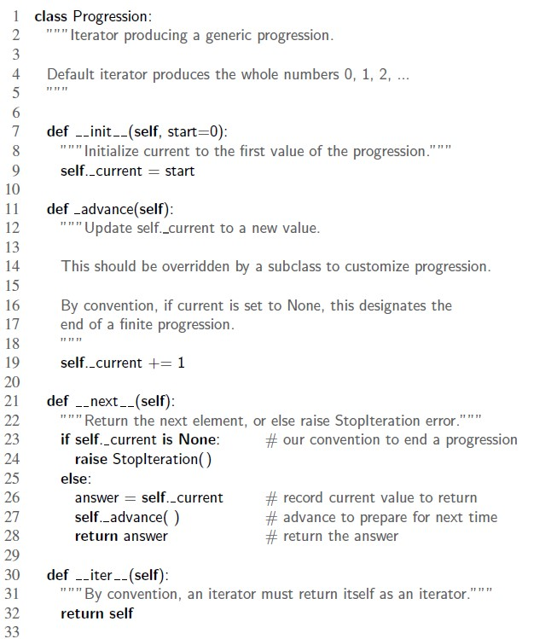

Super = for init call super().__init__(VAR)

__slots__ = The biggest higher-level reasons to use __slots__ are 1) faster attribute getting and setting due to data structure optimization and 2) reduced memory usage for class instances. Some reasons you wouldn’t want to use it is if your class has attributes that change during run-time (dynamic attributes) or if there’s a complicated object inheritance tree.

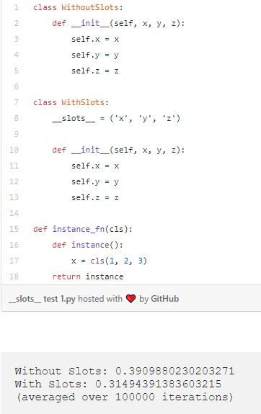
Copy / (shallow / deep) = import copy module then newstruct = copy.deepcopy(whatToCopy)

Inheritance – usually need to have “is a” relationship between two classes to work

Abstract classes in python
use built in module to implement abstract classes:
from abc import ABC, abstractmethod

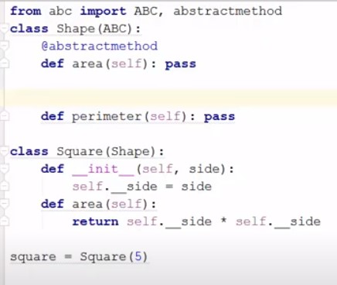

Loop Invariant = a statement about program variables that is true before and after each iter of the loop
- must be true before execution of the loop
- should also be true after the iteration
- optionally should tell something useful after loop is terminated

Stacks
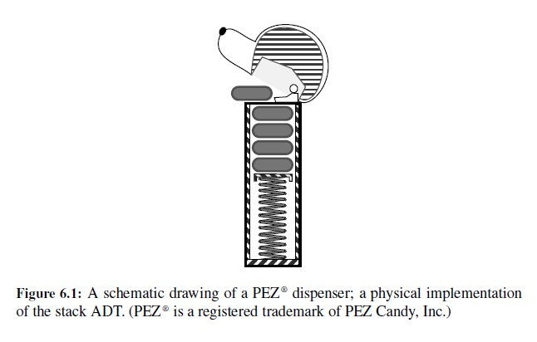
LIFO = last in first out...browser history recently visited site “pop back” with back button. Pez despenser
Queues
FIFO = first in first out

First / oldest element = head
Last / newest element = tail

Enqueue = when you add an element to the tail
Dequeue = when you remove the head
Peek = when you look at the head without removing it

Deques
Double ended queue, goes both ways, can enqueue / dequeue from both ends

Arrays vs Linked Lists

Array Based Seq Advantages
Provide constant time O(1) access to an element based on index A[k]. OTOH Linked lists req linear O(k) time

Less CPU instructions in “enqueue” vs the enqueue with linked lists having to instantiate a new node

Uses less memory – at worse case memory allocated for 2n object refs in a recently resized array. OTOH with linked lists memory has to be devoted to each stored object and also the references that link the nodes. A singly linked list requires 2n references (elem ref and next ref). With doubly linked list there are 3n refs (elem, prev, next)

Linked List Advantages
Provide worst case time bounds for their operations.

Support constant time O(1) time insertions and deletions at arbitrary (middle) positions. OTOH Arrays using insert or pop(k) use O(n-k +1) time because they have to shift all the subsequent elements

Trees
Binary Trees
- Every node has at most two children
- Each child node is labeled as being either a left child or a right child
- A left child comes before a right child

A binary tree is proper aka full if each node has either zero or two children. If not proper it is impromper.

Traversal
Depth First Search (DFS) = visit all child nodes first

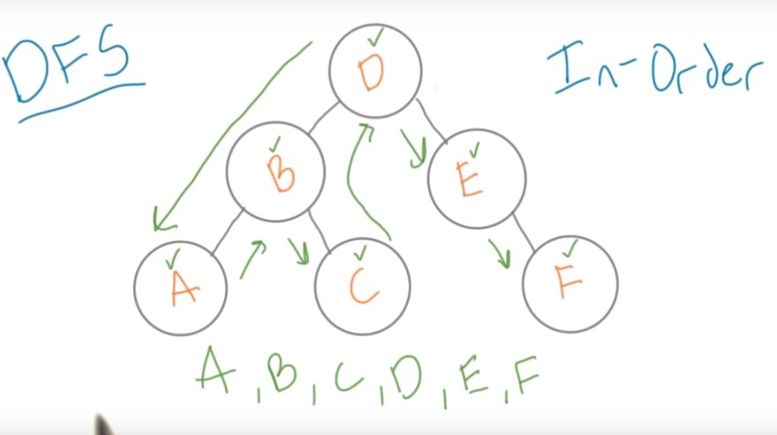
In Order = check off a node once you’ve seen its left child and came back to the node. Go all the way down to the leaf and then go back up to the parent then go to the right side. Then go back up to the root and start again

Post Order = cant check off a node until you see all of its descendants or visited both of its children and returned

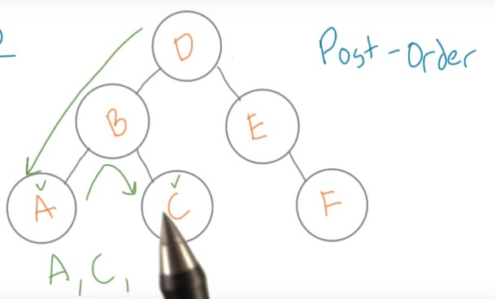

Breadth First Search (BFS) = visiti all nodes on the same level

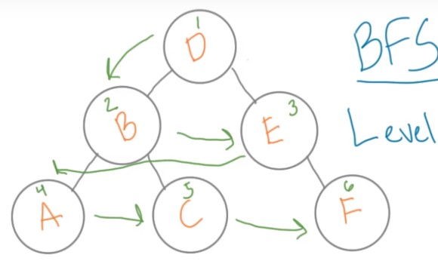

Hash Table
Buying tickets to a concert, randomly numbered, and numbers embeded in bar codes. Want to make sure that no doubles are handed out so when you check them in at the venue on concert day no one tries to sneak in with a copy.

Should store the ticket number in a hash function. You have generated all the numbers
ex: 8675309, 5555555, 0123456

hash function
one common pattern is to take the last few digits of a big number, divided it by a consistent number (n) and use the remainder from the divison and use that number (modulus) to generate the what the index of the array should be.

0123456……….56/10 = 6

Constant time lookup = you have big and random numbers that you need to convert into array indices quickly. You give your number to a hash function which returns a hash code which turns into the index of an array.

Using the last few numbers because in most cases they are the most random. If you go in numerical order the first digits are all the same.
12345, 12346, 12347

pythons built in hash() function only works on immutable objects: bool, int, float, tuple, str

Hash function collisions = when a hash function will return the same value for two different inputs (6 and 6).
Two diff solutions:
Change the hash function completely (from n to n+2 for ex). By using a bigger number you’re going to need a lot more space to store your values. Ex: X % 1,000,000. If you change the value of your hash function every time you get a collision you will have to move all your data to a new array and this will definetely increase the complexity of time and size.
Keep the hash function but change the structure of the array, storing a type of list that contains all values hashed at that spot (bucket). Will have to iterate through a collection (shorter however) every time you look for something. In the average case Hash functions have O(1) constant lookup time but they could in theory be so unlucky as have to store everything in one bucket and then its O(n) (actually O(m) since you’re in a list), the same as looking through a list. You can also have a second hash function within a larger bucket to split it up even more.

Hash table = a key value lookup. Given a key, a way of associating a value with it for very quick lookups. EX: need to associate someones name with some information about them.
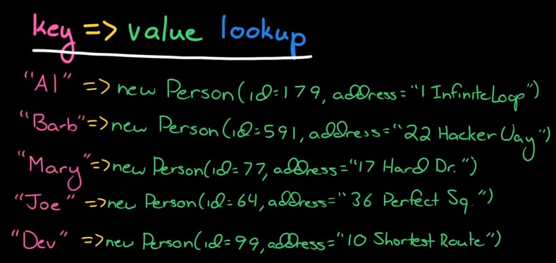

Want to store in an array. To jump from a str to a particular index in the array need to use a hash function which takes in an input (str), converts it into an int and the remaps that int into an index.
String….hash code…..index

The hash code is not actually the index. This is because the array that stores the data might be much smaller than the potential hash codes. Dont want to have an array of 3 billion potential hash codes. Thus you remap the hash code you generated into something smaller. Remember that there can possibly be collisions because of the unlimited nature of strings vs the limited number of hash codes (although still very big). Since we’re remapping to smaller: could have cases where two things with different hash codes are mapped to the same index. This is a collision. One way to resolve them (most common) is through chaining.

Chaining = when there is collisions, store them in a linked list. Instead of being an array of X its going to be an array of linked list of X.

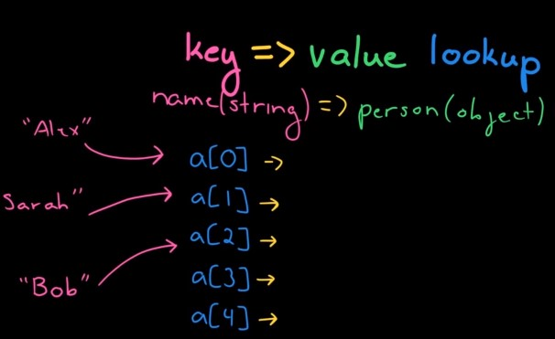

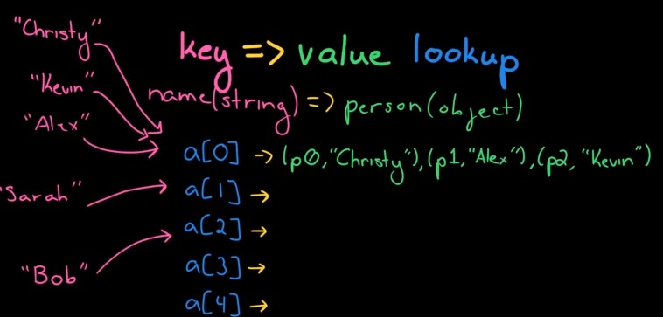

Now with the linked list you need to look through all the values in the linked list and find the value for that item. Need to store the str key with the object so you can identify it correctly.

Get me the value for X: call the hash function, get a hash code back, map it to an index, then at that indexs location go through the linked list until you find the thing with the key of X

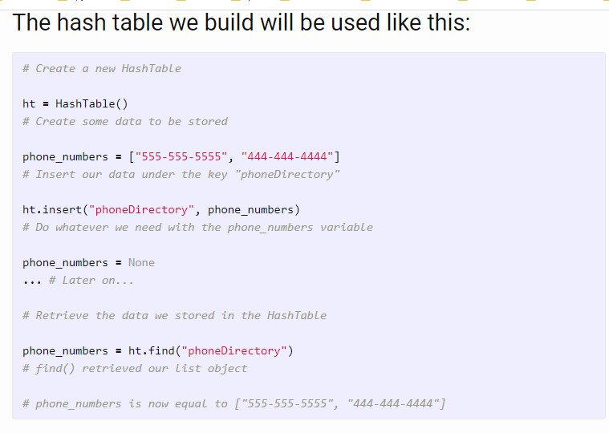

Dictionary
Hashtables implemented in python as dictionary. It maintains a set of items, each with a key. Item = (key, value) pair
insert(item) – overwrite any existing key…...D[key] = val
delete (item)………..del D[key]
search(key) return item with given key or report that it doesnt existing……..D[key]
Improves O(logn) to O(1)

Issues:
Keys may not be nonneg integers:
Solution: prehash – map keys to nonneg ints….hash(x)

Hash value keys too large to directly map to table:
Solution: hashing – reduce universe U of all possible keys (positive ints) down to reasonable size m for table

hash function reduces Universe of keys to {0 – m-1} where where m is the number of slots in the table

Semantic Versioning
Benefits = clearer compatibility/deps. Encourages well defined APIs. Makes upgrade decisions clearer.

5.21.17 – major version / minor version / patch
if you do bug fixes you need to change the patch version
if you have some new features and it remains compatible with prev versions then you change minor versions
if you introduce non-compatable features or change project completely you need to change major verison

1.0.0.-alpha < 1.0.0-alpha.1 < 1.0.0
7.0.0.-beta.51

Exact version | 5.21.17
Greater than | >5.21.1
Compatible changes | ^5.21.8
Minor-level changes | ~5.21.8

SSH
Secure shell, communication protocol (like http, https, ftp). Issue commands to the remote computer. Traffic is encrypted. Used mostly in the terminal / command line.

SSH is the client. SSHD is the server (Open SSH Daemon)

The server must have sshd installed and running or else you wont be able to connect using SSH.

Authentication
Password
ssh myName@192.168.1.29
Public / Private Key Pair (reccommended)
generate keys with ssh-keygen command
generates them in home folder:
~/.ssh/id_rsa (private key)
~/.ssh/id_rsa.pub (public key)

public key goes into server authorized_keys file

scp = secure file copy

HTTP
Hypertext Transfer Protocol, foundation for data communication on the web, the way the web works when it comes to delivering web pages. TCP/IP based, images/text/documents/audio/video can be transmitted through it. Request / response based. Unencrypted

Stateless protocol = server does not have to retain info or status about each user for the duration of multiple req (however you can do this with HTTP cookies, server side sessions, variables, and URL rewriting)

TCP/IP = transmission control protocol / internet protocol

When you want to browse a website first send a request to the server (HTTP message), then they send a response back
HTTP message made of 3 blocks: Start-line, headers, body.

Request

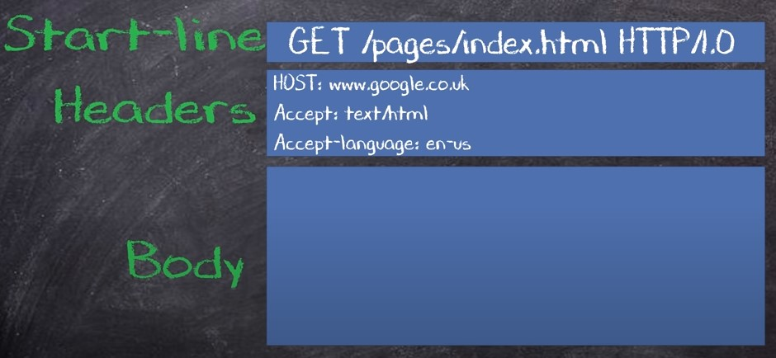
Response

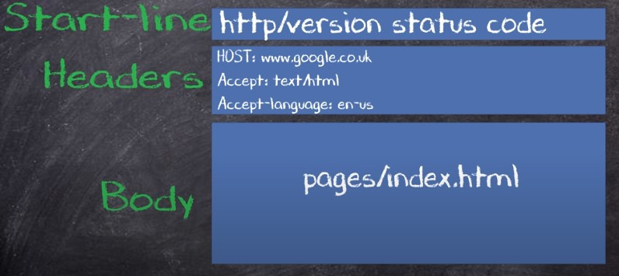
HTTPS – HTTP secure, designed to increase privacy over the internet when communicating with websites and sending sensitive data. This made man-in-the-middle attacks increasingly difficult as the data sent is no longer in plaintext. It used to only be found on payment transactions on banking websites however it is now widely used on many websites such as google, facebook, twitter

SSL certificate - To secure your website it requires the purchase of an SSL certificate (Secure socket layer). Most hosting companies will offer this. This is like an online ID card. This SSL certificate will also encrypt any data that is passed through the HTTPS protocol. Now when a client req data from the server it looks ate the SSL certificate which will verify the websites identity with the certificate authority. If everything is good a handshake takes place where an encryption method is decided through SSL. Now when data is sent to/from the client and server it is encrypted and decrypted but if a man-in-the-middle attack places the data is encrypted and unreadable.

UML = unified modelling language

Map function
Returns a map object(an iterator) of the results after applying the given function to each item of a given iterable(list, tuple, etc).
map(fun, iter)

Static Method
@staticmethod decorator
methods that are bound to a class, but know nothing about the class and just deal with the parameters of the static method. Cannot access the properties of the class itself. It is a utility function that doesnt access any class properties but still belongs with the class.

Class Method
a method that is bound to the class and not the object of the class
@classmethod decorator
@classmethod
def set_raise_amt(cls, amount)

__new__
called when an object is created

*args
used as a param to send non-keyworded variable-length argument list to a function

def multiply(*args):
z = 1
for num in args:
z *= num
print(z)

multiply(4, 5)
multiply(10, 9)
multiply(2, 3, 4)
multiply(3, 5, 10, 6)

**kwargs
Passes keyworded var length argument dictionary to a function
def print_kwargs(**kwargs):
print(kwargs)

print_kwargs(kwargs_1="Shark", kwargs_2=4.5, kwargs_3=True)

Character Encoding
A text file is just a collection of bytes. When you render it to screen you are interpreting those bytes (need to know char encoding). As soon as text enters program, decode to STR, work only with STR, then when you write it, encode it to BYTES.

with open('some-text.txt', 'rb') as f:
bytestring = f.read()
type(bytestring)
bytes

for ch in bytestring:
print(ch, end=' ')
118 111 105 108 226 148 156 196 128

utf-8 is correct here

bytestring.decode('utf-8')
'voil├Ā'
bytestring.decode('latin-1')
'voilâ\x94\x9cÄ\x80'

bytestring.decode('ascii')
UnicodeDecodeError
Important: There is no full-proof way to know the encoding of a text file! You either have to guess, or someone needs to tell you!

Normally, open() automatically applies a character encoding. Default is utf-8. NOT reading binary here

with open('some-text.txt', encoding='utf-8') as f:
s = f.read()
type(s)
str

to ENCODE
bystestring = s.encode(‘utf-8’)
with open(‘output.txt’, ‘wb’) as f:
f.write(bytestring)

this is the SAME as having python automatically handle the encoding
with open(‘output.txt’, ‘w’, encoding=’utf-8’) as f:
f.write(s)

INTERNET
How does the Internet work
made up of independantly operated networks, end to end connectiviety, distributed packet network. You get access from your local Internet Service Provider (ISP)

Made up of bits (binary on or off 100101101). Send bits by electricity, light, radio waves

clock, timer sets the amount of bits you can send per time interval (bandwidth)
bandwidth = maximum transmission of a device
bit rate = number of bits that we can send over a given period of time
latency = time it takes for a bit to travel from one place to another, from the source ot the requesting device

How to send efficiently?
With ethernet wire, signal loss over even a few hundred feet.

Send via light beams with fiber optic cables. No signal loss, can go under oceans.
Send wirelessly via radio waves = cant travel that far, cant pick up LA radio signal in chicago.
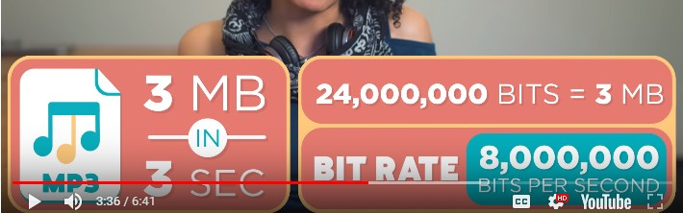

What is HTTP?
Hypertext transfer protocol

The World Wide Web is about communication between web clients and web servers. Clients are often browsers (Chrome, Edge, Safari), but they can be any type of program or device. Servers are most often computers in the cloud.

Req Cycle:
- The client (browser) sends an HTTP request to the web
- A web server receives the request
- The server runs an application to process the request
- The server returns an HTTP response (output) to the browser
- the client (browser) receives the response

ex:
the browser req an HTML page, the server returns an HTML file
the browser req a JPG image, the server returns a JPG image

Browsers and how they work
Today’s browsers are fully-functional software suites that can interpret and display HTML Web pages, applications, JavaScript, AJAX and other content hosted on Web servers . A browser does not display HTML tags but uses them to determine how to display the document.

Fetch, Process, Display, Storage
These systems are involved from accepting the web URLs, to displaying web content on the screen. They make network calls, fetch resources, parse HTML, CSS, and JavaScript files to create objects to render on the screen. These all combine to produce a wonderful website for the user.

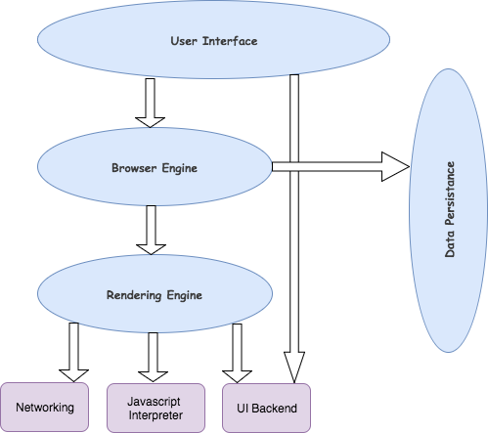

UI = address bar, forward / back / refresh / bookmark buttons etc
Browser Engine = The browser engine works as a bridge between the User interface and the rendering engine. According to the inputs from various user interfaces, it queries and manipulates the rendering engine.
Rendering Engine = responsible for rendering the requested web page on the browser screen. The rendering engine interprets the HTML, XML documents and images that are formatted using CSS and generates the layout that is displayed in the User Interface. PROCESS

- Chrome and Opera both use Blink
- Firefox uses Gecko
- Internet Explorer uses Trident
- Edge uses EdgeHTML
- Safari uses WebKit

Networking = Component of the browser which retrieves the URLs using the common internet protocols of HTTP or FTP. FETCH
JavaScript Interpreter = It is the component of the browser which interprets and executes the javascript code embedded in a website. The interpreted results are sent to the rendering engine for display. Google V8 used in Chrome, safari uses JavaScriptCore

UI Backend: UI backend is used for drawing basic widgets like combo boxes and windows
Data Persistence/Storage =This is a persistence layer. Browsers support storage mechanisms such as localStorage, IndexedDB, WebSQL and FileSystem. It is a small database created on the local drive of the computer where the browser is installed. It manages user data such as cache, cookies, bookmarks and preferences.

An important thing to note here is that in web browsers such as Google Chrome each tab runs in a separate process(multiple instances of rendering engine).

Rendering Engine part 2

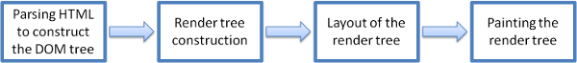

The rendering engine parses the chunks of HTML document and convert the elements to DOM nodes in a tree called the “content tree” or the “DOM tree”.

While the DOM tree is being constructed, the browser constructs another tree, the render tree. This tree is of visual elements in the order in which they will be displayed. It is the visual representation of the document. The purpose of this tree is to enable painting the contents in their correct order. Firefox calls the elements in the render tree “frames”. WebKit uses the term renderer or render object.

After the construction of the render tree, it goes through a “layout process” of the render tree. When the renderer is created and added to the tree, it does not have a position and size. The process of calculating these values is called layout or reflow. This means giving each node the exact coordinates where it should appear on the screen.

The next stage is painting. In the painting stage, the render tree is traversed and the renderer’s “paint()” method is called to display content on the screen

The rendering engine always tries to display the contents on the screen as soon as possible for better user experience. It does not wait for the HTML parsing to complete before starting to build and layout the render tree. It parses and displays the content it has received from the network, while rest of the contents stills keeps coming from the network.

DNS and how it works
Domain Name System is the “phonebook” of the internet. Each device connected to the internet has a unique Internet Protocol (IP) address. DNS translates domain names to IP addresses so browsers can load them.

The process of DNS resolution involves converting a hostname (such as www.example.com) into a computer-friendly IP address (such as 192.168.1.1). An IP address is given to each device on the Internet, and that address is necessary to find the appropriate Internet device - like a street address is used to find a particular home. When a user wants to load a webpage, a translation must occur between what a user types into their web browser (example.com) and the machine-friendly address necessary to locate the example.com webpage.

Computers and other network devices on the internet use an IP address to route your request to the site you're trying to reach. This is similar to dialing a phone number to connect to the person you're trying to call. Thanks to DNS, though, you don't have to keep your own address book of IP addresses. Instead, you just connect through a domain name server, also called a DNS server or name server, which manages a massive database that maps domain names to IP addresses.

Whether you're accessing a website or sending e-mail, your computer uses a DNS server to look up the domain name you're trying to access. The proper term for this process is DNS name resolution, and you would say that the DNS server resolves the domain name to the IP address. For example, when you enter "www.howstuffworks.com" in your browser, part of the network connection includes resolving the domain name "howstuffworks.com" into an IP address, for example 70.42.251.42, for HowStuffWorks' web servers.

What is a Domain Name?
Domain name is the address of your website that people type in the browser URL bar to visit your website. In simple terms, if your website was a house, then your domain name will be its address.

When you enter a domain name in your web browser, it first sends a request to a global network of servers that form the Domain Name System (DNS).
These servers then look up for the name servers associated with the domain and forward the request to those name servers.

For example, if your website is hosted on Bluehost, then its name server information will be like this:
ns1.bluehost.com
ns2.bluehost.com

These name servers are computers managed by your hosting company. Your hosting company will forward your request to the computer where your website is stored.
This computer is called a web server. It has special software installed (Apache, Nginx are two popular web server software). The web server now fetches the web page and pieces of information associated with it.
Finally, it then sends this data back to the browser.

What is Web Hosting?
Web hosting is a service that allows organizations and individuals to post a website or web page onto the Internet. Websites are hosted, or stored, on special computers called servers. They let you upload your pages and files. When Internet users want to view your website, all they need to do is type your website address or domain into their browser. Their computer will then connect to your server and your webpages will be delivered to them through the browser. Usually you get an email account / FTP access for that domain as well. Have them running 24/7

Basic Front End Knowledge

HTML
VS Code = press ! To use emmet to generate boilerplate code

semantic tags = let the browser know what content is where

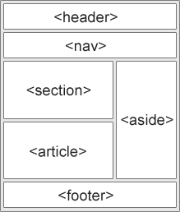

input types can be text, number, email, password, date. Can set min/max.
ex:
<input type="number" name="age" id="age" min="1" max="200"/>

<label> FOR specifies the type of form eleement a label is bound to

<span> tag is used for grouping and applying styles to inline elements. There is a difference between the span tag and the div tag. The span tag is used with inline elements whilst the div tag is used with block-level content.

Less than and greater than sign for spacing = &lt;gt;
<strong>

<a> link = <a href="https://www.w3schools.com">This is a link</a>
anchor open link in new tab = <a href=”url” target=”_blank”> vs _self(default)

images = <img src="w3schools.jpg" alt="W3Schools.com" width="104" height="142">
src = url
alt = text to be displayed if image cannot be loaded

image as a link =
<a href="default.asp">
<img src="smiley.gif" alt="HTML tutorial" style="width:42px;height:42px;border:0;">
</a>
<map> element = an image map that performs different actions depending on where in the image you click. Add usemap attr to image
<img src="workplace.jpg" alt="Workplace" usemap="#workmap">

<map name="workmap">
<area shape="rect" coords="34,44,270,350" alt="Computer" href="computer.htm">
<area shape="rect" coords="290,172,333,250" alt="Phone" href="phone.htm">
<area shape="circle" coords="337,300,44" alt="Coffee" href="coffee.htm">
</map>


button as a link = requires javascript code
<button onclick=”document.location = ‘default.asp’”>HTML Tut</button>

change <a> link color:
a:visited/hover/active{color: myColor; text-decoration;}
Jump to bookmark on page with <a>...first create ID
<h2 id="C4">Chapter 4</h2>
<a href="#C4">Jump to Chapter 4</a>
or on another page:
<a href="html_demo.html#C4">Jump to Chapter 4</a>

<div> tag = signifies a new division

<section> = the content inside is grouped (relates to a single theme)

<article> = independent, self contained content that makes sense on its own

<nav> = a major block / set of navigation links

button = <button>Click me</button>

list = <ul> or <ol>, listitems with <li>
<br> = line break
title attribute = tooltip…..<p title=”myTooltip”>Sample Text</p>

<hr> = horizontal rule

<pre> element = defines preformated text that respects the printed spacing and formatting

<b> = bold
<strong> = important
<i> = italic
<em> = emphasized
<sub> = subscript
<sup> = superscript
<del> = deleted

<abbr> = abbreviation...gives tooltip

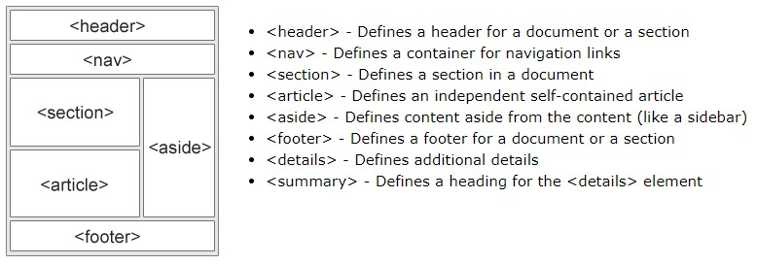

Responsive web pages = a web page should look good on large desktop screens and small phone screens

responsive image = <img src=”img_url.jpg” style=”width:100%;”>

max-width = if set to a value, the image will scale down below that value but never be larger than it. Ex:
<img src="img_girl.jpg" style="max-width:100%;height:auto;">

Show diff images depending on browser width = define multiple images and set different max-width

<picture>
<source srcset="img_smallflower.jpg" media="(max-width: 600px)">
<source srcset="img_flowers.jpg" media="(max-width: 1500px)">
<source srcset="flowers.jpg">
<img src="img_smallflower.jpg" alt="Flowers">
</picture>

Media queries

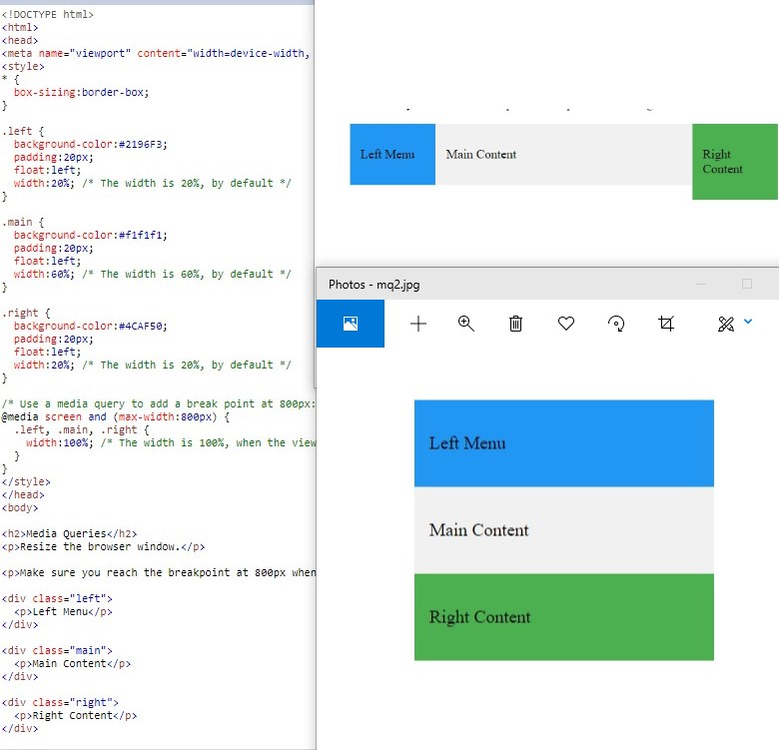

Set the div width depending on width of the browser.

CSS
Box Model = everything in CSS is a box
MBPC = Margin, Border, Padding, Content
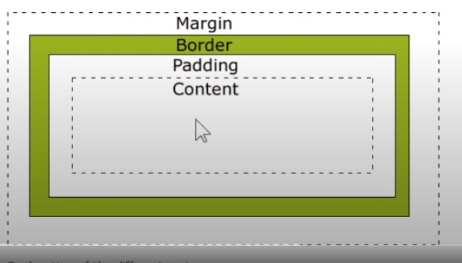

content = width / height
padding = has L and R
border = has L and R

consider using BORDER BOX property to make styling easier to make everything that you write as the height/width be the actual height/width, no matter the amount of padding
box-sizing:border-box;

div {
width: 300px;
padding: 25px;
border: 25px solid black;
margin: 25px;
background-color: red;
box-sizing:border-box;
}

selector = h1, p
ID selector = #{ }
<p id="para1">Hello World!</p>

Class selector = .{ }
<h1 class="center">Red and center-aligned heading</h1>
specific elements with class = element.class{ }…..ex p.center{ }
In this example only <p> elements with class="center" will be center-aligned:
p.center {text-align: center;}

(HTML) elements of more than one class = <p class = “center large”>xyz xyz</p>
grouping selectors h1, h2, p { }
remember - a class name cannot start with a number

Comments = /* */

external syle sheet = <link rel="stylesheet" type="text/css" href="mystyle.css">

Colors
RGB = 0-255
A = 1 to 0
HEX = 00-ff…….c0-c9 then ca-cf
HSL(0, 100%, 50%)…….HSLA

background image
background-repeat: no-repeat, repeat-x, repeat-y
background-position: right top
background-attachment: fixed, scroll (will not scroll with the rest of the page)
Shortcut: background(bg) bg-color/bg-image/bg-repeat/bg-attachment/bg-position
background:#ffffff url("img_tree.png") no-repeat right top;
Positioning
Static = default
Relative = can move it based on itself
Absolute = can move based on its parent element
Fixed = have the element stay in a spot on the page no matter where the page is scrolled
Sticky = default static but as soon as it scrolls outside the page it becomes fixed

Responsive design with media queries
@media (conditional check)...width/orientation/print
@media (max-width: 500px) {
body {
color: blue;
}
}

borders

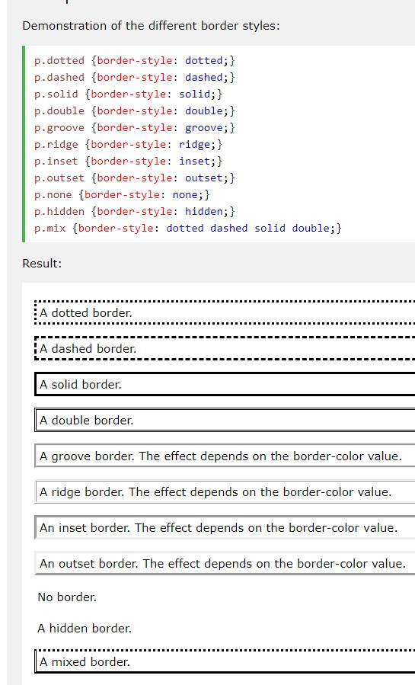

Display Properties
Display block = the default property for div. The div is going to take up the entire width given to it. It has to have a new line and takes up the full width.
Display inline = The default property for span. the minimum amount of space to fit all the content inside of the span. CANT have width/height
Display inline-block = inline but with width/height elements.
Display None = acts as if the element was deleted from the HTML, everything else moves around it
Display flex = see flexbox section below
Display grid =

<Div>
overflow (hidden) = no scrollbar even if you go outside the div

in Stylesheet access selectors with .CLASS {} for class, #{} for id

border-width = 5px, em, thin, medium, thick……..set for top/right/bottom/left
border-width: 25px 10px 4px 35px;
border-color = red…..set for top/right/bottom/left
border-color: red green blue yellow

different border STYLES for T/R/B/L
border-top-style, border-right-style, border-bottom-style, border-left-style,

border shorthand = border-width/style/color
border: 5px solid red;

can also do border-top/right/bottom/left

border-radius = rounded borders
border-radius: 5px;

margin = margin-top/margin-right/margin-bottom/margin-left
p {
margin: 25px 50px 75px 100px;
}
margin auto = horizontally centers the element within its container

padding = padding-top/padding-right/padding-bottom/padding-left
div {
padding-top: 50px;
padding-right: 30px;
padding-bottom: 50px;
padding-left: 80px;
}

padding shorthand = top/right/bottom/left
div {
padding: 25px 50px 75px 100px;
}

EM
1em = 16px
To allow users to resize the text (in the browser menu), many developers use em instead of pixels.

The font property is a shorthand property for: font-style/variant/weight/ (((size/line-height)))/family
p.a {
font: 20px Arial, sans-serif;
}

p.b {
font: italic small-caps bold 12px/30px Georgia, serif;
}
The font-size and font-family values are required. If one of the other values is missing, their default value are used.

Text-decoration = property mostly used to remove underlines from links
a:link { text-decoration: none; }
a:visited { text-decoration: none; }
a:hover { text-decoration: underline; }
a:active { text-decoration: underline; }

background-color = property can be used to specify a background color for links:
a:link { background-color: yellow; }

styling links = links can be styled differently according to their state
a:link / a:visited / a:hover / a:active – must be in this order

Tables
for <th> and <td>:
vertical-align = top/bottom/middle
text-align = left, right, center…..sets horizontal alignment
padding = sets the space between the border and content in a table
hover = tr:hover{ background-color: red; }
even/odd striped table = tr:nth-child(even) {background-color: #f2f2f2;}

responsive = add a container like <div> around the table and give it style of overflow-x:auto
<div style="overflow-x:auto;">
<table>.. table content ...</table>
</div>

Positioning
Overlapping elements
z-index = property that specifies the stack order of an element
img {
position: absolute;
left: 0px;
top: 0px;
z-index: -1;
}

Positioning text over an image
name the class something like bottomleft
.bottomleft {
position: absolute;
bottom: 8px;
left: 16px;
font-size: 18px;
}

Overflow = what to do when the content is too big to fit in the element (add scrollbar, clipped and hidden or not to clip)
div {
overflow: scroll/visible/hidden/auto;
}

float = how an element should float….right/left/none
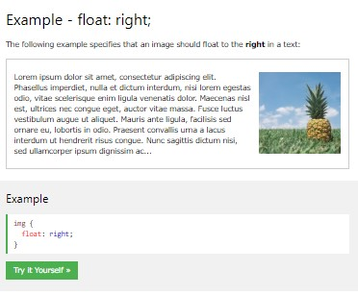

Centering stuff
Center align elements like <div> = use margin:auto….width must be set and (not 100%)
.center {
margin: auto;
width: 50%;
border: 3px solid green;
padding: 10px;
}

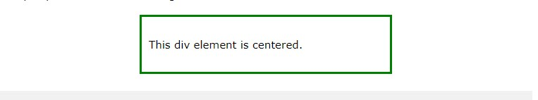

Center align text = use text-align: center
.center {
text-align: center;
border: 3px solid green;
}

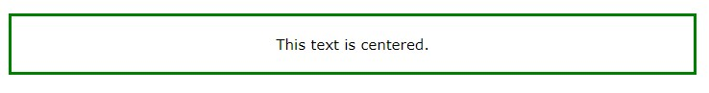

Center an image = set left/right margin to auto and make it into a block element
img {
display: block;
margin-left: auto;
margin-right: auto;
width: 40%;
}

Left/right align using float = use below. If element is taller than the telement containing it and it is floated, it will overflow outside the container. Use the “clearfix” hack to fix this by adding “overflow: auto;” to the containing element.
.right {
float: right;
width: 300px;
border: 3px solid #73AD21;
padding: 10px;
}

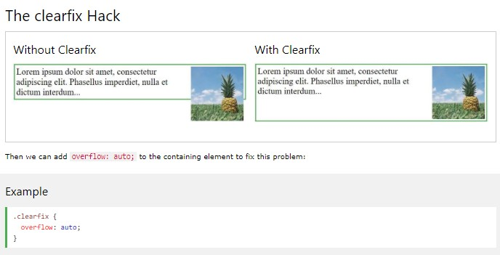

Combinator Selectors
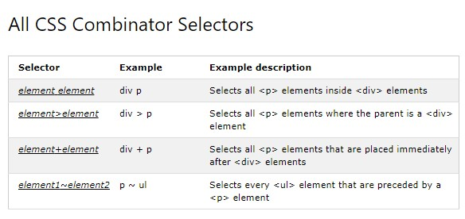

div p {
background-color: yellow;
}

Hover
div::hover {background-color: blue}

pseudo element – uses DOUBLE colon to distinguish between pseudo-classes
first-line = added to block level elements, adds a style to the first line of text

p::first-line {
color: #ff0000;
font-variant: small-caps;
}

use with the following properties:
font properties / color properties / background properties / word-spacing / letter-spacing / text-decoration / vertical-align / text-transform / line-height/ clear

first-letter = add style to the first letter of text
p::first-letter {
color: #ff0000;
font-size: xx-large;
}

selection = styles the portion of the text element that is selected by the user.

Can apply styles for:
color, background, cursor, outline
::selection {
color: red;
background: yellow;
}
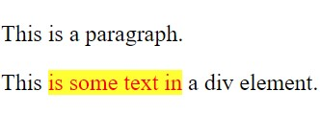

Opacity = property that specifies the opacity/transparency of an element, from 0 to 1. The lower the val the more transparent.
img {
opacity: 0.5;
}

img:hover {
opacity: 0.5;
}

Navigation Bar – vertical or horizontal
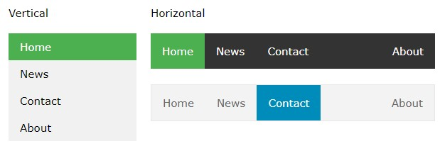

ul {
list-style-type: none;
margin: 0;
padding: 0;
}

make the whole link area clickable by settting the display to block
li a {
display: block;
width: 60px;
}

OR
ul {
list-style-type: none;
margin: 0;
padding: 0;
width: 60px;

*FOR FULL HEIGHT*
height: 100%; /* Full height */
position: fixed; /* Make it stick, even on scroll */
overflow: auto; /* Enable scrolling if the sidenav has too much content */
}

li a {
display: block;
}

OR

li a {
display: block;
color: #000;
padding: 8px 16px;
text-decoration: none;
}

/* Change the link color on hover */
li a:hover {
background-color: #555;
color: white;
}

Horizontal Navbar = display as inline or float to remove the line breaks before/after each item and display on one line
li {
display: inline;
}

OR
li {
float: left;
}

a {
display: block;
padding: 8px;
background-color: #dddddd;
}

RESPONSIVE TOPNAV – set float to none using a media query
@media screen and (max-width: 600px) {
ul.topnav li.right,
ul.topnav li {float: none;}
}

Dropdowns
https://www.w3schools.com/css/css_dropdowns.asp

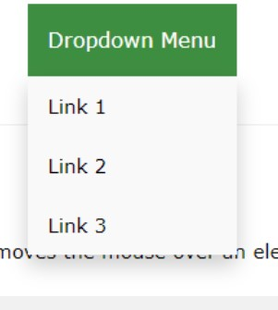

need position:relative on the dropdown class and place the content with position:absolute

Attribute selector = [attribute]….can be used to select elements with a specific attr OR attr and value

a[target] {
background-color: yellow;
}

a[target="_blank"] {
background-color: yellow;
}

https://www.w3schools.com/css/css_attribute_selectors.asp

Forms

https://www.w3schools.com/css/css_form.asp

Counters
https://www.w3schools.com/css/css_counters.asp
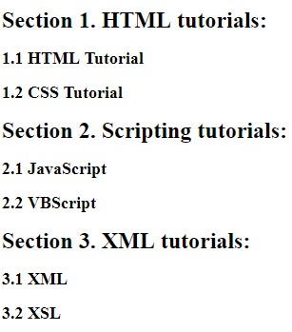

Website Layout
Content
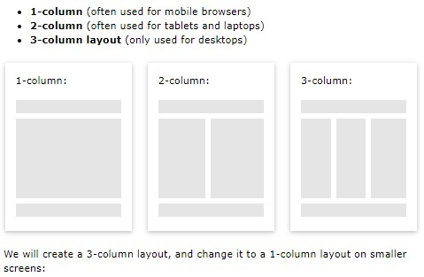

create the 3 col layout by setting float to left and width to 33% then have a media query if screen gets small to say below 600px that the width becomes 100% (single column)

Unequal columns
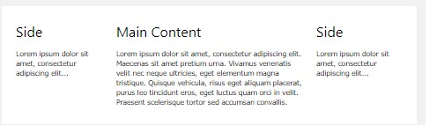

set the side column width to lower than the main, ie 25% vs 50% then have them both scale to 100% with a media query if the screen width gets too small

Flexbox
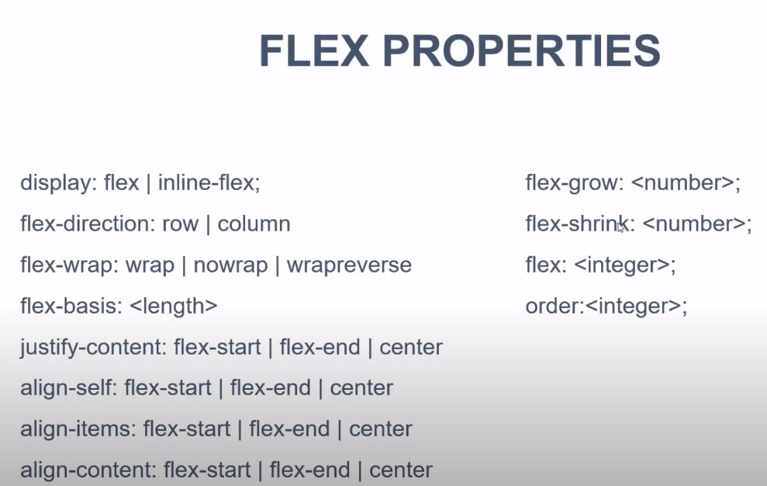

Javascript

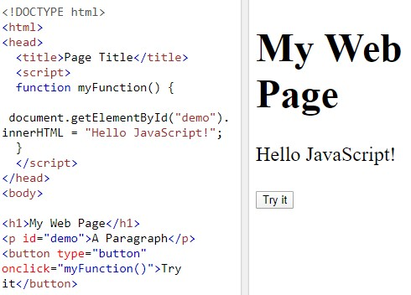

the <script> element write “Hello Javascript” into an HTML element with id=”demo”

Change HTML content = document.getElementById('demo').innerHTML = 'Hello JavaScript';

Change CSS style = document.getElementById("demo").style.fontSize = "35px";

variable = with var
var a = 10;
var b = 5;
var c = a + b;
var z = "Hello" + 5;
Hello5……...adding a number and a string will return a string

Template String =
const name = ‘John’
const age = 30;
const hello = `My name is ${name} and I am ${age};

private variables = common to use underscore _variableName for these

comment = // or /* */

Objects = written with curly braces {} and object properties are name / value pairs
var person = {firstName:"John", lastName:"Doe", age:50, eyeColor:"blue"};

Empty an object = set to null or undefined

Functions = function myFunction(p1, p2) {
return p1 * p2; // The function returns the product of p1 and p2
}
var x = myFunction(4, 3);

hello = function() {
return "Hello World!";
}

var myFunction = function (a, b) {return a * b};
var y = myFunction(4, 3);

document.getElementById("demo").innerHTML = hello();
function default parameter values in function declaration
function (a=1, b=1) {
// function code
}

function closures
var add = (function () {
var counter = 0;
return function () {counter += 1; return counter}
})();

add();
add();
add();

// the counter is now 3

Event on itself = <button onclick="this.innerHTML = Date()">The time is?</button>

break up lines of code to make line shorter = use single backslash \

String Methods
search() = can take regular expressions as
indexOf() = can take a second start pos argument
var pos = str.indexOf("locate", 15);

Extract string parts
slice(start, end) ...if a param is negative, start from the end of the string
var str = "Apple, Banana, Kiwi";
var res = str.slice(7, 13);…….Banana

if you omit the second param, slice() will slice out the rest of the string
var res = str.slice(7);…….Banana, Kiwi

substring(start, end)…similar to slice() but cannot accept negative indexes

substr(start, length)…...second param specifies length of extracted part

replace() = replaces the first match and can use regular expressions
str = "Please visit Microsoft!";
var n = str.replace("Microsoft", "W3Schools");

var n = str.replace(/MICROSOFT/i, "W3Schools"); ……..re for case insensitive
var n = str.replace(/Microsoft/g, "W3Schools");………..re to replace ALL matches

remove whitespace from both sides of string = trim()
var str = " Hello World! ";
alert(str.trim());………………...Hello World!

String to array = split() according to separator
var txt = "a,b,c,d,e"; // String
txt.split(","); // Split on commas
txt.split(" "); // Split on spaces
txt.split("|"); // Split on pipe
txt.split(""); // Split in characters

Arrays
Array Creation = var cars = ["Saab", "Volvo", "BMW"];

Object Array creation = var cars = [
{type:"Volvo", year:2016},
{type:"Saab", year:2001},
{type:"BMW", year:2010}
];

cars[0] = Saab……..use numbered indexes

vs Objects that use named indexes to access its “members”:
var person = {firstNAme:”John”, lastName:”Doe”};
person.firstname = John

to get last item of array CANNOT use [-1]…….have to use cars[cars.length – 1];

loop through an array = using a for loop
var fruits, text, fLen, i;
fruits = ["Banana", "Orange", "Apple", "Mango"];
fLen = fruits.length;

text = "<ul>";
for (i = 0; i < fLen; i++) {
text += "<li>" + fruits[i] + "</li>";
}
text += "</ul>";
or use forEach()
var fruits, text;
fruits = ["Banana", "Orange", "Apple", "Mango"];

text = "<ul>";
fruits.forEach(myFunction);
text += "</ul>";

function myFunction(value) {
text += "<li>" + value + "</li>";
}

Add to a pre-existing array = use push() to add a elem to the end…….fruits.push(“Lemon”)

delete elements = use delete fruits[0];……...may leave holes
pop elements = removes the last element of an array and returns it
shift elements = removes the first element of an array and returns it

splice array = fruits.splice(2, 0, "Lemon", "Kiwi");
the first param defines where new elements should be added (spliced in)
the second param defines how many elements should be removed
the rest of the params define the new elements to be added
returns an array with deleted items

fruits.splice(0, 1); // Removes the first element of fruits

merge arrays = concat()…….
Var myMergedArr = myArr0.concat(myArr1);

sort array alphabetically = fruits.sort()
reverse array = fruits.reverse()

sort array numerically =
ascending order
var points = [40, 100, 1, 5, 25, 10];
points.sort(function(a, b){return a - b});

descending order
points.sort(function(a, b){return b - a});

random order
points.sort(function(a, b){return 0.5 - Math.random()});

sort object array
cars.sort(function(a, b){return a.year – b.year});
Date = use Date()
var d = new Date();
Tue May 05 2020 20:09:02 GMT-0400 (Eastern Daylight Time)

Switch/case = used for going through many if/else statements...allways end with a default.
switch (new Date().getDay()) {
case 0:
day = "Sunday";
break;
case 1:
day = "Monday";
break;
default:
day = “unknown”;
}

Math
Random = returns a random num between 0 (included) and 1 (excluded)
as float
Math.random()
.148

as int from 0-n
Math.floor(Math.random() * n); // returns a random integer from 0 to 9

function to get random range
function getRndInteger(min, max) {
return Math.floor(Math.random() * (max - min + 1) ) + min;
}

Errors

custom error messages = use a combination of throw, try, and catch
finally = lets you execute code after try/catch regardless of the result

try {
if(x == "") throw "empty";
if(isNaN(x)) throw "not a number";
}
catch(err) {
message.innerHTML = "Input is " + err;
}
finally {
document.getElementById("demo").value = "";
}

Strict mode = declared by adding “use strict”; to the beginning of a script or a function. Makes it easier to write secure JS. For ex in normal JavaScript, mistyping a variable name creates a new global variable. In strict mode, this will throw an error, making it impossible to accidentally create a global variable.

This = differs between regular and strict mode
https://www.w3schools.com/js/js_this.asp

misunderstanding floats = floats may not be precise at the very smallest bit

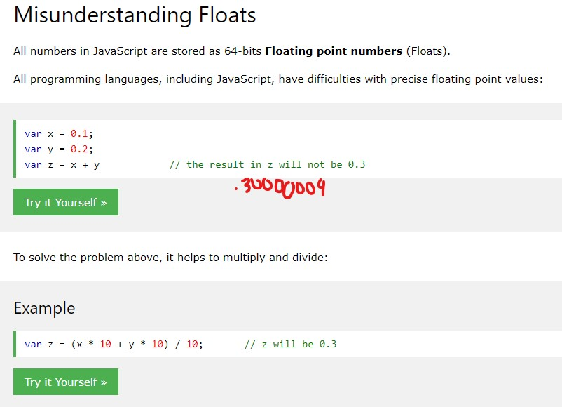

Let = block scope, variables inseide a block { } can not be accessed from outside the block if using the keyword let
{
let x = 2;
}
// x can NOT be used here

using let wont redeclare the same named variable outside of the block
var x = 10;
// Here x is 10
{
let x = 2;
// Here x is 2
}
// Here x is 10

can not redeclare a var variable with let or let variable with let in the same scope/block, only in another scope/block
let x = 2; // Allowed

{
let x = 3; // Allowed
}

{
let x = 4; // Allowed
}

Classes
class Car {
constructor(brand) {
this.carname = brand;
}
}
mycar = new Car("Ford");

class Car {
constructor(brand) {
this.carname = brand;
}
present(x) {
return x + ", I have a " + this.carname;
}

static hello() {
return "Hello!!";
}
}

mycar = new Car("Ford");
document.getElementById("demo").innerHTML = mycar.present("Hello");
document.getElementById("demo").innerHTML = Car.hello(); // static method called on class itself

class inheritance
class Car {
constructor(brand) {
this.carname = brand;
}
present() {
return 'I have a ' + this.carname;
}
}

class Model extends Car {
constructor(brand, mod) {
super(brand);
this.model = mod;
}
show() {
return this.present() + ', it is a ' + this.model;
}
}

mycar = new Model("Ford", "Mustang");
document.getElementById("demo").innerHTML = mycar.show();

getters / setters = use the get / set keywords
class Car {
constructor(brand) {
this.carname = brand;
}
get cnam() {
return this.carname;
}
set cnam(x) {
this.carname = x;
}
}

mycar = new Car("Ford");

document.getElementById("demo").innerHTML = mycar.cnam;
marGamora897

Debugging
Start debugger in browser with F12

console.log(); = display JS value in debugger console window

JSON
JavaScript Object Notation, a lightweight data interchange format, easy to understand uses attr/value pairs and array data types.

- Data is in name/value pairs
- Data is separated by commas
- Curly braces hold objects
- Square brackets hold arrays

"firstName":"John" – requires double quotes, followed by colon, followed by value

{
"employees":[
{"firstName":"John", "lastName":"Doe"},
{"firstName":"Anna", "lastName":"Smith"},
{"firstName":"Peter", "lastName":"Jones"}
]
}

convert JSON text to JS object = use JSON.parse()
var text = '{ "employees" : [' +
'{ "firstName":"John" , "lastName":"Doe" },' +
'{ "firstName":"Anna" , "lastName":"Smith" },' +
'{ "firstName":"Peter" , "lastName":"Jones" } ]}';

var obj = JSON.parse(text);

document.getElementById("demo").innerHTML =
obj.employees[1].firstName + " " + obj.employees[1].lastName;…...Anna Smith

Form Validation
<html>
<head>
<script>
function validateForm() {
var x = document.forms["myForm"]["fname"].value;
if (x == "") {
alert("Name must be filled out");
return false;
}
}
</script>
</head>
<body>

<form name="myForm" action="/action_page.php" onsubmit="return validateForm()" method="post">
Name: <input type="text" name="fname">
<input type="submit" value="Submit">
</form>

</body>
</html>

Objects

Object literal = the easiest way to create a JS object. Define and create an object in one statement, inside curly braces {}.
var person = {firstName:"John", lastName:"Doe", age:50, eyeColor:"blue"};

var x = person;
x.age = 10; // This will change both x.age and person.age

looping through properties of an object
var person = {fname:"John", lname:"Doe", age:25};

for (x in person) {
txt += person[x];
}

//John Doe 25

Constructor
<script>
// Constructor function for Person objects
function Person(first, last, age, eye) {
this.firstName = first;
this.lastName = last;
this.age = age;
this.eyeColor = eye;
}

// Create a Person object
var myFather = new Person("John", "Doe", 50, "blue");

// Display age
document.getElementById("demo").innerHTML =
"My father is " + myFather.age + ".";
</script>
// My father is 50.

adding a property to an object
myFather.nationality = "English";

adding a method to an object
myFather.name = function () {
return this.firstName + " " + this.lastName;
};

Getter
//Create an object
var person = {firstName:"John", lastName:"Doe"};

// Define a getter
Object.defineProperty(person, "fullName", {
get : function () {return this.firstName + " " + this.lastName;}
});

DOM = Document Object Model created when a page is loaded. Its created as a tree of objects.

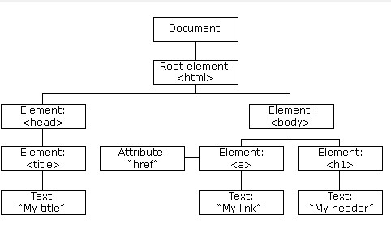

- JavaScript can change all the HTML elements in the page
- JavaScript can change all the HTML attributes in the page
- JavaScript can change all the CSS styles in the page
- JavaScript can remove existing HTML elements and attributes
- JavaScript can add new HTML elements and attributes
- JavaScript can react to all existing HTML events in the page
- JavaScript can create new HTML events in the page

getElementByID method and innerHTML property
<p id="demo"></p>

<script>
document.getElementById("demo").innerHTML = "Hello World!";
</script>

document.getElementById(id)
document.getElementsByTagName(name)
document.getElementsByClassName (name)

This example finds the element with id="main", and then finds all <p> elements inside "main":
var x = document.getElementById("main");
var y = x.getElementsByTagName("p");

this gets all elements with class name “intro”
<p class="intro">The DOM is very useful.</p>
<p class="intro">This example demonstrates the <b>getElementsByClassName</b> method.</p>

<script>
var x = document.getElementsByClassName("intro");
document.getElementById("demo").innerHTML =
'The first paragraph (index 0) with class="intro": ' + x[0].innerHTML;
</script>

finding element by CSS selector
var x = document.querySelectorAll("p.intro");………...returns a list of all <p> elements with class=”intro”

DOM Events

onclick
<h1 onclick="changeText(this)">Click on this text!</h1>

<script>
function changeText(id) {
id.innerHTML = "Ooops!";
}
</script>

onchange

<script>
function upperCase() {
var x = document.getElementById("fname");
x.value = x.value.toUpperCase();
}
</script>

<input type="text" id="fname" onchange="upperCase()">
<p>When you leave the input field, a function is triggered which transforms the input text to upper case.</p>

onmouseover and onmouseout = used to trigger function when the user mouses over or out of an element
<div onmouseover="mOver(this)" onmouseout="mOut(this)"
style="background-color:#D94A38;width:120px;height:20px;padding:40px;">
Mouse Over Me</div>

<script>
function mOver(obj) {
obj.innerHTML = "Thank You"
}

function mOut(obj) {
obj.innerHTML = "Mouse Over Me"
}
</script>

onmousedown and onmouseup = triggers functions on mouse press /release
<div onmousedown="mDown(this)" onmouseup="mUp(this)"
style="background-color:#D94A38;width:90px;height:20px;padding:40px;">
Click Me</div>

Dynamically Add / Remove / Replace HTML Nodes
https://www.w3schools.com/js/js_htmldom_nodes.asp

DOM collections
var x = document.getElementsByTagName("p");
y = x[1];
document.getElementById("demo").innerHTML = x.length;

Browser Object Model
get the inner height / width of the browser window in pixels
var w = window.innerWidth
var h = window.innerHeight

window.open() - open a new window
window.close() - close the current window
window.moveTo() - move the current window
window.resizeTo() - resize the current window

screen.width //1920
screen.height //1080

The window.location.href property returns the URL of the current page.

document.getElementById("demo").innerHTML =
"Page location is " + window.location.href;

Page location is https://www.w3schools.com/js/js_window_location.asp

AJAX
- Read data from a web server - after the page has loaded
- Update a web page without reloading the page
- Send data to a web server - in the background

AJAX is not a programming language. AJAX is a technique for accessing web servers from a web page. AJAX stands for Asynchronous JavaScript And XML.

<div id="demo">
<h2>Let AJAX change this text</h2>
<button type="button" onclick="loadDoc()">Change Content</button>
</div>

function loadDoc() {
var xhttp = new XMLHttpRequest();
xhttp.onreadystatechange = function() {
if (this.readyState == 4 && this.status == 200) {
document.getElementById("demo").innerHTML = this.responseText;
}
};
xhttp.open("GET", "ajax_info.txt", true);
xhttp.send();
}

XMLHttpRequest requests data from a web server

How AJAX works
An event occurs (page is loaded, button is clicked)
An XMLHttpRequest obj is created by JS
The XMLHttpRequest obj sends a req to a web server
The server processes the req
The server sends a response back to the web page
response is read by JS
proper action (like page update) is performed by JS

Sending a req to a server = use the open() and send() methods of XMLHttpRequest
xhttp.open("GET", "ajax_info.txt", true); //(method, url, async)
xhttp.send();

GET or POST?
GET can be used in most cases

use POST when
- A cached file is not an option (update a file or database on the server).
- Sending a large amount of data to the server (POST has no size limitations).
- Sending user input (which can contain unknown characters), POST is more robust and secure than GET.
- When using POST use a setRequestHeader

xhttp.open("POST", "ajax_test.asp", true);
xhttp.setRequestHeader("Content-type", "application/x-www-form-urlencoded");
xhttp.send("fname=Henry&lname=Ford");

<button type="button" onclick="loadDoc()">Request data</button>

<p id="demo"></p>

<script>
function loadDoc() {
var xhttp = new XMLHttpRequest();
xhttp.onreadystatechange = function() {
if (this.readyState == 4 && this.status == 200) {
document.getElementById("demo").innerHTML = this.responseText;
}
};
xhttp.open("POST", "demo_post2.asp", true);
xhttp.setRequestHeader("Content-type", "application/x-www-form-urlencoded");
xhttp.send("fname=Henry&lname=Ford");
}
</script>

onreadystatechange = defines a function to be executed when the request receives an answer

readyState =
- Holds the status of the XMLHttpRequest.
- 0: request not initialized
- 1: server connection established
- 2: request received
- 3: processing request
- 4: request finished and response is ready

status = 200 = OK
403 = Forbidden
404 = Page Not Found

When readyState is 4 and status is 200, the response is ready:

Callbacks = a function passed as a param to another function. Used when you have more than one AJAX task.

loadDoc("url-1", myFunction1);
loadDoc("url-2", myFunction2);

function loadDoc(url, cFunction) {
xhttp.open("GET", url, true);
}

function myFunction1(xhttp) {
// action goes here
}
function myFunction2(xhttp) {
// action goes here
}

response XML = parse the result of what you chose
xhttp.onreadystatechange = function() {
if (this.readyState == 4 && this.status == 200) {
xmlDoc = this.responseXML;
txt = "";
x = xmlDoc.getElementsByTagName("ARTIST");
for (i = 0; i < x.length; i++) {
txt = txt + x[i].childNodes[0].nodeValue + "<br>";
}
document.getElementById("demo").innerHTML = txt;
}
};

xhttp.open("GET", "cd_catalog.xml", true);

getAllResponseHeaders() = returns all the header info of a resource like length, content-type, last modified, etc
getResponseHeader() = returns specific header information

<script>
var xhttp = new XMLHttpRequest();
xhttp.onreadystatechange = function() {
if (this.readyState == 4 && this.status == 200) {
document.getElementById("demo").innerHTML =
this.getAllResponseHeaders();
this.getResponseHeader("Last-Modified");
}
};

AJAX PHP = can be use to provide dynamic hints while typing into a field
https://www.w3schools.com/js/js_ajax_php.asp

More AJAX Examples = https://www.w3schools.com/js/js_ajax_examples.asp

