Sorting
Insertion Sort

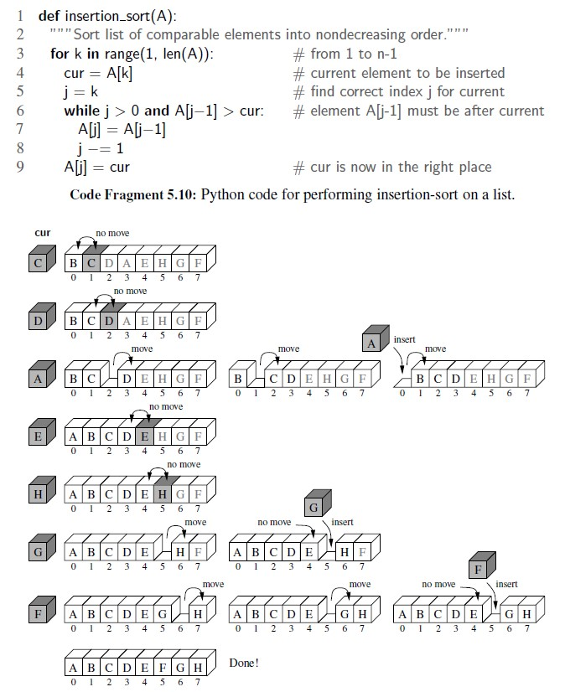

MultiDim array

row / column = [0, 0]
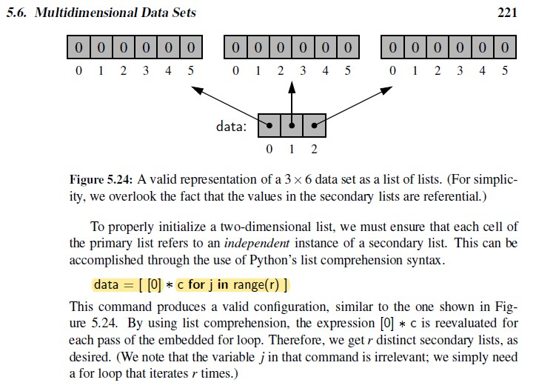
a

