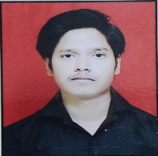

**SAJAN KUMAR SHARMA**

Email id : sajansharma08.02.2000@gmail.com

Mobile No : 9971929132.

Address : S-328 Prem nagar 2nd

Kirari sulaiman nagar

CAREER OBJECTIVE

* Obtain a responsible position in an organization with the best

Capabilities ,skills and knowledge.

ACADMIC QUALIFICATION :

|  |  |  |
| --- | --- | --- |
| ACADMIC | BOARD | DURATION |
| 10TH | CBSE | 2016-2017 |
| 12TH | CBSE | 2018-2019 |
| B.COM | DELHI UNIVERSITY | 2019-2022 |
| ADIT | IBM | pursuing |
|  |  |  |

PROFESSIONAL SKILLS :

* Basic knowledge of computer & TALLY ERP 9
* Spoken English

WORK EXPERIENCE :

* Fresher

PERSONAL DETAILS :

Father’s Name : Sudhir Sharma

Date of birth : 02 feb 2000

Gender : male

Nationality : Indian

Marital Status : unmarried

Language known : English & hindi

Hobbies : Reading books & playing cricket