Diagram window
The block diagram is created and changed using a diagram window. Block diagram editor can simultaneously load several independent projects. Each project is arranged in a dedicated diagram window. Projects can be calculated independently due to application of Windows operating system multitasking.
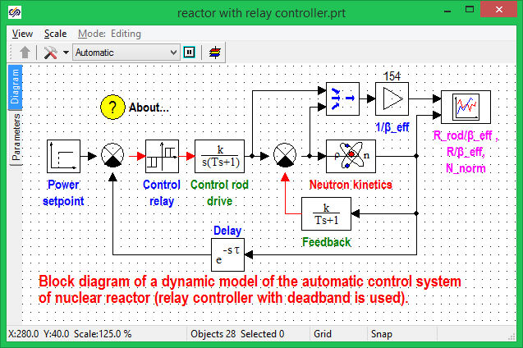
Project diagram window
Block diagram consists of the following elements: units, communication links and decorative elements. Decorative elements are objects not applicable for making up a calculation task (comments, figures); those are just graphical primitives and are added on a diagram window in the same way as to the graphics editor window as described below. Calculation task is made up using units and communication links – these are active elements of a diagram.
Unit is a diagram elements provided with ports.
Port is referred to an object on a unit image, from which a communication link can be drawn or to which a communication link can be attached. Ports and communication links can be of different types. Type of communication line is determined by a relevant identifier and can be changed. Communication link can be attached to a port only if their type is the same.
Communication link is a diagram element connecting two ports of a unit or more.
Both units and communication lines are graphical primitives and supports all functions of common graphic primitives but, besides, those have additional capabilities.
Active diagram elements have customizable lists of properties and parameters. Those have special fields required for calculation, i.e., name of calculation class and calculation template.
Diagrams editor provides possibility to create integrated units.
Integrated unit is a number of units integrated on the “parent-successor” principle, i.e., the case when one unit can belong to another one. Units can also belong to communication links, which enables visual construction of diagrams with complex nonuniform structure. To create a unit, which can be inserted into other diagram elements “Insert into others” properties of that shall be set as “Yes” and the unit shall be saved in the library of classes. Then the unit will be inserted from the library into other units.
Property of a diagram element is some data element, whose value can be changed using the diagram element properties editor. To change the value of properties of a diagram active element that shall be selected by clicking the mouse on the diagram, than double-click it or select “Correction – Object properties” menu item. Then the window of diagram element properties editor will appear. Properties of some types (real, integral, arrays, matrix) can be set up as an algebraic expression and, in the process, names of common signals of a project, properties and macro-model parameters can be used as operands. This option is used to parametrize sub-models.

Window of editor of diagram element properties
Parameter is a data element, which cannot be changed using the editor of diagram element properties. Parameters are intended for diagram calculation results to be recorded into them. Properties and parameters of diagram elements have title, internal name and data type description. Those are accessible by their names in script and list of links of system editor similar to other properties of graphical primitives.
Calculation class name is element type name in a calculation module corresponding to the considered unit or communication link on a block diagram.
Calculation template is description of an element in the calculation module corresponding to the considered unit or communication link on a block diagram.
Contents of lists of properties, parameters, number and type of ports and description of calculation class and calculation template of units are changed using the new units editor. Description for communication links can be changed using the editor of the library of classes. It is used to create dedicated units from empty ones or from units already available in the library of classes.
The editor of diagrams allows projects consisting of several independent files to be created. To this end, option of sub-model loading from a project external file is provided. Sub-models have special “File Name” property. If this property is not empty then in the process of loading of project, data on the sub-model contents will be read out from a relevant project file (*.prt), otherwise the sub-model will be read out from the project main file. Page files can be loaded via special file paths of files:
$(BIN)\ – path to program directory;
$(ROOT)\ – customizable working directory;
$(DATABASE)\ – database root directory;
Thus, if one project is changed all sub-models referring to that project in another project will be changed on its re-loading. When sub-models are loaded from an external file missing signals will be added to the main project, while missing properties will be added to the list of sub-model properties. To reload project pages “File – Reload pages” menu item shall be selected and, in the process, all sub-models referring to the external file will be reloaded. Such sub-models can be edited in separate project mode of a or in common project mode; for the second case to save changes of the page select “File – Save page” or “File -Save all” menu item or select the sub-model using the mouse right button and select “Actions – Save and link to file”.
There can be several sub-models, whose internal structure is loaded from the same file, in one project. Diagrams editor allows the contents of such sub-models to be matched without their re-loading from the file, i.e., when one is changed the others will be changed too. Models can be matched automatically in the moment of exit from sub-models and start-up of calculation, or in manual manner. To match those automatically select “File – Match pages automatically” menu item. To match a current page with its equivalents select “File – Match pages” menu item.
The diagram editor is provided with monitoring system for project file versions. To activate page file version monitoring option select “File – monitor project version” menu item. To activate data manager file version monitoring select “File – Monitor data manager file version” menu item. If version monitoring version is active then an old file of project page or data manager will be renamed, while being saved, - this file will be added with file version number as an extension starting with one. All old project file version can be erased; to this end select “File – Delete old file versions” menu item.

Window of diagram element properties editor
Parameter is the name referring to a data element, which cannot be changed using the diagram element editor. Parameters are intended for recording diagram calculation results in them. Properties and parameters of diagram elements have title, internal name and data type description. Those are accessible via names in script and list of links of the diagram editor similar to other properties of graphical primitives.
Calculation class name is a title of element type in the calculation module corresponding to a given unit or communication link on a block diagram.
Calculation template is description of an element in a calculation module corresponding to a given unit or communication link on a block diagram.
Components of lists of properties, parameters, number and type of ports and description of calculation class and calculation template of units are changed using the New Units Editor. Editor of Library of classes is used to change description for communication links. It can be used to create dedicated units using empty ones or from ones available in Library of classes.
Diagram editor allows projects consisting of several independent files to be created. For this purpose, option of sub-model loading from external file of a project is available. Sub-models have “File Name” special property. If this property is not empty then in the process of loading of a project data on sub-model contents will be read out from a relevant project file (*.prt), otherwise the sub-model will be read out from the main project file. Page files can be loaded using the special file paths:
$(BIN)\ – path to program directory;
$(ROOT)\ – settable working directory;
$(DATABASE)\ – database root directory.
Thus, when changing one project, all sub-models referring to this project in another project will be changed in the process of its reloading. When loading sub-models from an external file, missing signals are added to the main project, while missing properties will be added to the list of sub-model properties. To re-load project pages select “File – Reload pages” menu item, then all sub-models referring to the external file will be reloaded. Such sub-models can be edited in individual project mode or in common project mode; in the latter case to save changes in a page select “File – Save page” or “File – Save all” menu item, or select the sub-model by means of the right mouse button and select “Operation – Save and link to file” item.
The same project can have several sub-models, whose internal structure is loaded from the same file. Diagram editor allows the contents of such sub-models to be matched without their reloading from the file, i.e., when one of those is changed the others will be changed too. Models can be matched automatically, when exiting the sub-model or starting calculations, or manually. For automatic matching select “File – Match pages automatically” menu item. For manual matching select “File – Match pages ” menu item.

Diagram editor is provided with monitoring system for project file versions. To activate the monitoring options for page file version select “File – Monitor project version” menu item. To activate monitoring of data manager file version select “File – Monitor data manager file version” menu item. If version monitoring option is enabled then in the process of saving an old file of project page or data manager will be renamed, i.e., this file will be added with the file number starting with one appearing as the file extension. All old versions of project files can be erased, for which purpose select “File – Delete old file versions” menu item.

