Data manager
Special program module, i.e., data manager, is provided to collect data calculated in the diagram editor. Data manager allows the presentation of calculation results to be structured and be presented as a tree.
Data manager allows calculation results to be presented as curves or as tables of values (view window). Curves and view windows can be combined into categories, which allows calculation results to be structured if their quantity is large. Both curves and view windows can be added to each category. To generate a new curve the category shall be first created or designated.
Category can be created by pressing “Add Category” key in the data manager window. Then select a category in the data tree and press “Add Curve” key in the data manager window.
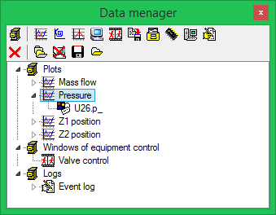
Data manager window
Curves and view windows can display values of properties and parameters of objects. To display a parameter on a curve add a reference to this parameter to the curve. Reference to a parameter can have dedicated settable name different from the parameter name.
Reference to a parameter can be added to a curve or view window using a special tool – parameter inspector, which allows parameters or properties of any object to be viewed and added to the data manager.
To activate the parameter inspector select “Calculation – Parameter Inspector” menu item.
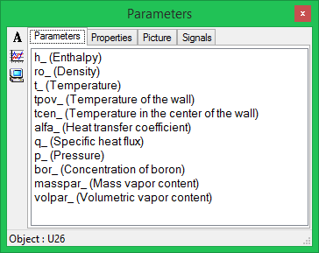
Object parameter inspector
On selection of a certain object in the diagram window, the parameter inspector will display its parameters, properties, visual properties as well as a list of project signals. To add a reference to the parameter use the mouse to drag the parameter from the parameter inspector to the window of curves or to the view window, or directly to the data manager tree. To delete the parameter from a curve or view windows select its name in the data manager tree and press “Delete” key in the data manager window.
Data manager configuration of every project is stored separately from the file with extension “*.mgr” located in the same directory with the project file. It is necessary to ensure correct operation of the program when creating distributed projects. When loading the project to be edited, the data manager file is checked for availability. If the file is available then the project data manager is loaded from it. Non-availability of the considered file will not lead to any error.

