Main window
On start-up of the software system, main window is displayed and contains: Components palette, Main menu and Tool bar:
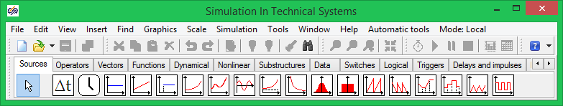
Graphic shell Main window
Description of commands of the program main menu is presented item by item as follows: File, Edit, View, Insert, Find, Graphics, Scale, Simulation, Tools, Window, Help, Automation tools.
“Tools” menu is customizable, it allows additional external programs to be activated. “Windows” menu allows diagram windows existing in the program to be displayed or hidden. Main menu items are partially backed up in tool bars.

