New units editor
To change description of any unit proceed as follows:
- Arrange the initial unit in the project diagram window. To this end either select “Paste – Base Units – Standard Unit” item menu or paste a required unit from the palette.
- Select “Correction – Change Unit” item menu, New units editor will be displayed:
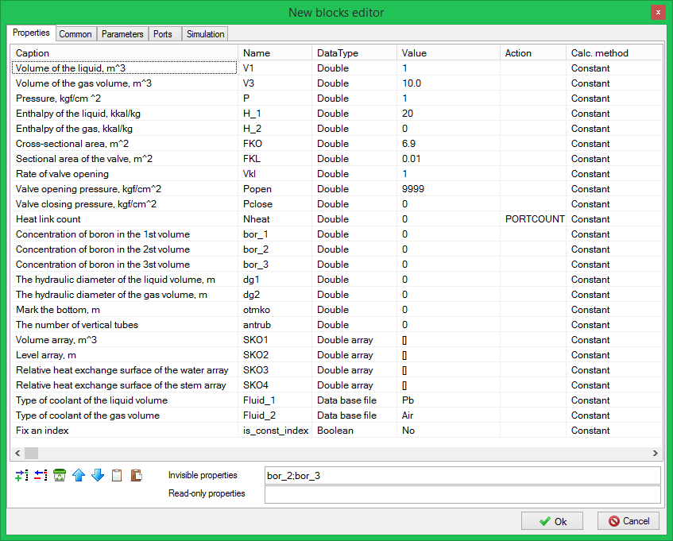
New units editor
This tool is used to add, delete, change names of properties (“Properties” tab), parameters (“Parameters” tab), ports (“Ports” tab) to be set up, names of calculation class and calculation template (“Calculation” tab).

