Library of classes
After changing a selected unit by means of New units editor, it can be saved in Library of classes. Not only individual units but separate segments of the system can be saved in Library of classes. To save one or more elements of a diagram to library of classes select “File – Save to library” item menu and write the name of the entry into the library in a displayed dialog.
Library of units can be changed using a special editor, to this end select “File – Edit Library” menu item.
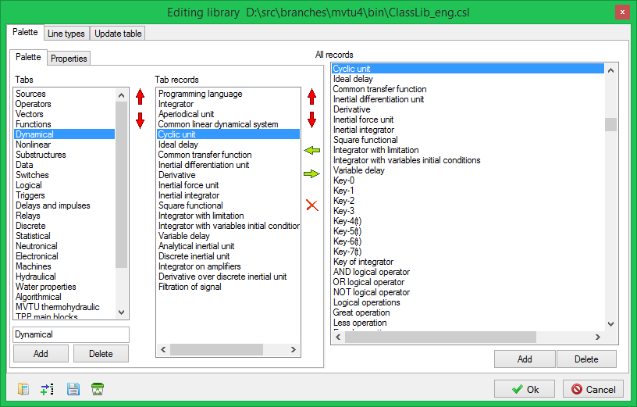
Window of units library editor
Using this tool the content of the library can be changed and appearance of the palette diagram editor components can be set up. Palette of components is divided into separate pages. Each page can contain several entries. To add a page press “Add” key in “Pages” section. To add a page with an entry from a common list use the mouse to drag a relevant name from “All Entries” list to “Page entries” list. An image, which will be displayed on a certain key in the palette of components, can be set for every entry as well as a help for this key.

