Calculation job setup
Prior to setting up a calculation job the block diagram of a project shall be transformed into an input data file of calculation module.
The first stage of transformation includes decomposition of the block diagram of a project, in the process of which description of geometrical parameters of elements and service elements of different kind will be deleted from the complete description.
Diagram editor supports two methods of decomposition of a project:
- unit-hierarchical decomposition;
- decomposition into calculation layers.
Unit-hierarchical decomposition implies sub-models available in the project.
Sub-model is a special unit with a segment of a diagram inside. To generate a sub-model select “Paste – Base Units – Sub-model” menu item. To view or change the sub-model contents double-click the mouse on the sub-model icon.
Ports can be determined in a sub-model. To change a number of sub-model ports special units of “Submodel port” type are used. To add a port to a sub-model proceed as follows: double-click the mouse on the sub-model icon and then select “Paste – Base Units – Sub-Model Ports” menu item and to determine the port type change related properties of the considered unit.
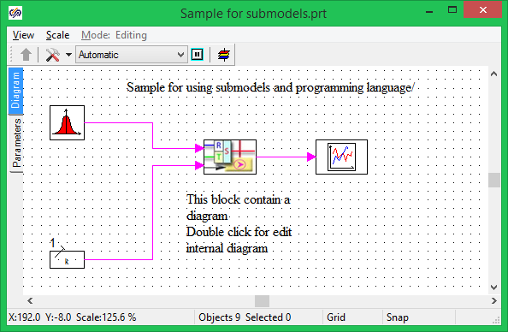
Example of block diagram with sub-model
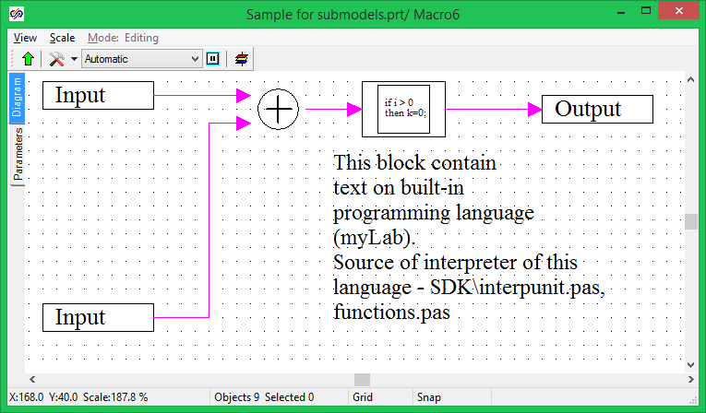
Internal structure of sub-model
Mechanism for sub-model parametrization is provided in the diagram editor, i.e., a list of properties can be set up for each sub-model as well as for other units. Properties of any elements arranged inside a sub-model can have a reference to sub-model properties using names of sub-model properties. Thus, simple elements can be used to combine more complicated nodes and be stored in the library of classes.

In the process of set-up of a calculation job the sub-model internal structure is decompressed for the project structure to become single-level. Two modes of sub-models are provided – description of a sub-model can be introduced into a calculation job or not to be introduced. These modes are determined via “Active model” property of a unit – if this property has “Yes” value then sub-model description is introduced into the calculation job and all units compressed in that are introduced into a list of subordinated units of a calculation element.
Decomposition into calculation layers means that each unit and link is provided with a layer identifier.
Layer is an object containing a certain collection of diagram elements and common properties of calculation job. Each calculation layer has individual settings and generates an individual calculation job for any calculation program. Layers can be added and deleted using “New layer” and “Delete layer” keys in the diagram window tool bar. A current layer of each project page is selected using “Layer selection” switch. The layer can be changed by means of a special layer editor.

Window of calculation layer properties editor
A list of calculation parameter (“Calculation parameters” tab), visual properties (“Common” tab) are set for each layer and calculation settings are set – name of transitional library for linking the diagram editor to the calculation program. A list of available classes can be set for each layer, i.e., the classes, which can be pasted into a current layer. Group of each class, group name is set in the command editor.
The same project can contain several layers, every one of which can be calculated in dedicated calculation program. This enables the generation of models of devices with processes featuring different physical natures.

