**Interquartile Range (IQR)** **Report**

**Placement Data Analysis Problem:**

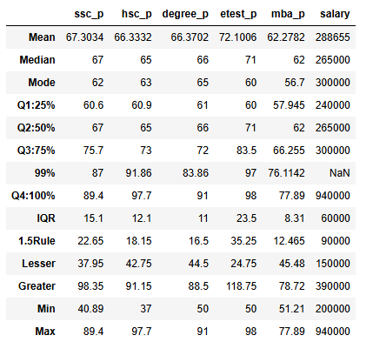



*Note:* Poor= below 40%, Average= 40-70%, Good= above 70%, Excellent= above 80%

**Table Description:**

From the above table we can find the following

* Interquartile range that is the difference between Q3 and Q1.
* Applied 1.5 rule which provides a reasonable compromise outlier that closely follows Gaussian distribution.
* Lesser and Greater outliers
* Minimum and Maximum values

Here are the quantitative value columns which we have taken from the placement dataset to calculate the IQR.

**ssc_p:**

The IQR value is 15.1. The lesser outlier (37.95) comes under the minimum value (40.95), so there are no lesser outliers. The greater outlier value (98.35) goes beyond the maximum value (89.4), so it has greater outliers.

**hsc_p:**

The IQR value is 12.1. The lesser outlier value (42.75) goes beyond the minimum value (37), so it has lesser outliers. The greater outlier (91.15) comes under the maximum value (97.7), so there are no greater outliers.

**Degree_p:**

The IQR value is 11. The lesser outlier (44.5) comes under the minimum value (50), so there are no lesser outliers. The greater outlier (88.5) comes under the maximum value (91), so there are no greater outliers.

**etest_p:**

The IQR value is 23.5. The lesser outlier (24.75) comes under the minimum value (50), so there are no lesser outliers. The greater outlier value (118.75) goes beyond the maximum value (98), so it has greater outliers.

**mba_p:**

The IQR value is 8.31. The lesser outlier (45.48) comes under the minimum value (51.21), so there are no lesser outliers. The greater outlier (78.72) comes under the maximum value (77.89), so there are no greater outliers.

**salary:**

The IQR value is 60000. The lesser outlier (150000) comes under the minimum value (200000), so there are no lesser outliers. The greater outlier (390000) comes under the maximum value (940000), so there are no greater outliers.

**Conclusion:**

The hsc_p and etest_p has lesser outliers. The ssc_p has greater outliers. The degree_p , mba_p and salary has no outliers.