SOP
In 2021, I lost my grandparents to COVID-19 within two months.
Any grandchild would be shocked, I know, but for me, my grandparents were almost like my other “parents.” My grandfather, a retired school director, was also like a teacher to me, a teacher of life who was always so warm-hearted and kind.
As such, every vacation, or whenever I could, I used to head out to their countryside home, where we would talk for hours while enjoying a bonfire.
Thus, the news (I couldn’t even go see them due to quarantine) hit me hard.
Before that tragic year, I did indeed have quite some exposure to medicine and health. During high school, I volunteered at a center for senior citizens, and I took absolutely all the related classes (life science, for instance) I was allowed to take. And at college, I took Actuarial Statistics and some other related classes.
To be honest, however, my interests were strictly academic, never personal, as I had always been perfectly healthy. Except for a broken arm when I was six, I had never been hospitalized. To me, health was a given that I never gave a second thought to.
But then, this shock, over the course of five years, slowly turned into a sense of mission: to learn the whys and underlying causes of illnesses and health complications so that I could be useful to the medical community.
Thus, now, this realm is personal to me, and biostatistics is my means of being useful. My CV reflects this newly found mission: over 20% of all my experiments and projects were related to the medical field, and whenever I had the chance, I would raise my hand to volunteer for such opportunities to apply all that I had learned, particularly statistical methodologies, to medical problems. For this, I had to seek out opportunities outside my lab because my lab is focused on fundamental statistics.
As such, I worked on life insurance risk classification at the Academic Conference hosted by the College of Business and Economics at my alma mater, utilizing SMOTE to address data imbalance to classify risk levels using Random Forest and XGBoost, and I also studied variable impacts alongside model fairness using SHAP. Additionally, I applied the methodology, Dominant Arm Identification, to the problem of clinical treatment selection. What was a bit different was that instead of merely comparing different treatments based on average effects, I recommended which treatment is superior by considering the distribution of treatment outcomes. Besides statistics, I also studied clinical and ethical conditions, in addition to the validation processes required for clinical application. This was my first attempt to apply my previous research on sequential decision-making methodologies to the medical domain.
However, the more I studied, the more my list of questions increased, especially when I participated in a subsequent project addressing medical diagnostic data, which allowed me to experience firsthand just how highly sensitive real-world medical data is.
Thus, I need your program.
High-Dimensional Inference
A major challenge in treatment decision-making is that there are simply too many "candidate" variables to consider. This is especially true for clinical data, which may include genomic profiles, electronic health records, imaging-derived features.
At the same time, gathering all kinds of information to analyze is not only costly but also time-consuming. Likewise, I would like to study the effects of key biomarkers and patient characteristics in treatment decisions after learning to discern out the significant variables first and foremost.
This interest naturally leads me to the problem of high-dimensional variable and biomarker selection, together with valid inference. Outcome weighted learning (Zhao et al., 2012) uses patient characteristics to derive individualized treatment rules aimed at improving expected clinical outcomes. I hope to extend this line of work to high-dimensional settings, where the goal is not only to estimate an effective treatment rule but also to identify which patient characteristics drive it and to quantify the uncertainty surrounding that identification.
For this goal, I also need to study the methodologies required to answer my questions, such as, “Which test is needed to identify significant variables in high-dimensional clinical data with limited information?”
As we all know, in statistics, there are various methods for estimating the influence of a variable on an estimate, including Cook’s distance, the coefficient of determination, and Fisher’s correlation. However, these measures of influence require more data than the number of dimensions in high-dimensional settings and are computationally inefficient. It is well known that in high-dimensional settings with limited data, it is impossible to test whether a specific variable is significant (i.e., whether its parameter coefficient is zero or not).
Currently, in a high-dimensional and sparse setting, I am conducting research on the early detection of high-influence variables that change the decision-making results in actuality by studying feature selection methods.
To advance this research, I am interested in an approach based on the information-theoretic limits on sparsity recovery in the high-dimensional and noisy setting (Wainwright, 2009). Building on this work, I hope to develop a convergence test that, by appropriately adjusting the weights of the given data, can determine whether the coefficient of a specific variable is zero under proper assumptions. This approach can be applied to so many different areas including genomics, electronic health records, and medical imaging, where data are high-dimensional and feature selection must be performed quickly.
Adaptive Clinical Trial Design
Beyond identifying which variables matter, I am also interested in how the relevant data should be collected.
I first realized how different real biomedical study design could be from what I had learned in class when I joined an industry consultation with a company involved in laboratory and nonclinical testing. Until then, I had thought of experimental design would be relatively straight forward: decide how many samples are needed, collect the data, and analyze the results. But the actual case was much more complex. The company already had a large amount of experimental data, yet some of it had been collected for different purposes or under different conditions, and some could not even be reused because of contractual restrictions. That experience made me realize that having a lot of data does not necessarily mean having the right data, and that designing a biomedical study in practice can be much more complicated than it looks in a textbook.
That experience also made me think about how the challenge of obtaining the right data becomes even more consequential in clinical settings.
Motivated by this experience, I need to study how clinical data are collected. All too many times while working on many projects, I witnessed instances in which data was collected with no clear goal set in the beginning. As such, very often than not, there was extensive waste in the data collection process. My goal is to minimize such waste by studying ways to mastermind just-right data plan, to survey selectively and smartly to identify an appropriate patient population — for instance, which patients to enroll or which samples to assay. As such, I need to study from the bandit/online learning/sequential optimal design perspective (Tao et al., 2018) to identify which experiment to carry out to improve policy, and how to ensure optimal exploration-exploitation trade-off along the way. In a biostatistical setting, this connects closely to response-adaptive randomization and sequential trial design.
Robust Sequential Learning and Inference
The difficulty becomes even greater when the data available today are either scarce or no longer representative of the population in which future decisions must be made. The moment a new treatment is introduced, there is often a lack of data and virtually no historical data. As such, it is essential to make smart assumptions based on existing data from similar treatments. However, there are many instances in which the data cannot be applied directly. Moreover, as everything changes so fast, past data may no longer be relevant, thus hindering good decision-making for the future. In other words, data may be insufficient, while existing data may no longer be relevant for treatment-effect estimation, risk identification, and so forth. To me, this was not only a question of forecasting precisely at a particular point in time. Instead, it seemed to be more of a question of which data to trust and which data to examine as a priority.
We all know that clinical data inevitably causes prediction results to fluctuate due to noise, missing values, heavy tails, and shifts in distribution. However, what matters is not the prediction itself, but how robust the clinical outcomes of treatment policies based on those predictions remain.
Therefore, I will study whether it is possible to design learning and optimization methods that are robust to changes in the data distribution while making sure that the optimal decision-making can be made with minimal data, and for this, I also need to study different forms of performance guarantees such as regret bounds or constraint violation control.
Towards this end, I also need to study reinforcement learning and sequential adaptive learning. In biostatistics, this points toward dynamic treatment regimes and adaptive interventions studied through designs such as micro-randomized trials. This includes learning treatment rules that adapt to a patient’s changing condition over time (Murphy, 2003). Related applications include learning treatment strategies for sepsis in intensive care (Komorowski et al., 2018) and personalizing digital interventions to support medication adherence (Xu et al., 2025).
Another question I have is whether it will be possible to perform learning and decision-making while controlling data for bias even when feedback is partially or selectively observed (action-dependent missingness). From what I know in the field of missing data, the doubly robust method is utilized extensively to obtain semi-efficient and unbiased estimates (Bang & Robins, 2005); however, its theoretical guarantees are often asymptotic, which limits its applicability to sequential decision-making problems with limited data(nonasymptotic).
In a manuscript I am currently co-authoring with my advisor (Sim & Kim, 2026), we address this issue in a multi-armed bandit setting where each arm’s reward distribution remains fixed over time. Rather than selecting the best arm based solely on its mean reward, we establish a new dominance score that partitions the reward space into regions where different arms are locally dominant and aggregates these comparisons across the entire distribution. To estimate this score when only the reward of the selected arm is observed, we combine current observations with recycled exploration samples and construct a doubly robust estimator that simultaneously estimates the reward distributions of all arms. Based on this estimator, we develop an elimination algorithm that identifies the arm with the highest dominance score at a desired confidence level, with a sample-complexity bound that matches the theoretical lower bound up to logarithmic factors.
With this in mind, I would like to study how recycled exploration samples should be weighted when treatment outcome distributions change over time, and how this affects the reliability and sample efficiency of treatment selection. This line of research could help inform treatment decisions when data from the current patient population are limited and historical observations may no longer be fully representative
All these are why I need you. With the right set of training, I know that I will walk out with many answers to these questions, supported by the set of qualities that will ensure the successful completion of my PhD program.
First, I tasted the joy of creating something out of nothing, which I feel is a mindset needed for biostatistics, as it deals with vast amounts of data, requiring smart guessing and assumption-making, which I am familiar with because I helped to build my lab. Today, I am an undergraduate RA at the SIAI Lab at my alma mater. At this lab, I learned so much because, although we are eight members today, a year ago there were only two desks: my advisor’s and mine, since I am the first lab disciple of my advisor, who joined the faculty fresh out of a PhD program.
Thus, together, we set up the lab, literally speaking. During the “founding” days, we held marathon meetings, just the two of us, to set up the direction of our research. We also experienced many trials and errors, which, now that I think about them, were my other “teachers,” as I learned by doing and mulling over the reasons behind our failures and mistakes.
It wasn’t easy building a lab together, especially since I was taking so many classes on the side. In fact, I must have set the record: I completed 165 credits because I was so eager to learn. But then, hitting the books and devouring papers after a full day at the lab was challenging.
But the joy of seeing us grow more than offset all the hardships.

Moreover, I have that ROI mindset per se as I grew up in a family of entrepreneurs. My family business is an oil refinery plant builder (we also maintain and troubleshoot) that spans three generations. Over 35 years, we built many plants in the Middle East. At our peak, our revenue was close to $94 million, with 100 people on the payroll and two offices in Korea and another in Indonesia.
Thus, our family dinners with my grandfather, the founder & CEO, uncles, and my father, all in management, often turned into business meetings.
As such, I grew up hearing about business, and thus, even as a scholar, I will be asking questions such as, “How can I commercialize this for the benefit of the greater population?” and so forth.
In addition, I feel very comfortable working with diverse people. My father, for instance, would have me accompany him to meetings with plant people, mechanics, robot specialists, and many others. Although I was there mostly to watch, I still learned how different people can bring so many different angles to the table. As such, in your program, I cannot wait to work with MDs and other medical professionals, as well as computer scientists. I am ready.
And I care. I go that extra mile to help, like when I served.
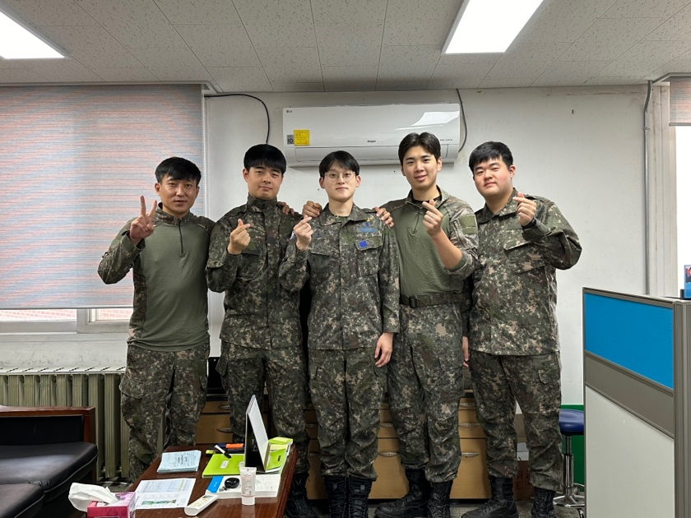
From socks to spinach, I managed at least 1,000 products while in the military. For two years at an Air Force base, I was responsible for managing all items, materials, and equipment, a position that I volunteered for because I have always been a management buff.
But to be honest, I almost regretted my decision on Day 1 because the warehouse I saw was messy and dirty, and dust had piled up on the goods since no one had been responsible for the job.
Thus, for the next two years, I worked day and night to leave behind an impeccably and beautifully managed warehouse, to the point that I often wondered whether I was a soldier, a sweeper, or an SCM specialist.
But I persisted because I thought about my fellow soldiers. I was responsible for managing food, for instance, and also for supplying safety gear for drills.
Last, but never least, I love research.
So, I am headed in that direction. I want to devote myself to research as a professor and scholar who never ceases to work with the field.

References
[1] Tao, C., Blanco, S. A., & Zhou, Y. (2018). Best arm identification in linear bandits with linear dimension dependency. In Proceedings of the 35th International Conference on Machine Learning (Proceedings of Machine Learning Research, Vol. 80, pp. 4877–4886).
[2] Murphy, S. A. (2003). Optimal dynamic treatment regimes. Journal of the Royal Statistical Society: Series B (Statistical Methodology), 65(2), 331–355.
[3] Komorowski, M., Celi, L. A., Badawi, O., Gordon, A. C., & Faisal, A. A. (2018). The Artificial Intelligence Clinician learns optimal treatment strategies for sepsis in intensive care. Nature Medicine, 24(11), 1716–1720.
[4] Xu, Z., Jajal, H., Choi, S. W., Nahum-Shani, I., Shani, G., Psihogios, A. M., Hung, P.-Y., & Murphy, S. A. (2025). Reinforcement learning on dyads to enhance medication adherence. In Artificial Intelligence in Medicine (AIME 2025) (Lecture Notes in Computer Science, Vol. 15734, pp. 490–499). Springer.
[5] Bang, H., & Robins, J. M. (2005). Doubly robust estimation in missing data and causal inference models. Biometrics, 61(4), 962–973.
[6] Sim, J., & Kim, W. (2026). Dominant arm identification with mixing and recycling observed samples. arXiv preprint, arXiv:2608.01545.
[7] Zhao, Y., Zeng, D., Rush, A. J., & Kosorok, M. R. (2012). Estimating individualized treatment rules using outcome weighted learning. Journal of the American Statistical Association, 107(499), 1106–1118.
[8] Wainwright, M. J. (2009). Information-theoretic limits on sparsity recovery in the high-dimensional and noisy setting. IEEE Transactions on Information Theory, 55(12), 5728–5741.

