SOP
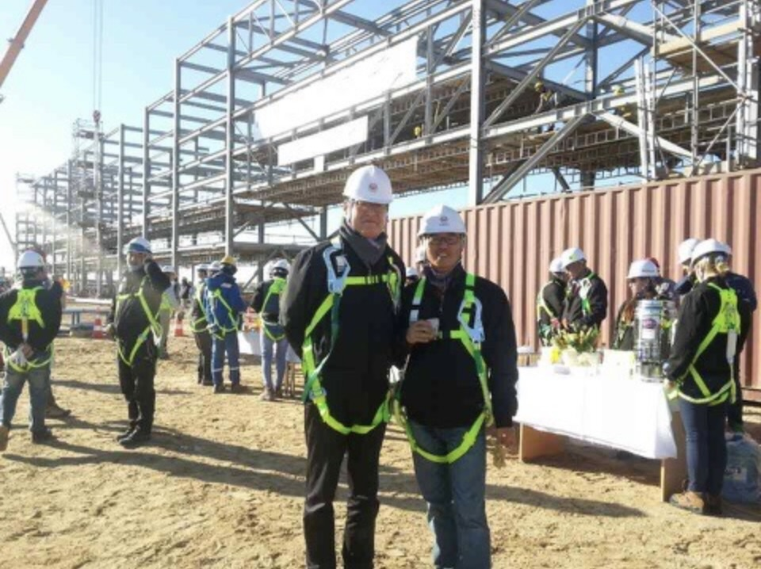
I grew up with plants and manufacturing, literally speaking. My family business is an oil refinery plant builder (we also maintain and troubleshoot) that spans three generations. Over 35 years, we built many plants in the Middle East. At our peak, our revenue was close to $94 million, with 100 people on the payroll and two offices in Korea and another in Indonesia.
Thus, our family dinners with my grandfather, the founder & CEO, uncles, and my father, all in management, often turned into business meetings.
As such, I grew up hearing about business, and I loved every moment of it. The concept that interested me the most was “efficiency.” How can we operate processes more efficiently with the least effort? This was the key question that often triggered discussions.
In many ways, this background influenced my academic choices, leading me to major in business and statistics.
However, I still have miles to go, and I need you to get answers to my many questions.
System Informatics and Control / Data
Factories are data-rich. Every moment, tons of data on facilities, processes, quality, and other aspects are generated. In fact, this has always been on my radar, and as a result, most of my education has centered on “from data to decision-making”, working with real data ranging from sparse, high-dimensional clinical data to stock price data and insurance risk data. In my lab today, I work on decision-making in high-dimensional environments with limited observations. But this is challenging because of many issues, ranging from data collection and cleansing to usage. For data collection, as we all know, there are simply too many “candidate” variables to consider. Thus, knowing which data to gather, and for what purpose, is essential because gathering all kinds of information to analyze is not only costly but also time-consuming. Likewise, I would like to study the effect of key variables on decision-making results after learning to distinguish the significant variables first and foremost. For this, I also need to study the methodologies required to answer my questions, such as, “Which test is needed to identify significant variables in high-dimensional data with limited information?” Currently, in a high-dimensional and sparse setting, I am conducting research on the early detection of high-influence variables that change the decision-making results in actuality by studying feature selection methods.
Another interest of mine is “reading” missing or limited data using smart assumptions. For example, when a new technology is adopted, there is often a lack of data and virtually no historical data. As such, it is essential to make smart assumptions based on existing data from similar technologies. However, there are many instances in which the data cannot be applied directly. Moreover, as everything changes so fast, past data may no longer be relevant, thus hindering good decision-making for the future. In other words, data may be insufficient, while existing data may no longer be relevant for forecasting, risk identification, and so forth. To me, this was not only a question of forecasting precisely at a particular point in time. Instead, it seemed to be more of a question of which data to trust and which data to examine as a priority.
Moreover, I have yet to study multi-sensor, multi-modal data for use at plants. Data fusion (Liu, Gebraeel & Shi, 2013), which combines signals from different sensors to “read” one state, is the core technology of this field, and I am very interested in it. Furthermore, in manufacturing processes, visual information such as product shape and color, sound and vibration from equipment, and temperature and pressure, which were considered in the realm of human control, all transform into data that showcase quality and risk. As I have handled mostly numerical tables, this is a new skill set.
Among these, within Quality and Reliability Engineering, particularly from the perspective of in-process quality improvement, where quality and reliability are built in real time using in-process data rather than simply filtering out defects through post-production inspection, I am especially interested in the following two problems.
Fault root-cause diagnostics
Usually, when a fault occurs in a plant, it takes a significant amount of time to identify the root cause. While there may be only a single anomaly signal, there may be many so-called “candidate” root causes.
Meanwhile, a factory is stopped, resulting in massive financial losses. My family business experience is a good example that clearly illustrates this problem. In plant-related projects, the prime contractor diagnoses the point at which a process-related error occurs and passes the results to the subcontractor responsible for maintenance. However, if the root cause of the error is not accurately identified before passing on the task, waste is incurred as the subcontractor carries out repetitive maintenance work without actually resolving the root-cause problem, naturally leading to significant waste. Likewise, I realized that root-cause diagnosis is a critical process that determines effective maintenance. As such, I wish to leverage advanced statistical modeling that connects process error sources with quality measurements to identify the root causes of variation (Zhou, Chen, & Shi, 2004). More recently, research has even expanded to address optimal sensor placement to maximize diagnostic capability under a limited number of sensors (Liu, Zhang, & Shi, 2014).
I will also focus on deciding which candidate cause to verify first and what to check next based on the result of the verification. Designing this sequence of inspections is precisely a sequential decision-making problem. By treating dozens of candidate root causes as options and each inspection as an observation, diagnosis becomes a sequential identification problem in which the next inspection is selected based on the outcome of each observation, systematically eliminating low-probability candidates. The methodologies I have researched can minimize the required number of inspections while maintaining the desired level of confidence, and supplement judgments for rarely inspected candidates using existing historical data.
This sequential approach also addresses a concern I encountered in data collection: gathering every possible measurement is costly and often unnecessary. In fault diagnosis, I therefore want to study adaptive data acquisition by drawing on bandit algorithms from online learning and sequential optimal design to select the most informative inspection at each stage.
As such, I plan to study ways to reliably formulate a strategy that utilizes the fewest number of inspections to identify the root cause.
Predictive Maintenance
This problem involves modeling equipment degradation to estimate remaining useful life (RUL) and deciding when to intervene. It is particularly meaningful that early research began by treating RUL as a distribution rather than a single deterministic number (Gebraeel et al., 2005). Saying, "the remaining life is two years on average" could mean that it will almost certainly last for two years, or it could also mean that half will last four years while the other half fails within a few months. Even with the same mean, these two scenarios represent completely different realities on a plant floor.
The manuscript I am currently co-authoring with my advisor addresses this issue. Because the mean is heavily skewed by rare extreme values, the option that appears best on average often yields disappointing results in reality. To address this, instead of summarizing the data into a single mean value, we established a new criterion that evaluates which option is more reliable within specific outcome intervals and aggregates these evaluations across the entire distribution. Furthermore, we developed an algorithm and the underlying theory to identify the optimal choice at a desired confidence level based on this criterion. Translated into the “language” of maintenance, our work addresses the problem of selecting a policy that remains consistently reliable across a wide range of real-world scenarios.
However, there is a shortcoming on my end. Until now, I focused mostly on methodologies. In other words, I have yet to experience their actual implementation. Although I have worked with high-dimensional data, it was mostly static data that was effectively organized (with no time domain), while a plant’s sensor stream is different: it flows over time, modalities get intermingled, and other factors come into play. As such, I need you to learn how to apply these methodologies in the actual field while customizing them appropriately for individual companies.
Digital Twin
Towards the above-mentioned goal, a Digital Twin is a must. A powerful tool, a Digital Twin is one of the effective ways to simulate changes to be adopted in a plant while quantifying uncertainties using simulators and AI. It is very effective for decision-making (Biller & Biller, 2023). My vision is to create an ecosystem that includes everything from monitoring to diagnostics and maintenance. As such, an integrated Digital Twin of the entire plant is my goal. In the end, the task of replacing risky work with robotics, as well as other issues such as additive manufacturing, is all about what to adopt, when to adopt it, and how to operate.
To support such decisions, however, a Digital Twin must remain reliable even as the plant and the data it generates continue to change. In practice, equipment deteriorates, operating conditions shift, and sensor data may be limited, noisy, missing, or drawn from distributions different from those used to construct the original model. Therefore, I want to study whether it is possible to design learning and optimization methods that are robust to changes in data distributions while ensuring that near-optimal decisions can be made with limited data. For this purpose, I also need to study different forms of performance guarantees, such as regret bounds and constraint-violation control. Regret bounds can quantify how much performance is lost while the system learns from sequential observations, while constraint-violation control can help prevent unsafe or excessively costly actions during the learning process. As such, I will work with questions such as, “What kinds of learning and optimization methods are needed to maintain stable decision quality in a changing environment?” Ultimately, I hope to develop Digital Twins that do not merely simulate a static plant but continuously update their models and support reliable decision-making as real operating conditions evolve.
Smart Factory
Smart Factory (manufacturing) that utilizes IoT, AI, Machine Learning, and others is hot these days.
Korea is no exception.
However, we still have a long way to go. According to a report published following the National Assembly´s (“Congress” of Korea) inspection of government offices, 79.9% of smart factories in Korea are at a basic stage, while only 1.3% enable real-time control.
For small and medium-sized enterprises (SMEs), the picture is even grimmer.
This is truly regrettable, as 99.0% of all companies in Korea are SMEs, totaling 8 million companies.
As such, I want to focus not only on large conglomerates, but also on SMEs, helping small factories maximize efficiency while minimizing human risk. Accordingly, although I do wish to become an academic/scholar/professor, my other “foot” will always remain in the field per se, working very closely with governments and companies.
But first, I really need you. For one, I will have to learn which of the latest technologies to apply. At the same time, however, I know that technological adoption is not easy because we have to consider not only the technological functions but also ROI and risk management.
A representative case is my father’s own experience with automatic welders. He did consider adopting them, but in the end, decided against it. Of course, they would offer many benefits like reduced labor costs and so forth. But at the same time, with at least 10 required for a plant of the average size that we build, they would require an investment of $12M. Moreover, automatic welders would need to be customized to individual plant sites, requiring complex and time-consuming calibration. Even after adoption, human supervision would still be essential.
Thus, I realized that technologies need to be scrutinized in depth and their benefits and costs (risks, potential losses included) need to be weighed carefully.
Some processes may be more effective as they are, while others may need automation through technology adoption. Discerning which processes need which action is something that I wish to learn. That is, to me, smart manufacturing may not mean automating every single process down to the bare bones. Instead, although one day we can dream of 100% automation, until then, strategizing and mixing human labor with technology may be essential. Thus, analyzing which technologies among many to adopt in line with company-specific processes, and which ones to maintain the status quo using existing processes, is a key challenge, especially for SMEs with limited capital.
That is, transformation from a so-called legacy factory to a Smart Factory requires extensive decision-making in stages.
Likewise, I will study ways to analyze companies in order to then identify processes that call for new technologies and others that do not (at least in the short run).
Moreover, smart manufacturing goes beyond the boundaries of a plant. It also involves careful supply chain management strategies. In this process, impeccable data analysis and statistical modeling are essential to cope with uncertainties. The following month's order volume can be forecasted utilizing a time-series model, but there may be deviations from actual demand at any time. Thus, companies must determine inventory levels by considering not only forecast values but also the costs of overstocking and stockouts when demand changes. Stochastic inventory theory addresses inventory policies that minimize costs under such uncertain demand, while the Markov decision process explains how to adjust ordering and production decisions whenever new information arrives over time.
What was interesting while studying these theories is that it is virtually impossible to make good decisions based merely on mean demand. That is, optimal inventory level is not determined simply by the mean demand; instead, it must be selected across the demand distribution by weighing the cost of excess inventory against the cost of a stockout. Distributionally robust optimization takes this a step further, seeking to find more resilient decisions under the premise that the assumed demand distribution itself may be inaccurate. This has driven my interest in decision-making models that can function realistically even when data is incomplete, and the future is uncertain.
The same principle applies from a temporal perspective, not just a spatial one. A factory requires constant change. This goes for a Smart factory as well. As everything changes, including working environments, facilities must be constantly calibrated to adapt to those changes. This is precisely why we need continual improvement through monitoring and diagnostics, fault analysis to pinpoint root causes of failure, AS-IS/TO-BE optimization to compare current and target processes, and model-based control to regulate system behavior using data.
All these are why I need you. With the right set of training, I know that I will walk out with many answers to these questions, supported by the set of qualities that will ensure the successful completion of my PhD program.
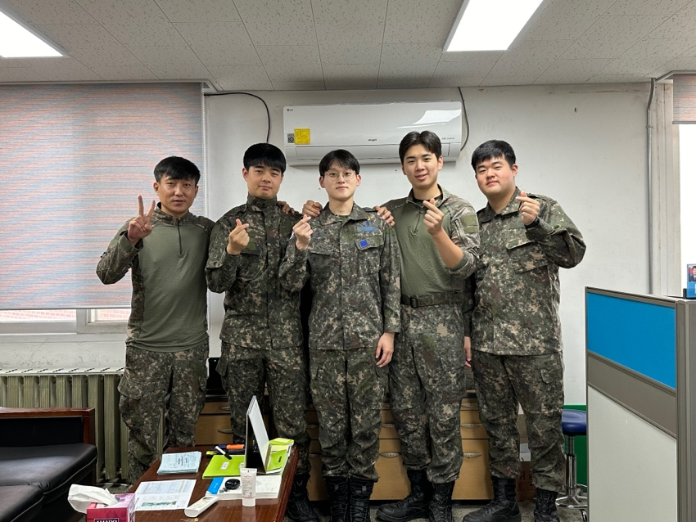
First and foremost, I am passionate about our field, which, to me, entails streamlining for maximum efficiency. As such, I volunteered to serve at a warehouse (SCM) in the military.
From socks to spinach, I managed at least 1,000 products while in the military. For two years at an Air Force base, I was responsible for managing all items, materials, and equipment – a position that I volunteered for because I have always been a management buff.
But to be honest, I almost regretted my decision on Day 1 because the warehouse I saw was messy and dirty, and dust had piled up on the goods since no one had been responsible for the job.
Thus, for the next two years, I worked day and night to leave behind an impeccably and beautifully managed warehouse, to the point that I often wondered whether I was a soldier, a sweeper, or an SCM specialist.
But it was the most fun and fulfilling experience. Nothing compared to the joy of seeing every process flow impeccably. I also walked away with many lessons, like how complex operations can be when handling everything from A to Z, from warehousing to inventory control, especially while forecasting demand. Moreover, having to keep records in line with those of other government offices on a real-time basis was challenging and time-consuming because the goods were constantly moving targets.
Meanwhile, having to work with very volatile factors like politics, SCM emergencies, and weather was especially difficult, as our base was located deep in the woods. Even the weather forecasts were not entirely reliable. Thus, if there is anything I learned, it is that anything can go wrong.
But when everything is tallied, and I think about my experience, it was a blessing in disguise, as I had the chance to work with SCM at possibly the largest organization in Korea (the military is certainly larger than Samsung)
Also, I am sure that most, if not all, organizations, whether private or public, experience the same. Thus, I am ready.
And in many ways, my military experience continues to help me today. I am now an undergraduate RA at the SIAI Lab at my alma mater. At this lab, I learned so much because although we are eight members today, a year ago, there were only two desks (my advisor’s and mine, since I am the first lab disciple of my advisor, who joined the faculty fresh out of a PhD program).
Thus, together, we set up the lab, literally speaking. During the “founding” days, we held marathon meetings, just the two of us, to set up the direction of our research. We also experienced many trials and errors, which, now that I think about them, were my other “teachers,” as I learned by doing and mulling over the reasons behind our failures and mistakes.
It wasn’t easy building a lab together, especially since I was taking so many classes on the side. In fact, I must have set the record: I completed 165 credits because I was so eager to learn. But then, hitting the books and devouring papers after a full day at the lab was challenging.

But I truly loved those busy days and our many discussions. And along the way, I found out something about myself as well: I love research.
Now, I am headed in that direction. I want to devote myself to research as a professor and scholar who never ceases to work in the field, whether in a plant for a fashion company or a semiconductor plant.

References
[1] Liu, K., Gebraeel, N. Z., & Shi, J. (2013). A data-level fusion model for developing composite health indices for degradation modeling and prognostic analysis. IEEE Transactions on Automation Science and Engineering, 10(3), 652–664.
[2] Zhou, S., Chen, Y., & Shi, J. (2004). Statistical estimation and testing for variation root-cause identification of multistage manufacturing processes. IEEE Transactions on Automation Science and Engineering, 1(1), 73–83.
[3] Liu, K., Zhang, X., & Shi, J. (2014). Adaptive sensor allocation strategy for process monitoring and diagnosis in a Bayesian network. IEEE Transactions on Automation Science and Engineering, 11(2), 452–462.
[4] Gebraeel, N. Z., Lawley, M. A., Li, R., & Ryan, J. K. (2005). Residual-life distributions from component degradation signals: A Bayesian approach. IIE Transactions, 37(6), 543–557.
[5] Sim, J., & Kim, W. (2026). Dominant arm identification with Mixing and Recycling Observed Samples. Preprint.
[6] Biller, B., & Biller, S. (2023). Implementing digital twins that learn: AI and simulation are at the core. Machines, 11(4), 425.

