SOP
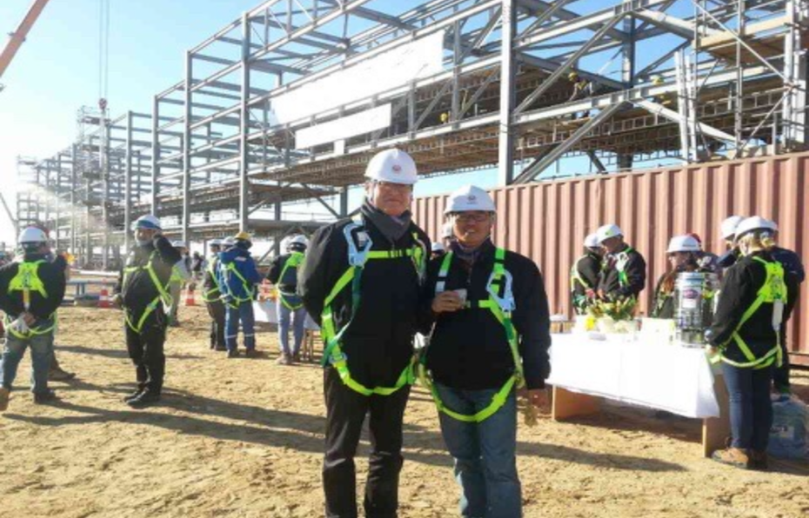
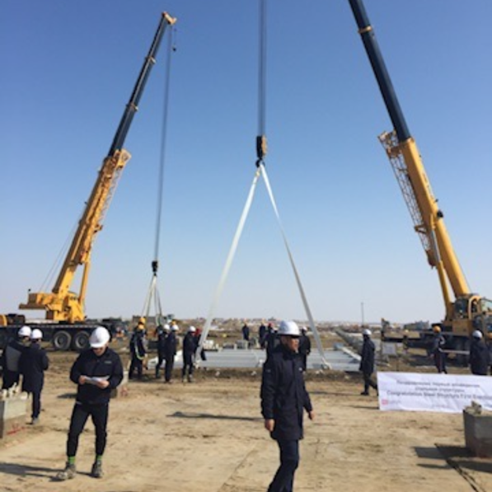
I grew up with plants and manufacturing, literally speaking. My family business is an oil refinery plant builder (we also maintain and trouble-shoot) that spans three generations. Thus, for over 35 years, we built many plants in the Middle East. During our heyday, our revenue was close to $94 million with 100 on the payroll with two offices in Korea and another in Indonesia.
Thus, our family dinners with my grandfather, the founder & CEO, uncles and my father, all in the management, often turned into business meetings.
As such, I grew up hearing about business, and I loved every moment of it. The word that interested me the most was “efficiency”. How to operate the processes more efficiently with least effort? This was the key question that triggered discussions.
In many ways, this background dictated my career, majoring in business and statistics.
But then, I still have miles to go, and I need you to get answers to my many questions.
System Informatics and Control / Data
Factories are data-rich. Every moment, tons of data on the facilities, processes, quality and others are churned out. In fact, this was always in my radar, and as such most of my education centered on “from data to decision-making”, working with real data ranging from sparse high-dimensional clinical data to stock price data and insurance risk data. And at my lab today, I work on decision-making in high-dimensional environments with limited observations.
But this is challenging because of many issues ranging from data collection, cleansing to use. For the collection, today as we all know, there are simply too many “candidate” variables to consider. Thus, knowing which data to gather, for what purpose is essential because gathering all kinds of information to analyze is not only costly but also slow. Likewise, I would like to study the effect of the key variables on decision-making results after learning to discern out the significant variables first and foremost. And for this, I also need to study methodologies required to answer my questions such as “Which test is needed to identify significant variables in high-dimensional data with limited information? Currently, in high-dimensional and sparse setting, I am conducting research on early detection of the high-influence variable that changes the decision-making results in actuality, by studying the feature selection method.
Another interest of mine is “reading” missing or limited data using smart assumptions. For example, the moment a new technology is adopted, there is a lack of data and virtually no historical data. As such, it is essential to make mart assumptions are made based on the existing data of similar technology, there are many instances in which the data cannot be applied directly. Moreover, as everything changes so fast, past data may no longer be relevant, thus hindering good decision making for the future. In other words, there is no data while exiting data may no longer be relevant for forecasting, risk identification and so forth. To me, this was not only a question of forecasting precisely at this particular point. Instead, it seemed to be more of a question of which data to trust, and which data to examine as a priority.
Moreover, I am yet to study multi-sensor, multi-modal data for use at plants. Data fusion (Liu, Gebraeel & Shi, 2013) that combines different sensors’ signals to “read” one state is the core technology of this field, which I am very interested in. Moreover, in manufacturing processes, visual information like product shape and color, sound and vibration from equipment, and temperature and pressure that were considered in the realm of human control, all transform into data that showcase quality and risk. As I handled mostly numerical tables, this is a new skill set.
Among these, within Quality and Reliability Engineering, particularly from the perspective of in-process quality improvement, where quality and reliability are built in real time using in-process data rather than just filtering out defects through post-production inspection, I am especially interested in the following two problems.
Fault root-cause diagnostics
Usually when a fault results in a plant, it takes significant amount of time to identify the root cause. While there may be only one single anomaly signal, there may be many so-called “candidate” root causes.
Meanwhile, a factory is stopped, resulting in massive financial loss. My family business’ experience is a good example that clearly illustrates this problem. In plant related projects, the prime contractor diagnoses the point when there is a process related error and passes the results to the subcontractor responsible for the maintenance. However, if the root cause of the error is not accurately identified before passing on the task, waste is incurred as the subcontractor carries out repetitive maintenance work without actually resolving the root-cause problem, naturally leading to significant waste. Likewise, I realized that root cause diagnosis is a critical process that determines effective maintenance.As such, I wish to leverage advanced statistical modeling that connects process error sources with quality measurements to identify the root causes of variation (Zhou, Chen, & Shi, 2004). More recently, research has even expanded to address optimal sensor placement to maximize diagnostic capability under a limited number of sensors (Liu, Zhang, & Shi, 2014).
I will also focus on deciding which candidate cause to verify first, and what to check next based on the result of the verification. Designing this sequence of inspections is precisely a sequential decision-making problem. By treating dozens of candidate root causes as options and each inspection as an observation, diagnosis becomes a sequential identification problem where the next inspection is selected based on the outcome of each observation, systematically eliminating low-probability candidates. The methodologies I have researched can minimize the required number of inspections while maintaining the desired level of confidence, and supplementing judgments for rarely inspected candidates using existing historical data.
This sequential approach also addresses a concern I encountered in data collection: gathering every possible measurement is costly and often unnecessary. In fault diagnosis, I therefore want to study adaptive data acquisition by drawing on bandit algorithms from online learning and on sequential optimal design to select the most informative inspection at each stage.
As such, I plan to study ways to formulate reliably by utilizing least number of inspections to identify the root cause.
Predictive Maintenance
This problem involves modeling equipment degradation to estimate remaining useful life (RUL) and deciding when to intervene. It is particularly meaningful that the early research began by treating RUL as a distribution rather than a single deterministic number (Gebraeel et al., 2005). Saying "the remaining life is two years on average" could mean it will almost certainly last for two years, or it could also mean that half will last four years while the other half fails within a few months—even with the same mean, these two scenarios represent completely different realities on a plant floor.
The manuscript I am currently co-authoring with my advisor addresses this issue (Sim, J., & Kim, W,2026).Because the mean is heavily skewed by rare extreme values, the option that appears best on average often yields disappointing results in reality. To address this, instead of summarizing the data into a single mean value, we established a new criterion that evaluates which option is more reliable within specific outcome intervals and aggregates these evaluations across the entire distribution. Furthermore, we developed an algorithm and the underlying theory to identify the optimal choice at a desired confidence level based on this criterion. Translated into the “language” of maintenance, our work addresses the problem of selecting a policy that remains consistently reliable across a wide range of real-world scenarios.
However, there is a shortcoming on my end. Until now, I focused mostly on methodologies. In other words, I am yet to experience actual implementation. Although I did work with high-dimensional data, it was mostly static data that was effectively organized (with no time-domain) while a plant’s sensor stream is different—it flows with time, modality gets intermingled, and other factors. As such, I need you to learn to apply to the actual field but by customizing just-right to companies.
Digital Twin
Towards the above-mentioned goal, Digital Twin is a must. A powerful tool, Digital twin is one of the effective ways to simulate changes to adopt in a plant that quantifies uncertainties with simulator and the AI. It is very effective for decision-making (Biller & Biller, 2023). My vision is to create an ecosystem that includes everything from monitoring to diagnostics and maintenance. As such, the digital twin that integrates the entire plant is my goal. In the end, the task of replacing risky work with robotics and other issues such as additive manufacturing are all about what to adopt, when and how to operate.
To support such decisions, however, a digital twin must remain reliable even as the plant and the data it generates continue to change. In practice, equipment deteriorates, operating conditions shift, and sensor data may be limited, noisy, missing, or drawn from distributions different from those used to construct the original model. Therefore, I want to study whether it is possible to design learning and optimization methods that are robust to changes in data distributions while ensuring that near-optimal decisions can be made with limited data. For this purpose, I also need to study different forms of performance guarantees, such as regret bounds and constraint-violation control. Regret bounds can quantify how much performance is lost while the system learns from sequential observations, while constraint-violation control can help prevent unsafe or excessively costly actions during the learning process. As such, I will work with questions such as, “What kinds of learning and optimization methods are needed to maintain stable decision quality in a changing environment?” Ultimately, I hope to develop digital twins that do not merely simulate a static plant, but continuously update their models and support reliable decision-making as real operating conditions evolve.
Smart Factory
Smart Factory (manufacturing) that utilizes IoT, AI, Machine Learning and others is hot these days.
Korea is no exception.
However, we still have a long way to go. According to a report published after the National Assembly (“Congress” of Korea) inspection of the administration (government offices), 79.9% of the smart factories in Korea are at a basic stage, while merely 1.3% enables real-time control.
For the Small and Medium sized Enterprises (SMEs), the picture is grimmer.
This is truly regrettable as 99.0% of all companies in Korea are SMEs, totaling 8 million companies.
As such, I want to focus not only on the large conglomerates, but also the SMEs to introduce small factories to maximize efficiency while minimizing human risk. Accordingly, although I do wish to become an academic/scholar/professor, my other “foot” will always be in the field per se, working very closely with the governments and the companies.
But first, I really need you. For one, I will have to learn the latest technologies to apply. At the same time, however, I know that technological adoption is not easy because not only do we have to factor in the technological functions, but also ROI and manage risks at the same time.
A representative case is my father’s own experience with automatic welders. He did contemplate them, but in the end decided against adoption. Of course, they would offer many benefits like reduced labor cost and so forth. But at the same time, with at least 10 required for a plant of the average size that we build, this would require $12M while automatic welders would need to be customized to individual plant sites, which requires complex time-consuming calibration. And even when adopted, human supervision would be essential all the same.
Thus, I realized that technologies need to be scrutinized in-depth and the benefits and costs (risks, potentials losses included) need to be weighed carefully.
Some processes may be more effective as they are, while some others would need automation through technology adoption. Discerning out which processes need which action is something that I wish to learn. That is, to me, Smart manufacturing may not mean automating every single process down to the bare bone. Instead, although one day, we can dream of 100% automation, until then, strategizing, mixing human labor with technology may be essential. Thus, analyzing which technologies among many to adopt in line with company-specific processes, and which one to maintain the status quo using existing processes is a key challenge especially for the SMEs with limited capital.
That is, transformation from so-called legacy factory to Smart Factory requires extensive decision-making in stages.
Likewise, I will study ways to analyze companies to then identify processes that call for new technologies and others that do not (at least in the short-run).
Moreover, Smart manufacturing goes beyond the boundaries of a plant. It also involves careful supply chain management strategy. And in this process, impeccable data analysis and statistical modeling are essential to cope with uncertainties. The following month's order volume can be forecasted utilizing time series model, but there may be a deviation from the actual demand at any time. Thus, companies must determine inventory levels by considering not only forecast values, but also the costs of overstock and stockouts when demand changes. Stochastic inventory theory addresses inventory policies that minimize costs under such uncertain demand, and the Markov decision process explains how to adjust ordering and production decisions whenever new information arrives over time.
What was interesting while studying these theories is that it is virtually impossible to make good decisions merely with mean demand. That is, optimal inventory level is not determined simply by the mean demand; instead, it must be selected across the demand distribution by weighing the cost of excess inventory against the cost of a stockout. Distributionally robust optimization takes this a step further, seeking to find more resilient decisions under the premise that the assumed demand distribution itself may be inaccurate. This has driven my interest in decision-making models that can function realistically even when data is incomplete and the future is uncertain.
The same principle applies from a temporal perspective, not just a spatial one. A factory requires constant change. This goes for a Smart factory as well. As everything changes such as working environments, facilities must be constantly calibrated to adapt to those changes, precisely why we need continual improvement through monitoring and diagnostics, fault analysis to pinpoint root causes of failure, AS-IS/TO-BE optimization to compare current and target processes, and model-based control to regulate system behavior using data.
All these are why I need you. With the right set of training, I know that I will walk out with many answers to these questions because of the set of qualities that will ensure successful completion of my PhD program.
First and foremost, I am passionate about our field, which to me entails streamlining for maximum efficiency. As such, I volunteered to serve at a warehouse (SCM) in the military.
From socks to spinach, I managed at least 1,000 products while in the military. For two years, at an Air Force base, I was responsible for managing all items, materials and equipment – a position that I had volunteered for since I was always a management buff.
But to be honest, I almost regretted my decision on Day 1 because the warehouse I saw was messy, dirty and dust had piled up on the goods since there was no one responsible for the job.
Thus, for the next two years, I worked day and night to leave behind an impeccable beautifully managed warehouse to the point that I often wondered whether I am a soldier, a sweeper or a SCM specialist.
But it was most fun and fulfilling. Nothing compared to the joy of seeing every process flow impeccably. I also walked out with many lessons like how complex operation is while handing A to Z from warehousing, inventory control, especially while forecasting demand. Moreover, having to keep records in line with those of other government offices on a real time basis was challenging and time-consuming because the goods were moving targets.
Meanwhile, having to work with very volatile factors like politics, SCM emergencies and weather were especially difficulty as our base was located deep in the woods. Even the weather forecasts were not entirely reliable. Thus, if there is anything I learned, it is that anything can go wrong.
But when everything is tallied now that I think my experience, this experience was a blessing in disguise as I had the chance to work with SCM at the possibly largest organization in Korea (military is certainly larger than Samsung).
Also, I am sure that most if not all organizations, whether private or public organizations, experience the same. Thus, I am ready.
And in many ways, my military experience helps me today well. Today, I am an undergrad-RA at the SIAI Lab at my alma mater. At this lab, I learned so much because although we are eight today, a year ago, there were only two desks (my advisor’s and mine since I am the first lab disciple of my advisor, who joined the faculty fresh out of PhD program.
Thus, together, we set up the lab, literally speaking. During the “founding” days, we help marathon meetings, just two of us, to set up the direction for research, and together, we also experienced many errors and trials, which now that I think about them, were my other “teachers” as I learned by doing and mulling over the whys of our failures and mistakes.
It wasn’t easy – building a lab together – especially since I was taking so many classes on the side. In fact, I must have set the record; I completed 165 credits because I was so eager to learn. But then, hitting the books and devouring papers after a full day at the lab was a challenge.
But then, I truly loved those busy days and our many discussions. And along the way, I found out something about myself as well – that I love research.
Now, I am headed towards that direction. I want to devote myself to research as a professor and scholar who never ceases to work with the field – whether a plant for a fashion company or semiconductor.

References
[1] Liu, K., Gebraeel, N. Z., & Shi, J. (2013). A data-level fusion model for developing composite health indices for degradation modeling and prognostic analysis. IEEE Transactions on Automation Science and Engineering, 10(3), 652–664.
[2] Zhou, S., Chen, Y., & Shi, J. (2004). Statistical estimation and testing for variation root-cause identification of multistage manufacturing processes. IEEE Transactions on Automation Science and Engineering, 1(1), 73–83.
[3] Liu, K., Zhang, X., & Shi, J. (2014). Adaptive sensor allocation strategy for process monitoring and diagnosis in a Bayesian network. IEEE Transactions on Automation Science and Engineering, 11(2), 452–462.
[4] Gebraeel, N. Z., Lawley, M. A., Li, R., & Ryan, J. K. (2005). Residual-life distributions from component degradation signals: A Bayesian approach. IIE Transactions, 37(6), 543–557.
[5] Sim, J., & Kim, W. (2026). Dominant arm identification with Mixing and Recycling Observed Samples. Preprint.
[6] Biller, B., & Biller, S. (2023). Implementing digital twins that learn: AI and simulation are at the core. Machines, 11(4), 425.

