Personal
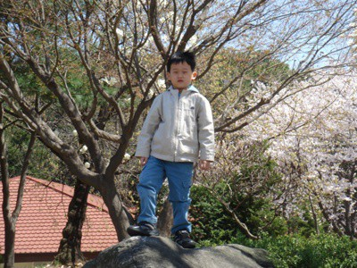
All my life, 24 years to be exact, I lived in one neighborhood, a suburb at least an hour’s drive from Seoul.
A tiny neighborhood, very safe, very peaceful, but there was also no drama per se. Residents were very much alike: middle-class families living the white-picket lifestyle. Nothing special.
But I had my father, an entrepreneur, an international businessperson who would bring me stories of the amazing wider world after living 2/3 of the year overseas, mostly in the Middle East, where he negotiated contracts to build plants right in the heart of the desert.
As such, his stories were exciting, interesting, and immensely fun. And they planted that seed of desire in me — the desire to venture out beyond my little neighborhood and to dream big.
And in many ways, this dream is not mine alone; it is one shared with my father, as well, because of his own life story.
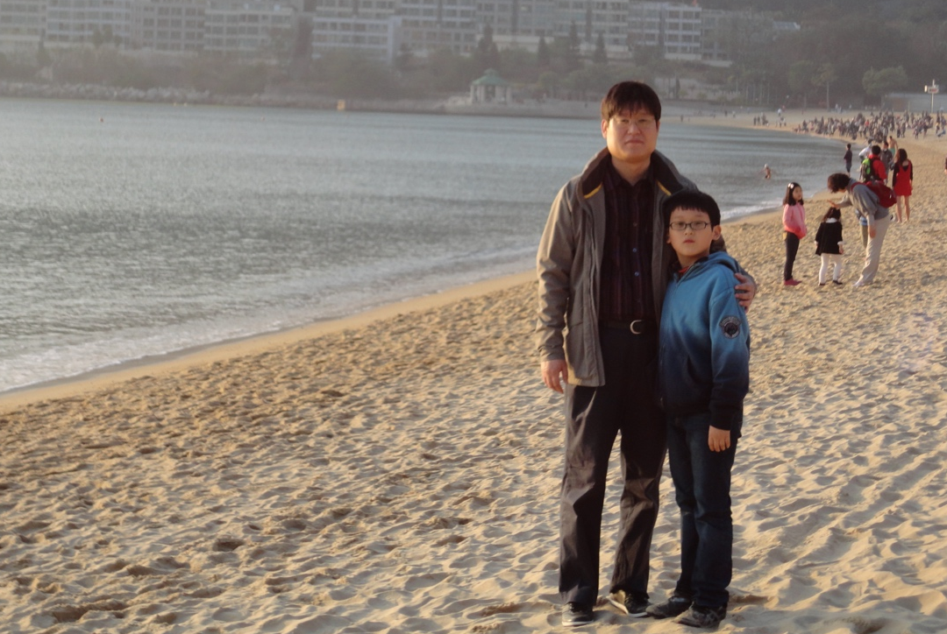
Movie director — this was his dream for decades. Although his life took a completely different turn (he had to join the family business out of necessity), that film bug in him is still very much alive. In fact, close to 90% of my memories with him are related to movies: walking together to a video rental shop whenever he could find time for us to spend together, watching and enjoying films side by side, and having long discussions about what we saw, felt, and learned.
Even today, he is a hopeless cinephile, a film buff (I’m sure he already watched most of what is available on Netflix).
At the same time, however, I would notice a certain longing in him after a particularly good movie — a longing for a life he never lived, that of a filmmaker instead of merely a consumer.
Perhaps because of this unfilled dream of his, his biggest mission in life became keeping my dream alive.
And for this, he really gave it his all, opening every door possible for me: sending me to a private English-speaking nursery school so that I could master English, a language for the world stage. There, I heard many stories from my teachers from all different parts of the world, which in turn continued to fuel my dream. And the thousands of movies I watched alongside my father also had me daydreaming of life beyond my neighborhood, my country, and even the earth itself (sci-fi is my favorite genre).
All I can say today is that I am most grateful for all the encouragement and support that allowed me to dream.
But more than anything, I am ever more grateful because they also taught me why I should aim high — so that I can contribute more, just as my parents are doing. My father, for one, is helping to create thousands of jobs and improve the lives of many through the plants being built. Meanwhile, my mother is a government official who works for the Constitutional Court of Korea, where she safeguards the constitution and the rights it protects, including human rights.
And they both have been contributing in this way for over 30 years.
Thus, naturally, after observing them all my life, I also found the answer as to why I must work hard for my dream.
And in many ways, I am already headed that way. I teach North Korean refugee children today as a volunteer. But I try to teach much more than math formulas and English phrases: I am also there to help them adapt to a completely different society and life, and to simply talk about life.
I am also the de facto caretaker for my grandparents; at times, a “nurse” who visits them once or twice every week to check their vital signs, measuring pulse rate, respiration rate, and blood pressure. I am also their “driver,” taking them to hospitals for over six years now.
And in the military (Air Force), where I also heard many life stories, I devoted myself to helping others, such as a fellow soldier who had quit high school to enter the workforce, pass his Korean GED, and others who dreamt of a better life after military service.
But all this isn´t enough. I want, and need, to grow much more so that I can help others more.

