Student: Simon Kong

Project Due date: 10/2/2021

Algorithm Steps:

Main

step 0: inFile, outFile1, outFile2 🡨 open via argv[]

step 1: numRows, numCols, minVal, maxVal 🡨 read from inFile

step 2: offSet 🡨 (int) (maxVal - minVal) / 10

dividePt 🡨 offSet

step 3: dynamically allocate histAry and GaussAry, and initialized to zero

maxHeight 🡨 loadHist (histAry, inFile)

Step 4: dynamically allocate all other arrays and initialized to zero

step 5: plotHistGraph (histGraph)

step 6: prettyPrint (histGraph, outFile1) // with caption

step 7: bestThrVal 🡨 biMeanGauss (dividePt, outFile2)

outFile1 🡨 output bestThrVal to outFile1 // with caption

step 8: bestFitPlot (bestThrVal) // plotting the result of Gaussian curves

prettyPrint(GaussGraph, outFile1) // with caption

step 9: prettyPrint(gapGraph, outFile1) // with caption

step 10: close all files

Bi-Mean Gauss

Step 0: (double) sum1

(double) sum2

(double) total

(double) minSumDiff

bestThr 🡨 dividePt

minSumDiff 🡨 999999.0 // a large value

Step 1: set1DZero (GaussAry) // reset for next computation

set2DZero (GaussGraph)

set2DZero (gapGraph)

step 2: sum1 🡨 fitGauss (0, dividePt, GaussAry, GaussGraph)

// fitting the first Gaussian curve

Step 3: sum2 🡨 fitGauss (dividePt, maxVal, GaussAry, GaussGraph)

// fit the second Gaussian curve

Step 4: total 🡨 sum1 + sum2

outFile2 🡨 print sum1, sum2, total with caption

Step 5: if total < minSumDiff

minSumDiff 🡨 total

bestThr 🡨 dividePt

Step 6: outFile2 🡨 print dividePt, minSumDiff and bestThr with caption

Step 7: dividePt ++

Step 8: prettyPrint (GaussGraph, outFile2)

Step 9: plotGaps (histAry, GaussGraph, gapGraph)

prettyPrint (gapGraph, outFile3)

step 10: repeat step 1 to step 9 while dividePt < (maxVal – offSet)

step 11: return bestThr

fitGauss

Step 0: (double) mean

(double) var

(double) sum

(double) Gval

(double) maxGval

sum 🡨 0.0

step 1: mean 🡨 computeMean (leftIndex, rightIndex, maxHight)

var 🡨 computeVar (leftIndex, rightIndex, mean )

outFile2🡨 write leftIndex, rightIndex, mean, var with captions

Step 2: index 🡨 leftIndex

Step 3: Gval 🡨 modifiedGauss (x, mean, var, maxHight)

Step 4: sum += abs (Gval – (double)histAry[index])

Step 5: GaussAry[index] 🡨 (int) Gval

GaussGraph[index][(int) Gval] 🡨 1

Step 6: index ++

Step 7: repeat step 3 – step 6 while index <= rightIndex

Step 8: return sum

computeMean

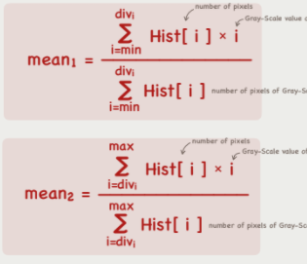

Step 0: maxHeight 🡨 0 // maxHight came via parameter, it is NOT local variable!

sum 🡨 0

numPixels 🡨 0

Step 1: index 🡨 leftIndex

Step 2: sum += (hist[index] * index)

numPixels += hist[index]

Step 3: if hist[index] > maxHeight

maxHeight 🡨 hist[index]

Step 4: index++

Step 5: repeat Step 2 to step 4 while index < rightIndex

Step 6: return (double)sum / (double) numPixels

computeVar

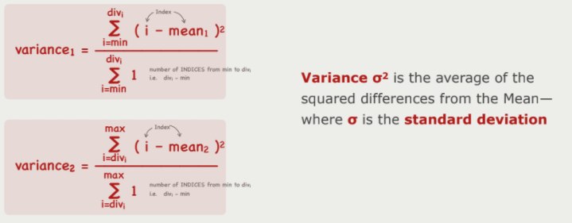

Step 0: sum ← 0.0

numPixels ← 0

Step 1: index ← leftIndex

Step 2: sum += (double) hist [index] * ((double) index – mean)^2)

numPixels += hist[index]

Step 3: index++

Step 4: repeat Step 2 to step 3 while index < rightIndex

Step 5: return (double) sum / (double) numPixels

ModifiedGauss



return (double) (maxHeight * exp( - ( (x-mean)^2 / (2*var) )

bestFitPlot

step 0: sum1 (double), sum2 (double)

Step 1: set1DZero(GaussAry)

set2DZero(GaussGraph)

set2DZero(gapGraph)

step 2: sum1 🡨 fitGauss(0, bestThrVal, GaussAry, GaussGraph)

Step 3: Sum2 🡨 fitGauss(bestThrVal, maxVal, GaussAry, GaussGraph)

Step 4: plotGaps(histAry, GaussGraph, gapGraph)

plotGaps

step 1: index 🡨 minVal

step 2: first 🡨 min(histAry[index], GaussAry[index])

last 🡨 max(histAry[index], GaussAry[index])

Step 3: gapGraph[index][first] 🡨 1

Step 4: first ++

Step 5: repeat step 3 to step 4 while first < last

Step 6: index ++

Step 7: repeat step 2 – step 6 while index < maxVal

Source Code

Main Class

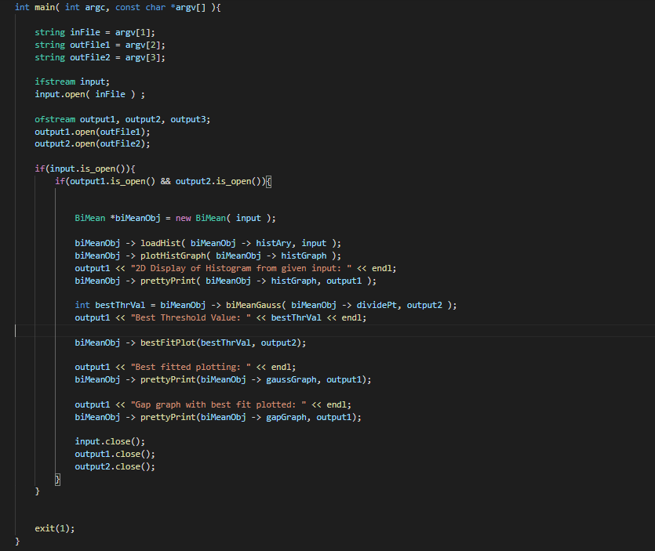

BiMean Class

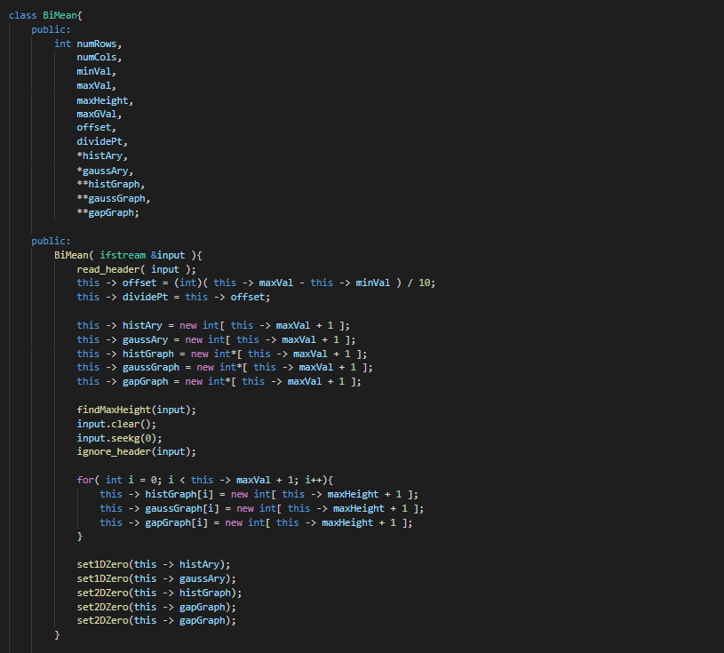

BiMeanGauss & bestFitPlot

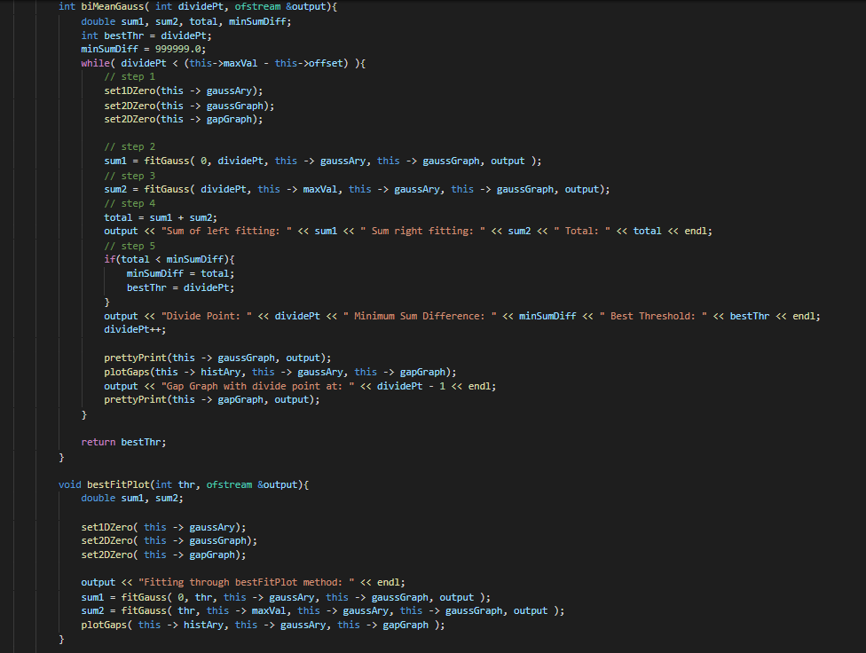

computeMean & computeVar

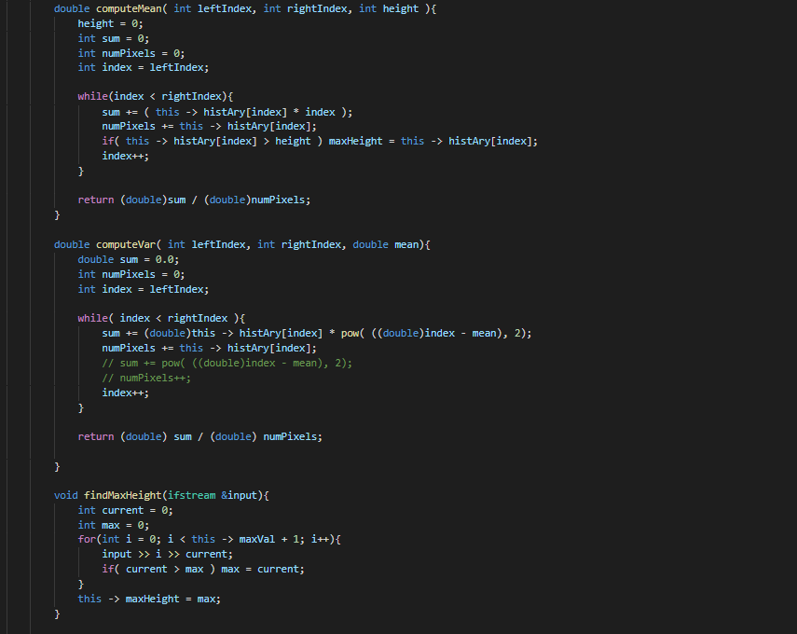

fitGauss & modifiedGauss

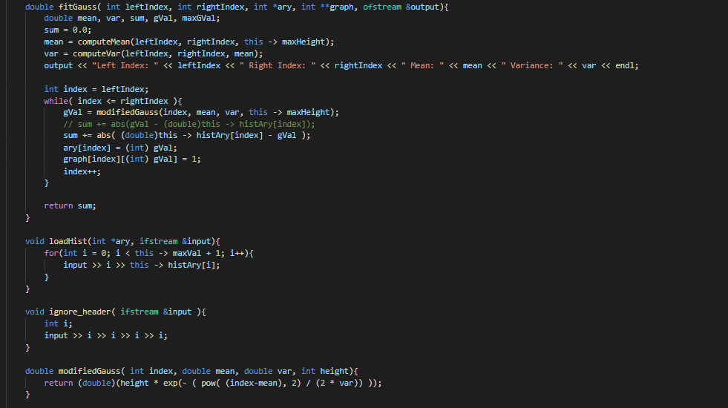

plotGaps & plotHistGraph & prettyPrint

set1DZero & set2DZero

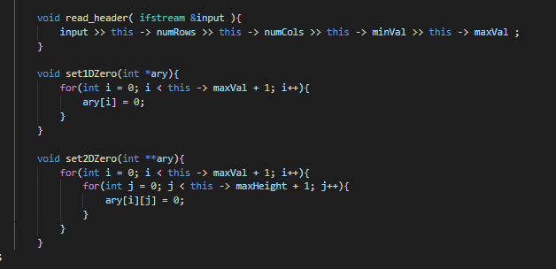

Outputs

Data 1 Output 1:

Histogram

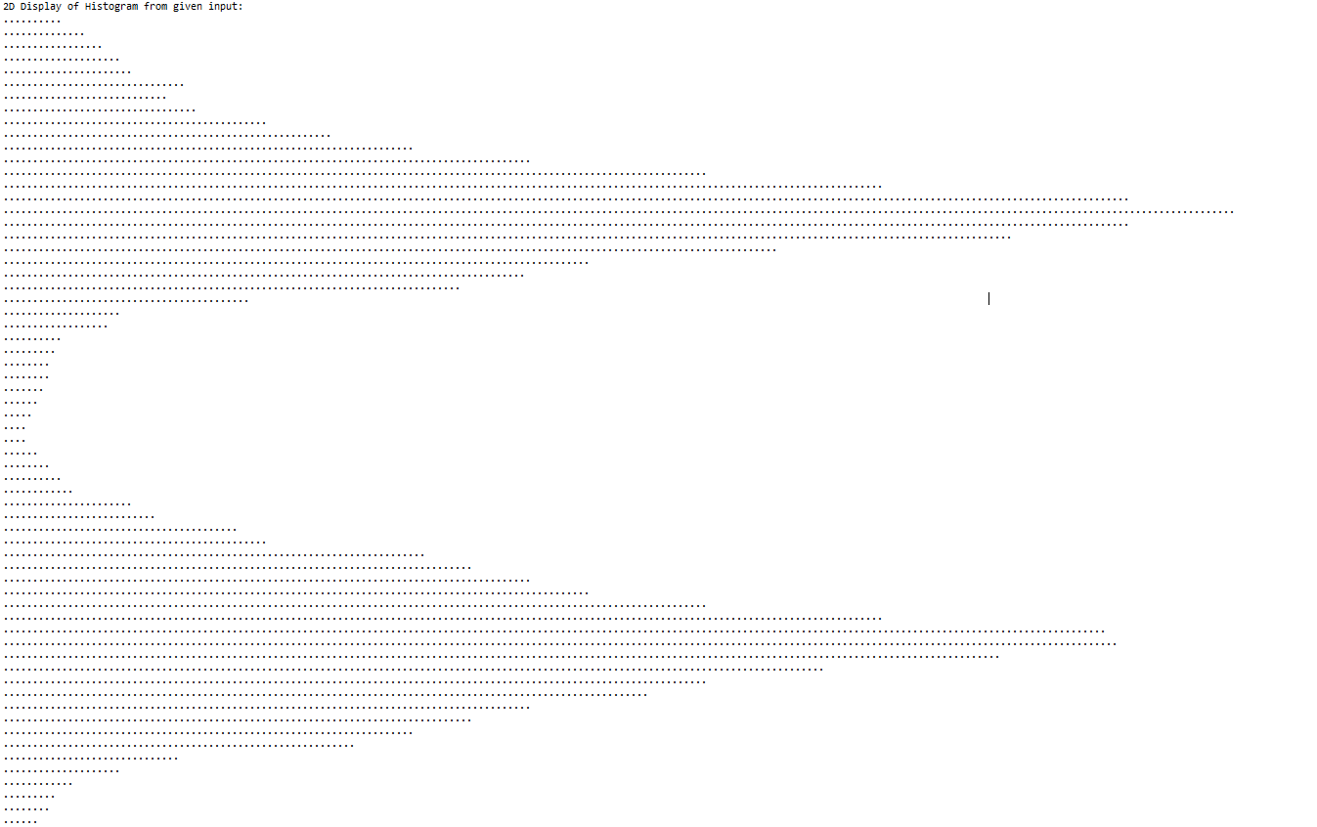

Best Fitted Plots

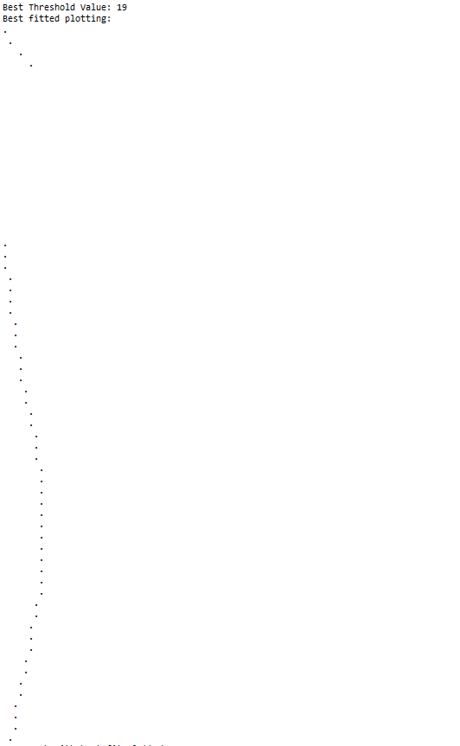

Gap Graph

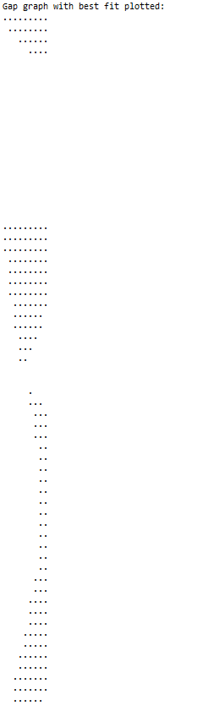

*Data 2 Output 1*

*Histogram*

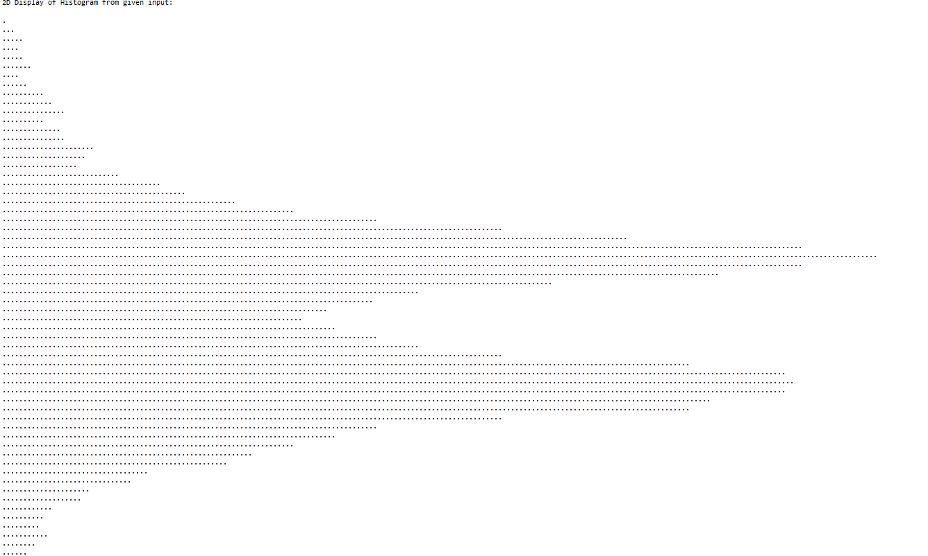

*Best Fitted Plot*

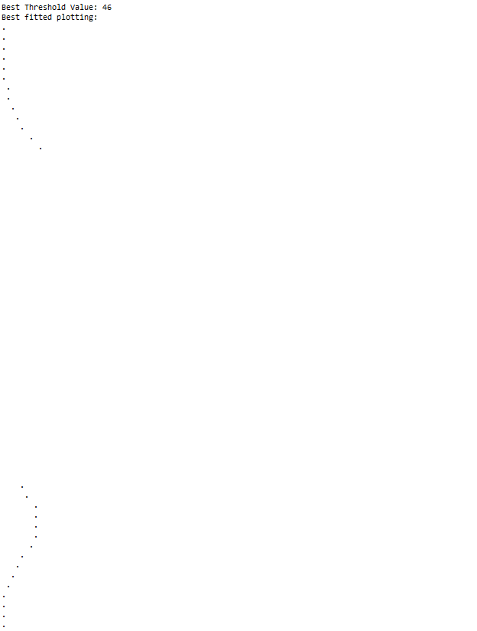

*Gap Graph*

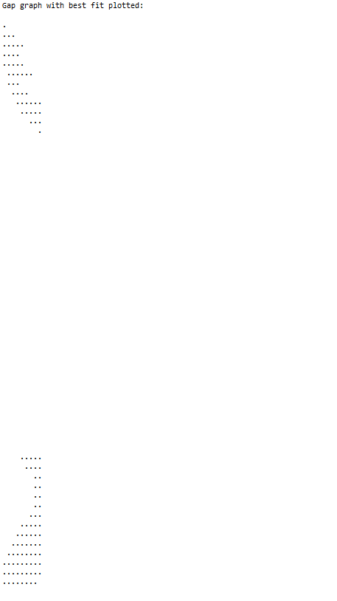

*Output 2 is hard to read on document, here is a link to my output files:*

[*Google Drive of Data 1 Output 2*](https://drive.google.com/file/d/1bGSYz-AibE7_bYlMX691J-kXf-tI4f7G/view?usp=sharing)

[*Google Drive of Data 2 Output 2*](https://drive.google.com/file/d/1iNEej2Ocr5I3JwxpSBXMa7WgvNiPcJId/view?usp=sharing)