Student: Simon Kong

Project Due date: 11/16/2021

Algorithm Steps

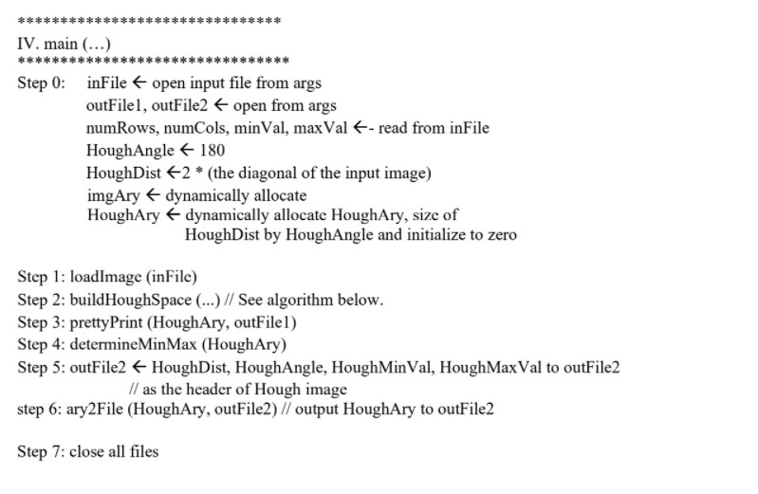

Source Code

*Main Class*

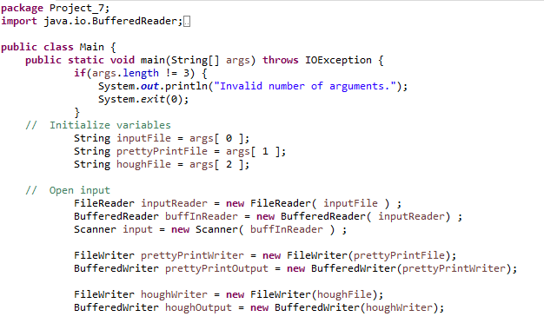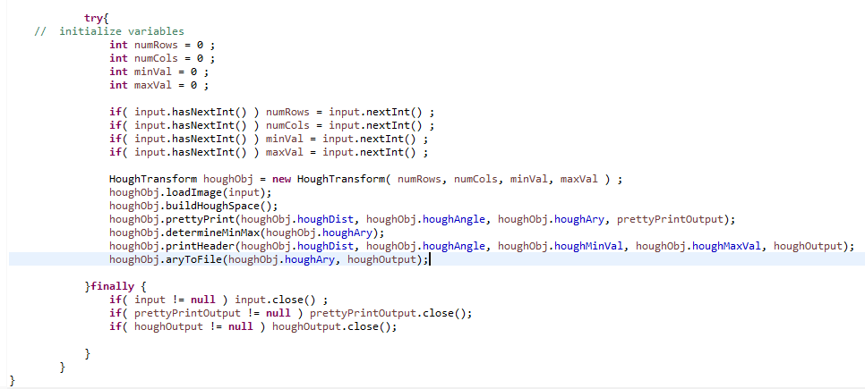

*HoughTransform*

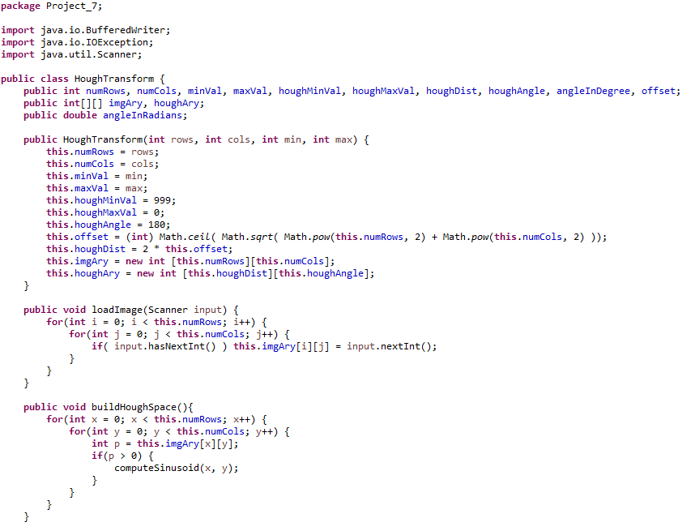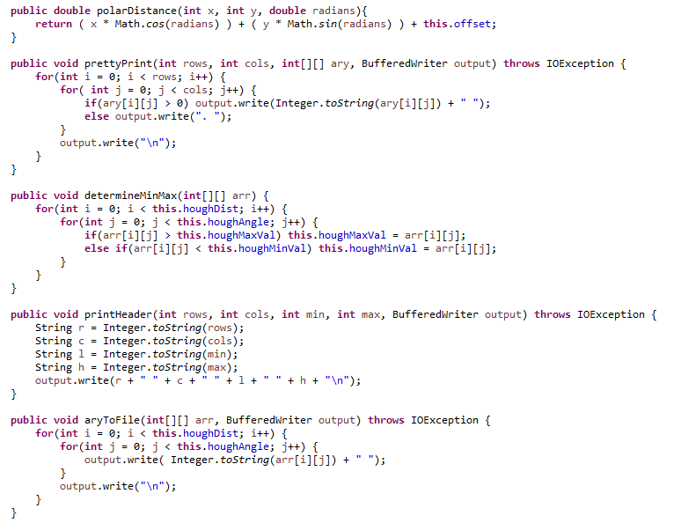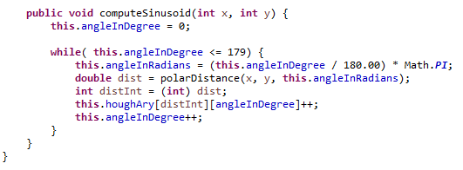

*Output Files*

**Output images are too large to be properly analyzed on Word. I have uploaded them to Google Drive for a better view.**

**Note: The image is not aligned properly if the values are greater than 9.**

**Note 2: Links have been tested using incognito mode.**

[Image 1 Pretty Print File](https://drive.google.com/file/d/1rkZW_nzJNIxcu3I4Nz42QmKAvaP_sm7l/view?usp=sharing)

[Image 1 Hough File](https://drive.google.com/file/d/1oX1tP93_3129XjjrJiIjm_i4v46lRBE5/view?usp=sharing)

[Image 2 Pretty Print File](https://drive.google.com/file/d/18k0MMOozhrW3rLNhzned8Qn6ZtW178nE/view?usp=sharing)

[Image 2 Hough File](https://drive.google.com/file/d/144licNRfdNTd1yG-QT-VEqhsMa1OGYf4/view?usp=sharing)

[Image 3 Pretty Print File](https://drive.google.com/file/d/10mMJd82pDWGSHDuJEUe1MkSNu33WfZUU/view?usp=sharing)

[Image 3 Hough File](https://drive.google.com/file/d/1pEGfmtIx_ogZ_5ZwzD04iKCg2ylhcqqr/view?usp=sharing)

[Image 4 Pretty Print File](https://drive.google.com/file/d/1lVPXC3ElNZeLmnFxuJqpcxjpYTKiy5lX/view?usp=sharing)

[Image 4 Hough File](https://drive.google.com/file/d/1aUto0OWO-oMnsufEFD7jPBWKzEMfDMfz/view?usp=sharing)

[Image 5 Pretty Print File](https://drive.google.com/file/d/1P8dUCdLYPN5nhjSfLumkWDZ2O_ToHEWM/view?usp=sharing)

[Image 5 Hough File](https://drive.google.com/file/d/1D2Z-rdw6v8BjWz6QuuuH2NLcKu4Zh7vW/view?usp=sharing)