Student: Simon Kong

Project Due date: 11/27/2021

Algorithm Steps

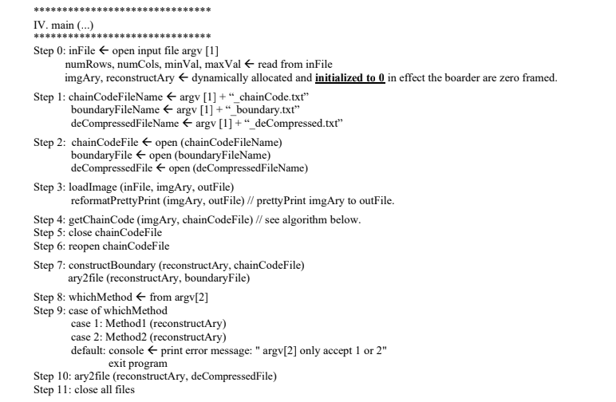

Source Code

*Main Class*

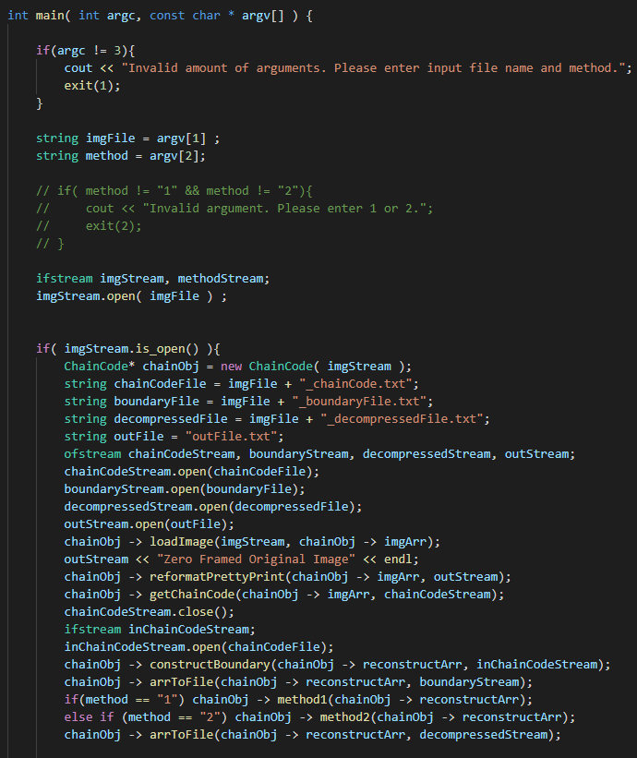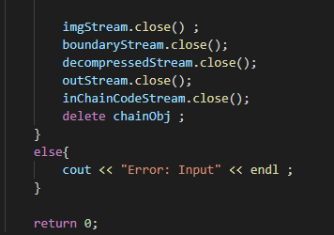

ChainCode

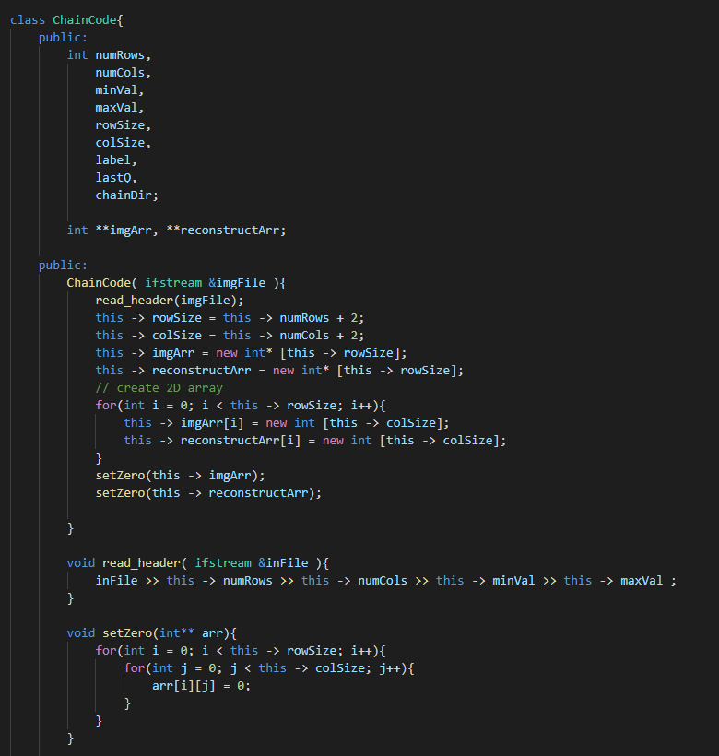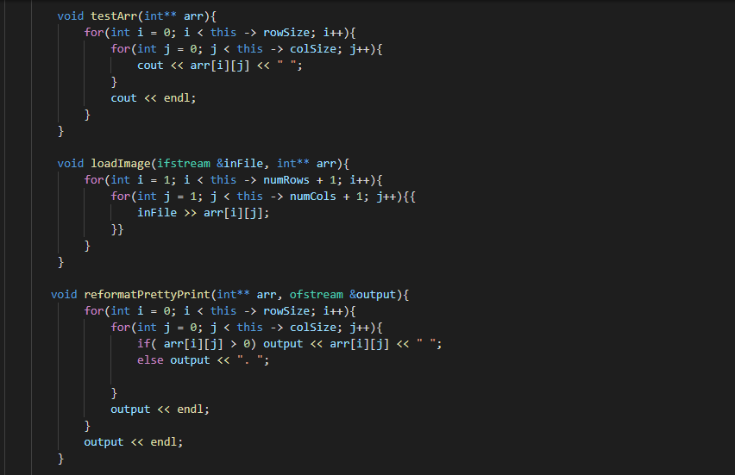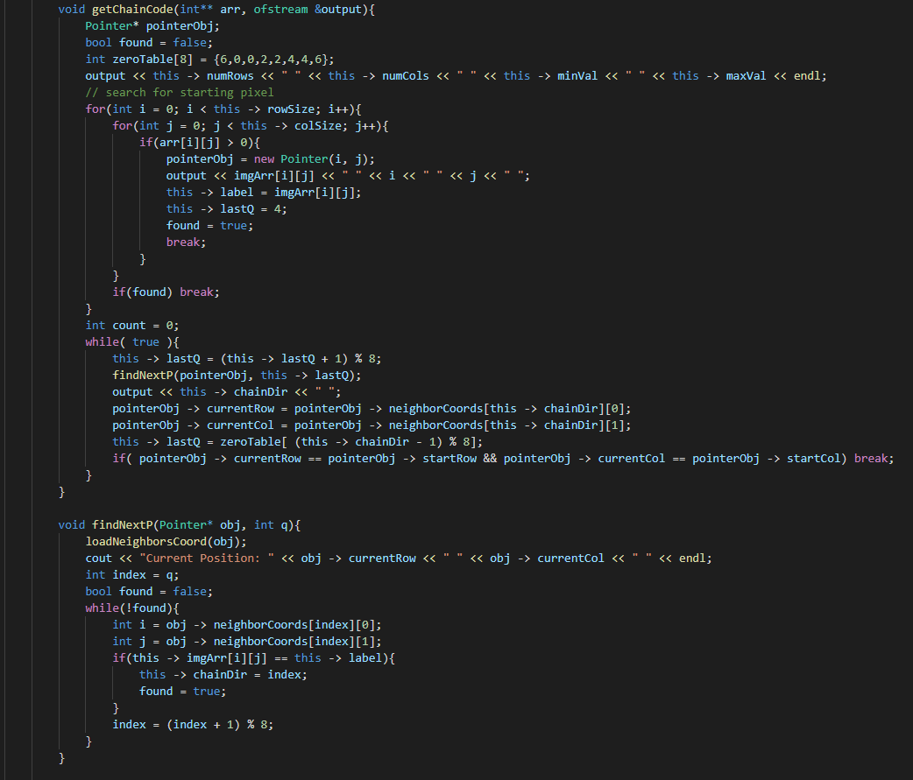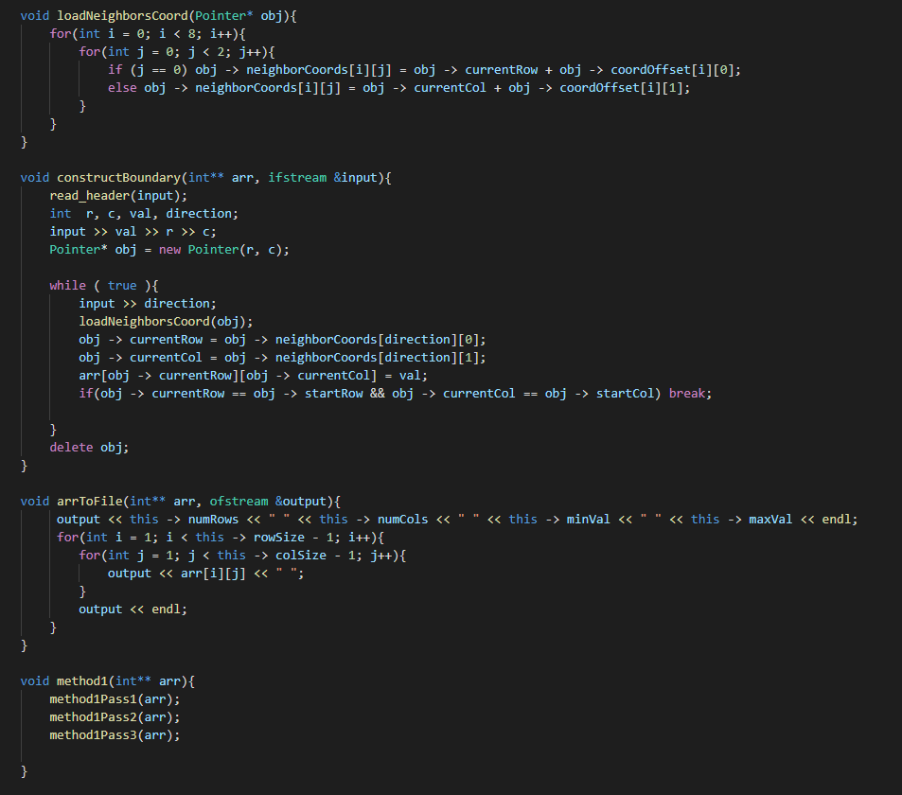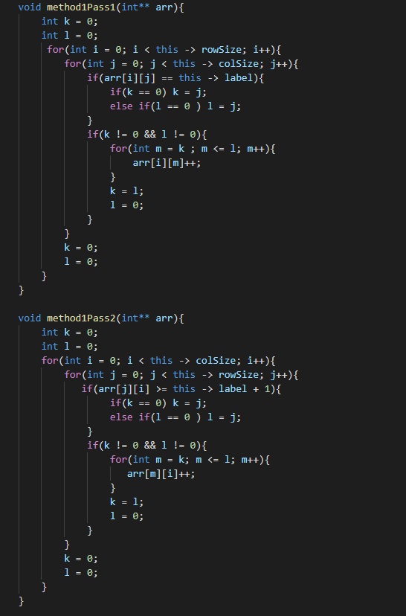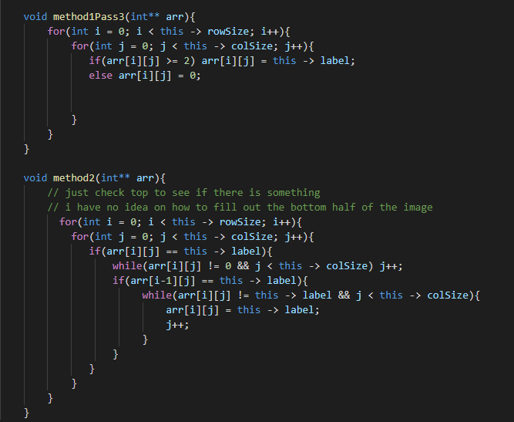

*Pointer*

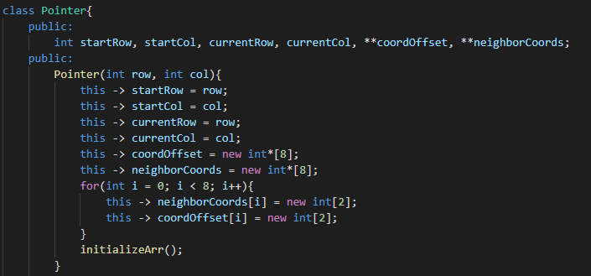

*Output Files*

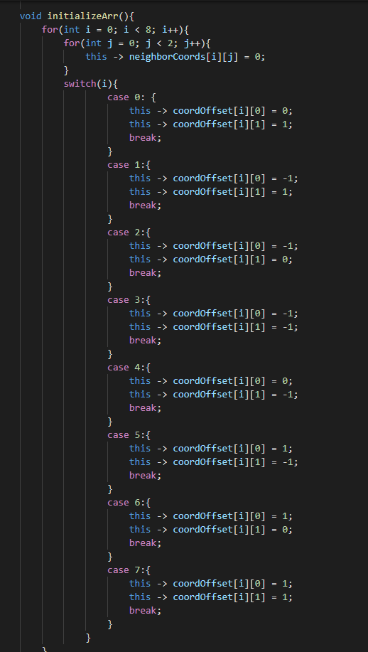

**Data 1**

*Output File (Pretty Print)*

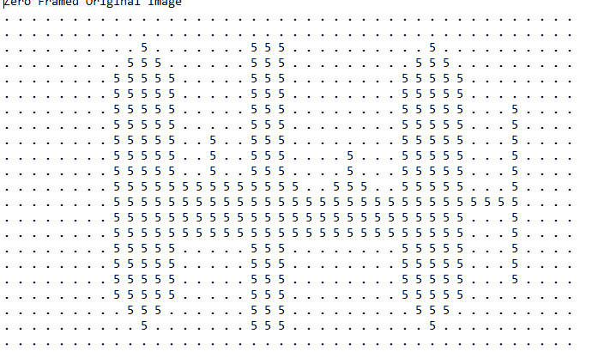

*Chain Code*

*20 40 0 5*

*5 2 10 5 5 6 6 6 6 6 6 6 6 6 6 6 6 6 6 7 7 1 1 2 2 2 1 0 0 0 0 7 6 6 6 6 6 0 0 2 2 2 2 2 1 0 0 0 0 0 0 0 7 6 6 6 7 7 1 1 2 2 2 2 2 1 0 0 7 6 6 6 6 2 2 2 2 2 2 2 2 2 2 2 6 6 6 6 6 5 4 4 3 2 2 2 2 2 2 2 3 3 5 5 6 6 6 6 6 6 6 5 4 3 3 2 6 5 5 4 3 3 2 2 2 2 2 2 2 2 4 4 6 6 6 6 6 6 6 6 5 4 3 2 2 6 6 5 4 3 2 2 2 2 2 2 3 3*

*Boundary File*

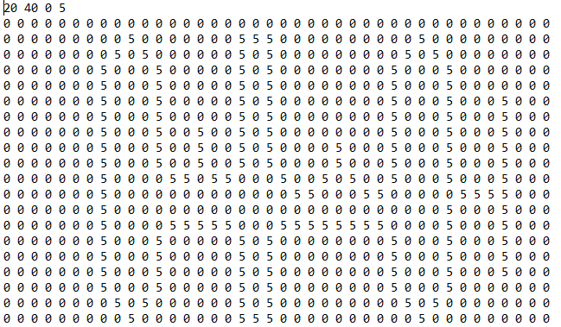

*Decompressed File Method 1*

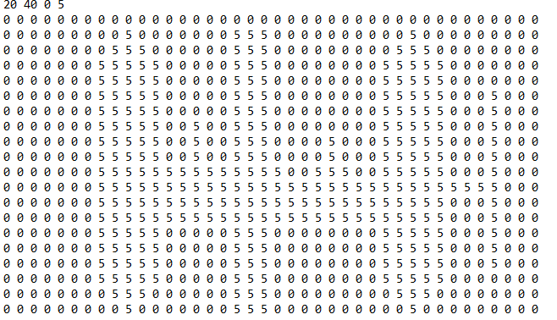

*Decompressed File Method 2*

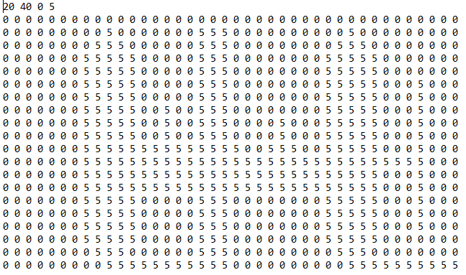

*Data 2*

*Pretty Print*

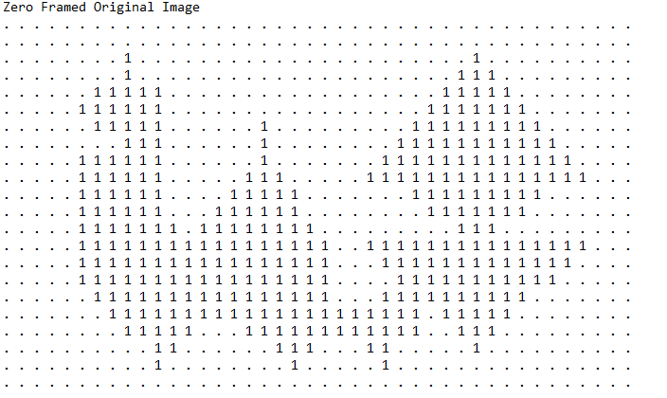

*Chain Code*

*20 40 0 1*

*1 2 8 6 5 4 5 7 0 7 5 4 4 6 6 6 6 6 6 6 7 7 7 0 7 6 1 1 1 0 0 7 0 7 7 1 1 0 0 7 7 2 1 0 2 1 7 7 7 1 1 1 1 0 1 1 4 4 4 4 4 3 1 0 1 1 0 0 3 3 3 3 3 3 3 5 5 5 5 5 5 5 0 0 7 7 0 7 5 4 4 4 4 4 7 7 5 5 4 4 3 2 2 2 3 3 2 3 3 2 2 6 6 5 5 5 5 5 3 3 2 2 2 2 2 2 2 4 3 2*

*Boundary File*

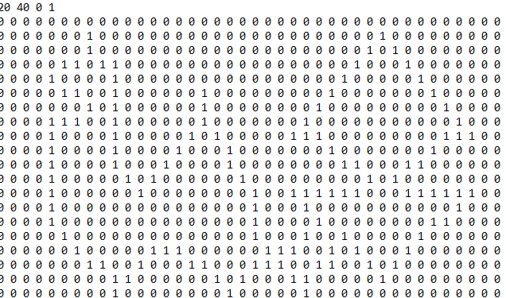

*Decompressed File Method 1*

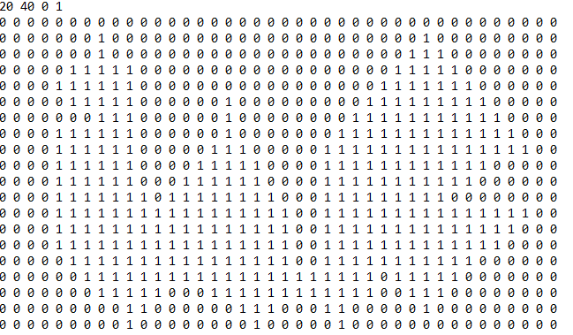

*Decompressed File Method 2*

