Student: Simon Kong

Project Due date: 12/8/2021

Algorithm Steps

1. Create DocImage and initialize all arrays to zero
2. Copy input data onto imgArr
3. Compute HPP and VPP
4. Output HPP and VPP to outputFile2
5. Threshold HPP and VPP using thrVal. Threshold version should be saved into HPPbin and VPPbin
6. Output HPPbin and VPPbin to outputFile2
7. Find zone box using HPPbin and VPPbin
8. Output zone box to outputFile2
9. Apply 1D morphological closing with mask of 1**1**1 to HPPbin and VPPbin. Save results onto HPPMorph and VPPMorph
10. Output HPPMorph and VPPMorph to outputFile2
11. Find document reading direction using HPPMorph and VPPMorph
12. Output reading direction to outputFile1
13. If Horizontal direction: find bounding box of text using HPPMorph

If Vertical direction: find bounding box text using VPPMorph

Insert bounding boxes onto queue.

1. Create Linked List of bounding boxes using queue
2. Output input data with bounding boxes applied to outputFile1
3. Output box type and box coordinates to outputFile2
4. Close all files

Source Code

*Box, BoxNode, DocImage Class*

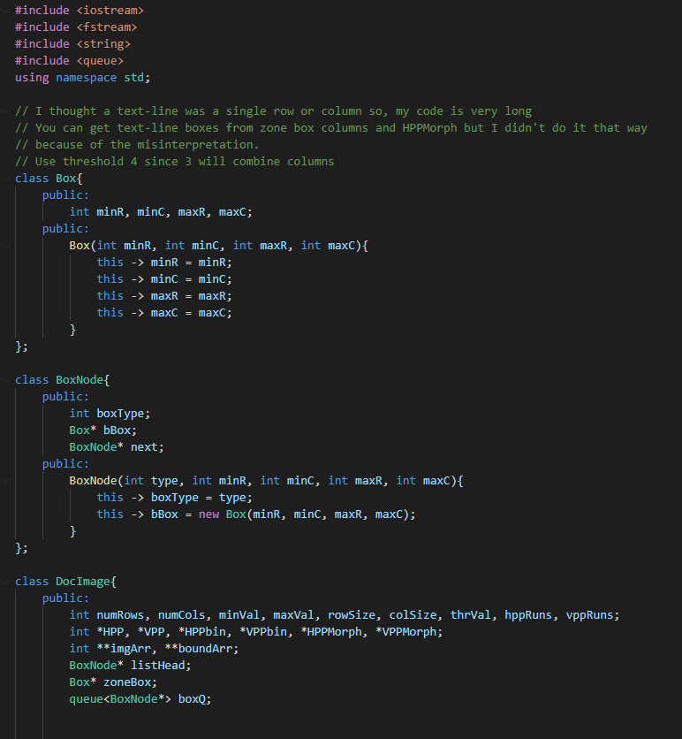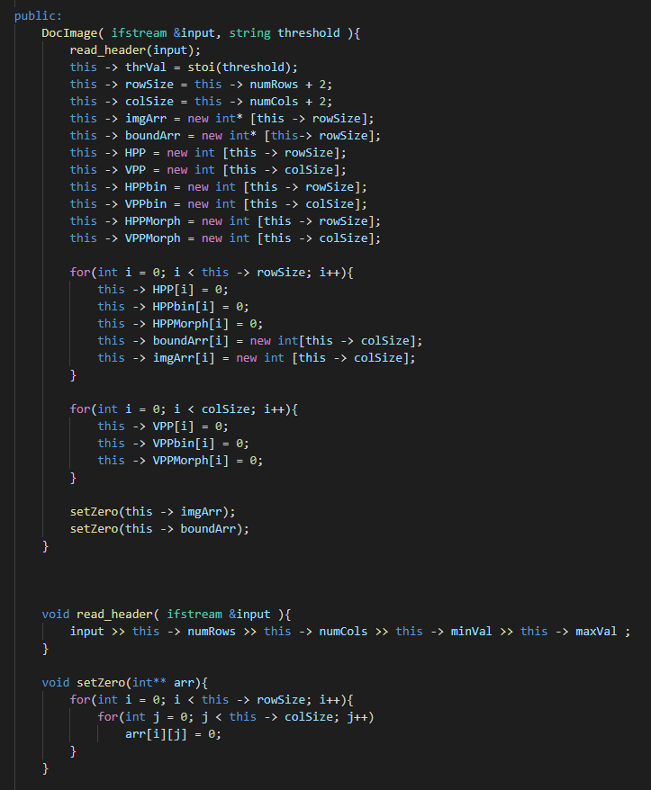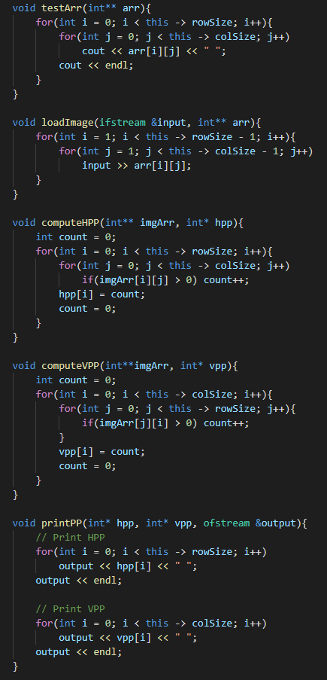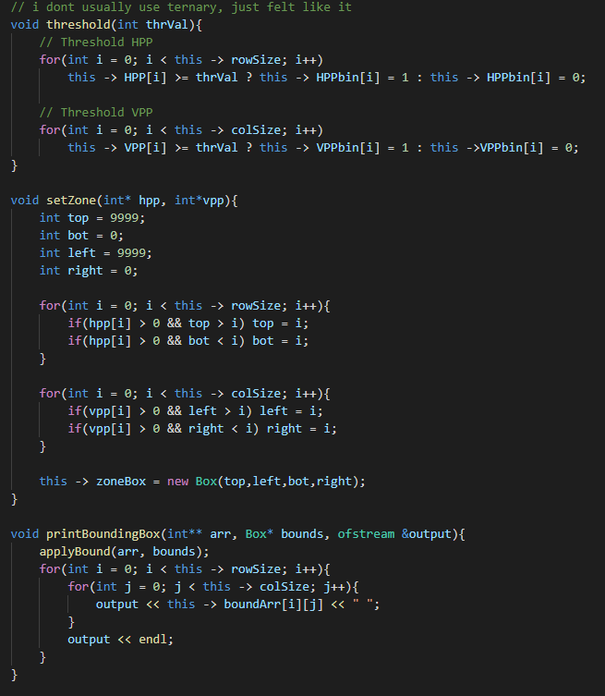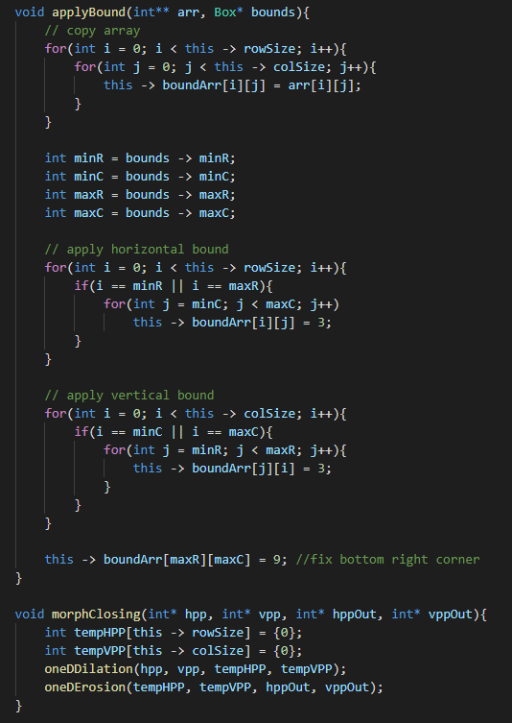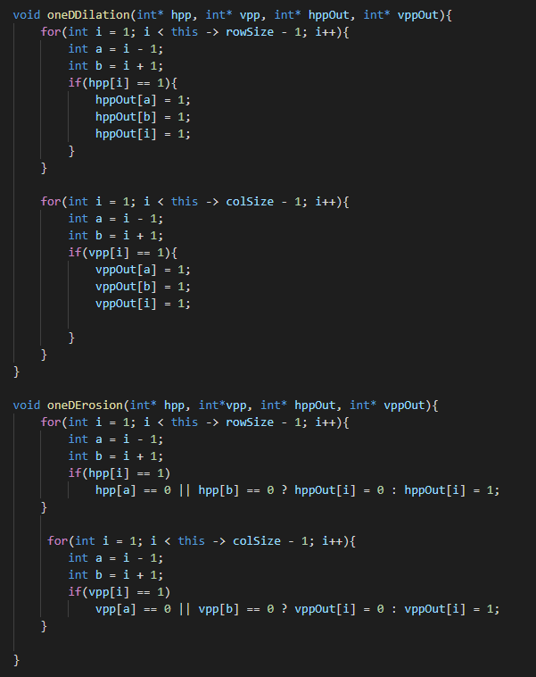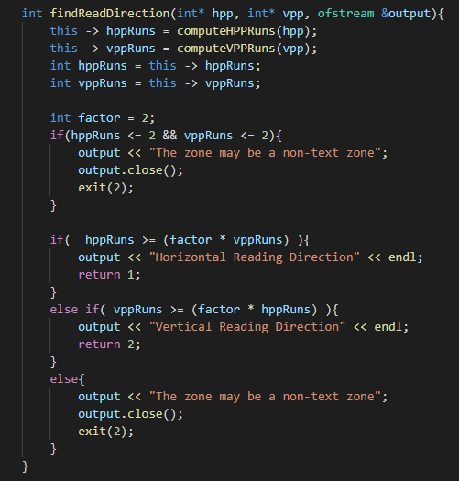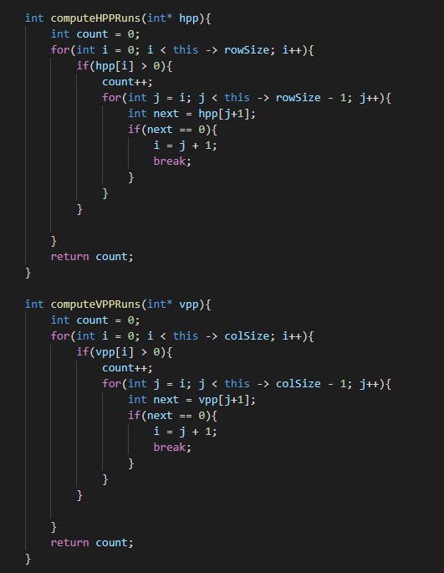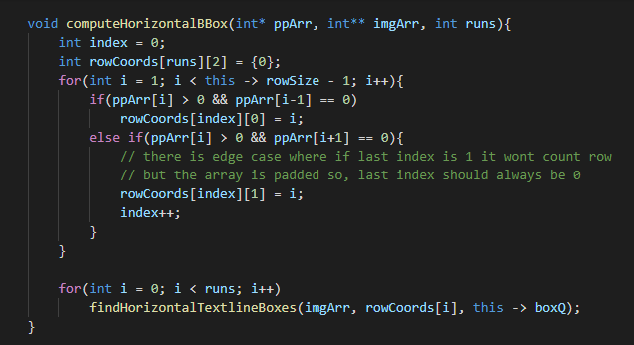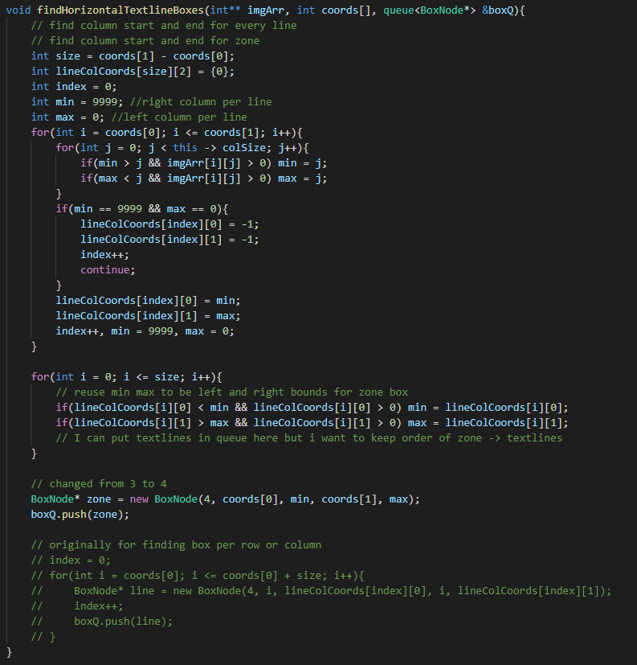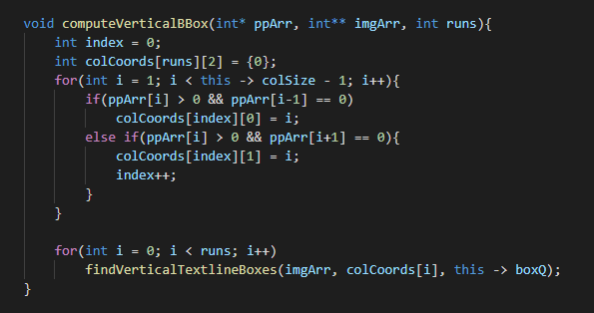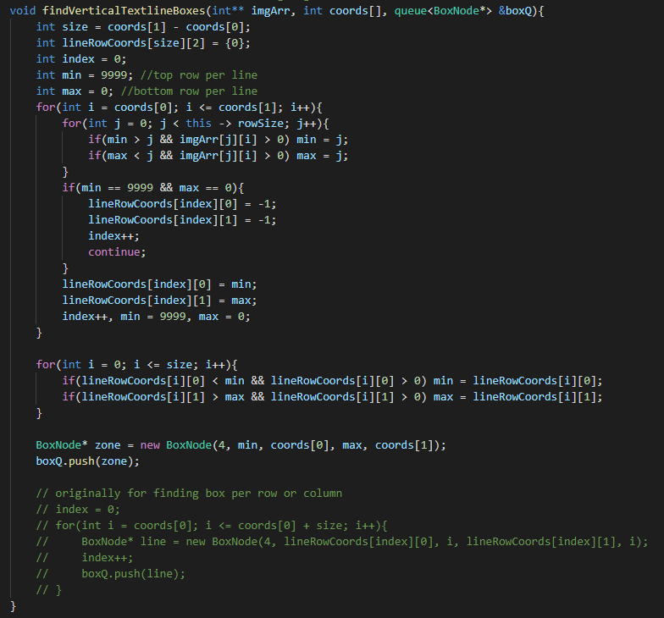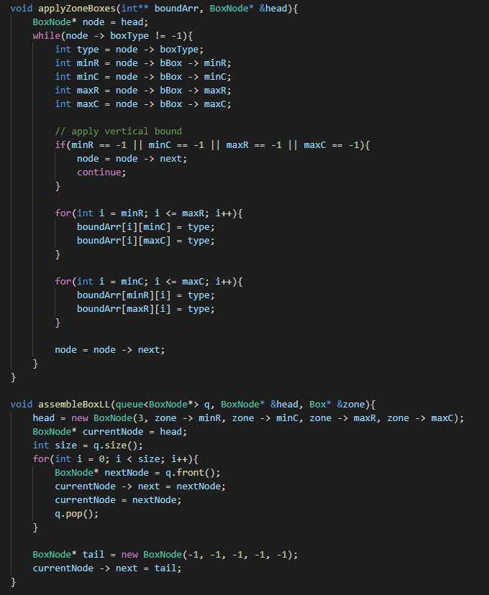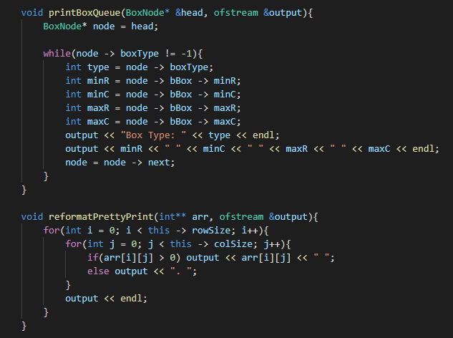

*Main Class*

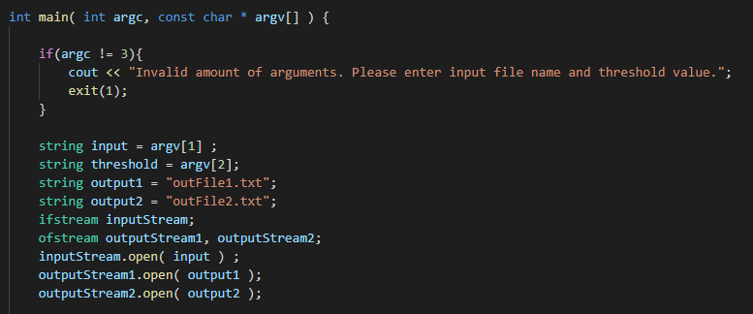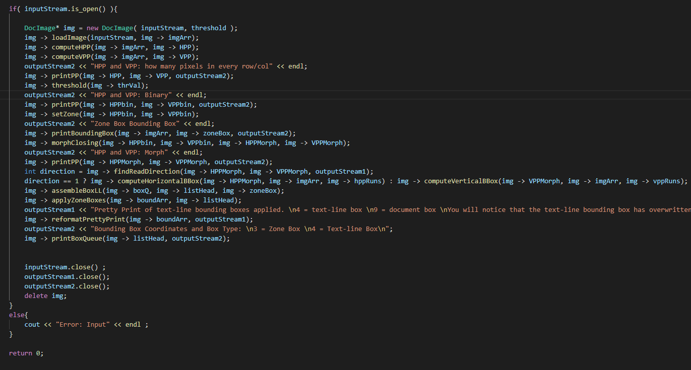

*Zone 1 Output 1 Threshold 4*

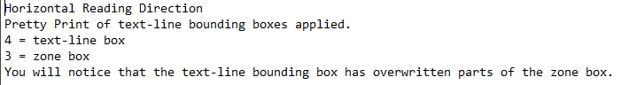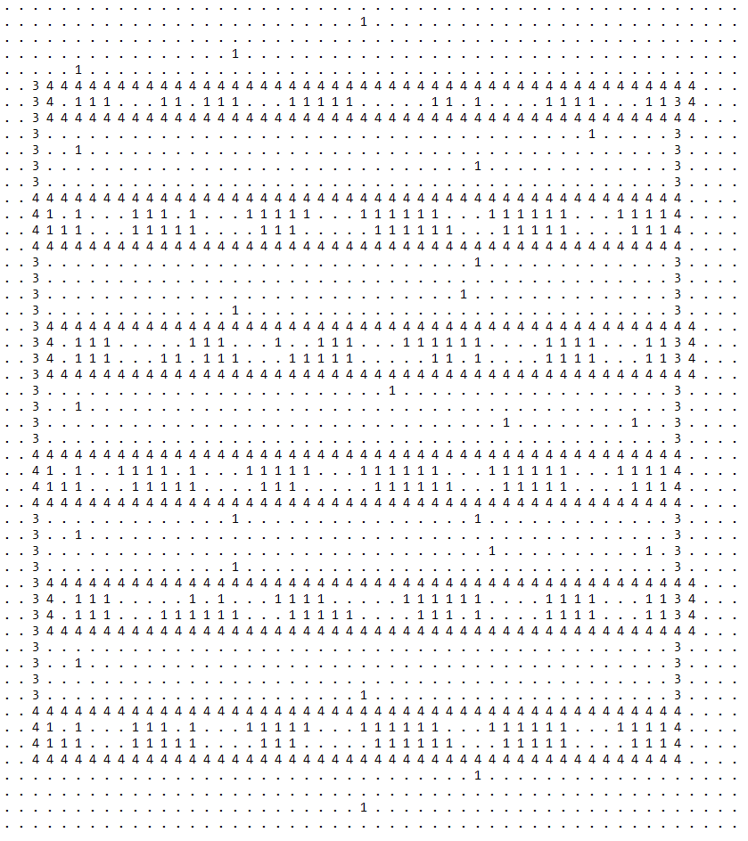

*Zone 1 Output 2 Threshold 4*

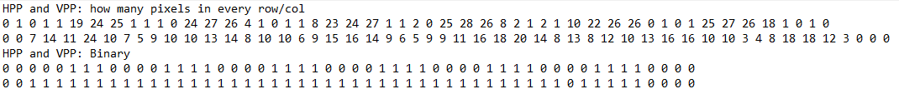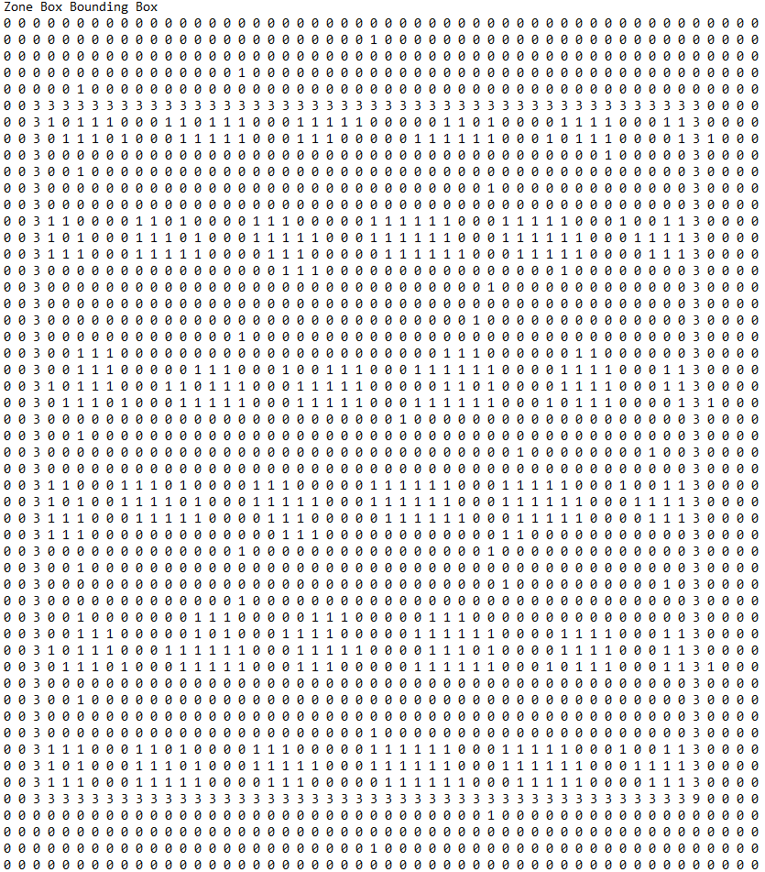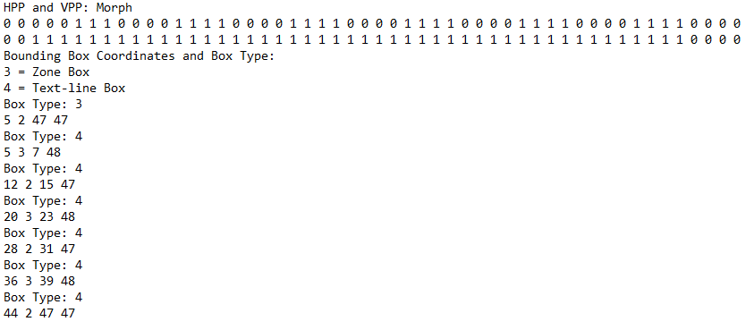

*Zone 2 Output 1 Threshold 4*

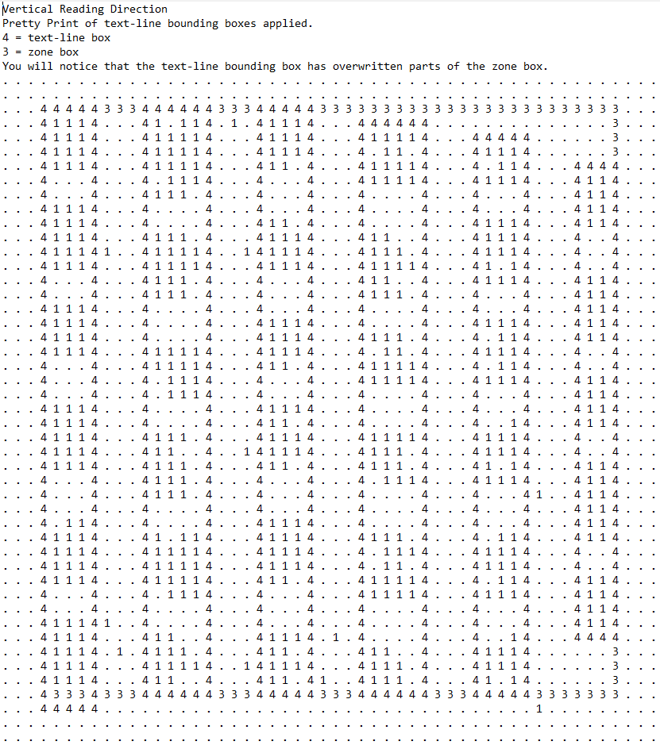

*Zone 2 Output 2 Threshold 4*

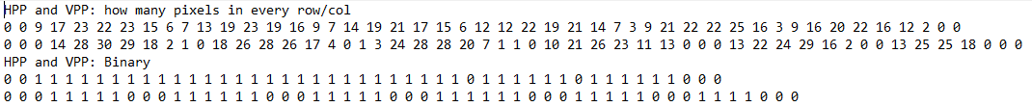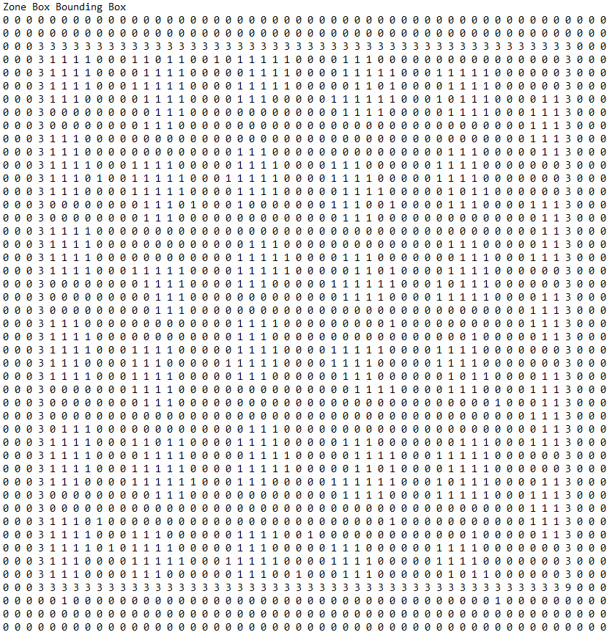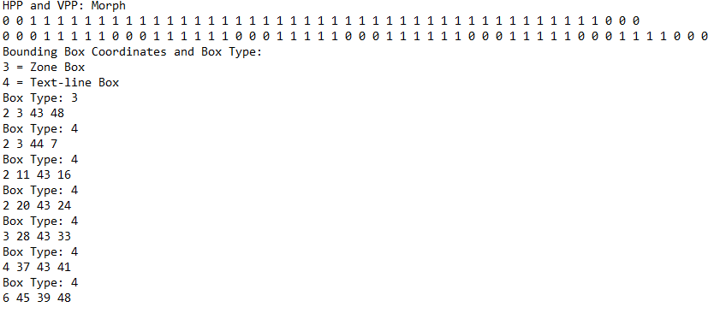

*Zone 3 Output 1 Threshold 4*



*Zone 3 Output 2 Threshold 4*

