# Introduction

In this Mini Project, you are required design and develop a single player 3D platformer level with challenges from “Fall Guys”. At the end of this development, you will need build the game into WebGL and upload to https://simmer.io/.

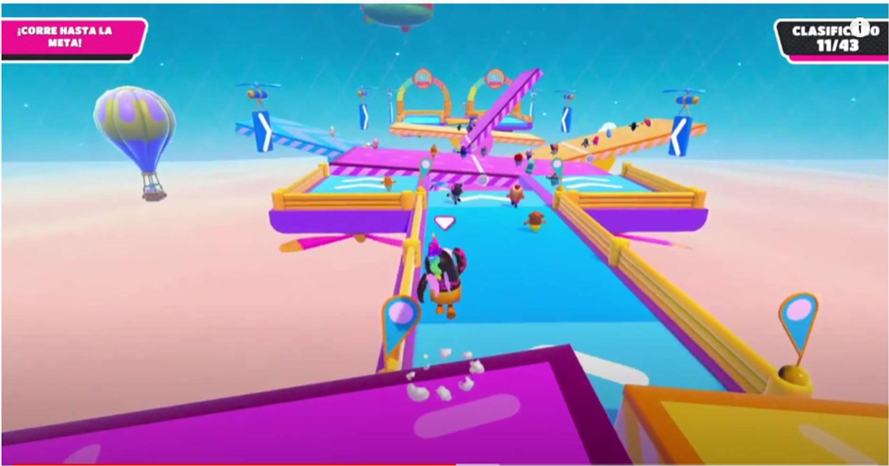

https://www.youtube.com/watch?v=Dys0UInmBsU

# Timeline

You are expected to have

* 3 weeks (individual project) OR
* 1 week (team of 4 person max) from 10th December 2020 till 18th December 2020

# Requirements

You must implement all codes in the project, you can refer to tutorials or previous assignments but not allowed to use codes or scripts from other packages.

# Documentation

* Use the given GDD structure below and fill up all the fields
* List down the obstacles (image) that you intend to implement in GDD

Assets

* You can download art assets.

# Game play

* Game level that at least for 2 minutes
* At least 3 different types of environment obstacles o Example: switches / moveable platforms / etc.
* Player’s ability
  + Move o Jump
* User interface o Menu scene o Game scene o Instruction scene o Credit scene
* Game must have both win and lose logic.
  + Win – When reached the end o Lose – When fall off the platform

# User interface

* Game must have UI.
* Game must instructions screen o How to play o Controls
* Game must have credit screen o List of assets used/downloaded o Source of reference/tutorial etc.

# Submission

Your submission should be no more than 1GB in size after zipped.

|  |  |
| --- | --- |
| 00_HanselKoh_WebGLProject |  |
| - 00_HanselKoh_GDD.doc | <Your GDD of this game> |
| - 00_HanselKoh_GameVideo.mp4 | <A video of you playing through the game> |
| * 00_HanselKoh_Source * 00_HanselKoh_Build | <Unity project folder> |
| o Exe | <Folder containing the executable file of the game> |
| o WebGL.txt | <URL of the game on simmer.io> |

Upload to MyConnexion (WebGL Project)

## Game Design Document

Name: Zack, Edmund, Lloyd, Kai Wen

Game title: Hollow Guys

Game description:

|  |
| --- |
| Get through the obstacle course. |

Controls and how to play:

|  |
| --- |
| WASD to move  SPACEBAR to jump |

List of Obstacles

|  |  |
| --- | --- |
| Obstacle (Reference) | Your Obstacle (Implementation) |
| Fall Guys Gate Crash guide – master the gate sequences |  |
| DESTROYED BY BIG BALLS | Fall Guys Gameplay - YouTube |  |
| Fall Guys Mid-Season Update Adds New Obstacles, A Huge Hammer, And  Anti-Cheat Measures - GameSpot |  |
| Does Fall Guys Support Cross-Platform Play? | Screen Rant |  |

List of camera features

|  |  |
| --- | --- |
| **Feature** | **Description** |
| Mouse movement | Camera moves according to mouse Y and X axis |

List of 3D models and animations

|  |  |
| --- | --- |
| **Model** | **Animations (if any)** |
| Player Model | 1. Idle 2. Run |

List of user interfaces

|  |  |
| --- | --- |
| **UI** | **Description** |
| Main Menu | Shows Play button and credit page button |
| Win/Lose Scene UI | Shows restart and return to Main Menu button |
| Restart Button | Shown when in game scene, to restart the current level |

Win or Lose condition

|  |  |
| --- | --- |
| **Type** | **Description** |
| Win Condition | Run into the rotating coin at the end of the obstacle course. |
| Lose Condition | Run out of lives |

Other unique features:

|  |
| --- |
| 1. Bouncing Walls  2. Moving Platforms  3. Moveable camera angles  4. Life HUD indicator |