Webshop Platform code CHECKOUT code
POST
JSON RESPONSE
Yes
GET
GET
No
GET
GET
HTTPSOCKET POST
products/view_cart action
products/checkout action
1) extract uuid indicating SESSION in database
2) create HttpSocket
3) HttpSocket POST to CHECKOUT > carts/add
4) Decision
orders/checkout
PAYPAL
products/view_cart webpage
carts/add action {
private function convertSessionDataIntoCartData {
Cart->prepareCartData
Cart->saveAll
}
return JSON
}
Paypal at Checkout Entry Point?
Yes
GET
syncAddressCustomerOrder
1) Order->convertCart
2) Order->saveForCheckoutStep1
GET
POST
orders/pay
orders/checkout action

orders/checkout webpage
From Paypal?
No
1) extractShippingDetails
2) syncAddressCustomerOrder
1) Cart->findByHash
2) display as webpage
GET
POST
GET
Yes
orders/pay

orders/pay webpage
PAYPAL
Paypal at Entry Checkout?
No
Order->findByHash
Show all
payments
Show 1
payment
Paypal at Entry Checkout?
Yes
No
Payment->save
GET
GET
orders/success action

PAYPAL
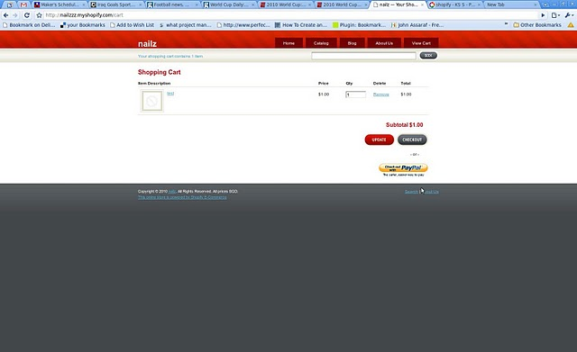

Goes to products/checkout action via POST

Fig 1. Products/view_cart view aka the cart page
This is for customers to view cart items and proceed to checkout

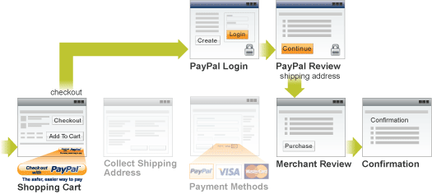

Fig 2. Paypal at Entry Checkout Point

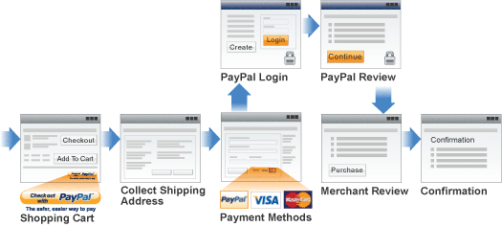

Fig 3. Paypal at Payment Option Point

