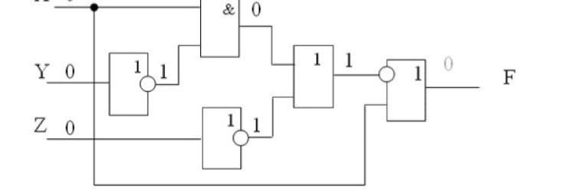

|  |  |  |  |
| --- | --- | --- | --- |
| X | Y | Z | F |
| 0 | 0 | 0 | 0 |
| 0 | 0 | 1 | 1 |
| 0 | 1 | 0 | 0 |
| 0 | 1 | 1 | 1 |
| 1 | 0 | 0 | 1 |
| 1 | 0 | 1 | 1 |
| 1 | 1 | 0 | 1 |
| 1 | 1 | 1 | 1 |