**EY ASSIGNMENT**

**To-Do List Application**

**Overview:**

This document describes the design working of basic To-Do list application using which a user can track his/her To-Do activities for the day. A basic login form & a display of to do grid has been implemented using Angular & Spring boot technologies.

**Technologies used:**

Front End: Angular 10

Back End: Java, Spring Boot, H2 Db

Source Code: Git

**Design:**

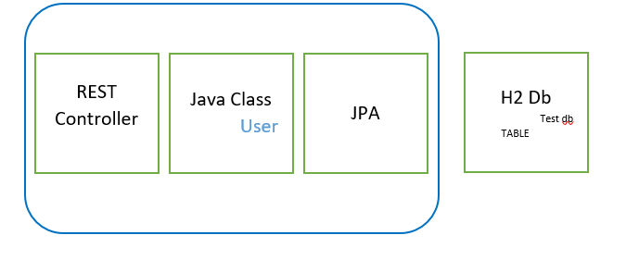

**DB**

**APPLICATION**

**POST/GET**

**RESPONSE**

**Customer Data**

ToDo

* MVC Design & Observer pattern are used

**Functionalities Implemented are as below:**

|  |  |
| --- | --- |
| **Requirements** | **Status** |
| * User can sign in using unique login and password securely (this can be hard coded to a default user list, at list one user e.g. with username: test, password: pwd123) | Completed |
| * User can view her/his task list | Completed |
| * User can add/remove task | Completed |
| * All changes can be persistent to allow view them in next sign in by the same user | Completed |
| * Each task should display the date of last updates and description | Available in database, data display is in progress |
| * User can check/uncheck any task on their list | In progress |

**GUI:**

Login – Basic login validations for user id & password is implemented. Once the user logs in using credentials (test1,pwd456), to-do list for that user will be displayed.

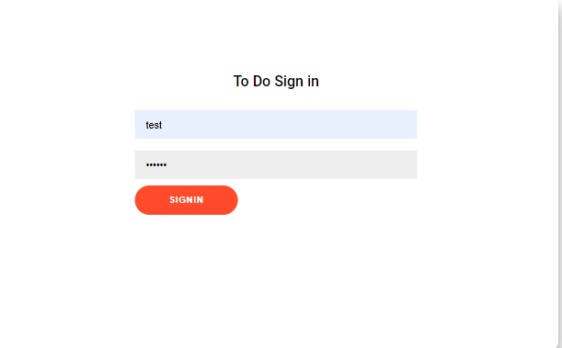

User can add a new activity, select and remove an existing activity or update a new activity.

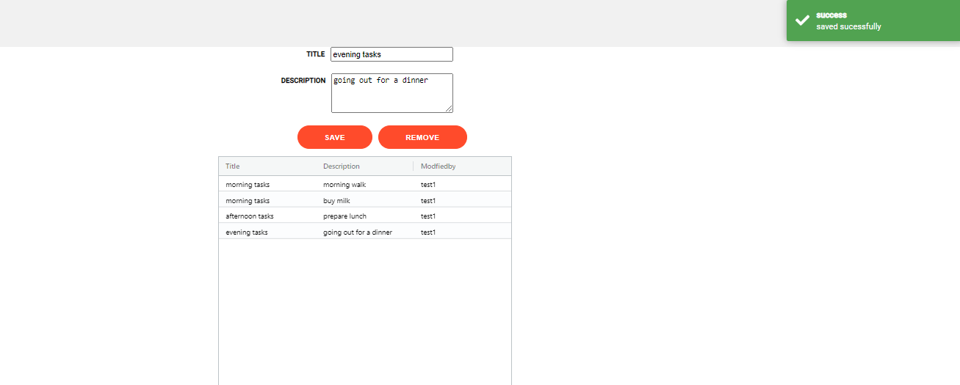

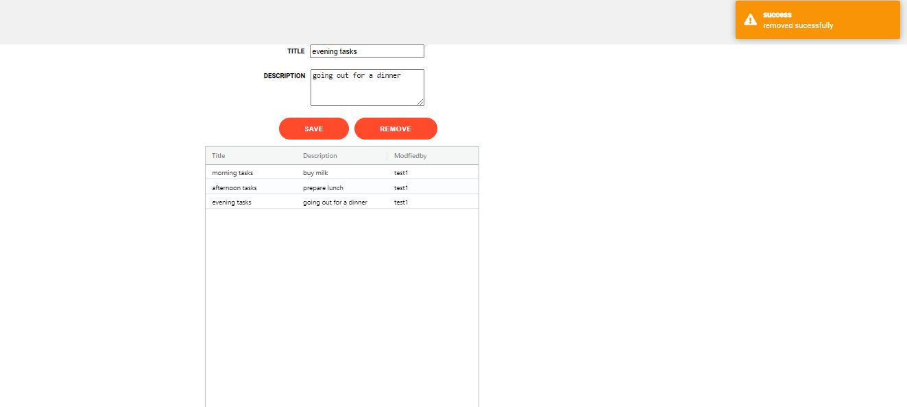

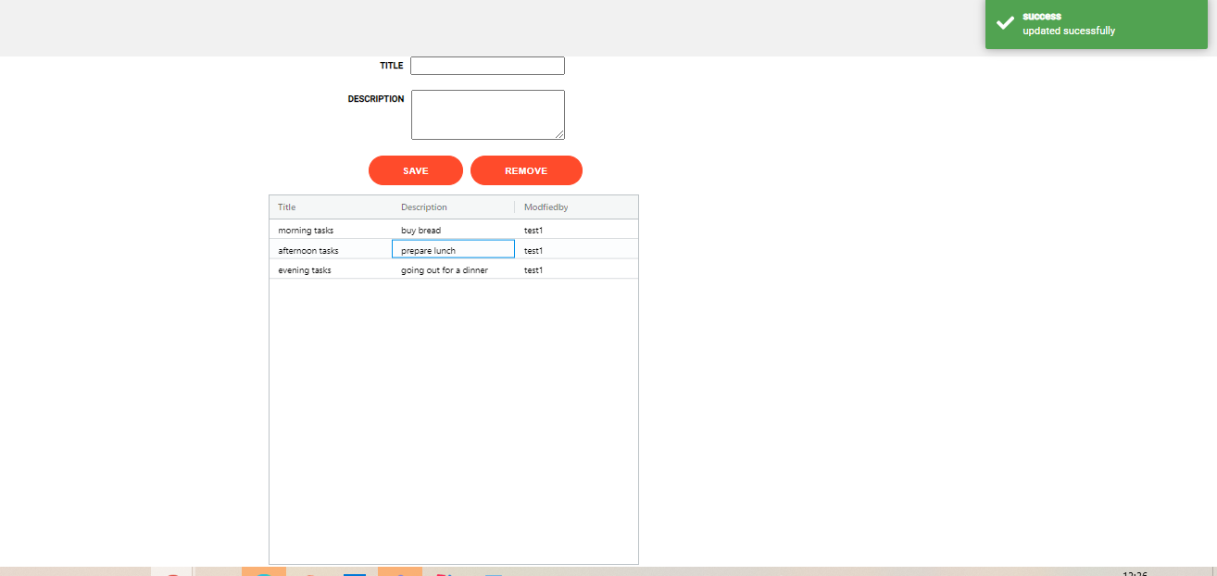

**Testing:**

Unit test cases are as below:

**Future work scope:**

1. Use of Spring security and AUTH2.0 for authentication & authorization
2. Controller Advice for exception handling
3. Implement calendar and select a date to view the to-do of that day
4. To Do – summary for each user with count of completed and pending tasks
5. Sending email notifications for completion
6. Better Look & Feel