Simlexx Wealth
Database Design & System Architecture

Simlexx is a digital financial progress platform that connects people with variable incomes to regulated investment providers (unit trusts, money market funds). This document covers the database schema implemented so far, the reasoning behind key design decisions, and the overall system architecture backing the API.

1. Overview
The backend is a FastAPI application backed by PostgreSQL (via SQLAlchemy's async ORM and the asyncpg driver), Redis (cache, plus Celery broker/result backend), and a Celery worker for background jobs. Schema changes are tracked with Alembic migrations rather than ad-hoc table creation, and the whole stack runs via Docker Compose for local development, with a GitHub Actions CI pipeline validating migrations and the Docker build on every pull request into dev and production.

2. Database Design

2.1 Primary key strategy
Every table uses a short, randomly generated string as its primary key instead of an auto-incrementing integer or a full UUID. The generator (app/model/generator.py) takes a uuid4, splits it on its hyphens, and concatenates two of the segments into a 16-character hex string:
def id_generator():
id_gen = str(uuid.uuid4()).split("-")
return id_gen[2] + id_gen[4]
This was a deliberate choice over a full 36-character UUID: it keeps IDs short while still drawing from UUID4's randomness, at the cost of fewer bits of entropy (64 bits vs. 128). Because it produces a plain string rather than a database-native UUID, every id column is typed as SQLAlchemy String, not the Postgres UUID/Uuid type.

2.2 Tables
Ten tables are currently defined in app/model/models.py:
Table | Purpose
Users | Core account record: phone/email, auth provider, account status, profile verification status, last login.
MoreAboutUsers | KYC / profile detail for a user: identity, address, profession, ID document type/number/expiry, verification status.
UserAccount | The single linked bank account per user: bank name, account number, balance, supporting account document reference.
UserAuthMFA | One row per user holding every multi-factor method they've enabled, stored as an array, plus a top-level enabled/disabled flag.
OtpVerification | One row per OTP code sent to a user over email, SMS, or WhatsApp: the code, expiry, verification time, and attempt count.
UserGoals | A savings/investment goal: target amount, running current amount, target date, linked product, status, onboarding flag.
Products | Catalog of investment products offered through partner providers: company, product name/type, minimum investment, active flag.
Transaction | A deposit or withdrawal: amount, type, status, the account and (optionally) the goal it's tied to, bank/unit-master references, and a failure reason if it failed.
Notifications | An outbound notification sent over SMS/WhatsApp/email: channel, delivery status, read status.
SystemLogs | Audit trail: who (nullable, for system-triggered actions) did what action to which entity, when, and from which IP.

2.3 Relationships
All relationships are enforced with real foreign keys and paired SQLAlchemy relationship() declarations (not just loose columns):
- Users ↔ MoreAboutUsers — one-to-one (unique FK on MoreAboutUsers.user_id)
- Users ↔ UserAccount — one-to-one (unique FK on UserAccount.user_id)
- Users ↔ UserAuthMFA — one-to-one (unique FK on UserAuthMFA.user_id)
- Users → OtpVerification — one-to-many
- Users → UserGoals — one-to-many
- Users → Transaction — one-to-many
- Users → Notifications — one-to-many
- Users → SystemLogs — one-to-many (nullable FK, for system-initiated entries)
- UserAccount → Transaction — one-to-many (every transaction belongs to exactly one account)
- Products → UserGoals — one-to-many (a product can back many users' goals; product_id is nullable since a goal can exist before a product is chosen)
- UserGoals → Transaction — one-to-many, optional (goal_id is nullable, so a "general" account deposit/withdrawal not tied to a specific goal is allowed)

2.4 Enum-backed fields
Rather than free-text status columns, the categorical fields below use Postgres-native enum types (app/model/mod_enum.py), so invalid values are rejected at the database level:
Enum | Values | Used by
AuthProvider | firebase_google_signin, firebase_email_password, phone_number_login | Users.auth_provider
MultifactorAuth | biometric_enable, email_verification, phone_verification, whatsapp_verification | UserAuthMFA.mfa_methods (array)
UserAccountStatus | pending, rejected, approved, disabled | Users.status, Users.profile_verification_complete, MoreAboutUsers.profile_verification_complete
NotificationChannel | sms, whatsapp, email | OtpVerification.channel, Notifications.channel
NotificationStatus | pending, sent, failed | Notifications.status
TransactionType | deposit, withdrawal | Transaction.type
TransactionStatus | pending, completed, failed | Transaction.status
GoalStatus | ongoing, completed, terminated, reopened | UserGoals.goal_status
ProductType | unit_trust, money_market_fund | Products.product_type

2.5 Entity-relationship diagram
The diagram below reflects the schema exactly as implemented in app/model/models.py (table names in parentheses show cases where the Python class name and the actual SQL table name differ, e.g. class Transaction maps to table "transactions").
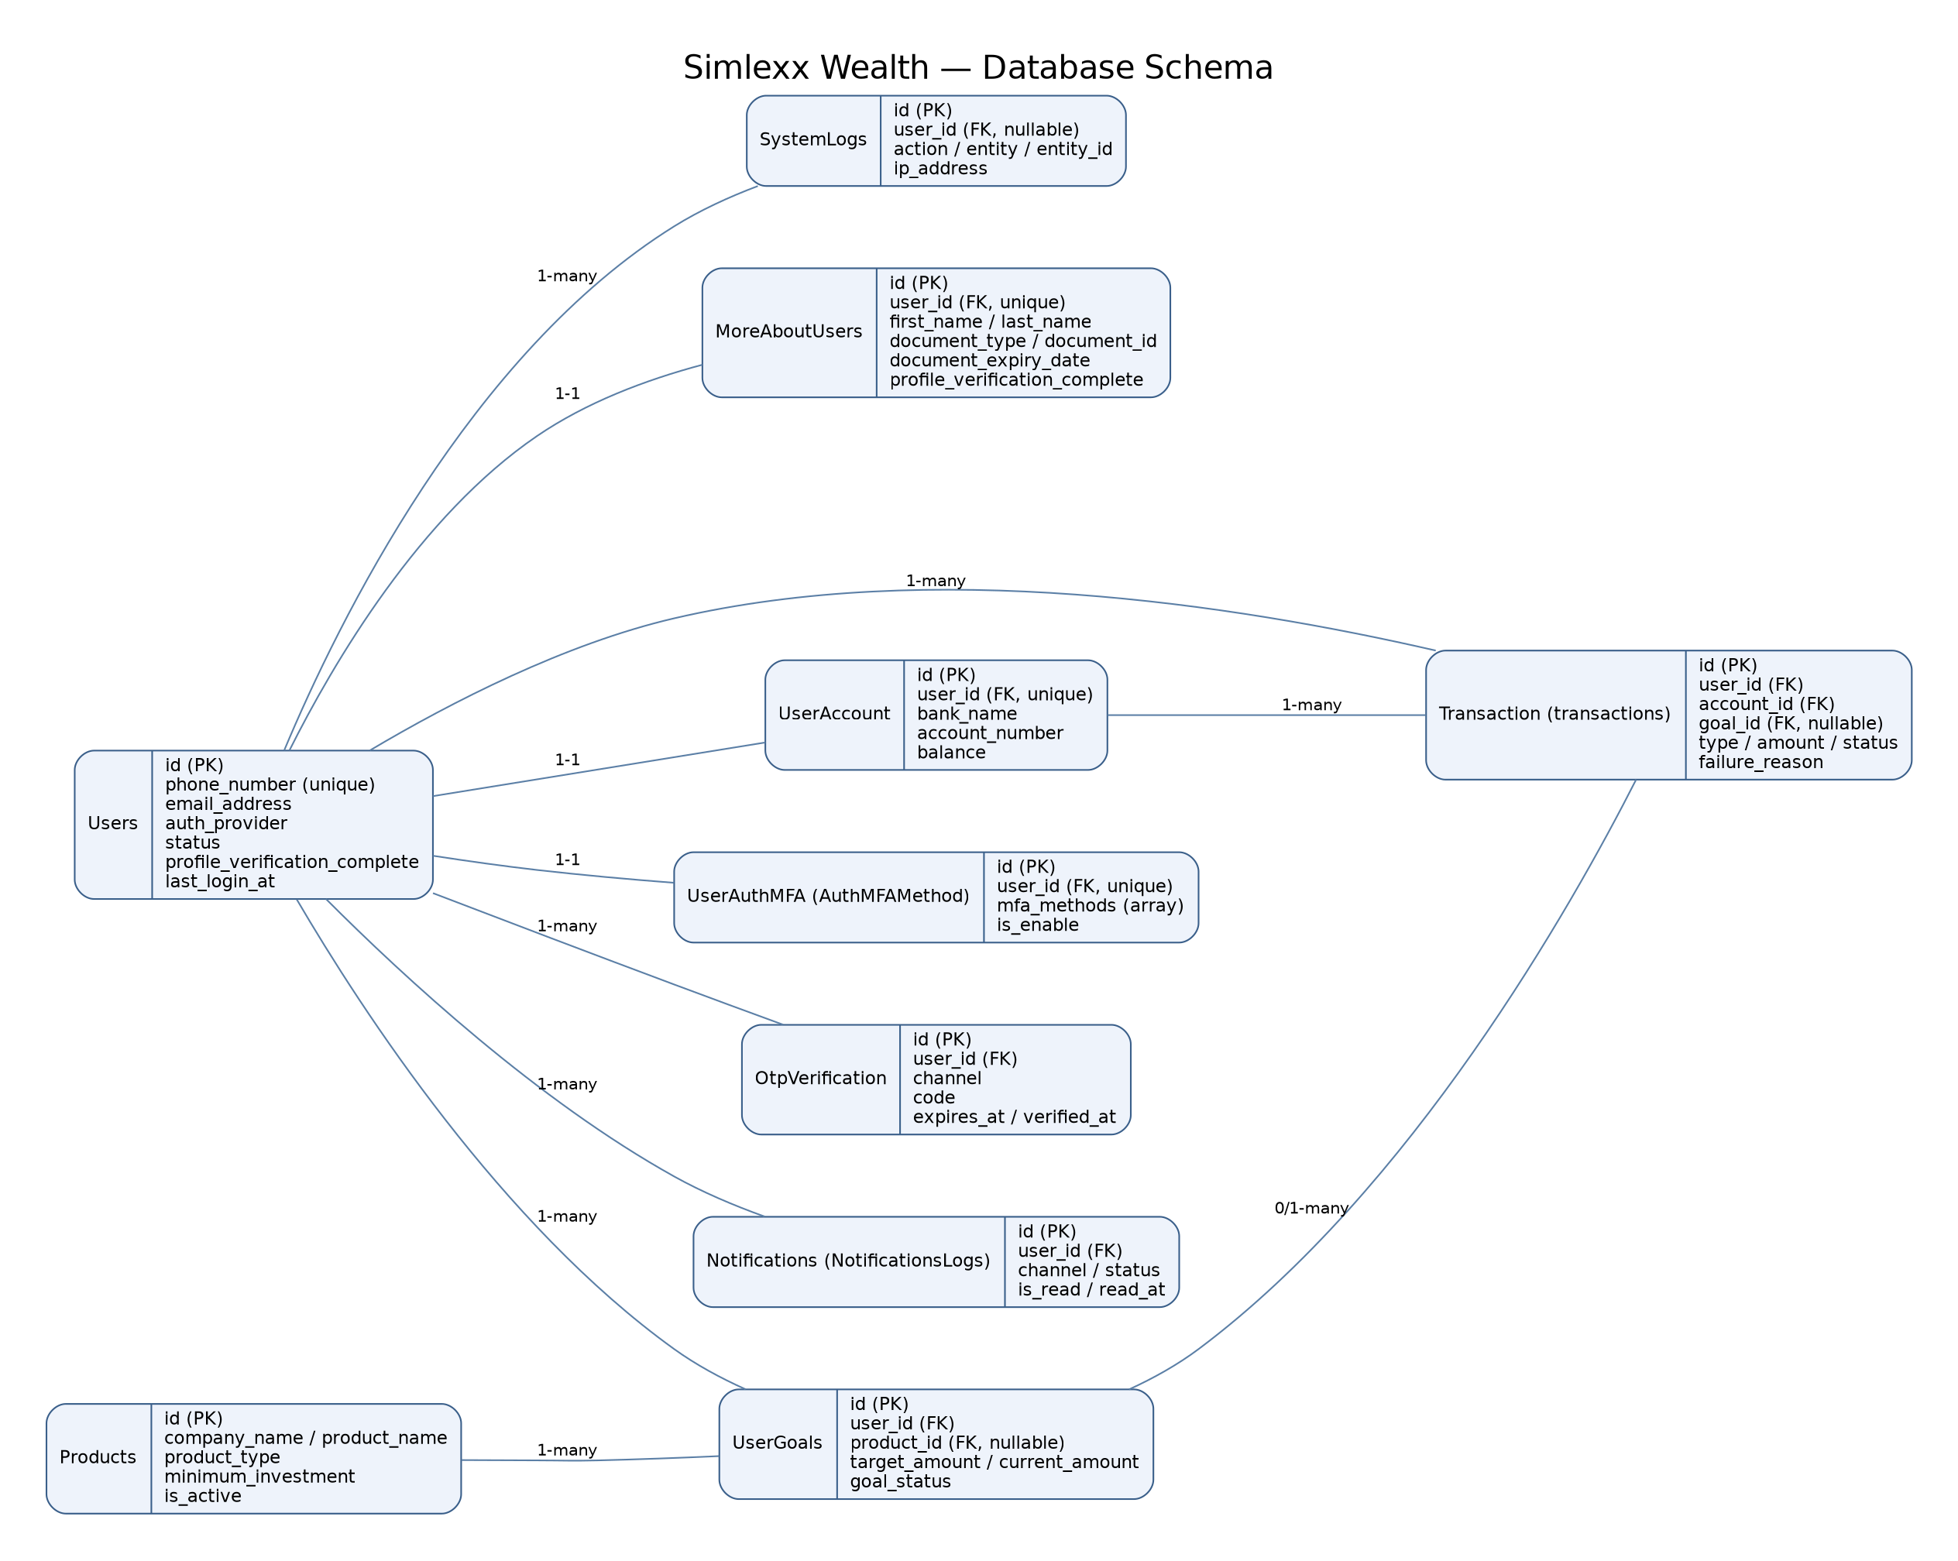

2.6 Migrations (Alembic)
Schema changes are managed exclusively through Alembic, using the async template (alembic init -t async). A few things worth calling out about the setup:
- alembic/env.py reads the database URL directly from the app's own Settings object (get_settings().DATABASE_URL) rather than duplicating a connection string in alembic.ini — one source of truth for both the app and migrations.
- The URL is passed straight to create_async_engine(), bypassing config.set_main_option()/configparser entirely. This matters because configparser treats "%" as its own interpolation syntax — a percent-encoded character in a password (e.g. "%40" for "@") would otherwise raise "invalid interpolation syntax" and silently block every migration.
- target_metadata is wired to app.model.Base.metadata, so "alembic revision --autogenerate" picks up every model automatically.
- At API startup (app/startup.py), the app runs "alembic upgrade head" itself (via Alembic's Python command API, in a background thread) rather than calling SQLAlchemy's Base.metadata.create_all(). create_all() only adds missing tables — it never alters existing ones and has no notion of migration history, so mixing it with Alembic risks a schema that's structurally complete but has no row in alembic_version, causing later migrations to conflict with tables that already exist.
- Running migrations from app startup is fine for a single instance; once there are multiple API replicas, migrations should move to a separate one-off deploy step so replicas don't race to migrate simultaneously.

3. System Architecture
The stack is orchestrated with Docker Compose for local development, and validated in CI on every pull request targeting dev or production.

3.1 Components
Component | Role
api | FastAPI app served by Uvicorn (port 8000, --reload for local dev). Runs Alembic migrations and verifies Postgres/Redis connectivity on startup (app/startup.py); exposes GET / and GET /health.
worker | Celery worker (app/queue/celery_app.py) consuming the same Redis instance as its broker (db 0) and result backend (db 1).
postgres | PostgreSQL 16 (alpine), the system of record for all application data.
redis | Redis 7 (alpine), doing double duty as the app's cache and as Celery's broker/result backend.

3.2 Request & startup flow
- A client calls the API over HTTP on port 8000.
- On container startup, the API applies pending Alembic migrations, then verifies it can reach both Postgres (SELECT 1) and Redis (PING) before accepting traffic — if either is unreachable, startup fails loudly instead of serving broken requests.
- GET /health independently checks database, cache, and the Celery broker connection, returning "running"/"healthy" per component, or "failed" if a check errors (the underlying exception is logged server-side, not exposed in the response).
- CORS is restricted to localhost/127.0.0.1 on any port (app/middleware/cors_middleware.py).

3.3 CI pipeline
GitHub Actions (.github/workflows/ci.yml) runs on every pull request into dev or production — there is no push trigger and no main branch.
- test job — spins up real Postgres and Redis service containers, installs dependencies, and runs "alembic upgrade head" against them. This is the meaningful regression check: any model change that breaks a migration fails CI. pytest runs too, but is skipped gracefully until a tests/ suite exists.
- docker-build job — builds the production DOCKERFILE image, catching build breakage (missing files, broken COPY paths, dependency issues) independently of the test job.

3.4 Architecture diagram
