B. TECH project report

on

Low-cost damage detection of road surface by accelerometer and machine learning.

Estimation of its maintenance cost.

by

Simma Sai Ram

190004038



**DISCIPLINE OF CIVIL ENGINEERING**

**INDIAN INSTITUTE OF TECHNOLOGY INDORE**

**September 15, 2022**

Low-cost damage detection of road surface by accelerometer and machine learning. Estimation of its maintenance cost.

**A PROJECT REPORT**

*Submitted in partial fulfillment of the requirements for the award of the degrees*

of

**BACHELOR OF TECHNOLOGY**

**In**

**CIVIL ENGINEERING**

*Submitted by:*

Simma Sai Ram

*Guided by:*

Dr. Guru Prakash

(Assistant Professor, Civil Engineering)



**CANDIDATE’S DECLARATION**

I hereby declare that the project entitled “Low-cost damage detection of road surface by accelerometer and machine learning. Estimation of its maintenance cost.” submitted in partial fulfillment for the award of the degree of Bachelor of Technology in ‘Civil Engineering’ completed under the supervision of Dr. Guru Prakash, Assistant Professor, Civil Engineering, IIT Indore is an authentic work.

Further, I/we declare that I/we have not submitted this work for the award of any other

degree elsewhere.



**Signature and name of the student(s) with date**

**CERTIFICATE by BTP Guide(s)**

It is certified that the above statement made by the students is correct to the best of my/our knowledge.

**Signature of BTP Guide(s) with dates and their designation**

**Preface**

This report on “low-cost damage detection of road surface by accelerometer and machine learning. estimation of its maintenance cost” is pre-pared under the guidance of Dr. Guru Prakash.

Through this project, I have made some techniques to collect data from accelerometer with minimum noises using android based application in smart phone and made a simple algorithm to divide the series of accelerometer data into tensors that used to train a supervised machine learning model. Further I use different machine learning techniques to train the data and choose best of them as my model based on the obtained results like accuracy score ,recall, f1-score, precision.

I have tried to the best of our abilities and knowledge to explain the content in a lucid manner using tables, source codes, flow charts etc, .

**Simma Sai Ram**

**190004038**

**B.Tech 4th Year**

**Discipline of Civil Engineering**

**IIT Indore**

**Outline:**

Road condition monitoring is a challenging problem in road transport infrastructure worldwide. A bad zone on the road surface can damage vehicles and endanger drivers leading to accidents. The reason is the lack of accurate and up-to-date information about the condition of the road. Municipal authorities have spent millions of dollars to maintain and repair these roads.

Methods that already exist in road condition monitoring, such as RADAR, GPR, and LASER systems, are inefficient, expensive in terms of equipment and labour, and time-consuming. Currently, sensors such as accelerometer, gyroscope, smartphone with integrated GPS and accelerometers are widely used in road surface monitoring because they guarantee adequate maintenance by road managers by having cheap, sufficient, and accurate information about the quality of road infrastructure in a short time. Since this is a less time-consuming process, we can monitor a piece of road several times in short periods of time.

This project focuses on the damage detection and classification of the road surface using z-accelerometer measurement, because the road anomalies such as potholes, bumps, patches, ruts, etc. are in the Z-axis. The project approach is simple that the best indicator is , that the z-acceleration tends to stay at the gravitational acceleration, which is +10 m/s2. From this information it can be deduced that a vehicle crossing a normal road will have a z-acceleration relative to +10 m/s2. If there is any rise or fall from +10 m/s2, it indicates a road anomaly. So, train different machine learning models such as logistic regression, decision tree, random forest, support vector classifier using series (arrays) of accelerometer data with proper labels, select the model which gives better accuracy and predictions out of them.

Then count the number of damages of each type and estimate the cost of repairing the road surface.

Keywords: Accelerometer, RADAR, GPR, LASER, logistic regression, decision tree, random forest, support vector classifier, prediction.

**CONTENTS**

**1. Introduction…………………………………………………………….7**

**1.1 Motivation………………………………………………………………….7**

**1.2 Accelerometers……………………………………………………………..7**

**1.3 Literature Review………………………………………………………….9**

**2. Objective………………………………………………………………..10**

**2.1 Project goal…………………………………………………………………10**

**3. Preliminaries……………………………………………………………11**

**3.1 Smart phone sensors……………………………………………………….11**

**3.2 Accelerometers……………………………………………………………..11**

**3.3 Confusion matrix…………………………………………………………..13**

**4. Methodology…………………………………………………………….15**

**4.1 Data collection………………………………………………………………15**

**4.2 Data Pre-processing……………………………………………………...…15**

**4.2.1 Data Manipulation………………………………………………..16**

**4.3 Features and Targets………………………………………………………..16**

**4.4 Build Models…………………………………………………………………17**

**4.5 Patterns………………………………………………………………………18**

**5. Result…………………………………………………………………….20**

**5.1 Confusion matrices………………………………………………………….20**

**5.2 Discussion……………………………………………………………………21**

**6. Conclusion……………………………………………………………….22**

**6.1 Future work………………………………………………………………….22**

**7. References………………………………………………………………...23**

**1.INTRODUCTION**

* 1. **Motivation**

The condition of the road surface is one of the main indicators of road quality. Anomalies on the road, such as bumps, potholes, patches, cracks, and small defects on the surface, are a big problem for vehicles, drivers, and pedestrians, because they are one of the main causes of damage to vehicles, sometimes they are very dangerous for drivers. and pedestrians. So, it is necessary to detect and fix them. Therefore, road condition monitoring systems are very important solutions for improving traffic safety, reducing accident rates, and protecting vehicles from damage due to bad roads. Both road managers and drivers are interested in the speedy improvement of the road condition. However, these conditions must first be ascertained. Municipalities and road managers can guarantee adequate maintenance by having sufficient and accurate information about the quality of road infrastructure. In addition, drivers can drive safely. They need to use special equipment to get this information. For municipalities and road managers, they use ground penetrating radar (GPR) for surface analysis. However, this device is very expensive, thus limiting its availability. In order to get this information, drivers must install some equipment in their vehicles. Another alternative is to use sensing technologies to obtain this information to solve the problem of road condition monitoring. Smartphones and sensors are widely used these days. Because most smartphones are equipped with various kinds of sensors like camera, accelerometer, GPS, gyroscope, microphones etc. Thus, smartphone and accelerometer-based road condition monitoring is one such useful application where built-in sensors are used for road monitoring. conditions.

* 1. **Why Accelerometers**

In road condition surveys, a variety of sensing technologies has been made available in the civil and transportation industry, mainly including the following these three methods:

Mechanical wave method which Utilizes specialized ultrasonic or acoustic sensors that transmit mechanical waves to measure the road profile. Electromagnetic wave method which Depends on a series of professional equipment like GPR, LiDAR, and laser systems that uses electro-magnetic wave.

Vibration monitoring sensors like accelerometers, gyroscope which are less expensive as compared to above mentioned devices are used in monitoring road surface. It can be further inexpensive if we use our sensors embedded smart phone for collection of data. The sensors can be activated by using some android applications like AndroSensor, Sensor Toolbox, android sensor manager etc., So by using this sensing techniques we can monitor wide range of road networks and the trained machine learning model take care of classification.

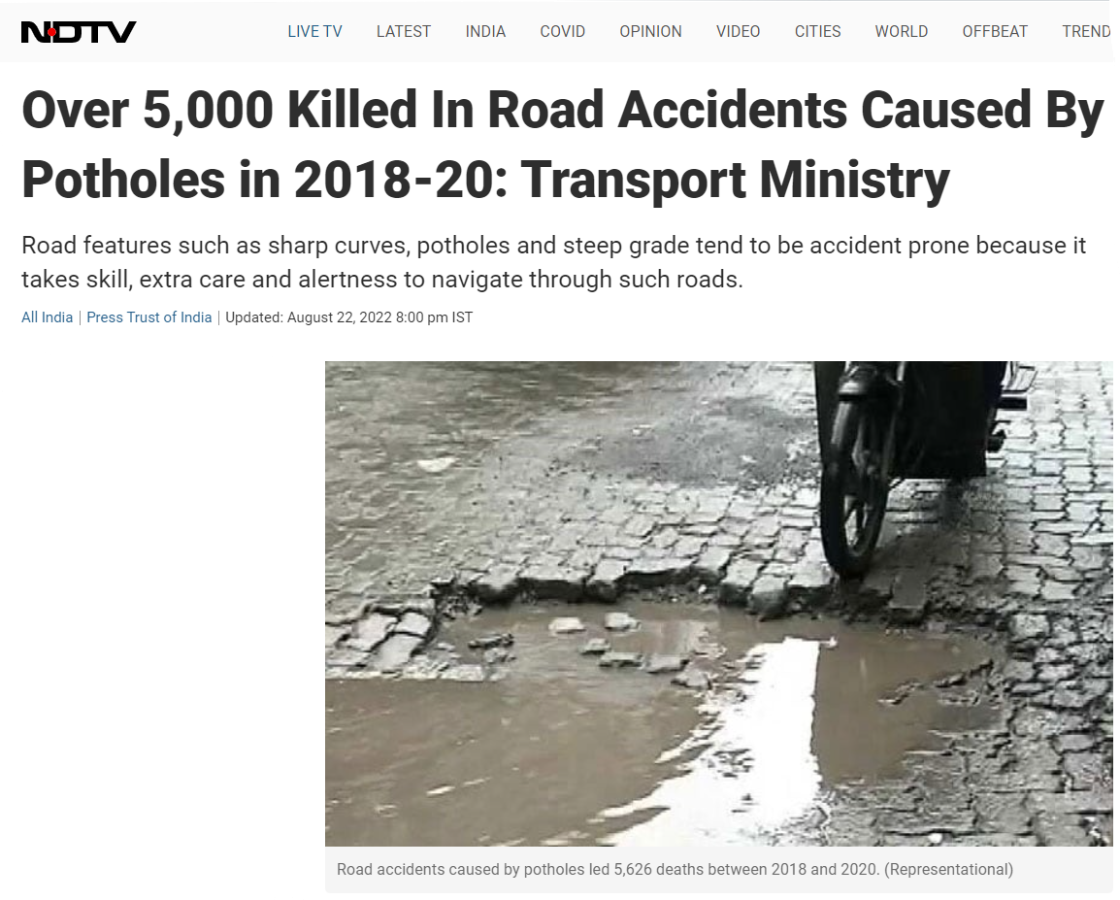

**SOURCE:**[**https://www.ndtv.com/india-news/over-5-000-killed-in-road-accidents-caused-by-potholes-in-2018-20-transport-ministry-3276432**](https://www.ndtv.com/india-news/over-5-000-killed-in-road-accidents-caused-by-potholes-in-2018-20-transport-ministry-3276432)**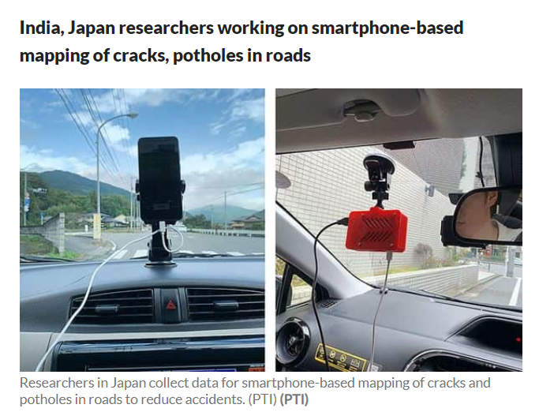 SOURCE:**[https://www.livemint.com/news/india/india-japan-researchers-working-on- smartphone-based-mapping-of-cracks-potholes-in-roads-11636879522104.html](https://www.livemint.com/news/india/india-japan-researchers-working-on-%20%20%20%20%20%20smartphone-based-mapping-of-cracks-potholes-in-roads-11636879522104.html)

* 1. **literature overview**

Most of today's smartphones allow sensing through several powerful built-in sensors such as accelerometer, gyroscope, GPS, ambient light sensor and barometer. These sensors have developed a new application paradigm in a wide range of fields. One of these proposed applications is to build a road monitoring framework that collects basic information about road surface quality.

Nashwa El-Bendary in [1] in this paper proposes a road condition monitoring framework that detects road anomalies such as speed humps. In the proposed approach, the main indicator of road anomalies is the gyroscope around the gravitational rotation along with the accelerometer sensor as a cross-validation method to confirm the detection results that were collected from the gyroscope.

Thanuka Wickramarathne, Varun Garg in [2] reports recent results of using accelerometers for road abnormality detection. In particular, with an emphasis on the development of a low-cost but robust road abnormality detection system, the predictive effectiveness of features generated by acceleration sensors is investigated. Utilizing a signal transfer model that captures system dynamics and low-frequency filtering effects associated with a vehicle's suspension system, a simplified approach to "reconstructing" road surface conditions from vertical acceleration measurements is presented. In addition, with this particular model of signal transmission in place, the predictive performance of features derived from acceleration sensors is investigated using a statistical approach referred to as the denoising algorithm. The signal model and feature analysis approach is demonstrated through a real data set.

Kasun et al. in [3] used an acceleration sensor board for their current running project (BusNet), which was essentially designed for environmental pollution monitoring, to monitor road surface conditions in Sri Lanka. Acceleration sensor boards can measure the existence of a pothole by changing the vertical acceleration, in addition, they detect the change in the car's speed using the horizontal acceleration. The main disadvantage of BusNet road surface monitoring is the uncertainty of potholes, as a change in the horizontal components of acceleration does not necessarily indicate a rough piece of road; it may mean a traffic jam.

**2. OBJECTIVE**

Roads are always exposed to different weather conditions. Extreme weather has a direct impact on our roads. In heat waves, the road surface can melt and expand under the unrelenting heat of the sun. During floods and periods of heavy rain, roads in need of maintenance can become victims of the appearance of potholes, cracks and other surface deformations. Similarly, during the winter months when there is heavy snowfall and freezing, damaged roads are prone to potholes due to freezing and thawing. So, we need to inspect the roads frequently, which is impossible with traditional methods for a wide range of road network for countries like India.

**2.1 Project goal**

Build the best machine learning model to classify different types of road surface defects based on a series of Z-axis accelerometer data in which accelerometer data collected from a smartphone.

**3. PRELIMINARIES**

**3.1 Smartphones supported sensors**

Modern cell phones are smart, meaning they come with a variety of built-in sensors such as accelerometer, gyroscope, compass, and GPS .An accelerometer is an electromechanical device used to measure the change in acceleration in one, two, or three orthogonal axes (dimensions).Accelerometer-based applications include orientation detection, vibration changes, and velocity measurement. Using an accelerometer to simultaneously detect a change in gravity and acceleration of motion can become a problem; that a sudden stop or a sudden change in acceleration of movement can be detected as a change in gravity (obstacle). Therefore, for cross validation there is a need for another device for gravity change. This device is a gyroscope (gyro) sensor. While the accelerometer measures linear acceleration, the gyroscope measures the change in angular orientation (rad/s). Hence it is known as angular velocity sensor or angular velocity sensor. Using the mobile's built-in gyroscope will ensure the existence and classification of damage.

**3.2 Accelerometer:**

**I will prefer ADXL335 OR ADXL345 for the following reasons.**

This accelerometer has selective scale so that we can adjust the scale according to our requirements .Low voltage supply (2 ~ 3.6V) is enough. High sensitivity approximately 256 LSB/g when it’s range is (±2g) and 32LSB/g when its range is (±16g). Surface Adhesive so we can mount it on test drive vehicle using adhisives.it can give acceleration change along X,Y,Z axis. It has Analog output and medium Cost. This device come up with High Acceleration range (2g, 4g, 8g, 16g) is sufficient to conduct this project. The acceleration data can be accessed either by Secure Digital (SD) card or using USB cable connected to our personal computer (PC). Pack consists of AURDINO board which is used to connect accelerometer to PC and to insert SD card. Programming Code of accelerometer can be modified by connecting the Arduino board to PC & Open Arduino app. Go to Files —> Examples —> Sensors —> ADXL345.

**3.2.1 Schematic diagram of connection**

Connections of ADXL335 accelerometer with Arduino and shown below

VCC – 3.3 V

X-axis – A3

Y-axis – A2

Z-axis – A1

GND - GND

SD Slot

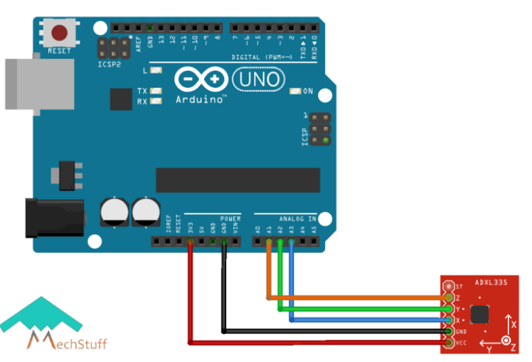

Connecting jack to PC

Accelerometer(ADXL 335)

(

Arduino Board

## **Plotting graph of acceleration values**

To plot values of the acceleration values received, you need to comment the “**Serial.println(“g “);”**line & upload the code again. Now we go to **Tools —> Serial Plotter** then graph will be plotted.

Source for images and code of sensor is extracted from :

<https://mechstuff.com/adxl335-accelerometer-arduino-tutorial-with-calibration/>

**3.3 confusion matrix**

|  |  |  |  |  |
| --- | --- | --- | --- | --- |
|  | Pothole (0) | Rut (1) | Bump (2) | Smooth (3) |
| Pothole (0) | True Pothole  [0,0] | [1,0] | [2,0] | [3,0] |
| Rut (1) | [0,1] | True Rut  [1,1] | [2,1] | [3,1] |
| Bump (2) | [0,2] | [1,2] | True Bump  [2,2] | [3,2] |
| Smooth(3) | [0,3] | [1,3] | [2,3] | True Smooth  [3,3] |

**Predicted Values**



Unlike binary classification, there are no positive or negative classes here. At first, it might be a little difficult to find True Positive (TP), True Negative (TN),False Positive (FP) and False Negative (FN) since there are no positive or negative classes, but it is easy. What we must do here is to find TP, TN, FP, and FN for each individual class.

**True Positive (TP):** It refers to the number of predictions where the classifier correctly predicts the positive class as positive.

**True Negative (TN):** It refers to the number of predictions where the classifier correctly predicts the negative class as negative.

**False Positive (FP):** It refers to the number of predictions where the classifier incorrectly predicts the negative class as positive.

**False Negative (FN):** It refers to the number of predictions where the classifier incorrectly predicts the positive class as negative.

Example for pothole class TP = [0,0] block

TN =

FP =

FN =

**Accuracy score :** It gives you the overall accuracy of the model, i.e., the fraction of the total samples that were correctly classified by the classifier.

Accuracy score =

**Recall:** It tells you what fraction of all positive samples were correctly predicted as positive by the classifier. It is also known as True Positive Rate (TPR), Sensitivity, Probability of Detection.

Recall =

**Precision:** It tells you what fraction of predictions as a positive class were actually positive.

Precision =

**F1-score:** It combines precision and recall into a single measure. Mathematically it is the harmonic mean of precision and recall.

F1-score = **2**  =

**4. METHODOLOGY**

**4.1 Data Collection**

Data acquisition phase is the most important one since it is responsible for collecting road information. The data acquisition process has been done using Realme 3 pro smart phone that was placed inside test vehicle. Readings of road surface conditions were gathered using accelerometer sensors. The sensors gathered data along the vehicle path. The collected data was stored locally in the memory of the mobile device. Also, the GPS coordinates (if location needed) of the manually marked road bumps points are kept within the memory. The application is not dedicated only for this device, it can be customized to work on other smart devices.

The flow-chart shows the data acquisition framework, starts by installing application from play store (for android). Login to the application and go to settings and check the existence of accelerometer and gyroscope sensors. Modify the following settings like set g=+10 m/s2 (in order to remove noises), update interval = 0.1sec(to get high frequency ),graph values = 100 and activate required sensors in active sensors before beginning of data collection .Then application initializes a timer to start receiving sensors data. For saving mobile memory space, specific readings were pre-processed before being stored, like optimizing the time structure in the log files by putting the difference with a certain time stated at the beginning of the file. Once we stop the data acquisition, the application dumps the log files exist within the phone memory and collected data is in CSV format.

AndroSernsor App

Application login

Go To Settings

Modify settings

**4.2 Data Pre-processing**

The collected data is stored in CSV format, so load it to the excel spread sheet into PC and fill null values with median value and copy all z-axis accelerometer ,x-axis gyroscope and time columns into new excel spread sheet . Make target labels corresponding to sequence of accelerometer data by creating new column such as path hole ,rut, bump, crack, and no damage manually that observed from test drive vehicle in order to make datasets to build machine learning model.

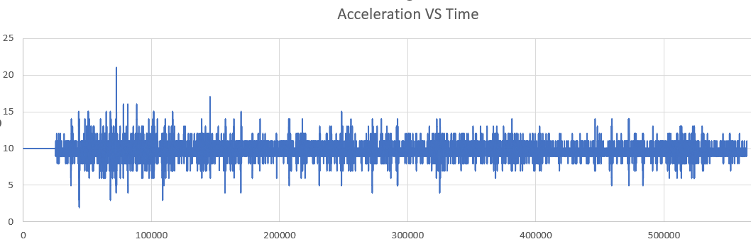

As we plot the collected z-axis acceleration on y-axis data against time on x-axis in excel data, we can clearly observe the spikes in y-direction are the irregularities on road surface that the sensor detected for the collected data.

**4.2.1 Data Manipulation**

Individual accelerometer readings have no use in classification of damage, but a series of accelerometer readings can indicate a type of damaged surface. So, I wrote a simple python code to divide all accelerometer readings into a different sized python lists like shown below.

[[9, 9, 9, 9, 9, 9, 11, 11, 11, 11, 11, 11, 11, 11, 11, 11, 11, 11, 11, 11, 11, 11, 11, 11, 11, 11, 8, 8, 8, 8, 8, 8, 8, 8, 8, 8, 8, 8, 8, 8, 9, 9, 9, 9, 9, 9, 9, 9, 9, 9, 9, 9, 11, 11, 11, 11, 11, 11, 11, 11, 13, 13, 13, 13, 13, 11, 11, 11, 11, 11, 11, 11, 11, 11, 8, 8, 8, 8, 8] ----->indicates pothole

[10, 10, 10, 10, 10, 10, 10, 10, 10, 10, 10, 10, 10, 10]------> smooth

[11, 11, 11, 11, 11, 11, 11, 11, 11, 11, 11, 11, 11, 11, 11, 11, 11, 11, 13, 13, 13, 13, 13, 13, 11, 11, 11, 11, 11, 11] ----->bump

**4.3 Features and Targets**

Import the libraries and modules to load and manipulate data such as NumPy to deal with arrays, pandas to deal with excel file ,TensorFlow to convert 2-D arrays into tensors and finally sci-kit learn to build models. Then load the accelerometer data from excel using pandas Data Frame. A code was written to divide the accelerometer data into sub-lists in which each sub-list contains a sequence of accelerometer readings that indicates a type of road abnormality as we discussed above. Machine Learning models will not work when it will provide with different sized arrays as feature and target labels. Since the sub-lists that were made by above code are of different sizes. So, find maximum length among all sub-lists and append 10 to all sub-lists to maximum length in order to make same sized arrays. After that ,covert feature vectors which are 2-D list into 2D-numpy array and labels into integer values. Since ML models will not able to extract features from N-dimensional arrays in multi-class classification, so convert them into tensors using TensorFlow.Finally save the tensor feature and target labels using NumPy. Save (__) function, then the data is ready to load into different models.

Code link:<https://github.com/simma-ram/Low-cost-Road-damage-detection-and-classification-using-accelerometer-sensor-and-machine-learning/blob/main/manipulating_algorithm.ipynb>

* 1. **Build Models**

Load the data which is previously saved by above python code. Take features as x and target as y from loaded data. Split dataset into training and testing sample. Define a function fit and predict to fit the training data and predict the testing data. Fit the training sample into model and make predictions using testing sample. Make report like accuracy score, predictions of y_test of different Machine Learning models. Define a function to get predictions of testing sample.

Create a list of the machine learning models to be used for classification and regression. Run a for loop through the list of models and use function fit and predict to do operations inside function and make predictions. Run a for Loop through the list of prepared models and make predictions on testing data using function get predictions. Run a for loop through prepared models to get confusion matrices of respective models.

Code link:<https://github.com/simma-ram/Low-cost-Road-damage-detection-and-classification-using-accelerometer-sensor-and-machine-learning/blob/main/ML_models.ipynb>

**4.5 Patterns**

**Pothole:** 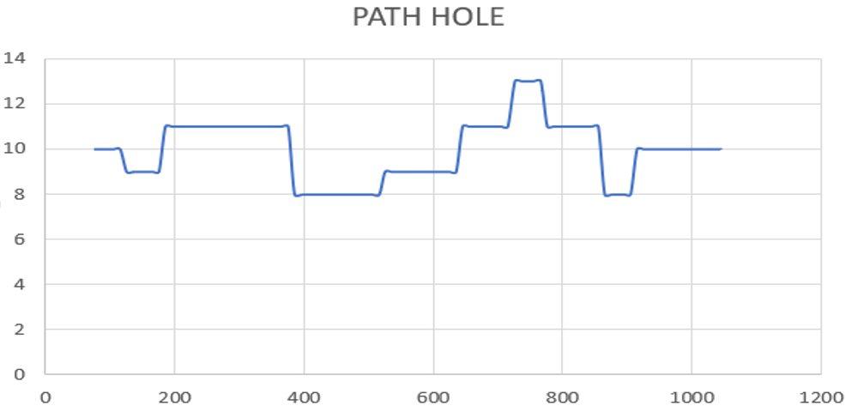

Notice that starting from the normal value of gravity acceleration, the z-acceleration falls to 8 m/sq-sec. It is when the front wheel hits the base of the pothole. after that the z-acceleration starts to rise signiﬁcantly to 11–13 m/sq-sec. it is when the front wheel exits the pothole, the next drop is caused by the rear wheel hitting the pothole base.

**Bump/patch:** 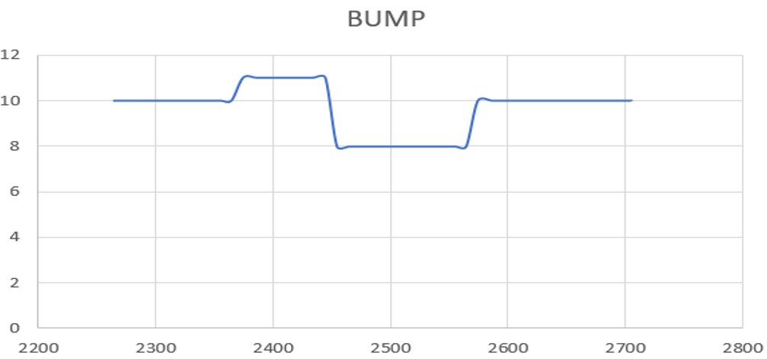

The z-axis accelerometer reading first increases above 10 m/sq-sec to 11 m/sq-sec when front wheel raises on patch and then decreases below 10 m/sq-sec when front wheel deceases down to the bump indicates bump. If acceleration rise is high that indicates a bump.

**Rutting:**

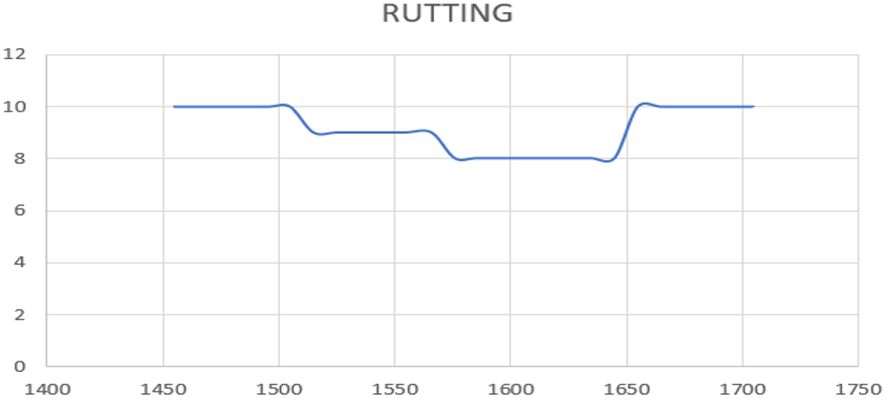

When the vertical acceleration decreases steadily to 8 or 9 m/sq-sec or further below and come back to 10m/sq-sec indicates that rut type of dam

**5. RESULTS**

The accuracy score on testing dataset , weighted average of recall, precision and f1 score of logistic regression with Hyperparameter(C=1.0), decision tree classifier, random forest classifier and support vector classifier with linear kernel are shown below.

|  |  |  |  |  |  |  |  |  |  |  |  |  |  |  |  |  |  |  |  |  |  |  |  |  |  |  |  |  |  |  |  |  |
| --- | --- | --- | --- | --- | --- | --- | --- | --- | --- | --- | --- | --- | --- | --- | --- | --- | --- | --- | --- | --- | --- | --- | --- | --- | --- | --- | --- | --- | --- | --- | --- | --- |
| |  |  |  |  |  | | --- | --- | --- | --- | --- | | MODEL | Accuracy score  (Testing set) | F1 score  (Weighted Avg) | Precision  (Weighted Avg) | Recall  (Weighted Avg) | | Logistic Regression | 80% | 77% | 77% | 80% | | Decision Tree Classifier | 99% | 99% | 99% | 99% | | Random Forest Classifier | 99% | 99% | 99% | 99% | | Support Vector Classifier (linear) | 87% | 83% | 90% | 87% | |  |  |  |  |  |  |  |
| **5.1 Confusion Matrices**  Logistic Regression(C=1.0)  [[416 0 0 0]  [ 40 52 0 0]  [ 2 0 135 23]  [ 35 18 40 30]]  DecisionTree Classifier()  [[416 0 0 0]  [ 0 92 0 0]  [ 0 0 158 2]  [ 0 1 4 118]]  RandomForest Classifier()  [[416 0 0 0]  [ 0 92 0 0]  [ 0 0 159 1]  [ 0 0 3 120]]  SVC(kernel='linear', random_state=0)  [[416 0 0 0]  [ 0 92 0 0]  [ 0 0 160 0]  [ 8 29 67 19]]  **5.2 Result Discussion**  As we compare results of above four supervised classifiers Random Forest and Decision Tree classifiers gives better and same accuracy among others.  DECISION TREE VS RANDOM FOREST:  Random Forest classifier has slightly higher precision and recall than Decision Tree classifier. When we observe the confusion matrices of these classifiers Random Forest predicts 788 out of 791 values of testing set correctly, where Decision Tree predicts 786 out of 791 values. So, we prefer Random Forest as our best model over other models for our classification. |  |  |  |  |  |  |  |

**6. CONCLUSION**

Up to this the model is ready to classify different types of road abnormalities as we give z-axis accelerometer data & we can count number of each type of damages. In this project supervised machine learning techniques are used to classify the road anomalies using accelerometer dataset.

**6.1 Future work**

Further try to use unsupervised machine learning techniques to divide different road anomalies using clustering technique. I collected the data used in this project is comparatively small and labelled the target vectors based on some individual plot patterns .I will further take gyroscope readings to build classification models in order to cross check the results of accelerometer results. Further I use these models on original dataset and target vectors. Then will try to estimate rough cost of rectification of each type of damage and from that we can estimate overall rectification cost of the road .

|  |  |  |  |  |  |  |  |
| --- | --- | --- | --- | --- | --- | --- | --- |
| **7. REFERENCES**  [1] El-Bendary, N., Alessandroni, G., Mohamed, A., Mostafa Fouad, M. M., Elhariri, E., Zawbaa, H. M., & Ella Hassanien, A. (n.d.). *RoadMonitor: An Intelligent Road Surface Condition Monitoring System Cite this paper Related papers A St udy on t he Influence of Speed on Road Roughness Sensing: T he Smart RoadSense Case RoadMonitor: An Intelligent Road Surface Condition Monitoring System*. <http://www.egyptscience.net>.  [2] El-Bendary, N., Alessandroni, G., Mohamed, A., Mostafa Fouad, M. M., Elhariri, E., Zawbaa, H. M., & Ella Hassanien, A. (n.d.). *RoadMonitor: An Intelligent Road Surface Condition Monitoring System Cite this paper Related papers A St udy on t he Influence of Speed on Road Roughness Sensing: T he Smart RoadSense Case RoadMonitor: An Intelligent Road Surface Condition Monitoring System*. <http://www.egyptscience.net>  [3] Brewer, Eric., Saif, Umar., Association for Computing Machinery. Special Interest Group on Data Communications., & ACM SIGCOMM Conference (2007 : Kyoto, J. (2007). *Proceedings of the 2007 Workshop on Networked Systems for Developing Regions : 2007, Kyoto, Japan, August 27-27, 2007*. ACM Press.  [4] Aleadelat, W., Ksaibati, K., Wright, C. H. G., & Saha, P. (2018). Evaluation of pavement roughness using an android-based smartphone. *Journal of Stomatology*, *144*(3). https://doi.org/10.1061/JPEODX.0000058  [5] Ashok, A. (2016). ISSN: 2393-2835 Special Issue. In *International Journal of Advances in Electronics and Computer Science*.  [6] Chen, K., Lu, M., Fan, X., Wei, M., & Wu, J. (2011). Road condition monitoring using on-board three-axis accelerometer and GPS sensor. *Proceedings of the 2011 6th International ICST Conference on Communications and Networking in China, CHINACOM 2011*, 1032–1037. <https://doi.org/10.1109/ChinaCom.2011.6158308>  [7] Institut Teknologi 10 Nopember (Surabaya, I. F. T. E., Institute of Electrical and Electronics Engineers. Indonesia Section, & Institute of Electrical and Electronics Engineers. (n.d.). *2015 International Seminar on Intelligent Technology and Its Applications (ISITIA) : proceeding : Surabaya, Indonesia, 20-21 May 2015.* |  |  |  |  |  |  |  |
|  |  |  |  |  |  |  |  |
|  |  |  |  |  |  |  |  |