NAME; simma Mahesh

Id: ACTE2415

ROLE:Junior Software Engineer

JIRA BUG ISSU TRACKER

Create User Stories & Issues, Plan Sprints, & Distribute Tasks Across Your **Software** Team

A user story is an informal, general explanation of a software feature written from the perspective of the end user or customer.

Bug − A problem that impairs or prevents the functions of the product

 Epic − A big user story that needs to be broken down. Created by JIRA Software - do not edit or delete. Improvement − An improvement or enhancement to an existing feature or task.

THIS IS THE FIRST STEP HERE WE ARE ASSIGNING SITE NAME

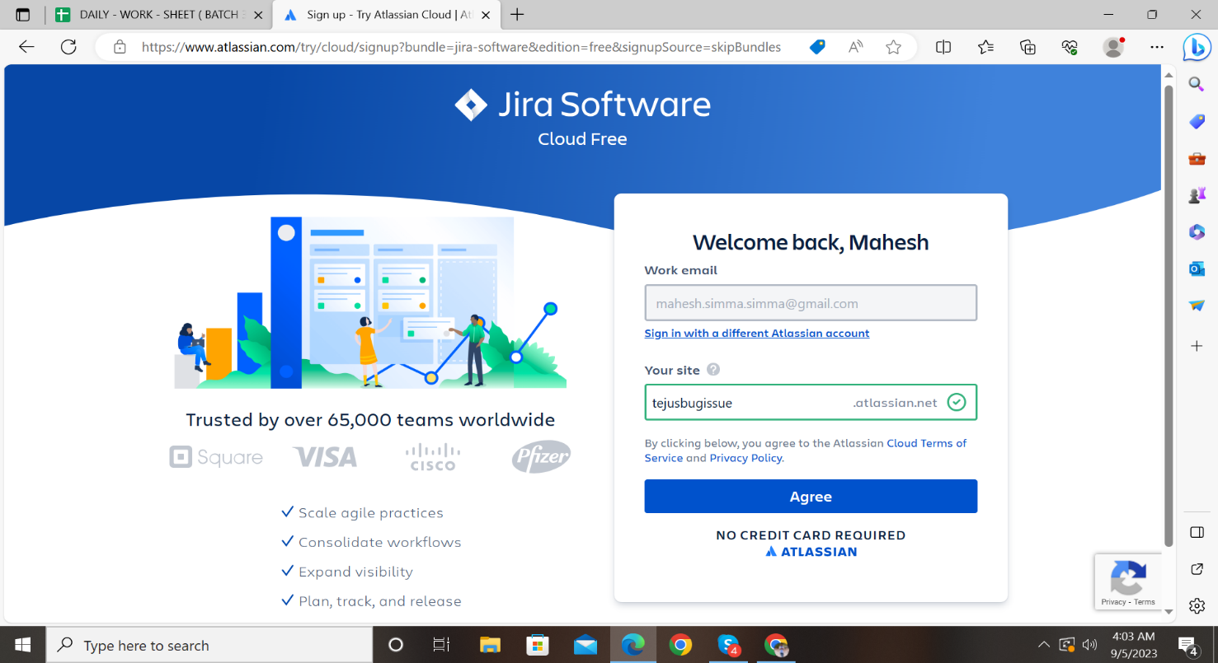

Here our site will be starting up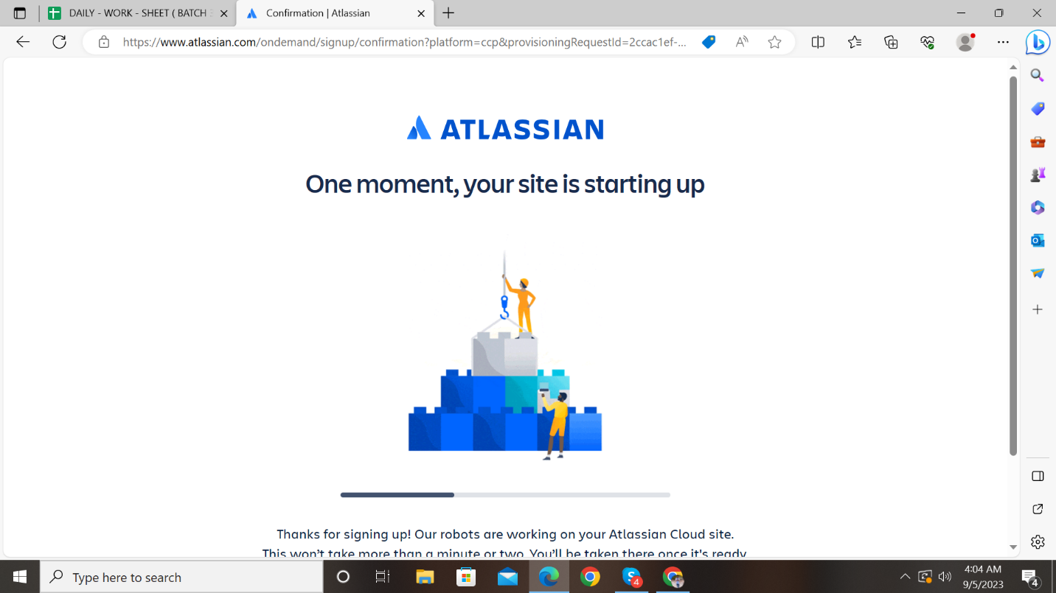

In this phase we select the scrum management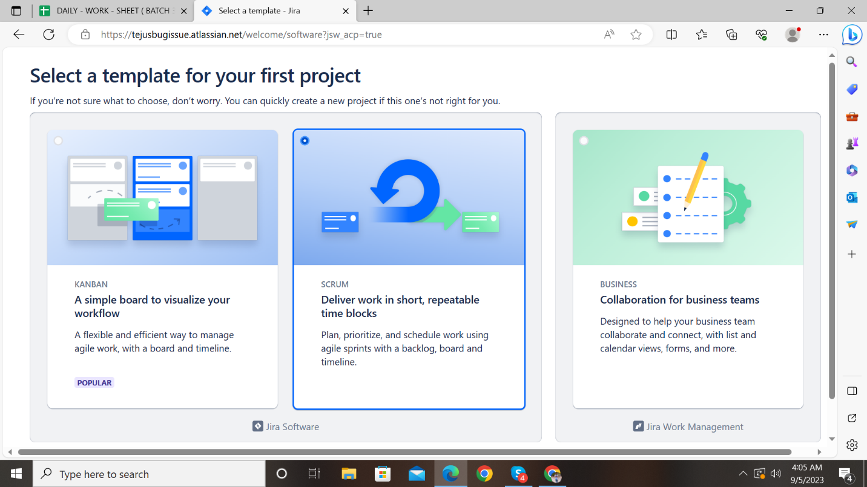

Here we are creating 2 user issues and create one bug issue and assign some description to the bug issue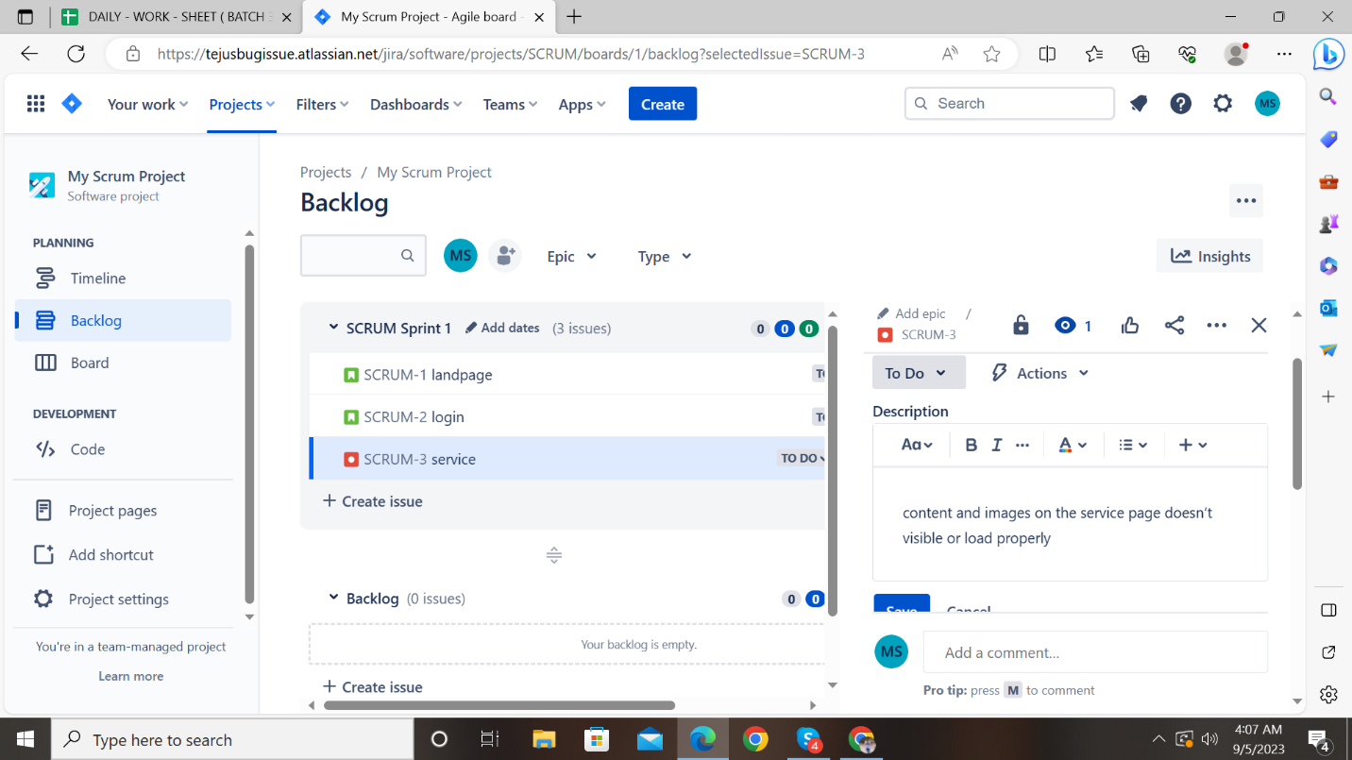

In thi s stage we are assigning bugissue to team member

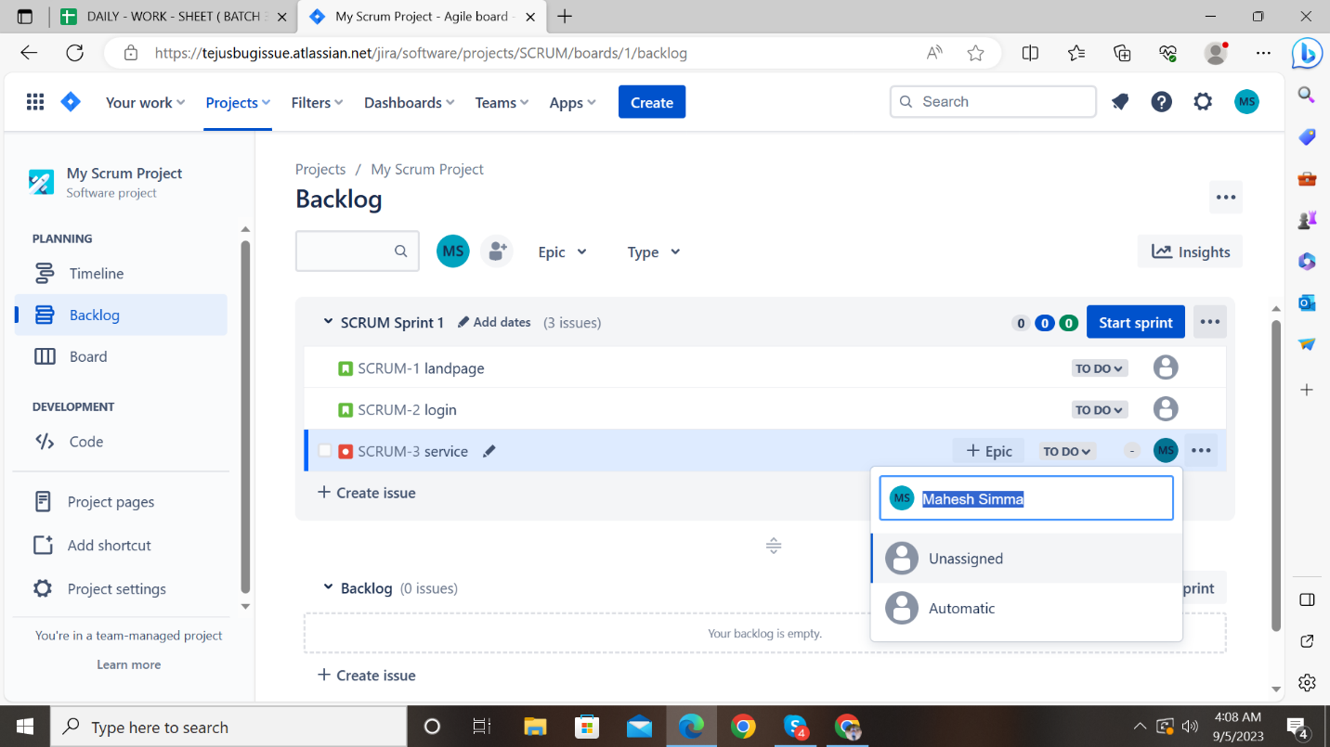

Aftewr asiigning bug issue tro team mate we have to update the workflow

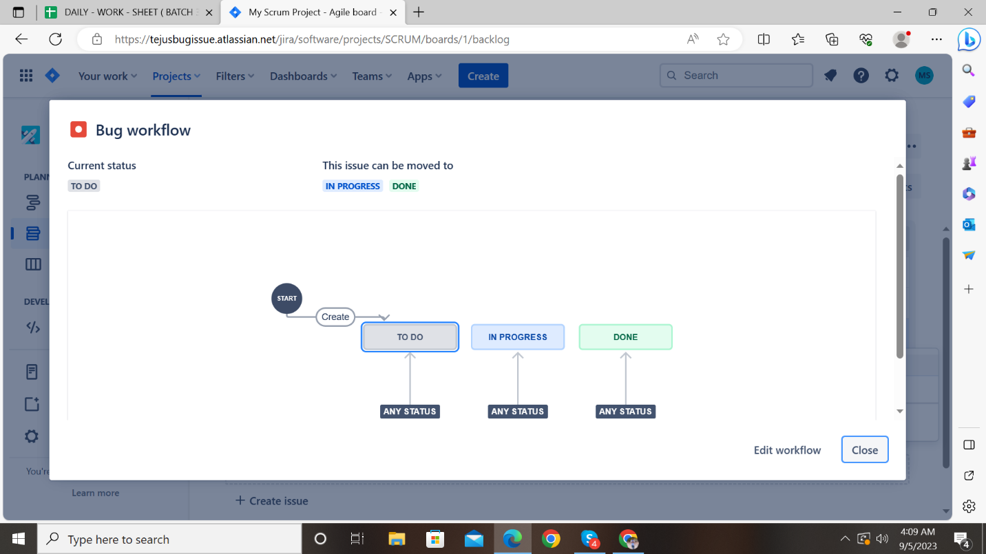

And after just add testing to the work flow and update the workflow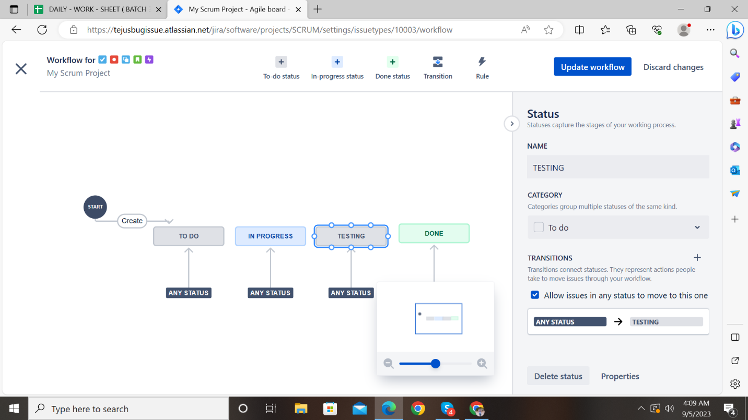

Here We got the updated workflowmodel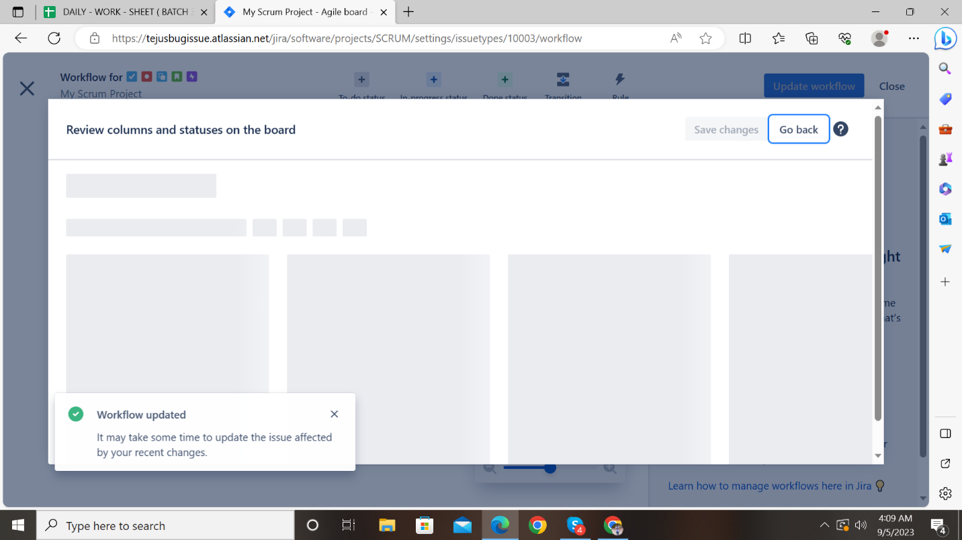

Inb this page we observe the status

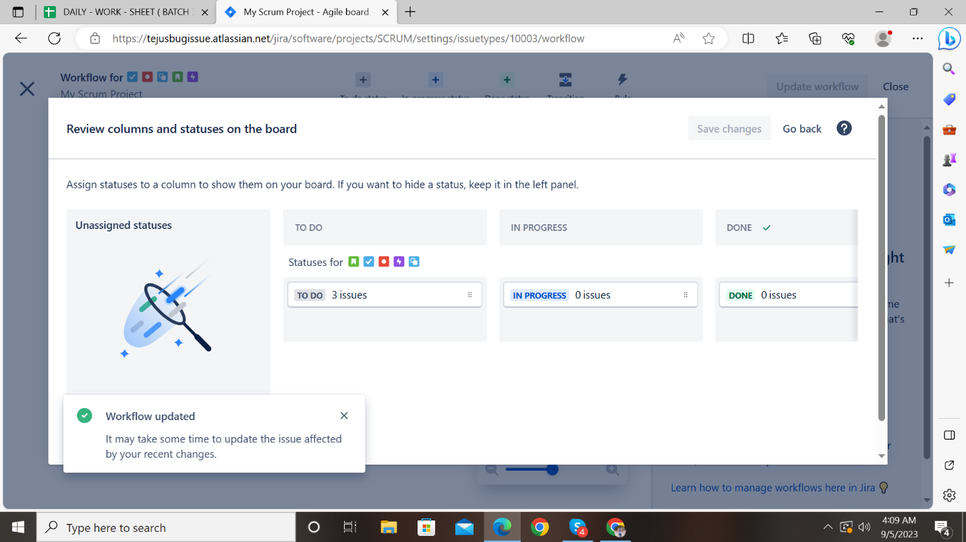

After update the work flow we have to start the sprint amd the bug assigned to testing remaining 2 user stories moving done state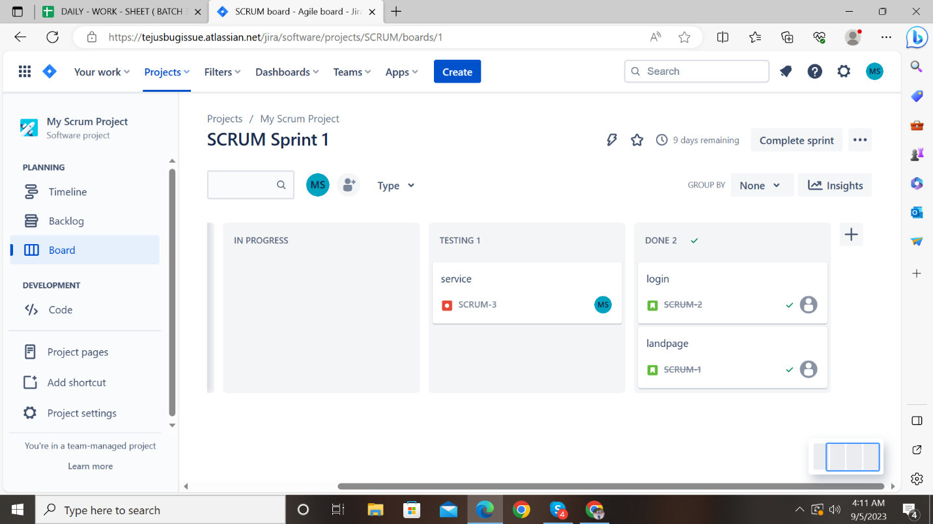

Finally the sprint is complted we got the final output here