In the verified Trainium model, the second factor U₂ is folded into the core tensor, producing a single rank-3 tensor G. The model then denoises the triple (U₁, U₃, G):
with the SDF recovered at sample time by the contraction
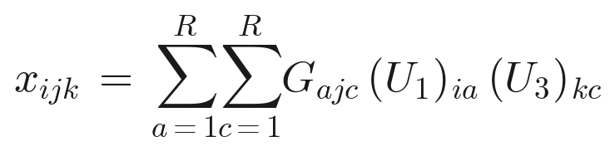

1 Factor matrices U₁, U₃ with shape N×R)
Each matrix is transposed to R×N, so its R rows become R tokens of dimension N, then projected by Wᵤ ∈ ℝ^{H×N}. A learned position embedding and a token-type embedding are added:

2 Core-fold tensor G with shape R×N×R
G is reshaped to (R·N, R): every (rank a, spatial j) pair becomes one token of dimension R, projected by W_G ∈ ℝ^{H×R}. Two separate position embeddings are added, one for the rank index a, one for the spatial index j , so the model can localize each token along both axes:
This is the dominant contributor to sequence length: G alone yields R·N tokens (24×256 = 6144), versus R = 24 tokens for each of U₁ and U₃.

3 Time Token
Rather than the usual AdaLN-Zero conditioning, the diffusion timestep t is encoded as its own token and prepended to the sequence. It uses a sinusoidal embedding followed by a 2-layer MLP.

4 Sequence Assembly
The four token groups are concatenated along the sequence axis:
giving total length

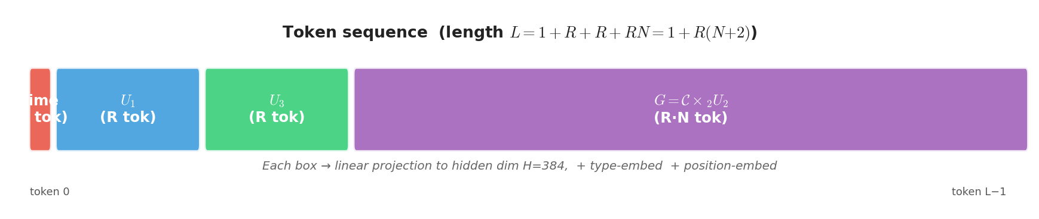
Embeddings: Four token types {time, U₁, U₃, G} are distinguished by a 4-entry type embedding table; position is provided by separate embedding tables: pe_U1 ∈ ℝ^{R×H}, pe_U3 ∈ ℝ^{R×H}, pe_G_rank ∈ ℝ^{R×H}, and pe_G_spa ∈ ℝ^{N×H}.

5 Transformer Body and De-Tokenization
The sequence passes through 6 pre-norm transformer blocks. Attention is computed with an explicit matmul:
After the final LayerNorm, the time token (position 0) is dropped and the remaining tokens are split back into their three groups. Zero-initialized output heads project each group back to its native factor shape:
Zero-init: Here output heads are zero-initialized so the model predicts about equal to 0 at step 0, giving a stable training start.

6 Dimensions at a Glance (N=256, R=24, H=384)
Component | Tensor shape | # tokens | Token dim → H | Projection
Time token | scalar t | 1 | 256 → 384 | sinusoidal+MLP
U₁ (transposed) | R×N = 24×256 | R = 24 | 256 → 384 | W_U1 ∈ ℝ^{384×256}
U₃ (transposed) | R×N = 24×256 | R = 24 | 256 → 384 | W_U3 ∈ ℝ^{384×256}
G (reshaped) | R·N×R = 6144×24 | R·N = 6144 | 24 → 384 | W_G ∈ ℝ^{384×24}
Total sequence | — | L = 6193 | — | —

