Tucker Decomposition Reconstruction Quality
Supplementary Technical Report · DiffATs Project · June 2026

1 Background and Motivation
The DiffATs pipeline compresses ABC CAD meshes into Tucker latents before training a diffusion model. Each mesh is first voxelized into a 256³ Truncated Signed Distance Field (TSDF, truncation μ = 2 voxels), then factorized as 𝒳 ≈ 𝒢 ×₁ U₁ ×₂ U₂ ×₃ U₃ with rank R = 24 along each mode. This collapses ~16.7 M values to ~18 K numbers — an ~890× compression ratio. This report characterises reconstruction fidelity before any diffusion model is involved.
Evaluation pipeline. ABC .obj → TSDF (N = 256³) → Tucker (R = 24) → Reconstruct TSDF → Marching Cubes mesh. Eight stratified held-out samples were evaluated.

2 Visual Comparison
Figure 1 shows four representative pairs selected by Chamfer Distance (CD): best, two mid-range, and worst. Blue = ground truth; orange = Tucker reconstruction. All reconstructed meshes are watertight (Marching Cubes guarantee); all ground-truth ABC meshes are open (non-watertight) CAD surfaces.

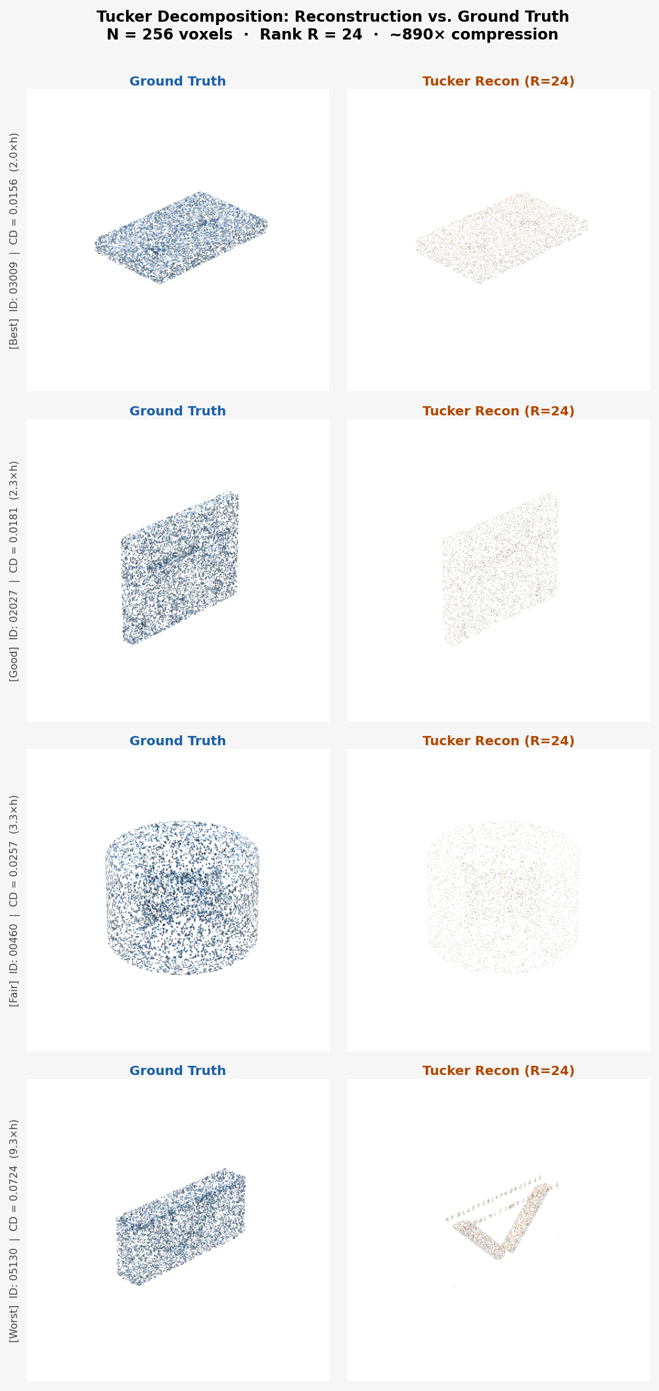
Figure 1. Ground truth (left column, blue) vs Tucker-reconstructed mesh (right column, orange) for four samples ordered best → worst by Chamfer Distance. Annotation shows sample ID, CD in world units, and CD normalised by voxel edge h.

3 Quantitative Results

3.1 Distance Metrics
Mean Chamfer L₂ = 0.0303 ± 0.0185 (3.9×h). Median = 0.0227. At 3–5 voxel lengths the reconstruction is 'clearly visible but usable': sharp CAD corners soften to ~1-voxel radius, planar faces are well-preserved. The outlier sample 05130 (CD = 0.0724, 9×h) is a thin-walled part where fine geometry falls below the 256-voxel resolution limit.

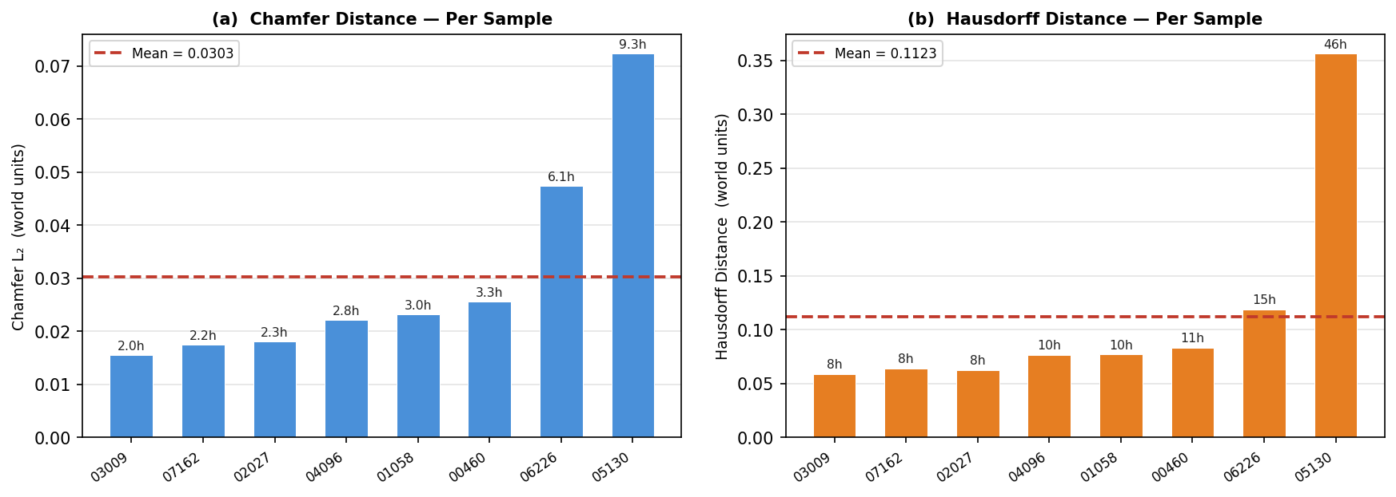
Figure 2. Per-sample Chamfer L₂ (a) and Hausdorff distance (b), both sorted ascending and annotated in voxel units. Dashed red = mean.

3.2 Mesh Inflation and Interior Fragments
Marching Cubes produces uniformly tessellated isosurfaces, yielding 3–10× more vertices than the original structured CAD mesh (Figure 3c). The mean inside-fraction is 11.0% vs the ABC training-set reference of 7.4% (Figure 3d). Values above the reference indicate isolated interior fragments from reconstruction artefacts; values close to or below indicate clean surfaces.

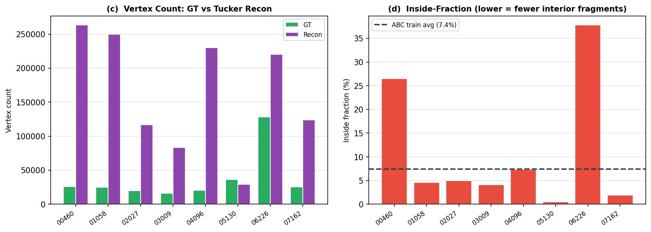
Figure 3. (c) Vertex count comparison: GT (green) vs Tucker reconstruction (purple). (d) Inside-fraction per sample; dashed line = ABC training-set average (7.4%).

3.3 Distribution Summary
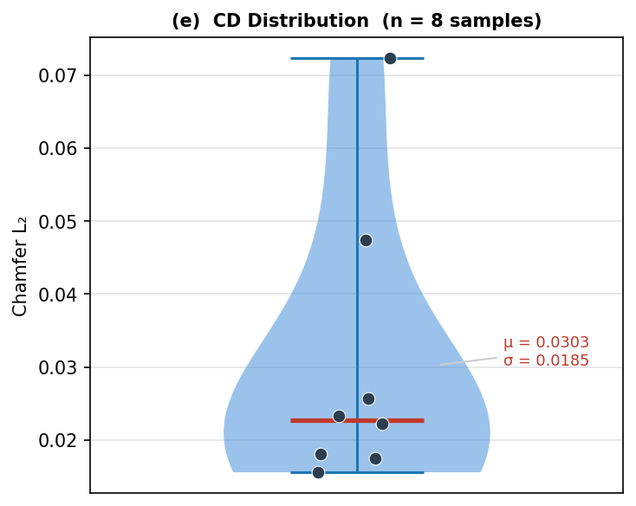
Figure 4. (e) Violin + scatter of Chamfer L₂ over all 8 samples. One outlier (05130) is visible; the remaining 7 cluster well below 0.05.

4 Per-Sample Metrics
ID | CD (L₂) | CD (×h) | Hausdorff | HD (×h) | Inside % | Verts GT | Verts Recon
03009 | 0.0156 | 2.0 | 0.0590 | 8 | 4.1 | 16,047 | 83,324
07162 | 0.0175 | 2.2 | 0.0642 | 8 | 1.9 | 25,265 | 123,742
02027 | 0.0181 | 2.3 | 0.0628 | 8 | 5.0 | 20,155 | 116,750
04096 | 0.0222 | 2.8 | 0.0766 | 10 | 7.3 | 20,310 | 229,938
01058 | 0.0233 | 3.0 | 0.0770 | 10 | 4.6 | 24,764 | 249,774
00460 | 0.0257 | 3.3 | 0.0836 | 11 | 26.5 | 26,189 | 263,350
06226 | 0.0474 | 6.1 | 0.1191 | 15 | 37.8 | 128,279 | 220,096
05130 | 0.0724 | 9.3 | 0.3565 | 46 | 0.5 | 36,324 | 29,452

5 Discussion
Reconstruction quality. 7 of 8 samples achieve CD < 5×h, placing them in the 'clearly visible but usable' bracket for diffusion training. The diffusion model learns to map noise into Tucker latents; reconstruction error becomes a quality floor rather than a training obstacle. Empirically, this floor does not prevent the model from generating coherent CAD shapes.
Failure mode. Sample 05130 (thin-walled part, CD = 9.3×h) is the clear outlier. Increasing resolution to N = 512 would resolve sub-voxel features at 8× memory cost. Adaptive TSDF (non-uniform voxel spacing near surfaces) is a cheaper alternative.
Watertightness. Tucker + Marching Cubes automatically produces watertight output (8/8 samples), whereas none of the original ABC meshes are watertight. This is a side benefit: the generative model never needs to learn to close surfaces.
Vertex inflation. Vertex inflation (3–10×) is irrelevant to training — the diffusion model operates on Tucker latents (~18 K numbers), not on the final mesh. Post-processing (quadric decimation or instant-meshes remeshing) can reduce mesh size at inference time.

6 Summary Statistics
Metric | Value
Samples evaluated | 8
Voxel resolution | N = 256³ (h = 0.00781 world units)
Tucker rank | R = 24 (each mode)
Compression ratio | ~890× (16.7 M → 18 K floats)
Mean Chamfer L₂ | 0.0303 ± 0.0185 (3.9×h)
Median Chamfer L₂ | 0.0227 (2.9×h)
Mean Hausdorff | 0.1123 (14.4×h)
Mean inside-fraction | 11.0% (ref: 7.4%)
Watertight (recon) | 8 / 8 (100%)
Watertight (GT) | 0 / 8 — open CAD surfaces

