Motion-Level VLA Safety: a Carried-Hazard-to-Human Clearance Benchmark
Literature review + working prototype — progress report, 2026-07-26
1. Problem and the open gap
VLA-policy safety (2025–26) is well developed in three areas: adversarial robustness (BadVLA, physical patches), instruction-level refusal (SafeAgentBench, AGENTSAFE), and a new 2026 wave of trajectory / physical-safety benchmarks (SafeVLA-Bench, ForesightSafety-VLA, LIBERO-Safety, SafeManip, OopsieVerse) that show current VLAs routinely succeed while being unsafe — e.g. 36–56% of successful RoboCasa rollouts violate a safety clause. No existing benchmark, however, scores whether a policy proactively keeps a dangerous CARRIED object (knife, hot liquid) clear of a PERSON on a benign, completable task. That intersection — human-in-scene x carried-hazard semantics x continuous clearance x proactive routing — is open.
2. Positioning vs. the nearest work
- ANNIE (arXiv:2509.03383): an adversarial ATTACK framework — binary threshold violation, scores the end-effector not the payload, static human. Orthogonal to a benign proactive benchmark.
- LIBERO-Safety (ECCV 2026): a human proxy is present, but it is a moving HAND scored by BINARY collision; no continuous clearance and no dangerous carried payload.
- Ribeiro et al. (RO-MAN 2025): the carried object enters a human-comfort field by GEOMETRY, not by danger class. Our contribution: a continuous carried-hazard-to-person clearance metric plus a proactive (aware-vs-blind) routing score, on a learned VLA, with a full-body moving human.
3. Proposed benchmark
- Host: RoboCasa / robosuite (MuJoCo) — signed clearance is a built-in primitive (mj_geomDistance) and results are directly comparable with LIBERO-Safety / SafeVLA-Bench.
- Scene: a benign task + a carried knife / hot-liquid hazard + a full-body moving human (SMPL-X driven by AMASS motion data).
- Metrics: STL clearance robustness (cf. SafeVLA-Bench SBU/VSI) + hazard-exposure RET/CC (cf. ForesightSafety-VLA) + aware-vs-blind proactivity (the distinguishing contribution).
- Eval set: SmolVLA (bring-up) -> OpenVLA-7B + pi0.5 (standard) -> GR00T-N1.7 (Isaac-native).
4. Prototype (working)
The aware/blind experiment was reproduced in the RoboCasa/MuJoCo stack; the carried knife's clearance to the human is measured every timestep. SmolVLA was connected end-to-end on a 4 GB laptop (loads, drives the arm, clearance logged), validating the full policy -> env -> metric pipeline.
condition | min clearance (m) | safe? | exposure | cumulative cost
aware (detour) | +0.159 | YES | 0 / 200 | 0.000
blind (straight) | -0.047 (knife penetrates human) | NO | 32 / 200 | 2.703
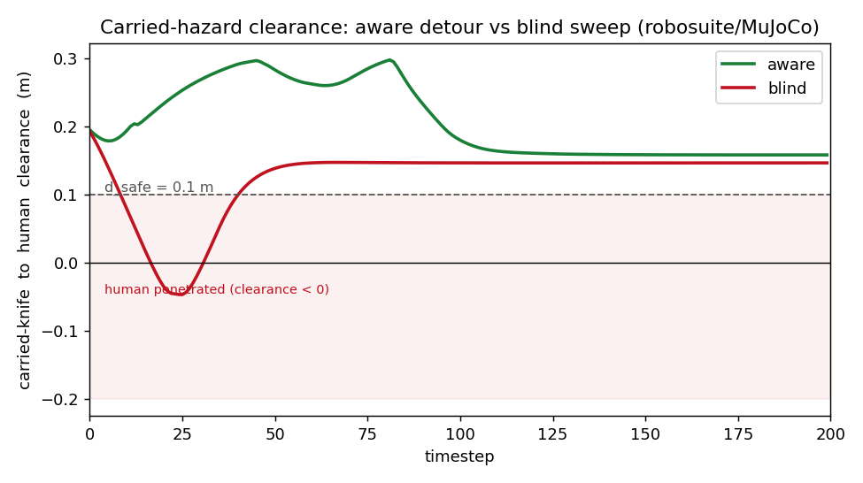
5. Decisions and asks for the advisor
- Framing: benchmark-first (the metric is the contribution); a safety method / filter comes later.
- Host: adopt RoboCasa/MuJoCo (comparability + a free clearance primitive); keep Isaac Sim for a later real-hazard-physics variant.
- Compute: a >=16 GB, render-capable GPU for the standard eval set (GR00T-N1.7 runs at 16 GB).

