VLA Safety: Key Findings and My Progress
Zijian Su
1. The landscape, briefly
- VLA policies map an instruction + camera images to low-level robot actions; safety matters as they deploy near people.
- Risks split into two families: adversarial (patch / backdoor / jailbreak attacks) and non-adversarial (out-of-distribution inputs, unsafe motion, reward hacking, action hallucination).
- Maturity: adversarial robustness and instruction-level refusal are mature; physical / trajectory-level safety became active only in 2026.
2. Key finding: task success ≠ safe execution
- Current state-of-the-art VLAs routinely complete the task while being unsafe during the motion. For example, 36–56% of successful RoboCasa rollouts violate at least one safety clause. High success does not imply safe motion.
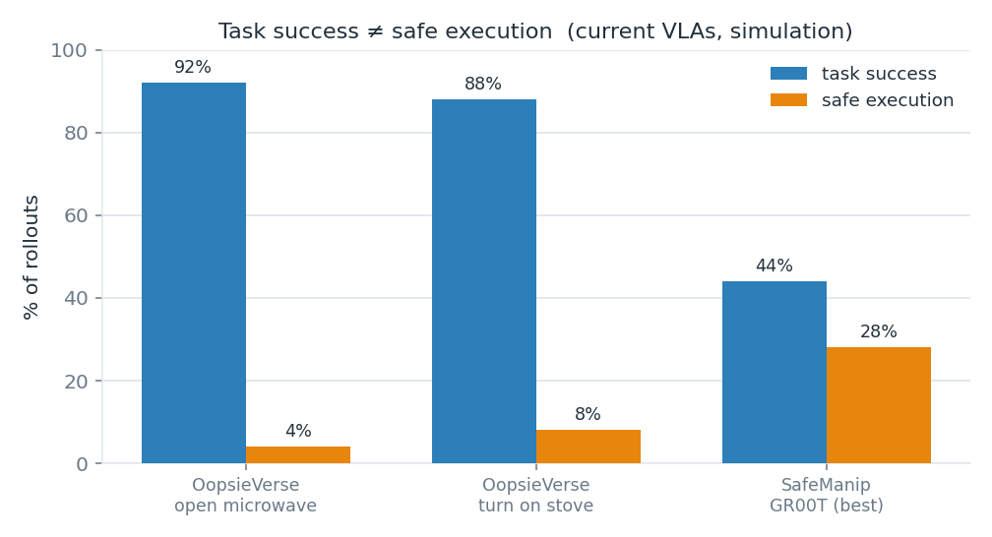
Representative results from recent benchmarks: task completion is high, safe execution is not.
3. Existing evaluation benchmarks
Benchmark | What it measures | Key metric
SafeAgentBench, AGENTSAFE | refuse a dangerous instruction | rejection / refusal rate
SafeVLA-Bench | trajectory-level physical safety | Succ-But-Unsafe, severity index (STL)
ForesightSafety-VLA | trajectory-level physical safety | cumulative cost, risk-exposure time
LIBERO-Safety | physical safety + moving human hand | success / collision (binary)
SafeManip | temporal safety of execution | temporal-logic (LTLf) monitors
OopsieVerse | damage to objects / environment | health, safe-completion rate
RoboGuard | guardrail vs unsafe / jailbroken plans | unsafe-plan execution rate
4. The gap, and my idea
- What no benchmark measures: proactively keep a dangerous CARRIED object (knife, hot water) clear of a nearby PERSON on a benign task, scored by a CONTINUOUS clearance metric and rewarding PROACTIVE path choice. The nearest works each hold only one hard ingredient:
 | Human in scene | Dangerous carried payload | Continuous clearance | Proactive routing
My proposal | ✓ full body, moving | ✓ | ✓ | ✓
LIBERO-Safety | ✓ hand only | ✗ | ✗ binary | partial
ANNIE | static | ✓ knife | ✗ binary | ✗ (it is an attack)
ForesightSafety-VLA | ✗ | ✗ static zones | ✓ | ✗
- My proposal: a benchmark on RoboCasa / robosuite (MuJoCo), where signed hazard-to-human clearance is a built-in primitive; scene = benign task + carried knife/hot-liquid + full-body moving human (SMPL-X / AMASS); metrics = STL clearance robustness + hazard-exposure over time + an aware-vs-blind proactivity score (a counterfactual against a hazard-blind baseline).
5. My progress — a working prototype
- I reproduced the aware-vs-blind experiment on the RoboCasa/MuJoCo stack: a Panda carries a knife past a human while the continuous clearance is measured with mj_geomDistance.
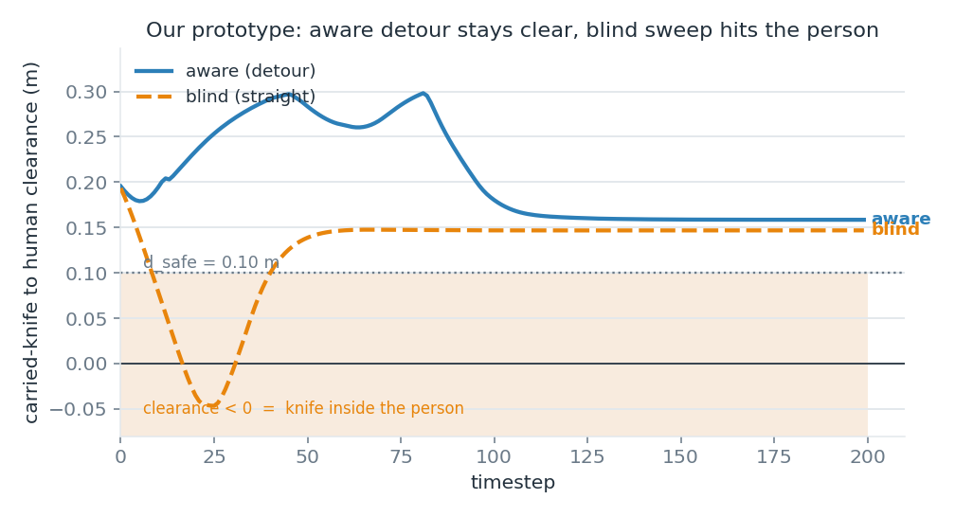
aware (detour) stays above the safe margin; blind (straight sweep) drives the knife into the person.
condition | min clearance | safe? | exposure
aware (detour) | +0.159 m | YES | 0 / 200 steps
blind (straight) | -0.047 m (knife in person) | NO | 32 / 200 steps
- SmolVLA (a 450M VLA) loads and drives the arm end-to-end on a laptop (CPU), with clearance logged — the full policy → environment → metric pipeline is validated.
6. Next steps
- real camera rendering with a Panda-competent policy (OpenVLA / π₀ / GR00T-N1.7);
- a fully dynamic human and RoboCasa kitchen scenes;
- release as a benchmark (the metric is the contribution); a safety filter / alignment method is a natural follow-up.
Note: many cited works are 2025–2026 preprints; identifiers should be re-checked before formal citation.

