**May 23, 2017:**

1. Editor in Question creation:

In Owner role -> Quizzes -> Question Bank -> Create Questions:

The following editors were in the old script, and is currently absent in the demo site:

* Code Snippet
* FMath Editor
* Extended Symbol selector
* CodeCogs Equation Editor

1. One more missing details from “Improvement and Questions 20170330.docx”

**“2. Copy Function**:

- Should directly duplicate that question under the same subject and topic.”

currently the copy function will ask for the "subtopics" and the "topics" for each "copied" question, please change this to be automatically the same as the question it was copied from.

1. Question editing problem 1:

I remember I have mentioned this before (or did I forget), after “Update” a question, the page will be redirected to the “Question Topics”, this is not right. It should have redirected to the “topic” question list where the question was originated from.

Here is the question I edited:

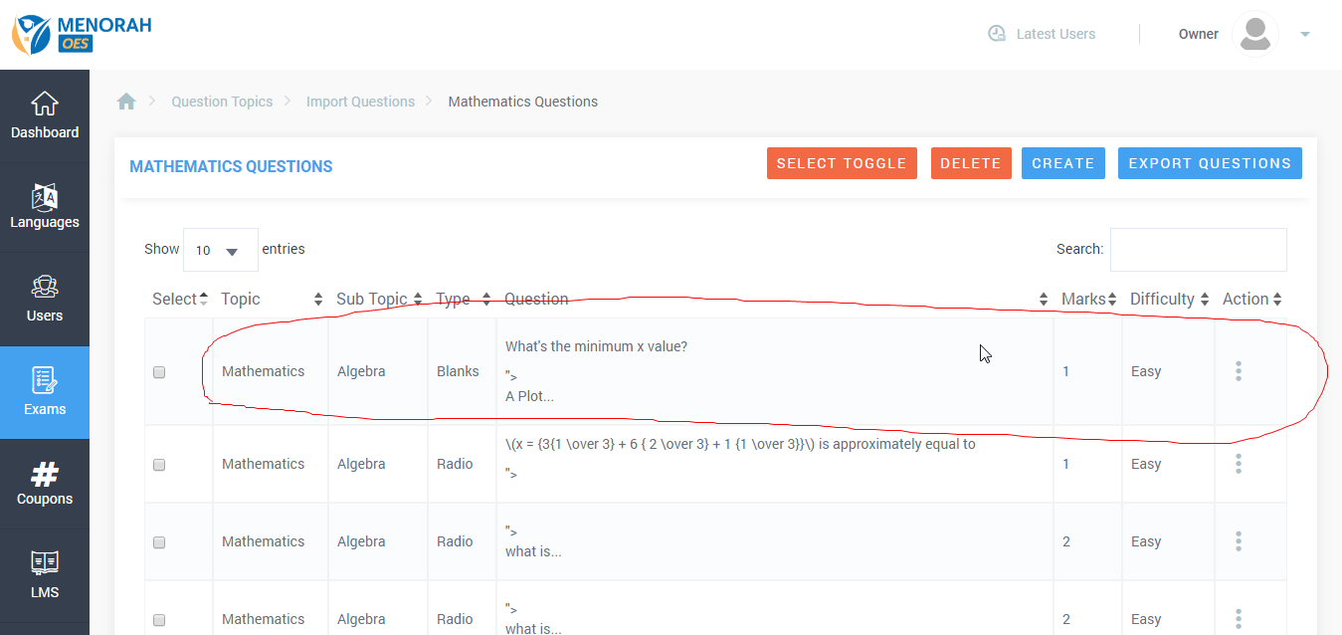

After editing, the page should be **redirecting to this above page as well**.

Instead the page will send me to here:

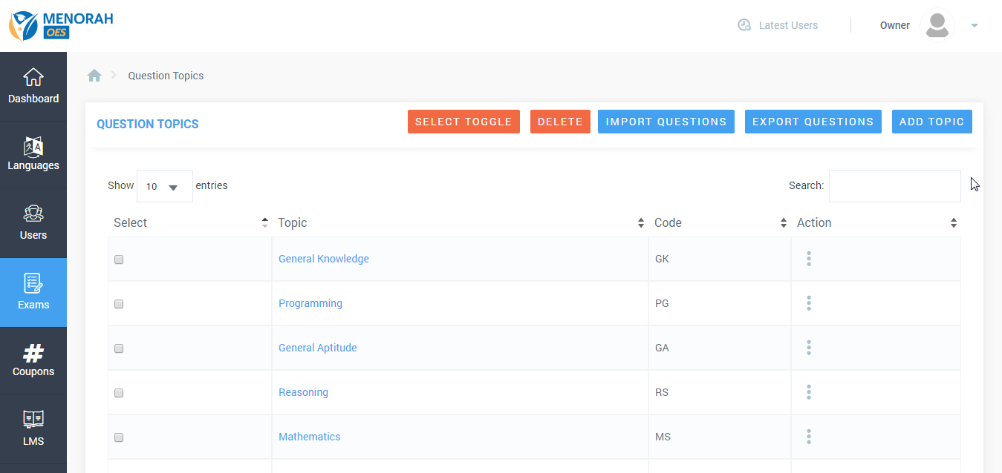

1. Question editing problem 2:

Current system allows uploading image, but **NOT** allow change the size of image (no matter how big the uploaded image is or what format it was in). How do I change this?

Screenshot of the question editing: no way to set size. The image setting is NOT found in the source code either.

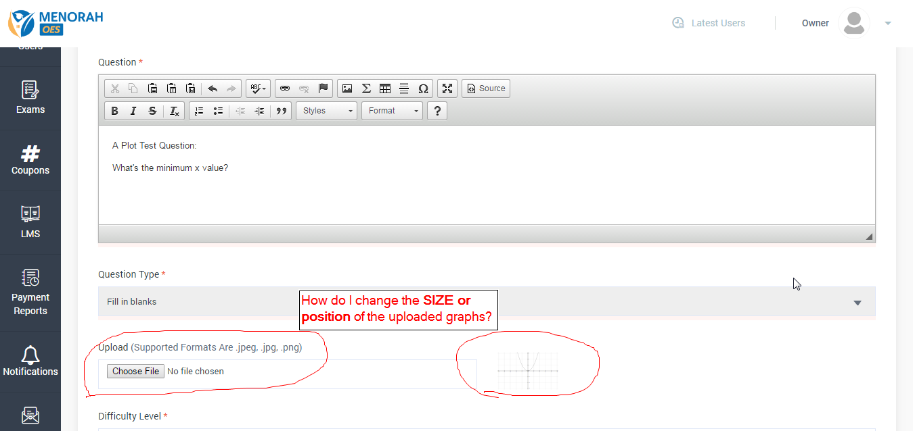

Here is what it looks like:

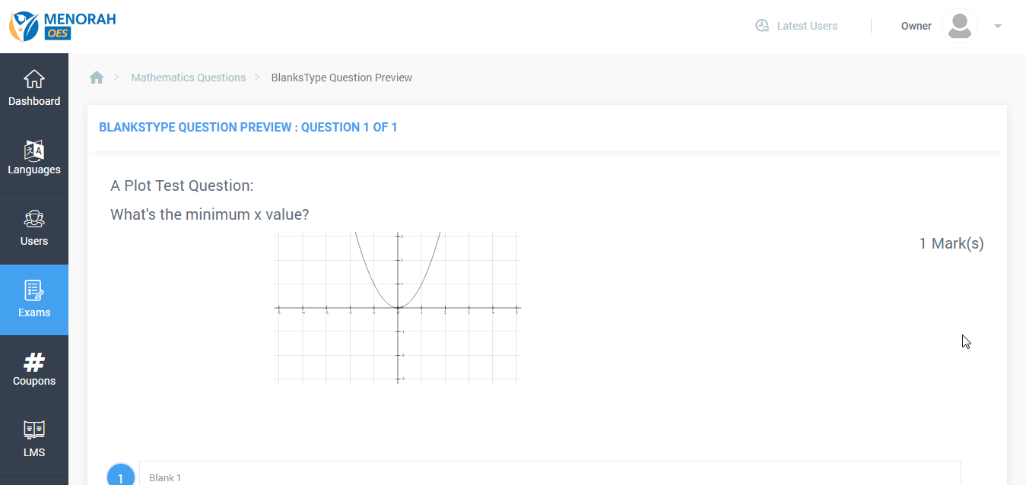

1. How do I add custom CSS codes or setting? Please give me a linked place in Owner setting to edit this if possible?