**Ultrasound project**

**Component:**

hc-sr04 arduino……………………………………………………..

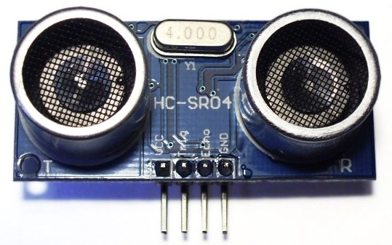

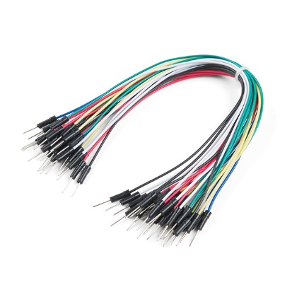Jumper Wires…………………………………………….

Arduino uno……………………………………………….

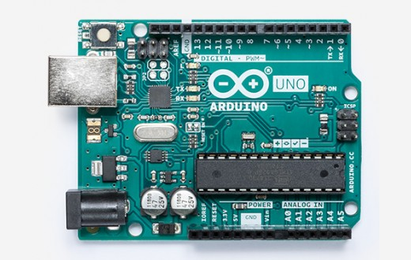

Serial I2C LCD (16x2) ……………………………………….

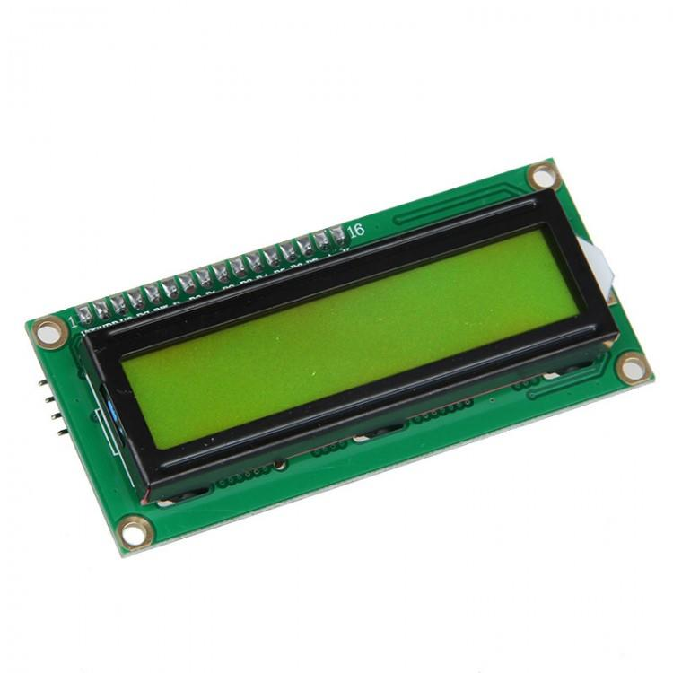

Momentary button x3.......................................................

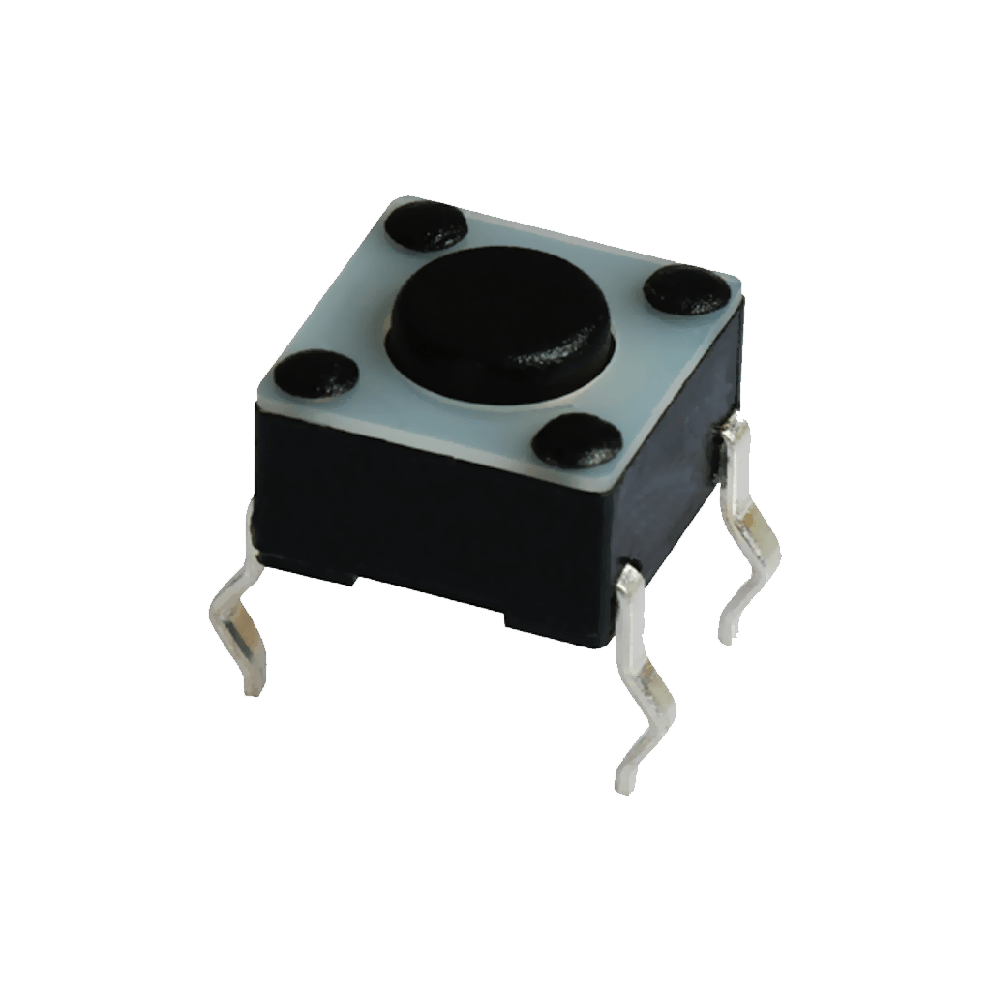

Breadboard…………………………………………………………………..

