KDCIM 설치 및 환경구성 / opendcim 24.01 대응 - ACE

written by simmon
simmon@nplob.com

1. 기본 프로그램 설치성
dnf install httpd php php-devel mariadb-server php-pdo php-mysqlnd php-mbstring php-pecl-zip php-snmp php-xml php-snmp php-gd php-ldap php-intl graphviz graphviz-gd wget vim tar mod_ssl
sed -i "s/SELINUX=enforcing/SELINUX=disabled/g" /etc/selinux/config
setenforce 0

2. 필요한 서비스 데몬 mariadb, apache

가. 데몬 활성화

systemctl enable mariadb --now
Created symlink '/etc/systemd/system/mysql.service' → '/usr/lib/systemd/system/mariadb.service'.
Created symlink '/etc/systemd/system/mysqld.service' → '/usr/lib/systemd/system/mariadb.service'.
Created symlink '/etc/systemd/system/multi-user.target.wants/mariadb.service' → '/usr/lib/systemd/system/mariadb.service'.
systemctl enable httpd --now
Created symlink '/etc/systemd/system/multi-user.target.wants/httpd.service' → '/usr/lib/systemd/system/httpd.service'.
systemctl enable php-fpm --now
Created symlink '/etc/systemd/system/multi-user.target.wants/php-fpm.service' → '/usr/lib/systemd/system/php-fpm.service'.
나. Mariadb 기본구성 및 보안설정

mysql_secure_installation
NOTE: RUNNING ALL PARTS OF THIS SCRIPT IS RECOMMENDED FOR ALL MariaDB
SERVERS IN PRODUCTION USE! PLEASE READ EACH STEP CAREFULLY!
In order to log into MariaDB to secure it, we'll need the current
password for the root user. If you've just installed MariaDB, and
haven't set the root password yet, you should just press enter here.
Enter current password for root (enter for none):
OK, successfully used password, moving on...
Setting the root password or using the unix_socket ensures that nobody
can log into the MariaDB root user without the proper authorisation.
You already have your root account protected, so you can safely answer 'n'.
Switch to unix_socket authentication [Y/n] Y
Enabled successfully!
Reloading privilege tables..
... Success!
You already have your root account protected, so you can safely answer 'n'.
Change the root password? [Y/n] Y
New password:
Re-enter new password:
Password updated successfully!
Reloading privilege tables..
... Success!
By default, a MariaDB installation has an anonymous user, allowing anyone
to log into MariaDB without having to have a user account created for
them. This is intended only for testing, and to make the installation
go a bit smoother. You should remove them before moving into a
production environment.
Remove anonymous users? [Y/n]
... Success!
Normally, root should only be allowed to connect from 'localhost'. This
ensures that someone cannot guess at the root password from the network.
Disallow root login remotely? [Y/n]
... Success!
By default, MariaDB comes with a database named 'test' that anyone can
access. This is also intended only for testing, and should be removed
before moving into a production environment.
Remove test database and access to it? [Y/n]
- Dropping test database...
... Success!
- Removing privileges on test database...
... Success!
Reloading the privilege tables will ensure that all changes made so far
will take effect immediately.
Reload privilege tables now? [Y/n]
... Success!
Cleaning up...
All done! If you've completed all of the above steps, your MariaDB
installation should now be secure.
Thanks for using MariaDB!

다. 데이타베이스 생성 (손으로 입력해요)
# mysql -u root -p
> create database dcim;
> grant all privileges on dcim.* to ‘dcim’@’localhost’ identified by ‘dcim’;
MariaDB [(none)]> flush privileges;
Query OK, 0 rows affected (0.001 sec)

라. opendcim을 위한 아파치 설정
갸. httpd.conf 환경설정 추가 및 수정
# vi /etc/httpd/conf/httpd.conf
Alias /dcim /opt/opendcim/KDCIM
Listen 443
마. opendcim 환경구성
(1) 예시
# vim /etc/httpd/conf.d/opendcim.conf
<VirtualHost *:443>
SSLCertificateKeyFile "/etc/pki/tls/private/localhost.key"
SSLCertificateFile "/etc/pki/tls/certs/localhost.crt"
SSLCACertificateFile "/etc/pki/tls/certs/ca-bundle.crt"
AllowEncodedSlashes On
<Directory /opt/openDCIM/opendcim>
AllowOverride All
AuthType Basic
AuthName "openDCIM"
AuthUserFile /opt/openDCIM/.htpasswd
Require valid-user
</Directory>
</VirtualHost>

(2) 실제 적용 F42 서버에 실제 적용한 환경구성 – 해당 서비스로만 제한 (하나씩 입력해서 적용)
# vim /etc/httpd/conf.d/opendcim.conf
<Directory /opt/opendcim/KDCIM>
AllowOverride All
AuthType Basic
AuthName "openDCIM"
AuthUserFile /opt/opendcim/KDCIM/.htpasswd
Require valid-user
</Directory>

(3) 복붙(ctrl+c → ctrl+v 의 결과)한 경우 모든 공백부분 제거해 넣기
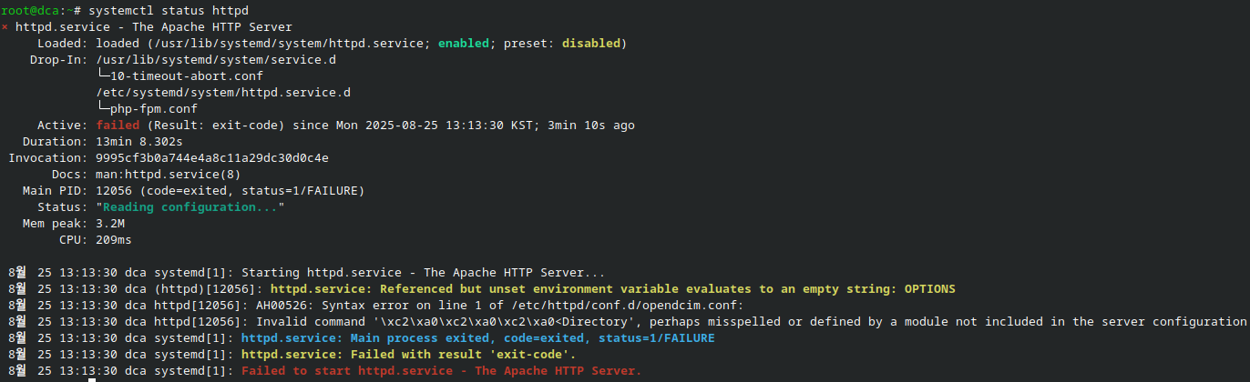
(4)/etc/httpd/conf.d/ssl.conf 환경설정 수정분
<VirtualHost _default_:443>
# Use separate log files for the SSL virtual host; note that LogLevel
# is not inherited from httpd.conf.
ErrorLog logs/ssl_error_log
TransferLog logs/ssl_access_log
LogLevel warn
# SSL Engine Switch:
# Enable/Disable SSL for this virtual host.
AllowEncodedSlashes On
SSLEngine on
3. https 구성을 위한 ssl 파일생성
가. ssl 생성을 위한 인증구성
# openssl genrsa -out ca.key 4096
# openssl req -new -key ca.key -out ca.csr
You are about to be asked to enter information that will be incorporated
into your certificate request.
What you are about to enter is what is called a Distinguished Name or a DN.
There are quite a few fields but you can leave some blank
For some fields there will be a default value,
If you enter '.', the field will be left blank.
-----
Country Name (2 letter code) [XX]:kr
State or Province Name (full name) []:seoul
Locality Name (eg, city) [Default City]:seoul
Organization Name (eg, company) [Default Company Ltd]:nplob
Organizational Unit Name (eg, section) []:technology
Common Name (eg, your name or your server's hostname) []:simmon
Email Address []:simmon@nplob.com
Please enter the following 'extra' attributes
to be sent with your certificate request
A challenge password []:
An optional company name []:
# openssl x509 -req -days 36500 -in ca.csr -signkey ca.key -out ca.crt
Certificate request self-signature ok
subject=C=kr, ST=seoul, L=seoul, O=nplob, OU=technology, CN=simmon, emailAddress=simmon@nplob.com
# cp ca.key /etc/pki/tls/private/
# cp ca.crt /etc/pki/tls/certs/ca.crt
# cp ca.csr /etc/pki/tls/private/ca.csr
나. /etc/httpd/conf.d/ssl.conf/ssl.conf 인증서 설정
# vi /etc/httpd/conf.d/ssl.conf

# Point SSLCertificateFile at a PEM encoded certificate. If
# the certificate is encrypted, then you will be prompted for a
# pass phrase. Note that restarting httpd will prompt again. Keep
# in mind that if you have both an RSA and a DSA certificate you
# can configure both in parallel (to also allow the use of DSA
# ciphers, etc.)
# Some ECC cipher suites (http://www.ietf.org/rfc/rfc4492.txt)
# require an ECC certificate which can also be configured in
# parallel.
SSLCertificateFile /etc/pki/tls/certs/ca.crt
# Server Private Key:
# If the key is not combined with the certificate, use this
# directive to point at the key file. Keep in mind that if
# you've both a RSA and a DSA private key you can configure
# both in parallel (to also allow the use of DSA ciphers, etc.)
# ECC keys, when in use, can also be configured in parallel
SSLCertificateKeyFile /etc/pki/tls/private/ca.key
# Server Certificate Chain:
# Point SSLCertificateChainFile at a file containing the
# concatenation of PEM encoded CA certificates which form the
# certificate chain for the server certificate. Alternatively
# the referenced file can be the same as SSLCertificateFile
# when the CA certificates are directly appended to the server
# certificate for convenience.
#SSLCertificateChainFile /etc/pki/tls/certs/server-chain.crt
4. KDCIM 가져오고, 기본 환경설정 만들기
가. KDCIM 기본구성(설치 및 기본구성)
mkdir -p /opt/opendcim/
cd /opt/opendcim/
git clone https://github.com/simmon-nplob/KDCIM/KDCIM.git
cd KDCIM
mkdir -p assets/{pictures,drawings,reports}
chown apache:apache assets/*
cp db.inc.php-dist db.inc.php

* 건너뛰기 (참조)

- If translations are desired install the relevant locales / 한국어 부분적용 / 상위배포판에 적용하기
dnf -y install $(for x in $(ls /opt/opendcim/KDCIM/locale/); do echo -n " glibc-langpack-${x%_*}"; done)

Selinux 환경에서 적용 - Either disable selinux or plan to deal with it.
semanage fcontext -a -t httpd_sys_rw_content_t "/opt/opendcim/openDCIM/assets(/.*)?"
restorecon -R -v /opt/opendcim/KDCIM/assets

나. 보안설정 - Add user to htpasswd for apache authentication
htpasswd -c /opt/opendcim/KDCIM/.htpasswd dcim
# htpasswd -c /opt/opendcim/KDCIM/.htpasswd dcim
New password:
Re-type new password:
Adding password for user dcim

다. 아파치 최종 상태확인 후 접속 / 오류와 문제를 제거한 상태의 아파치
# systemctl status httpd
● httpd.service - The Apache HTTP Server
Loaded: loaded (/usr/lib/systemd/system/httpd.service; enabled; preset: disabled)
Drop-In: /usr/lib/systemd/system/service.d
└─10-timeout-abort.conf
/etc/systemd/system/httpd.service.d
└─php-fpm.conf
Active: active (running) since Mon 2025-08-25 13:29:26 KST; 52min ago
Invocation: 0eb9c113c8df4bd899bd89c2e5857ecc
Docs: man:httpd.service(8)
Main PID: 14674 (httpd)
Status: "Total requests: 0; Idle/Busy workers 100/0;Requests/sec: 0; Bytes served/sec: 0 B/sec"
Tasks: 177 (limit: 9412)
Memory: 14.9M (peak: 16.1M)
CPU: 6.802s
CGroup: /system.slice/httpd.service
├─14674 /usr/sbin/httpd -DFOREGROUND
├─14676 /usr/sbin/httpd -DFOREGROUND
├─14677 /usr/sbin/httpd -DFOREGROUND
├─14678 /usr/sbin/httpd -DFOREGROUND
└─14679 /usr/sbin/httpd -DFOREGROUND
8월 25 13:29:26 dca systemd[1]: Starting httpd.service - The Apache HTTP Server...
8월 25 13:29:26 dca httpd[14674]: Server configured, listening on: port 443
8월 25 13:29:26 dca systemd[1]: Started httpd.service - The Apache HTTP Server.
라. 웹서버 동작을 위한 최소 방화벽(443/tcp) 개방상태 확인
# firewall-cmd --list-all
FedoraServer (default, active)
target: default
ingress-priority: 0
egress-priority: 0
icmp-block-inversion: no
interfaces: enp0s3
sources:
services: cockpit dhcpv6-client ssh
ports: 443/tcp
protocols:
forward: yes
masquerade: no
forward-ports:
source-ports:
icmp-blocks:
rich rules:

마. db환경 비번확인/지정값 변경시 수정
# vi /opt/opendcim/KDCIM/db.inc.php

// Set to true if you want to skip the installer check
$devMode = strtoupper(getenv('OPENDCIM_DEVMODE'))=="TRUE" ? true:false;
$dbhost = getenv('OPENDCIM_DB_HOST') ? getenv('OPENDCIM_DB_HOST'):'localhost';
$dbname = getenv('OPENDCIM_DB_NAME') ? getenv('OPENDCIM_DB_NAME'):'dcim';
$dbuser = getenv('OPENDCIM_DB_USER') ? getenv('OPENDCIM_DB_USER'):'dcim';
$dbpass = getenv('OPENDCIM_DB_PASS') ? getenv('OPENDCIM_DB_PASS'):'dcim';
$dbport = getenv('OPENDCIM_DB_PORT') ? getenv('OPENDCIM_DB_PORT'):'3306';
$initialAdminUser = getenv('OPENDCIM_ADMIN_USER') ? getenv('OPENDCIM_ADMIN_USER'):'dcim';
바. 서버 데몬 재동작
# systemctl daemon-reload
# systemctl restart httpd php-fpm mariadb

5. 서버 동작을 위한 웹서버 접속

가. 서버 주소확인
# ifconfig|grep broadcast
inet 192.168.150.73 netmask 255.255.255.0 broadcast 192.168.150.255
나. 웹접속(https)로 접속
(1) 고급 – 안전하지않은연결(직접 ssl을 만들었으므로)
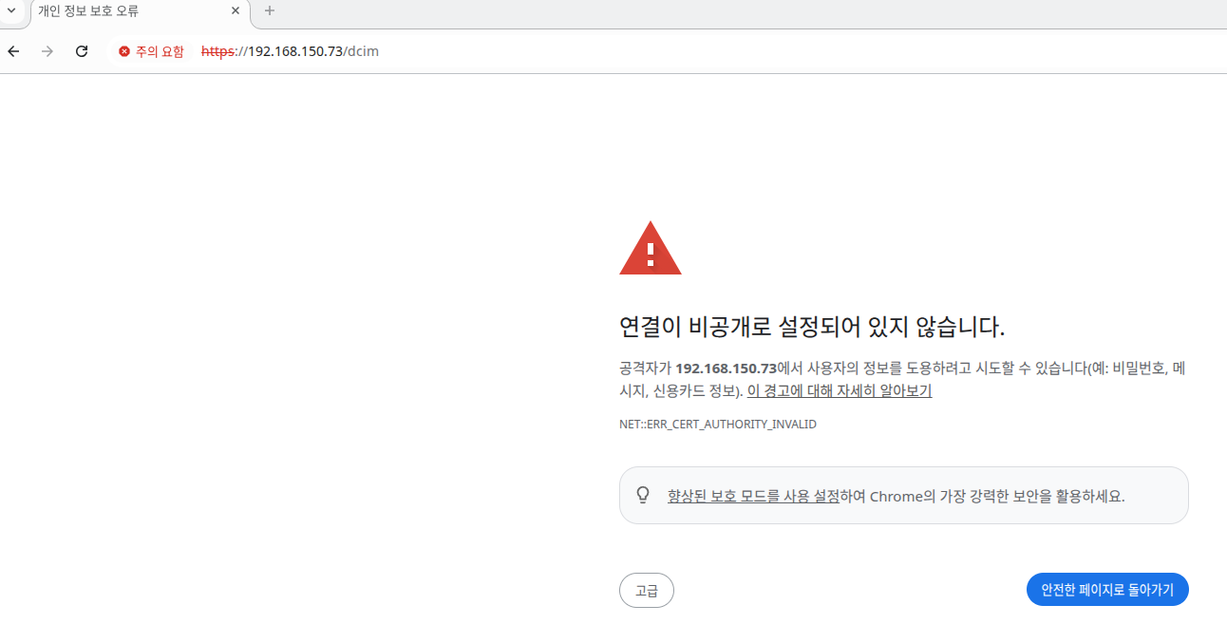
(2) .htpasswd로 구성한 계정 및 비밀번호 입력
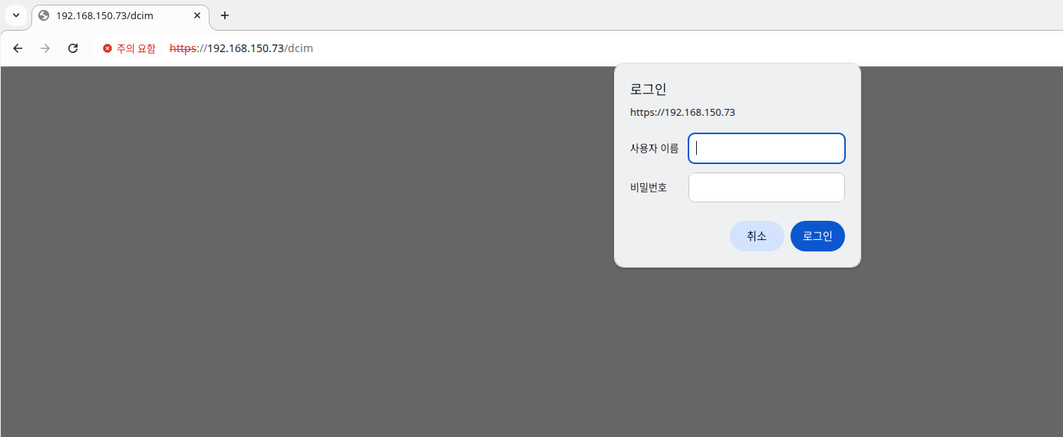

6. 기타 오류 및 문제점 점검부분

가. httpd 환경설정관련 오류 – mod_ssl 관련 미설치에 따른 문제
나. ssl 환경구성 오류와 지정값 문제
다. httpd 환경구성 부분 오류부분(기본 설정값 점검)
라. mariadb db 구성 및 환경설정부분 확인
마. openDCIM 환경구성과 DB 연동문제
바. 각종 폴더 및 파일 위치 지정 부분이 일치하는지 확인 할 것.

7. 서버 연동 및 기존 db 가져오기

가. 구성된 서버의 sql을 덤프해서 가져오기 전에, 이식하여야 할 서버의 db 테이블(dcim)이 일치해야 한다.
나. db를 만들고, 이전 서버의 db를 가져온다.
다. openDCIM의 사진과 도면 위치는 설치폴더의 assets/{picture,drawings,reports}에 위치한다.
라. 한국어 번역과 적용부분은 다음 폴더를 수정해 참고한다.

해당 배포판은 KDCIM – opendcim 23.04/24.01용 한글화 적용판입니다.
/opt/opendcim/KDCIM/locale/ko_KR/LC_MESSAGES# openDCIM.po

마. 초기 동작 기본화면
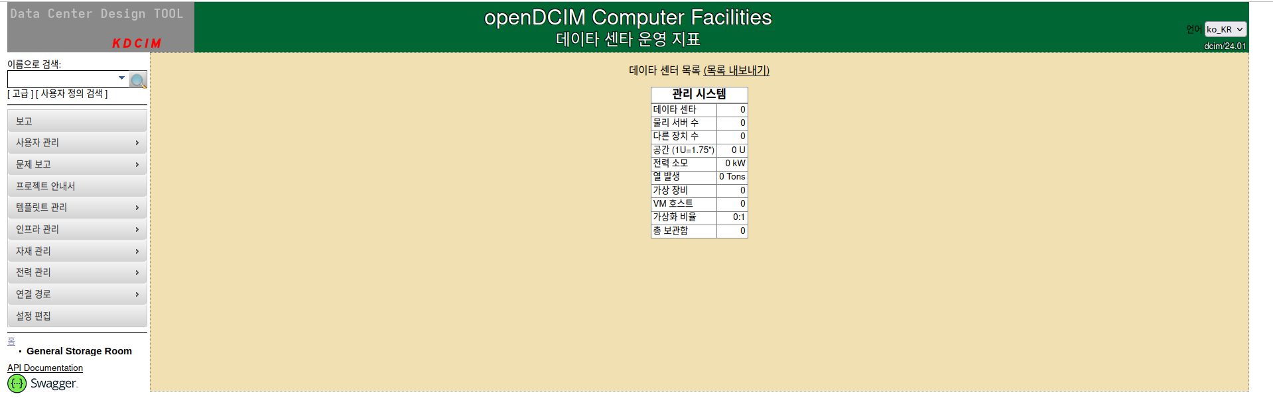
8. 기타
openDCIM은 데이타센타 설계 및 서버 제어군 구성을 시험 할 수 있는 훌륭한 도구입니다. 서버관리에 적용하세요.
해당 부분은 KDCIM으로 한글화 적용부분으로, 사용 가능한 환경에서 시험되었습니다.

