**Bedtime Story Generator**

Tiancheng He

**Overview**

Kids love stories, but for parents, after a busy day, they could hardly come up with a new story

for their kids. The stories from books will exhaust sooner or later. That’s when our Bedtime Story Generator could be a good helper! The Generator enables the users to enter a very basic idea of the story, it can be anything happened from work, from any source they have read, anything interesting. Also, the generator can let the user to choose a merit to include in the story so that kids can learn something while having fun. After the story, there will be an extra interesting fact related to the story, so kids can learn some extra knowledge.

**Installing**



Use the requirements.txt to build up the venv. Use the venv to play with it.

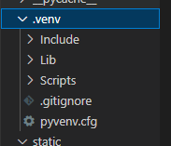

**Code**

Run the generator.py, there are two main functions.

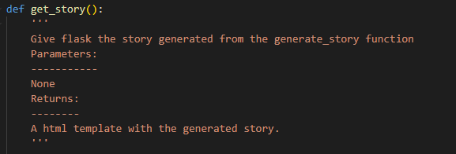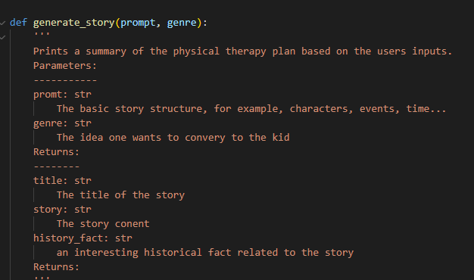

**Flask**

Use $flask run to get a website, connect to it.

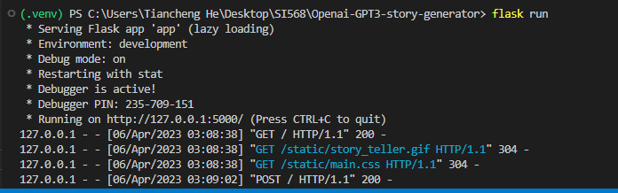

Use the <http://127.0.0.1:5000/> to connect to the website interface:

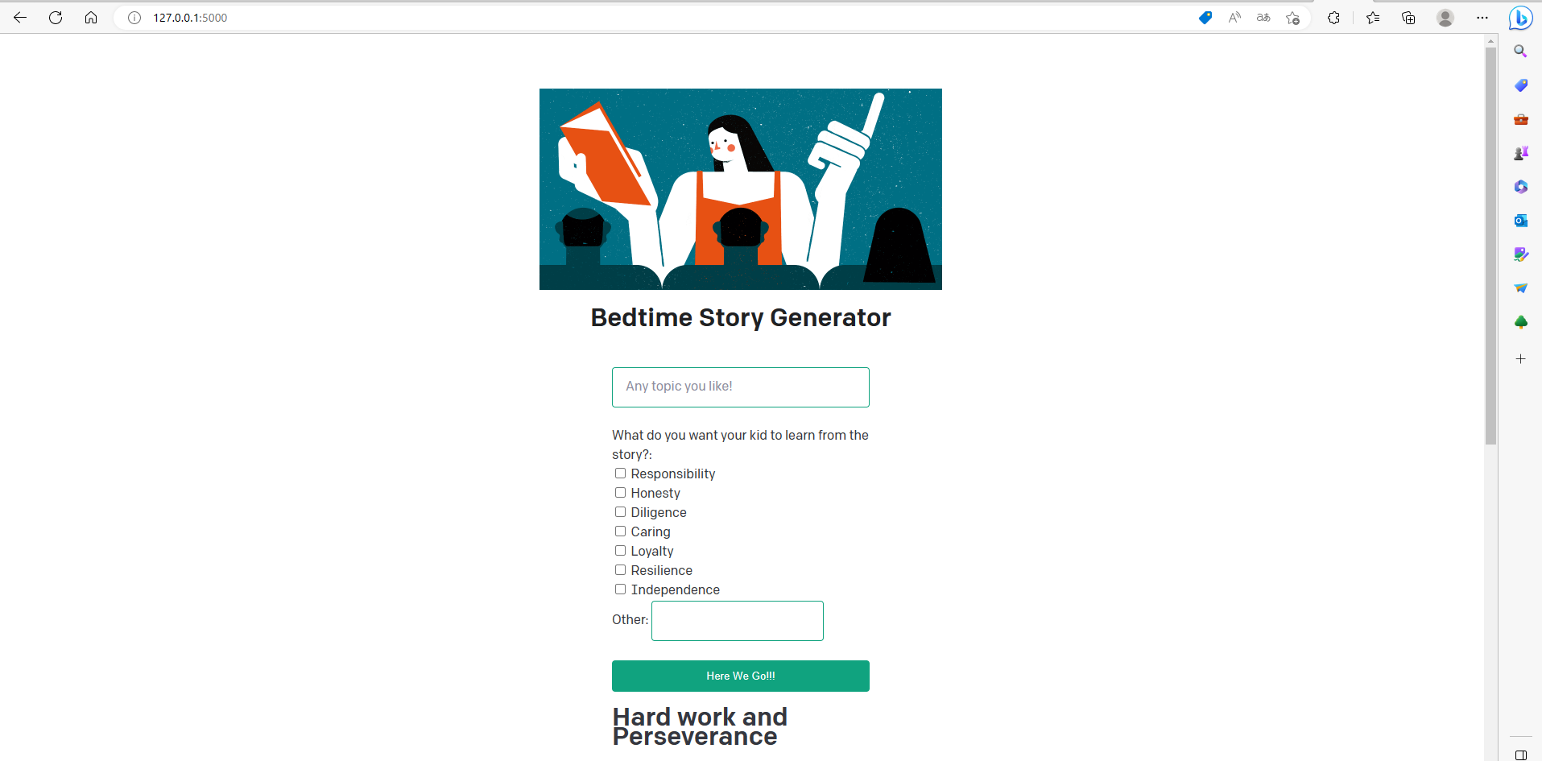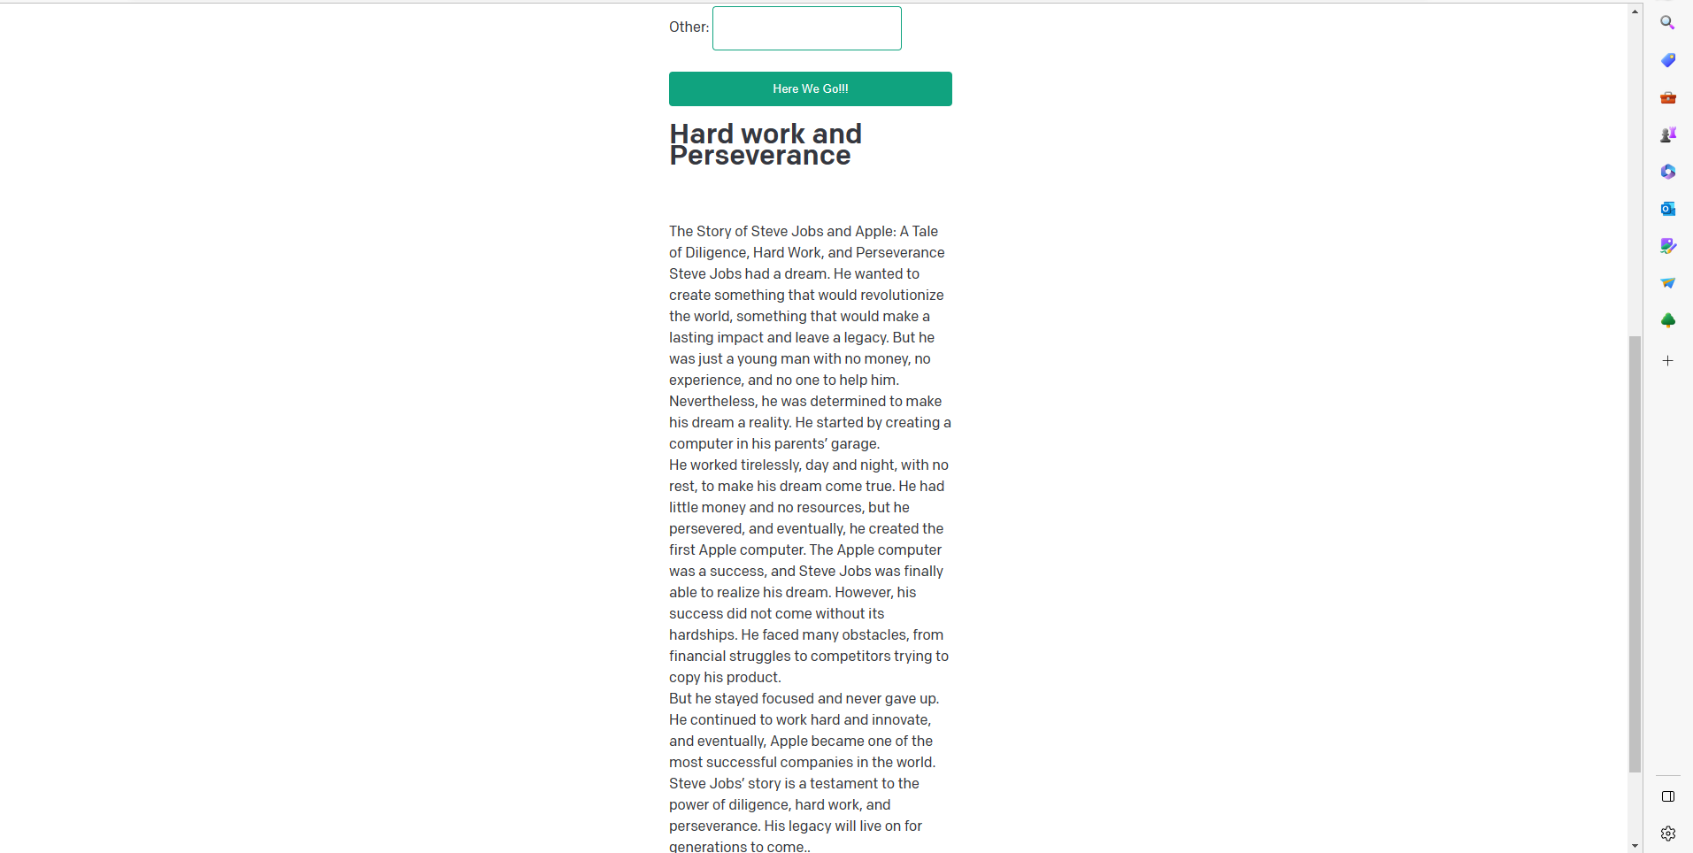

When the story is finished, user can just type another story idea, click another checkbox and generate again!

**Citing**

I generated some ideas from “astro-satyam75” on github.