**INSPIRATION**

The Covid-19 pandemic has adversely affected the global economy, leaving investors baffled over questions like, should they invest or stay put? With this in mind, we developed a mobile application- Bullz and Bearz, that helps individuals in making their investment decisions, particularly in the Stock Market.

**WHAT IT DOES?**

In the world of investing, there is a popular saying that market crashes should be seen as opportunities to lap up quality stocks and there’s something that we hear over and over again, that an investor should avoid putting all their eggs in the same basket.

Bullz and Bearz does exactly that for you, it serves personalised recommendations to the users and uses sentiment analysis based on latest news headlines to render a sentiment score to each stock, which users can use to compare against other stocks.

Instead of predicting a volatile environment like the stock market, the sentiment analysis score is a statistical score that doesn’t give false directions to the users, and rather gives them a statistical comparison between different stocks.

That makes both our things; Recommendation (Clustering) and Sentiment Analysis subjective instead of giving false objective values.

**TECHNICAL IMPLEMENTATION**

The Bullz and Bearz iOS application (built with Swift) acts as the portal between the layman user and our Flask APIs deployed on Heroku. Making use of several key financial indicators and Machine Learning techniques, the application serves personalised recommendations to the users. To enable third-party developers and first-party improvements, all APIs are exposed publicly without any restrictions.

Using Web Scraping, News Analysis and NLTK, we give each stock a subjective sentiment rating based on current headlines regarding the company. Instead of providing half-baked predictions, this sentiment rating can be judged by the user to reduce risk and to make decisions regarding their holdings.

To facilitate user privacy, no data from the user is collected and/or stored by the application.

The UI elements are built and exported from Sketch. To conform with Apple’s Human Interface Guidelines, the app looks and works just as expected in Dark Mode.

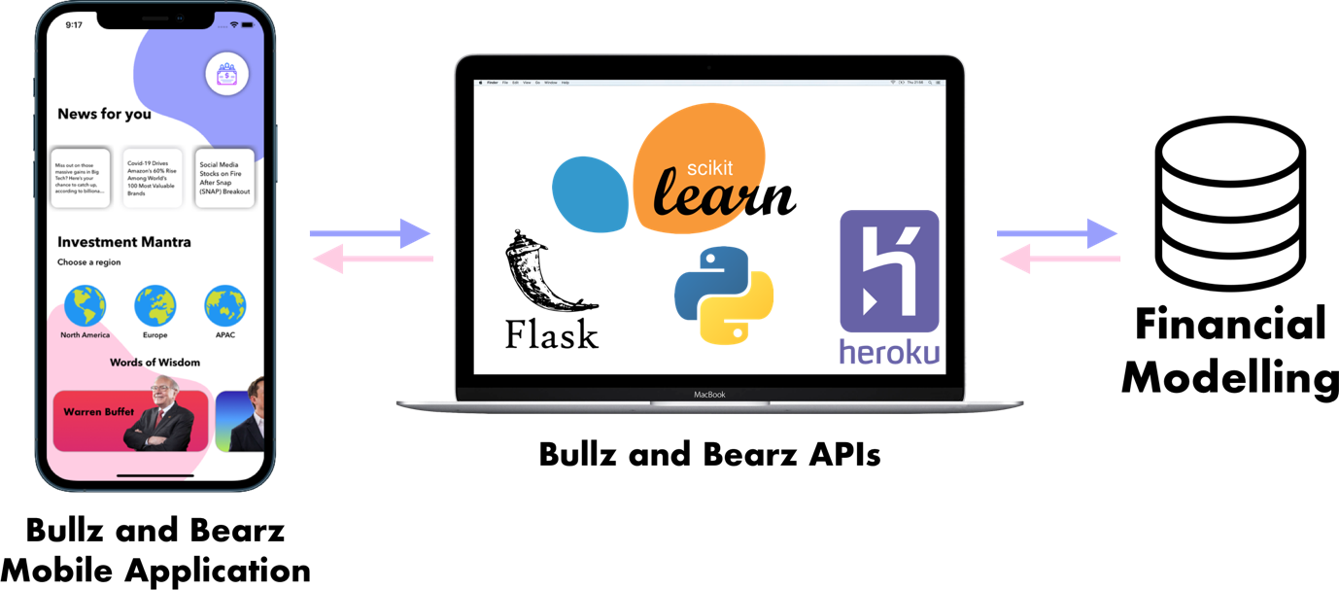

Fig 1: Technical framework

**KEY FEATURES**

There are 8 indicators that will help individuals in choosing a suitable investment option for them –

1. **Gross profit ratio-** This would help in analysing the profitability and financial performance of a company, indicating its efficiency.
2. **PE ratio-** Would determine if a stock is overvalued or undervalued and will reflect the market’s opinion on the earning capacity of a company.
3. **Price cash flow ratio-** This ratio is used for comparing a company’s market value to its cash flow, thereby, providing a reliable indication of long-term returns and a more accurate picture of the company.
4. **EPS diluted-** The diluted earnings per share is a constructive metric because it indicates earning capacity of a shareholder in the worst-case scenario in terms of EPS as it takes into account all convertible securities, such as convertible bonds or convertible preferred stock, which are changed into equity or common stock.
5. **Price book value ratio-** It indicates what each share of a company is worth according to the company’s books of accounts.
6. **Asset turnover ratio-** A measurement of the ability of management to use a firm's net assets to generate sales revenue.
7. **Dividend yield percentage-** This indicates the percentage of return that can be expected by way of dividends on the investment made at the prevailing market price.
8. **Price earning to growth ratio-** It draws the relationship between a stock’s P/E ratio and projected earnings growth rate over a specific period and gives investors an idea about a stock’s actual value taking projected growth rate into account.

**CHALLENGES**

Collecting data of over 20000 stocks was a challenge due to centralised databases, API restrictions and time boundations. We solved it by using multiple accounts and two different instances of an API. Financial modelling was done on the collected data to reduce network overhead.

**FUTURE GOALS**

At present we have incorporated a wide range of exchanges but we plan on adding more to the list later on. Along with this, we would offer an option of portfolio management and a more customised sector research option which would include- Sector-based Industries, Companies in a sector/Industry and their price movement. We intend to extend our services beyond the Stock market as well i.e. we would include mutual funds, bonds and real estate.