**Implementation**

The *Bullz and Bearz* iOS application (built with Swift) acts as the portal between the layman user and our Flask APIs deployed on Heroku.

Making use of several key financial indicators and Machine Learning techniques, the application serves personalised recommendations to the users. To enable third-party developers and first-party improvements, all APIs are exposed publicly without any restrictions.

Our *Bullz and Bearz* API also serves sentiment analysis for stocks that are recommended to the user, and also for any stocks that the user wants to explore on their own.

Using Web Scraping, News Analysis and NLTK, we give each stock a subjective sentiment rating based on current headlines regarding the company. Instead of providing half-baked predictions, this sentiment rating can be judged by the user to reduce risk and to make decisions regarding their holdings.

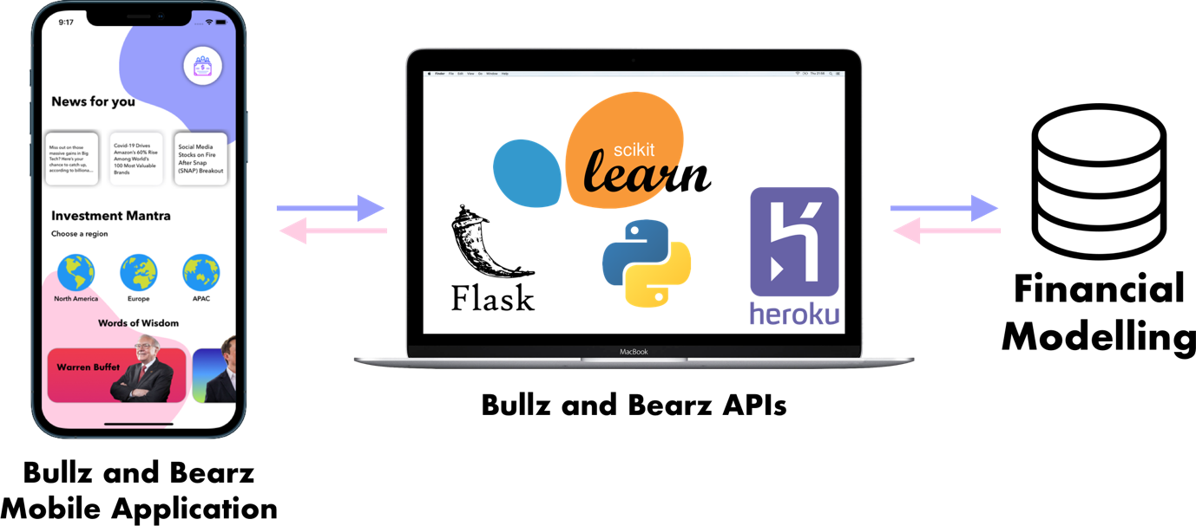

Fig.: Technical Framework

To facilitate user privacy, no data from the user is collected and/or stored by the application.

The UI elements are built and exported from Sketch. To conform with Apple’s Human Interface Guidelines, the app looks and works just as expected in Dark Mode.