QuickMoney

by The Thunderbolts ⚡

**How it works?**

*QuickMoney* starts with the borrower. With our aim to provide relief to economically stricken individuals, the whole application is centered around the requirements of the borrower.

On the platform, borrowers can send in a loan request with the total amount required and a short description of the loan request. Along with these details, a credit score of the borrower is attached to the request. The latest credit score of the user is sent along with the loan proposal. Users can retake the credit assessment before applying or re-applying for loans.

Our credit scoring system doesn’t offer a binary decision for loans, keeping in line with the decentralized nature of the platform, we use industry-standard metrics like Weight of Evidence (WoE) and Information Value (IV), used by Financial Analysts, along with Machine learning models like Logistic Regression to provide a scorecard for each user.

Lenders on *QuickMoney* can browse all loans and submit their terms. Decision on submitting proposals are completely on the mercy of the lenders, and we don’t have any say on that matter. The credit score of the borrowers puts itself as a truly decentralized method to judge loan requests.

After submitting proposals, lenders can cancel them and claim their refund till the time a borrower confirms the proposal. After the confirmation from the borrower, the loan amount is transferred to the borrower’s wallet and a smart EMI plan is started.

The borrower is notified about their total, and per-loan EMI so that they can keep track of their finances. All EMIs are paid directly to the lender, and *QuickMoney* doesn’t keep any middle-man charges.

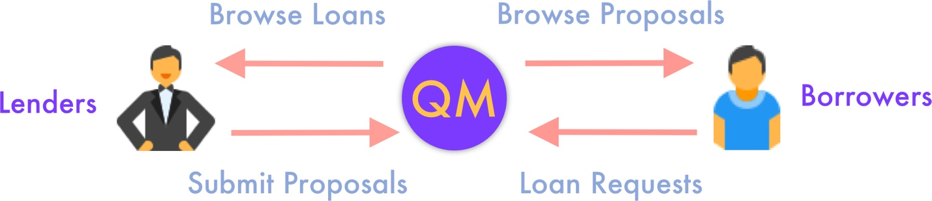

*Framework*

Cryptocurrency-based peer-to-peer lending on *QuickMoney* allow us to bypass any middlemen or third-party dealings. Bringing together lenders and borrowers under a common decentralized umbrella, we are able to provide a highly secure, fault-proof system. Since all transactions are made on the Ethereum blockchain and are publicly exposed, users are completely accountable for their financial dealings and all loans and dues can be traced back.

**Implementation**

QuickMoney is built on top of the Ethereum and Matic blockchains. Levering all the perks of the powerful ecosystem, our smart contracts are written in Solidity. During development, the Truffle CLI is used for compiling and migrating the contracts.

The front-end Web Application is built on React, offering a highly scalable and responsive platform. Users are exposed to financial transactions using Metamask, where they can add any account of their choice. And the entire application connects to the Ethereum Blockchain using Infura and communicates using the web3.js library.

Using Ethers (ETH) as the default mode of payment on the platform also allow us to target a global market, where users can complete cross-border payments seamlessly. *QuickMoney* allows users to engage in transactions using any cryptocurrency of their choice, be it stable coins like DAI (pegged to a 1 USD value) or any other ERC20 token of their choice.

We have used Portis as a Wallet Provider because of its seamless user interface which keeps the technical jargon out of the user’s view and lets them focus at what it important.

Our breakthrough financial credit scoring model is built in Python and deployed as a Flask App on Heroku.

Users credit ratings are persisted in a connected Firebase Realtime Database. Using graphical charts made available in the user interface, borrowers can keep a track of their credit ratings over time. Our scorecard follows the first principle of financial modelling, i.e., it is easy to interpret. Advance users can keep a deep dive into the distributions employed by the scorecard.

The complete application is deployed publicly using automatic deploys from GitHub to Netlify.

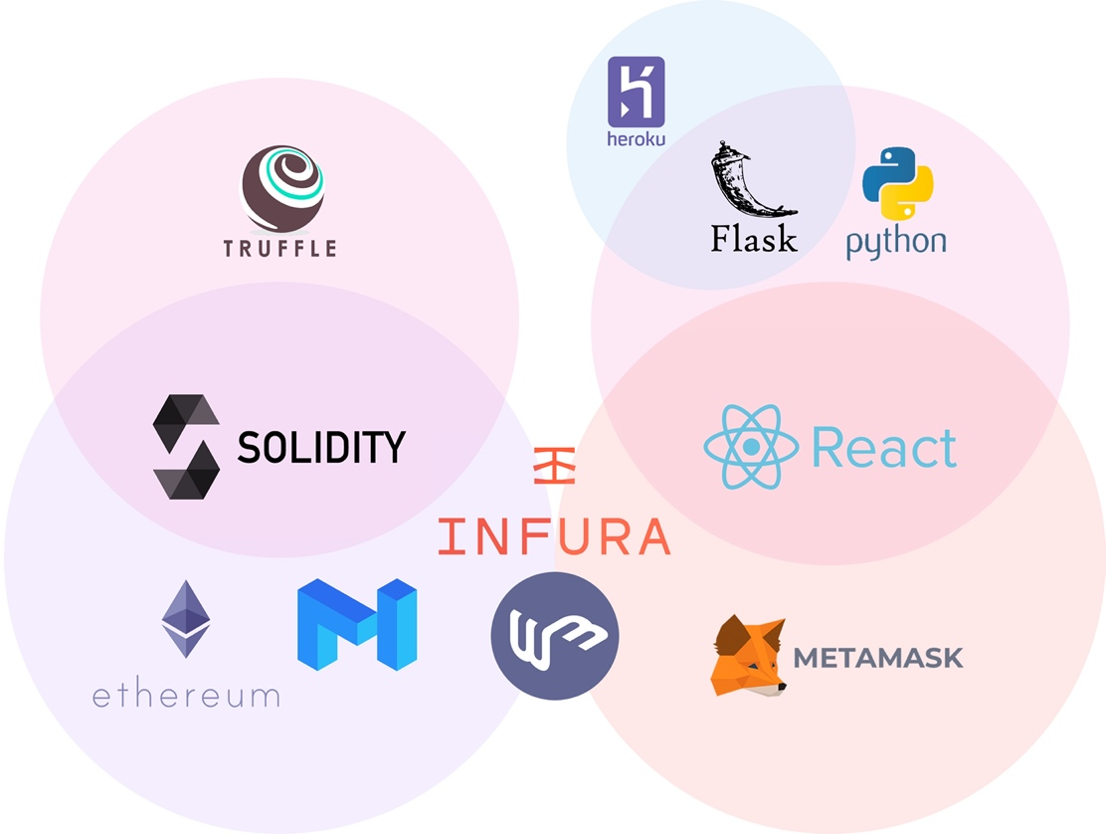

*Technical Implementation*