SimNIBS 2.1
TDCS cap files in MNI space

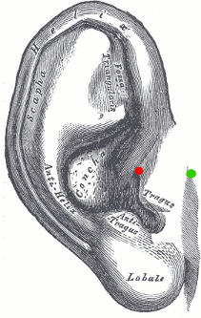
Fiducials.csv
The four fiducials were taken from Cutini et al., NeuroImage, 2011 and projected on the skin surface. The LPA and RPA (Left and Right Pre-Auricular) points correspond to the junction between the tragus and the helix (indicated by the red dot in the left figure; figure taken from fieldtrip wiki). Visual inspection suggests that their (projected) positions seem to be quite accurate.

EEG10-10_Cutini_2011.csv
The positions (61 electrodes, 4 fiducials) were taken from Cutini et al., NeuroImage, 2011
They were projected on the skin surface, as some of them had a small distance. The position of the 4 (projected) fiducials seem to be quite accurate.

EEG10-10_UI_Jurak_2007.csv
The four fiducials were taken from Cutini et al., NeuroImage, 2011 and projected on the skin surface. The 76 electrode positions were then created on the skin surface of the MNI template using the “UI” procedure described in Jurak et al., Neuroimage, 2007. They fit quite well with the positions reported in Cutini 2011.

EEG10-20_Okamoto_2004.csv
All 19 electrode positions were taken from Okamoto et al., NeuroImage, 2004
The four fiducials were taken from Cutini et al., NeuroImage, 2011, as Okamoto did not report their positions. All positions were projected on the skin surface, as they had small distances.

EEG10-20_extended_SPM12.csv
The positions (343 electrodes, 4 fiducials) were taken from spm12/EEGtemplates/ext1020.sfp
They were projected onto the skin, as they did not fit well on the skin surface. The LPA and RPA positions are lower than the junction between tragus and helix. The Iz position is lower than the inion of the MNI skull. Rather, position OIz seems to fit to the inion position. We thus would not recommend to this file as reference for the MNI coordinates for EEG coordinates. However, it gives a dense coverage of the head and might thus be useful for, e.g. testing optimization approaches.

A. Thielscher, O. Puonti, 2018

