Homework 1 – Advanced Software Engineering (2019/20)
Millionaire
Author: Simone Russo
ID: 531646
Repository: https://github.com/simo-r/ASE/tree/master/Homework1

1. Description

The development of the homework started by taking a tour of the provided skeleton. The tour aimed to discover and understand the class quiz.py and the methods already provided in the quizzes.py to exploit them in the development phase.
The implementation followed the specification provided inside the quizzes.py and in the PDF but at a certain point, I had to take a look at the test_quiz.py to understand the syntax and the values expected and returned by each endpoint.
I also added the keyword methods to the Flask route annotation restricting the usage of such methods to the only HTTP methods supported by them, so now Flask manages unsupported HTTP method on each route.
Note that, in the method all_quizzes() inside the quizzes.py the variable result gives a warning because “Local variable result might be referenced before assignment” but that will never happen because the execution of the method will either enter in PUT or the GET case thanks to the Flask route annotation.
The screenshot of the successfully passed tests below shows a warning due to the alias tested_app in the import “from myservice.app import app as tested_app” because Pytest scans every python file trying to execute as a function “everything” that starts with the test keyword.

2. Screenshots

2.1 PyTest
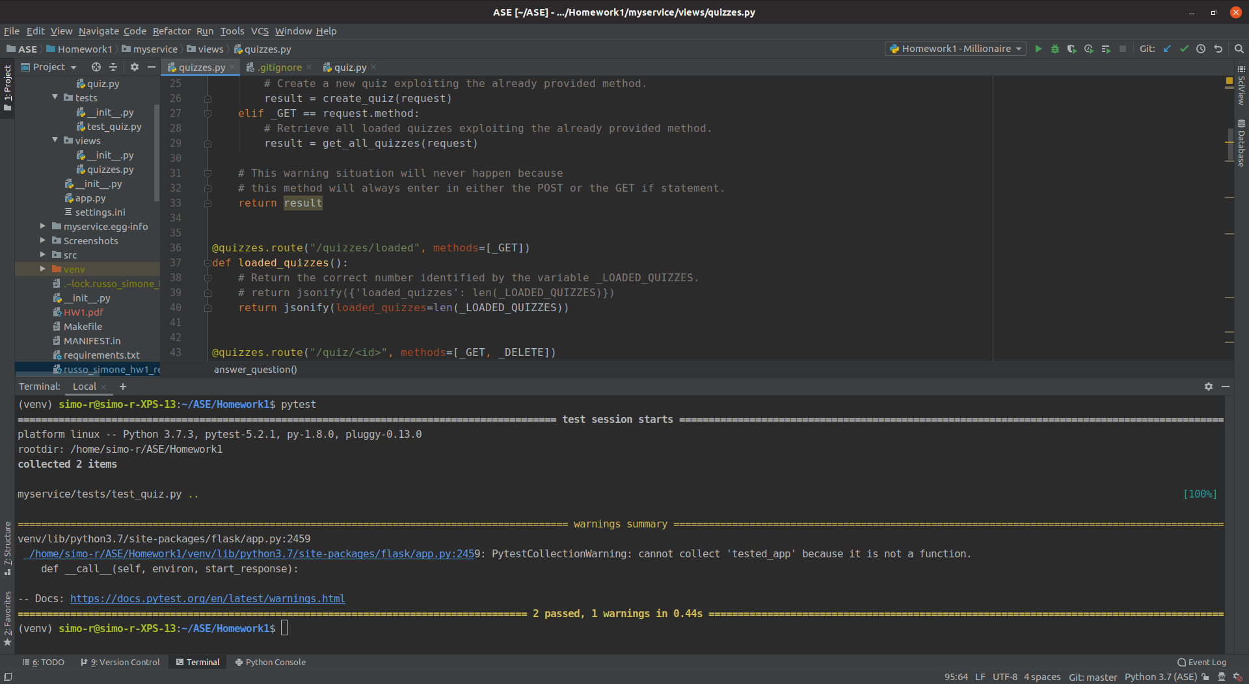Figure 1: test_quiz.py passed

2.2 Postman – All polls
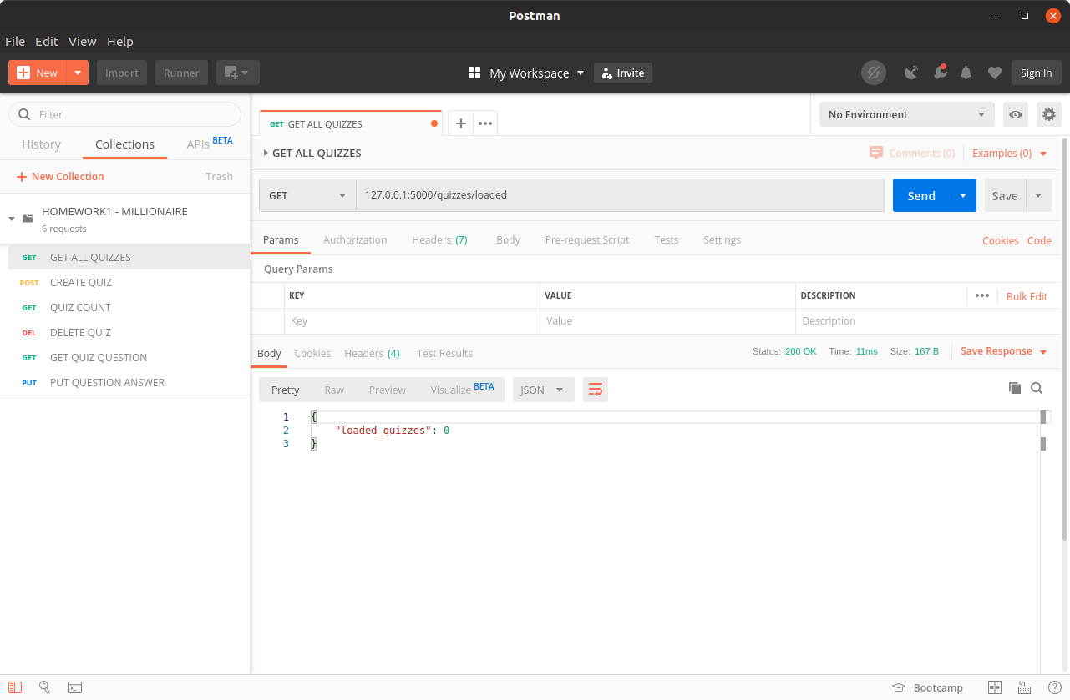Figure 2: Test1 - No loaded quiz
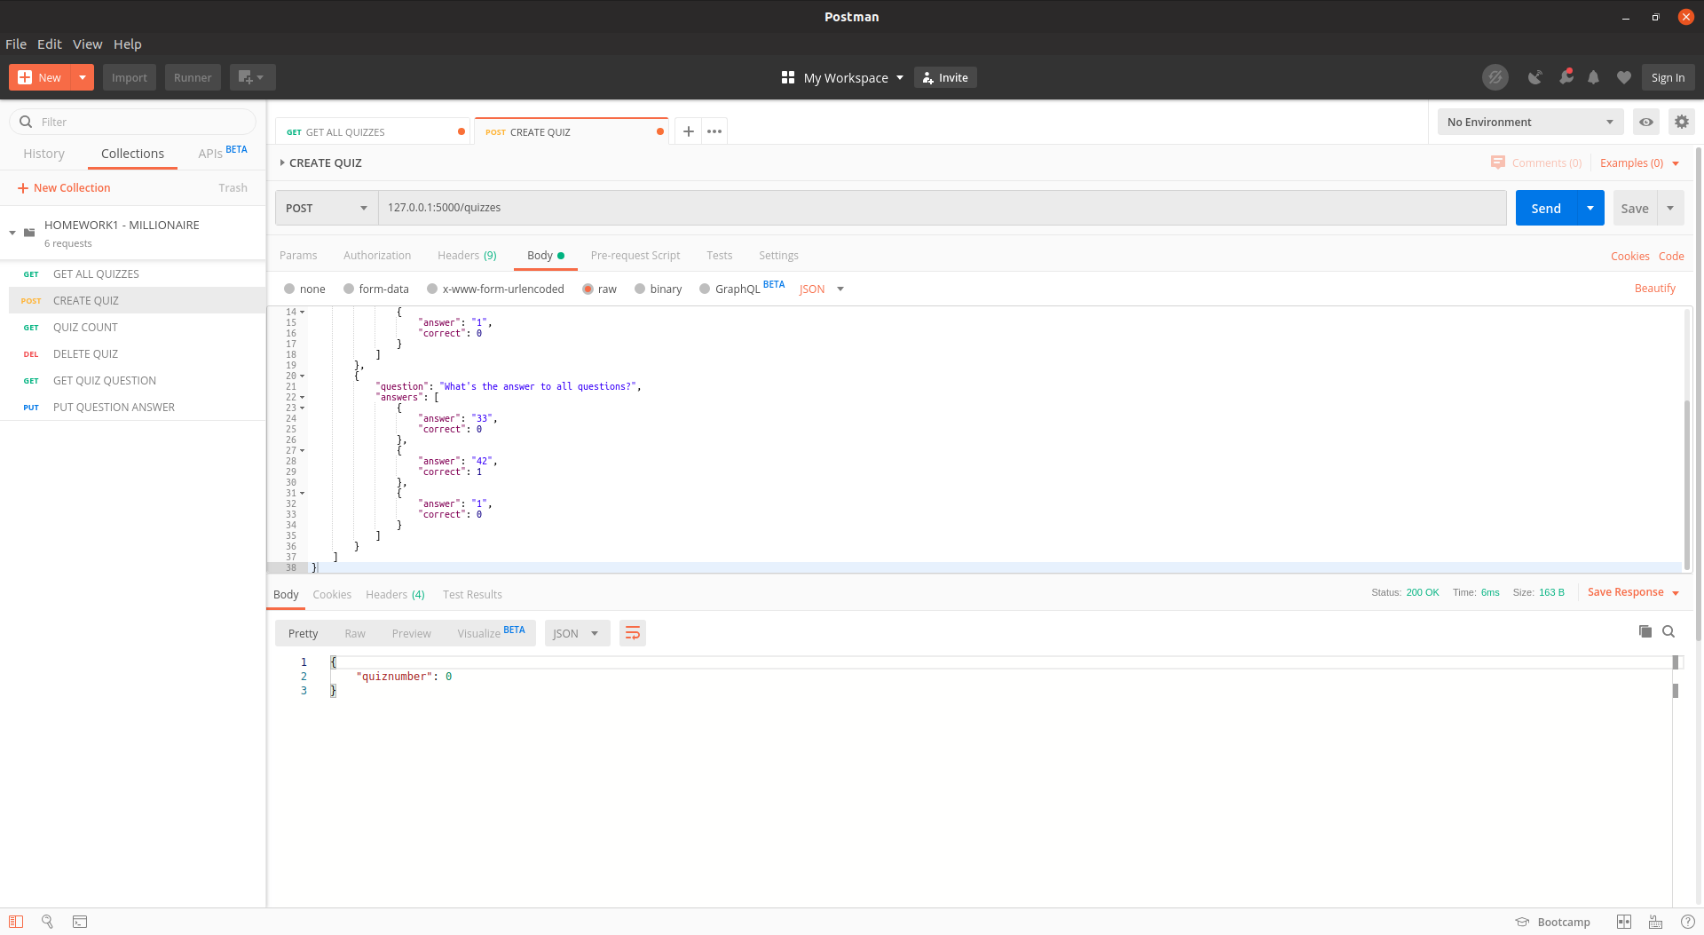Figure 3: Test2 - Create 1st quiz with 2 questions
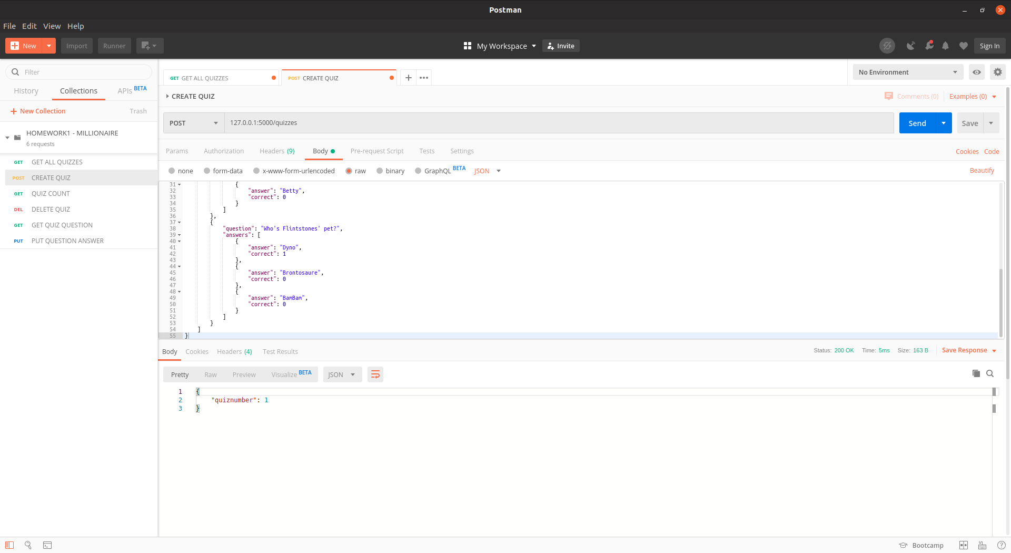Figure 4: Test3 - Create 2nd quiz with 3 questions
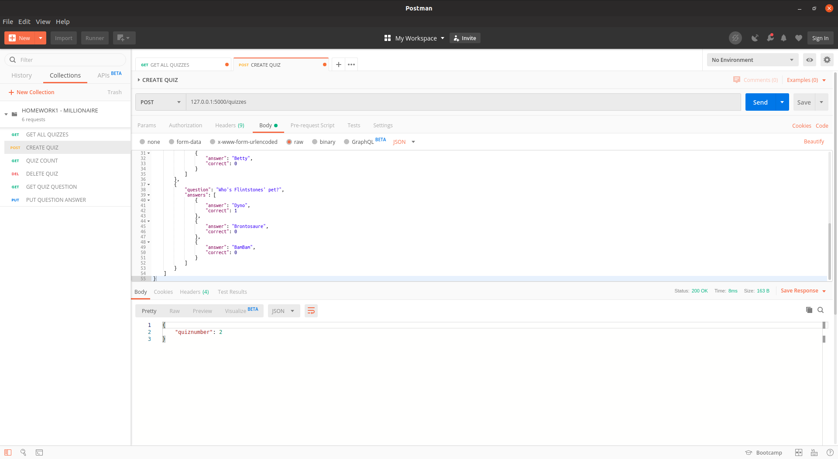Figure 5: Test4 - Create 3rd quiz with 3 questions

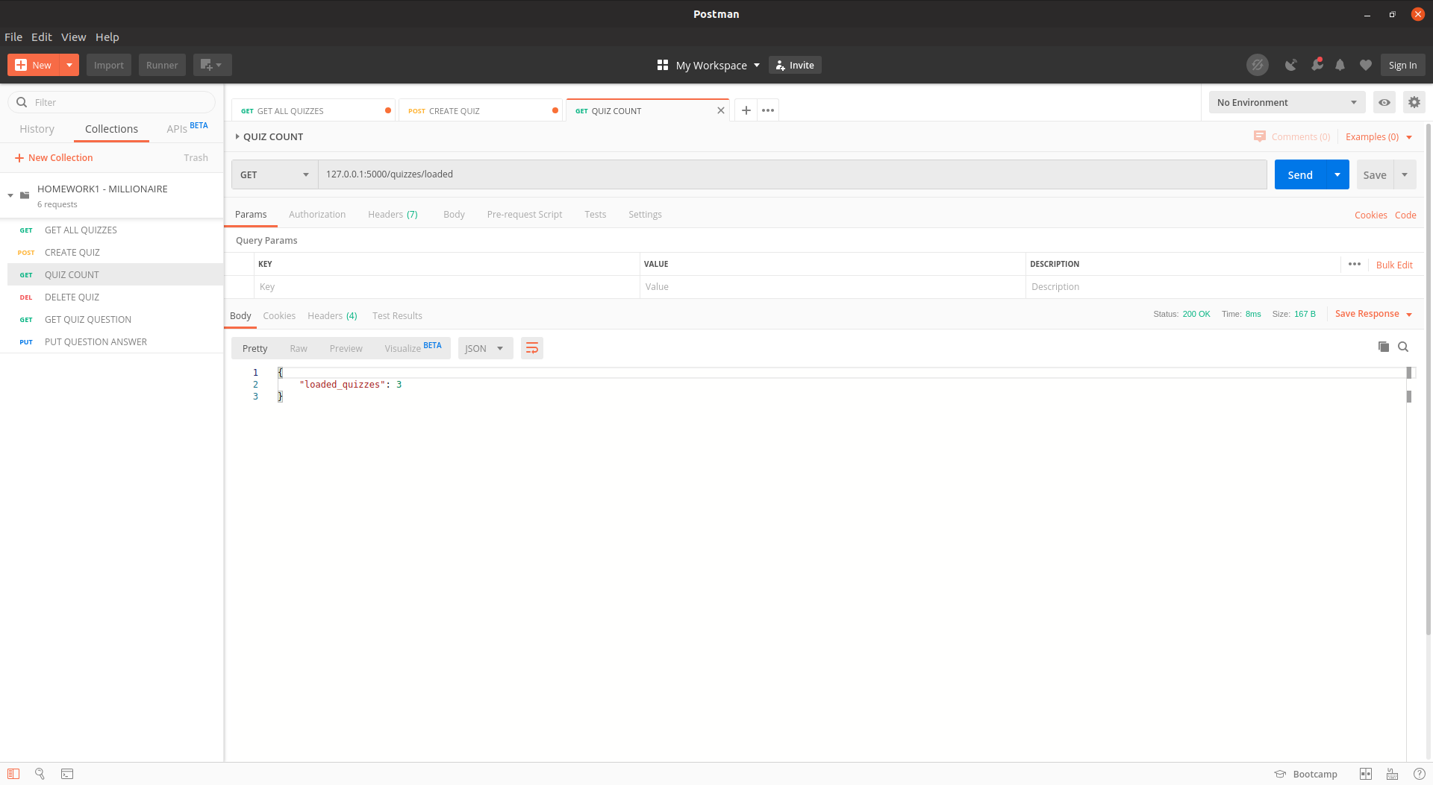Figure 6: Test5 - Get the number of loaded quizzes
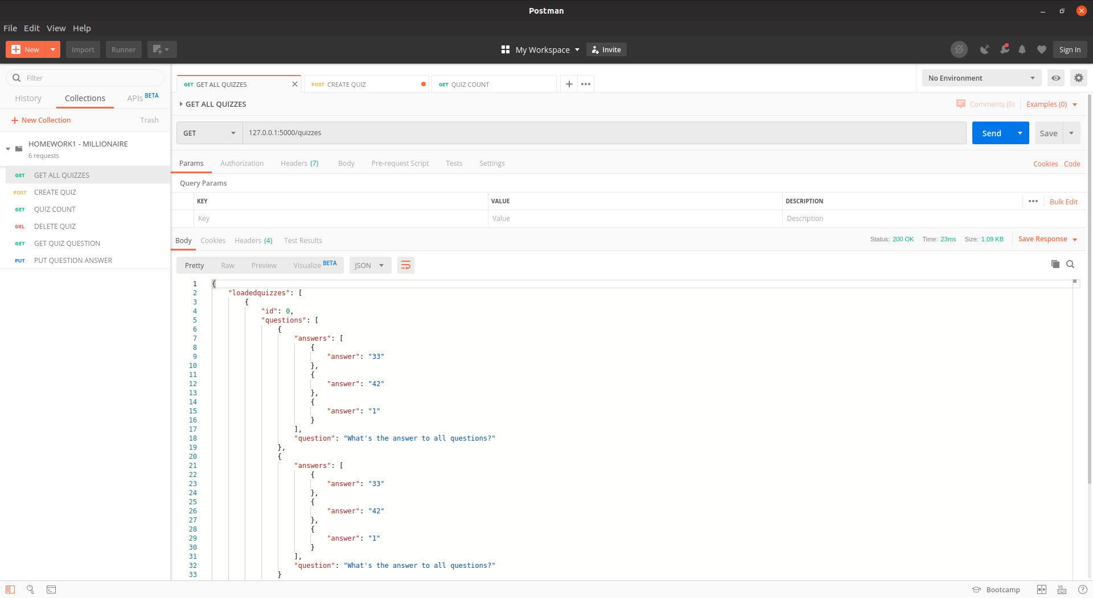Figure 7: Test6 - Get all loaded quizzes
2.3 Postman - /quiz
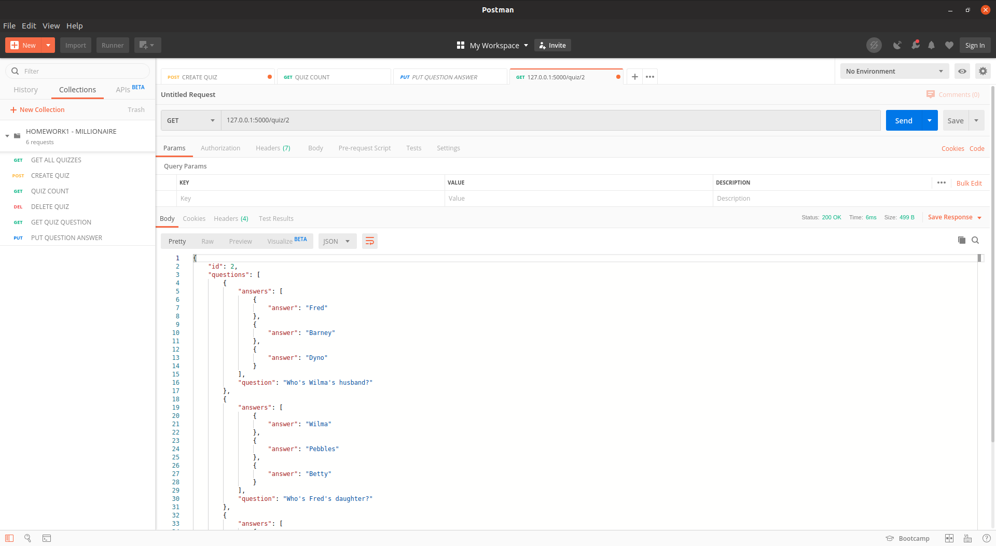Figure 8: Test7 - Retrieve the 2nd quiz
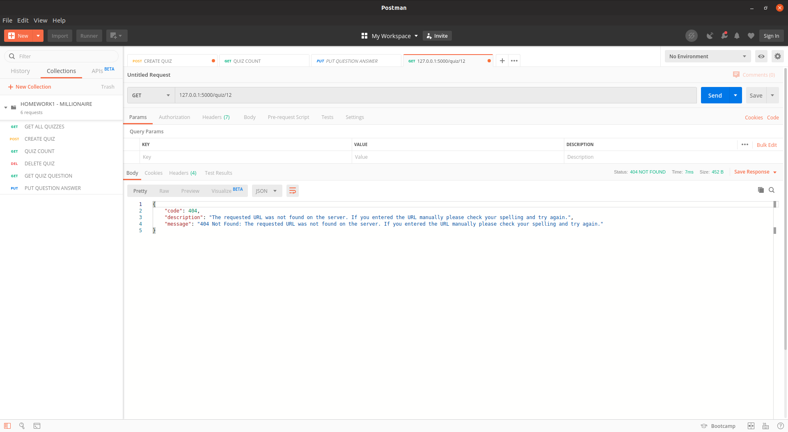Figure 9: Test8 - Retrieve non-existing quiz

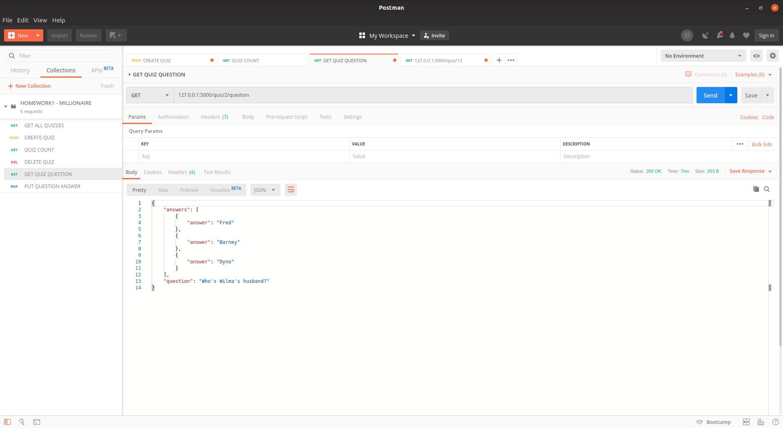Figure 10: Test9 - Get questions of the 2nd quiz
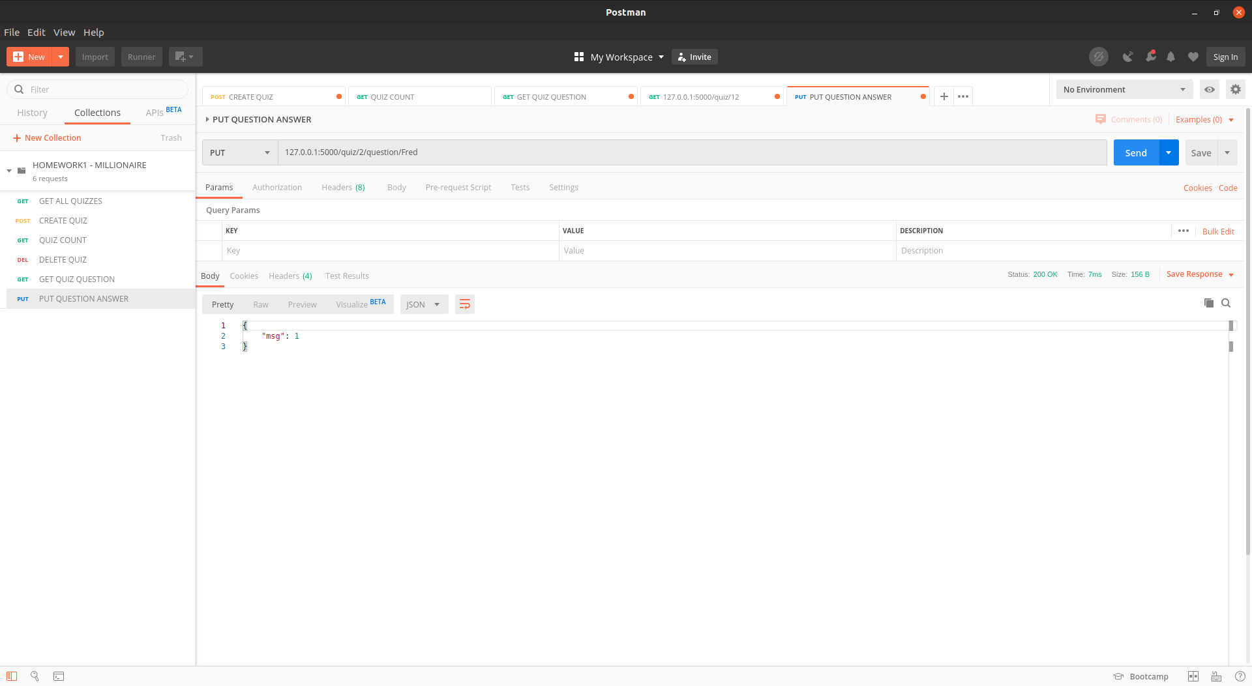Figure 11: Test10 - Answer first question of the 2nd quiz

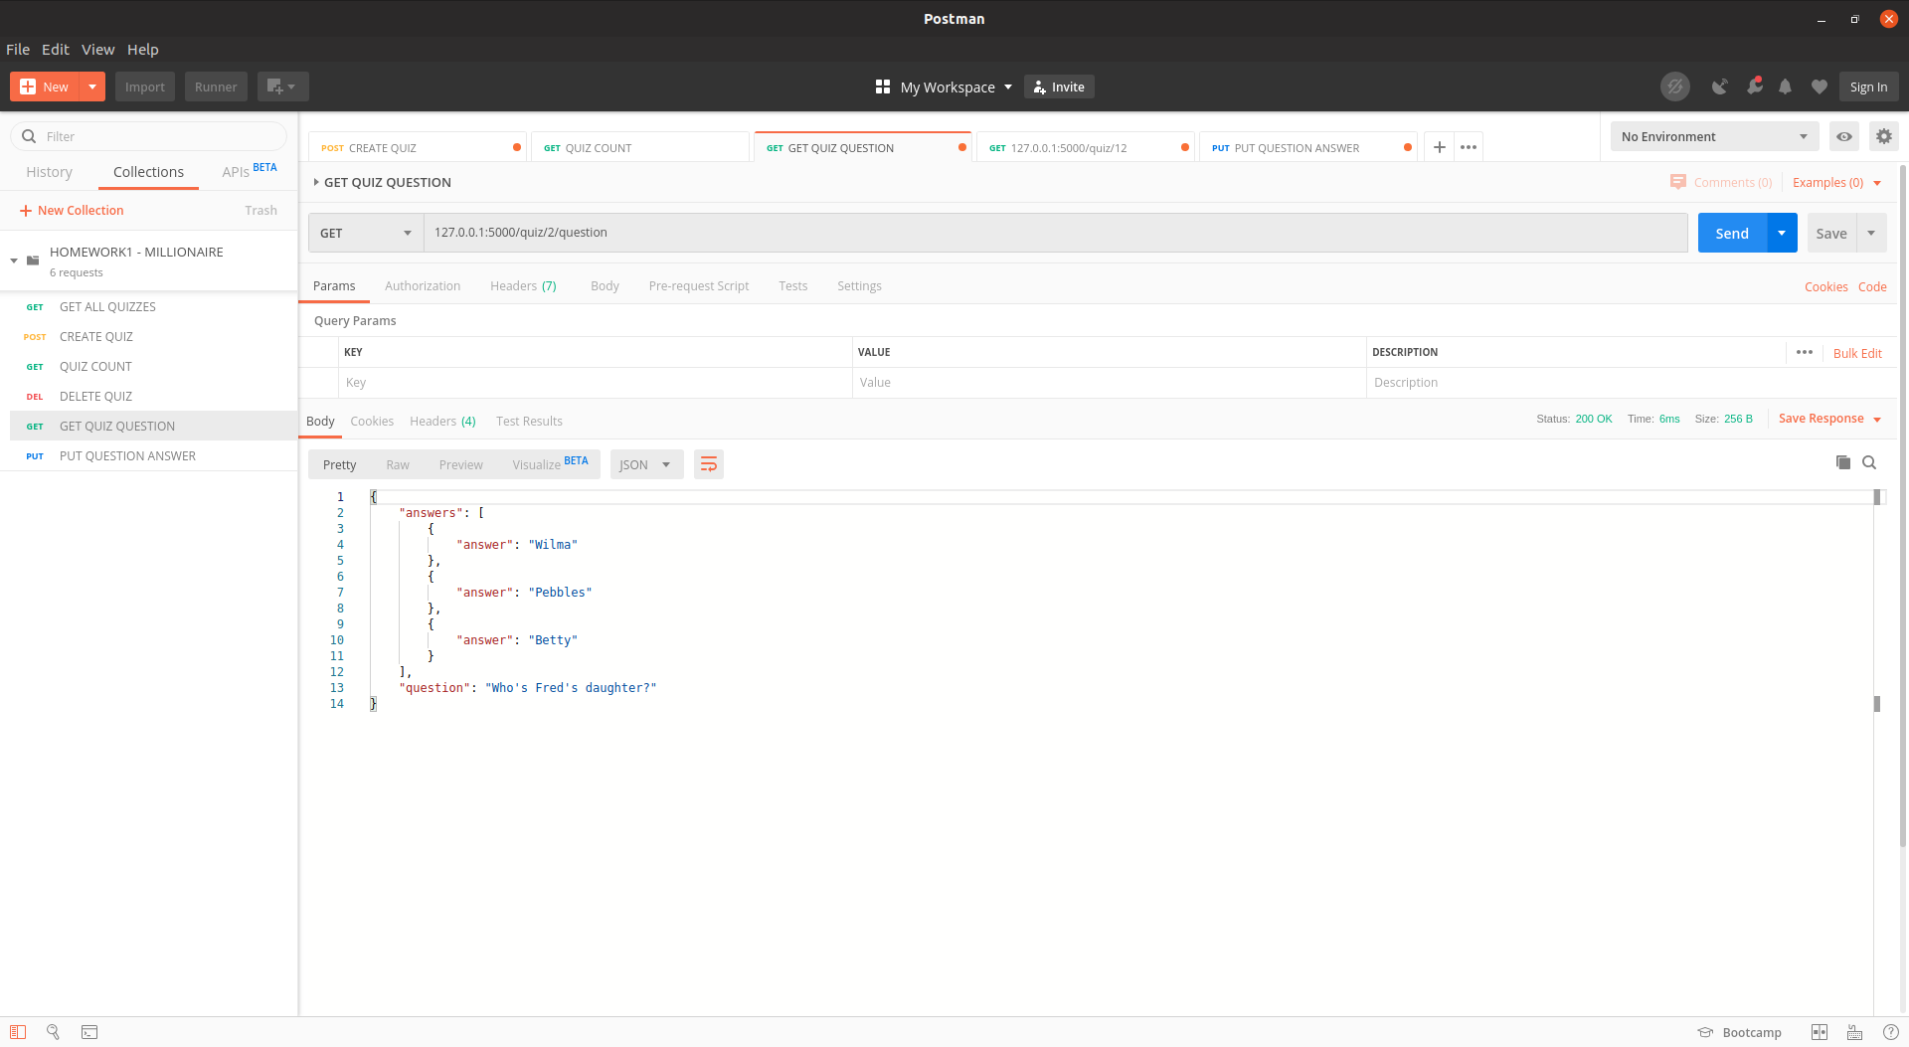Figure 12: Test11 - Get the next question of the 2nd quiz

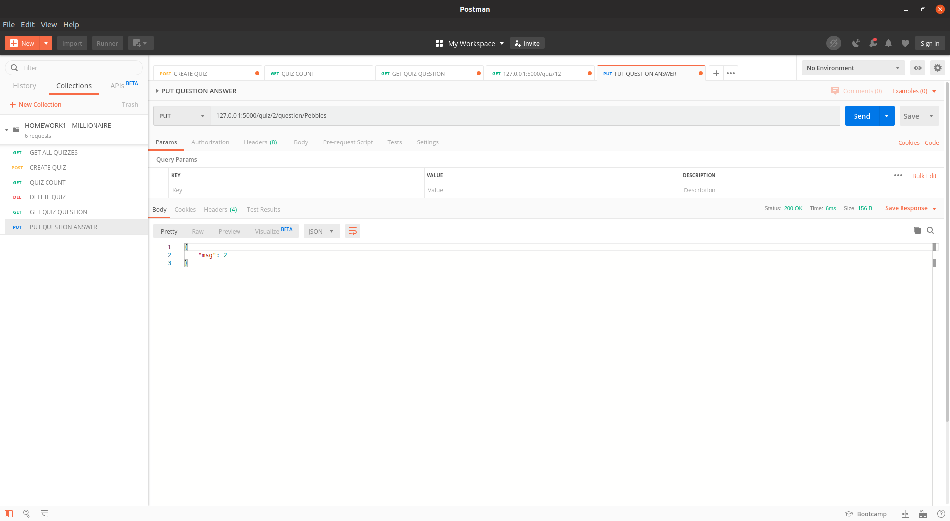Figure 13: Test12 - Answer 2nd question of the 2nd quiz

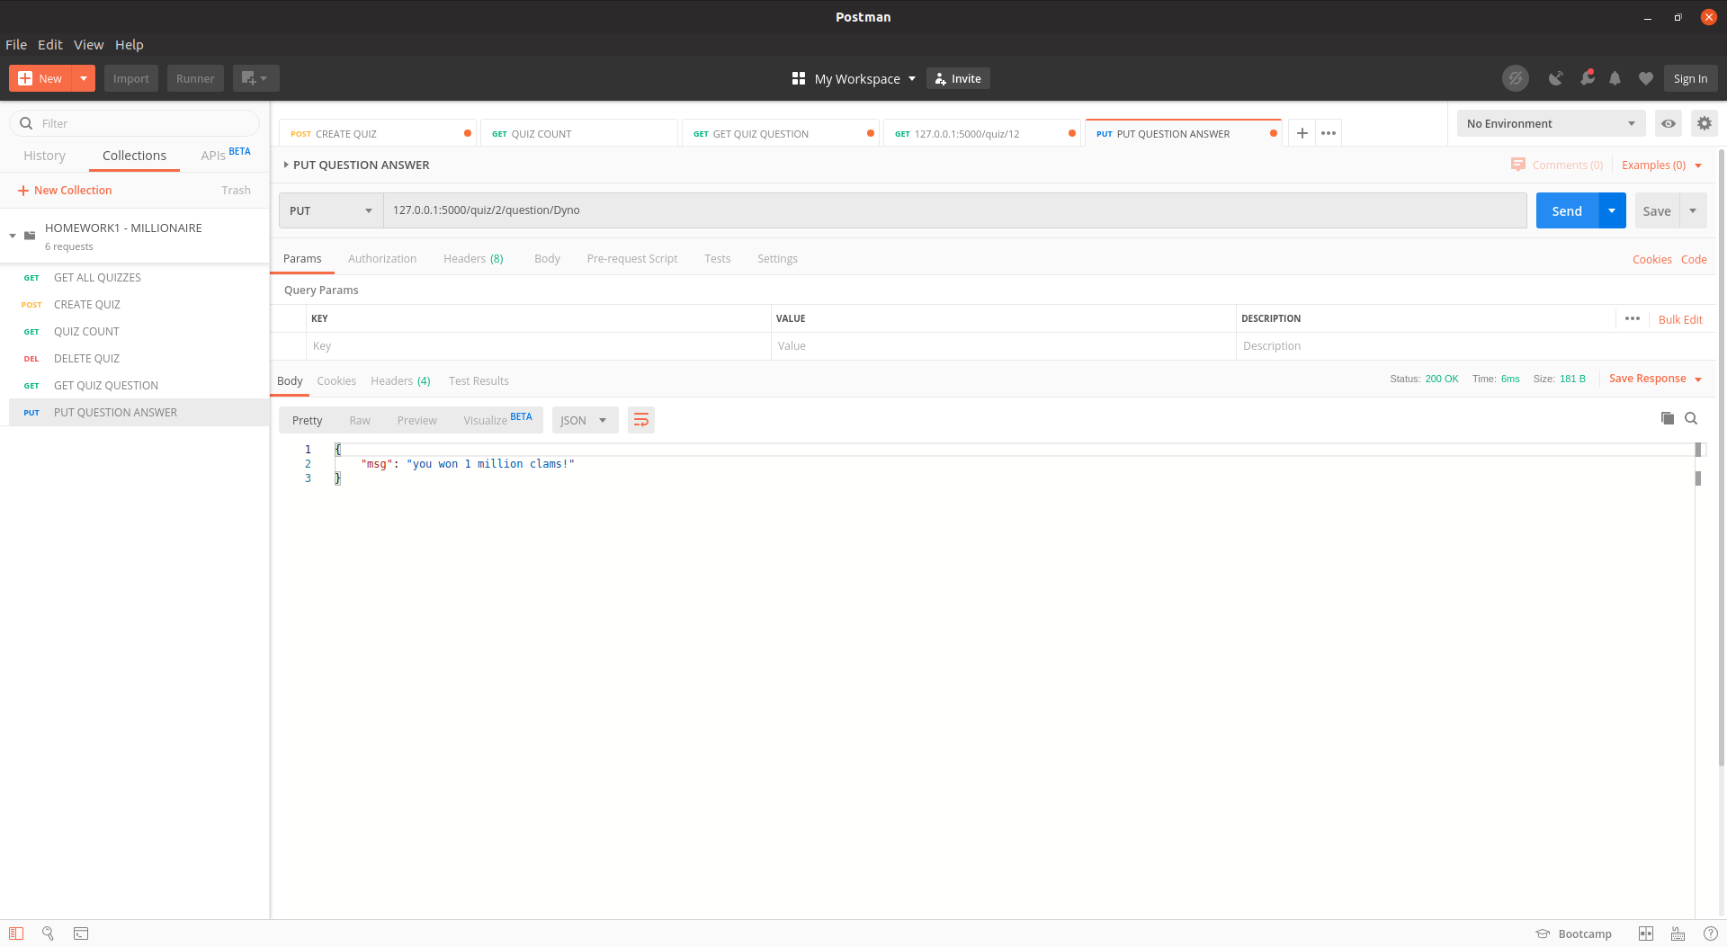Figure 14: Test13 - Answer 3rd question of the 2nd quiz and win!

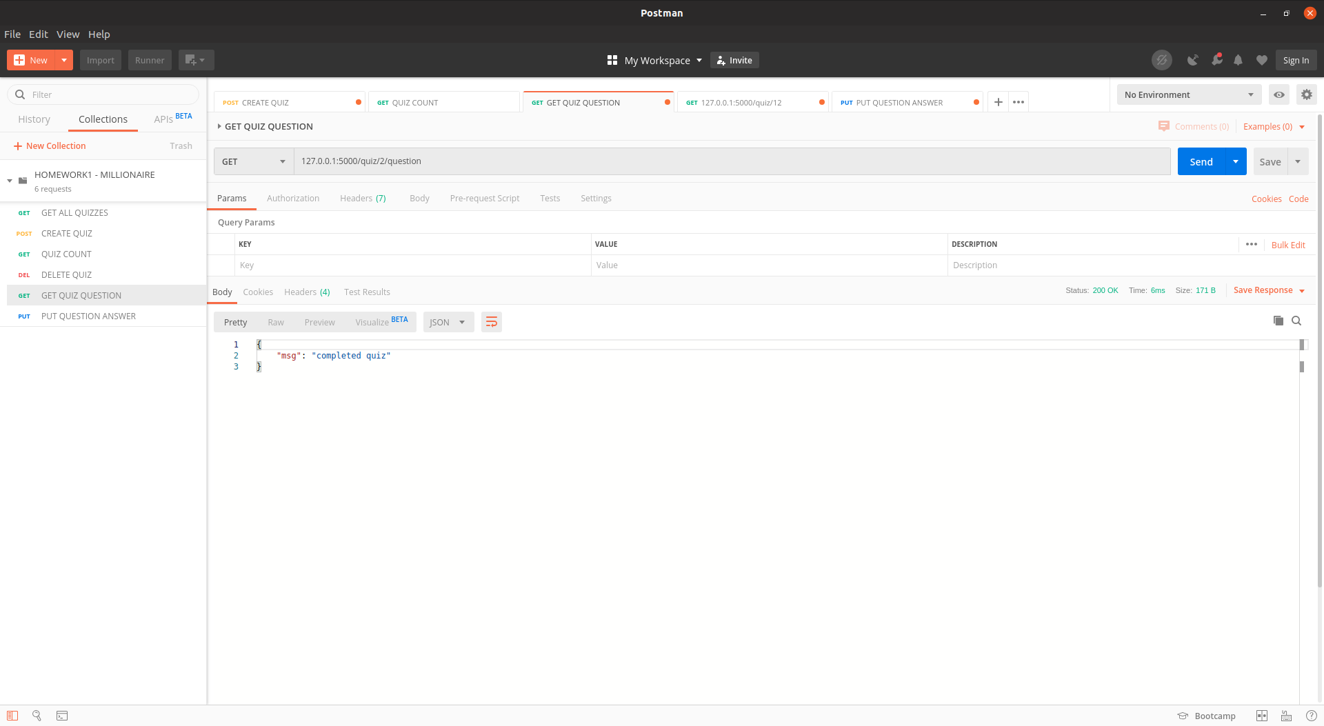Figure 15: Test14 - Get questions of the already won quiz

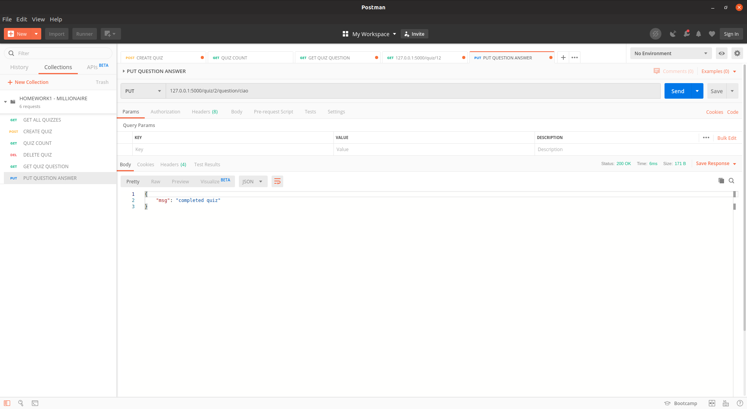Figure 16: Test15 - Answer an already answered question of the 2nd quiz

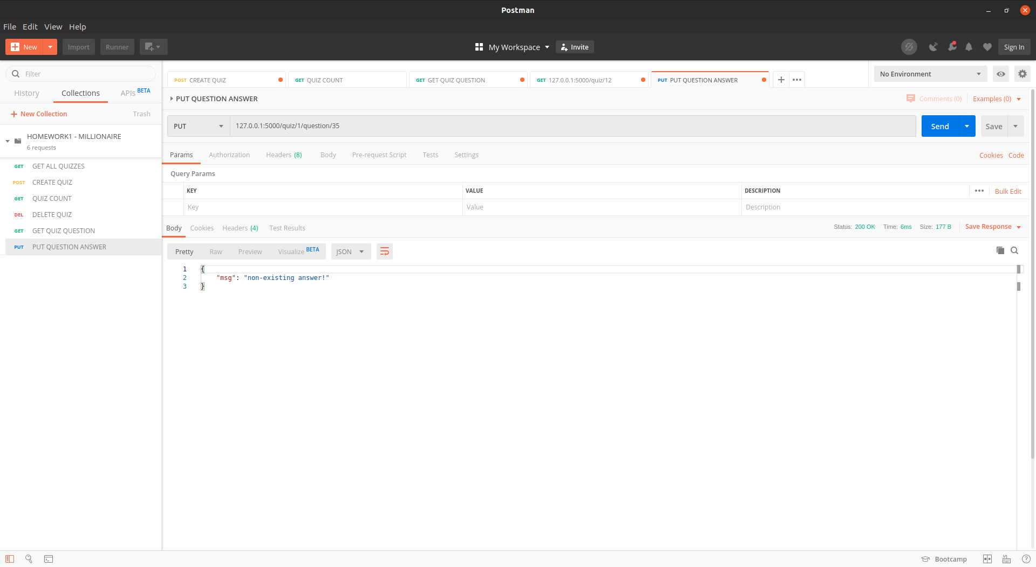Figure 17: Test16 - Answer with non-existing answer

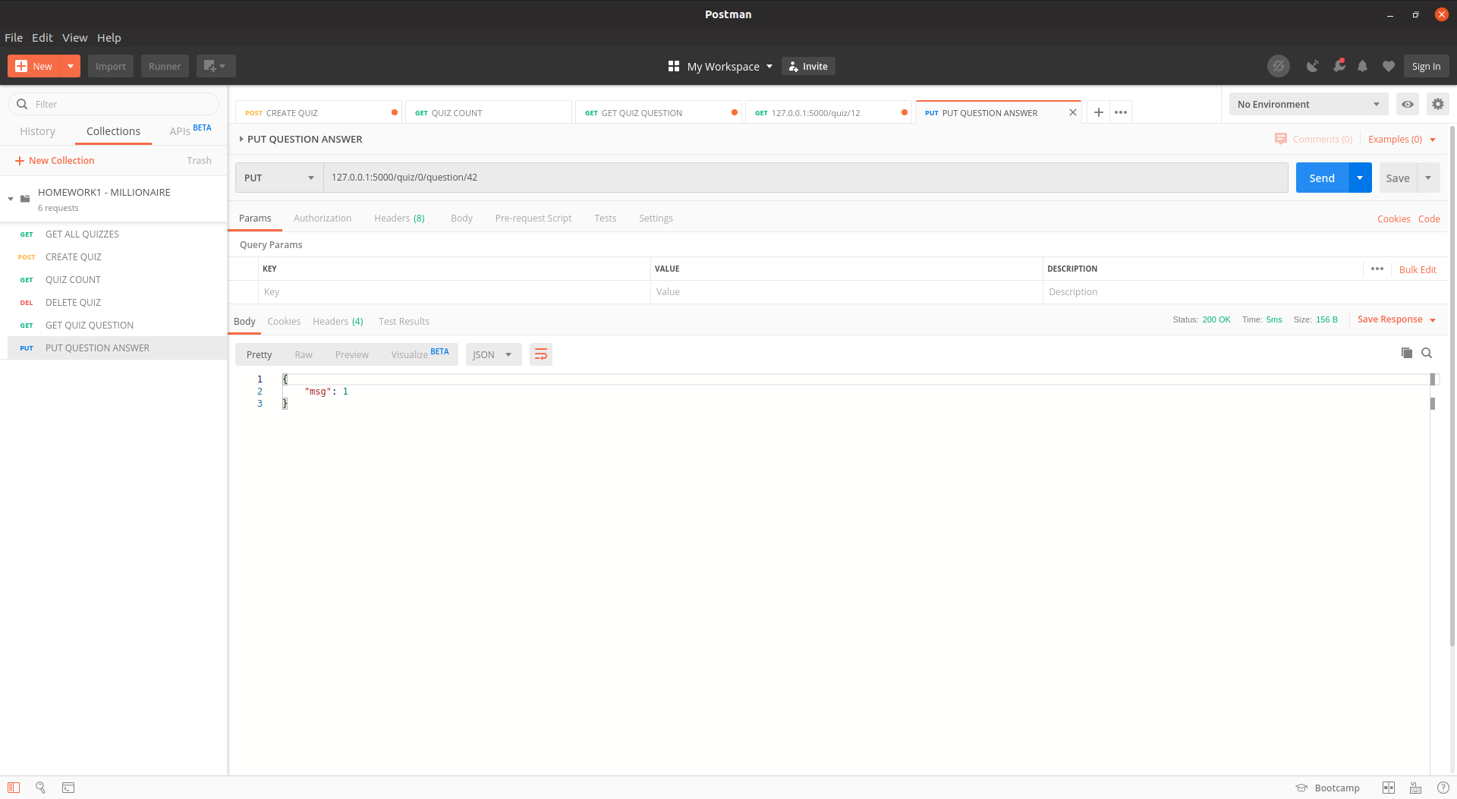Figure 18: Test17 - Correct answer of a question

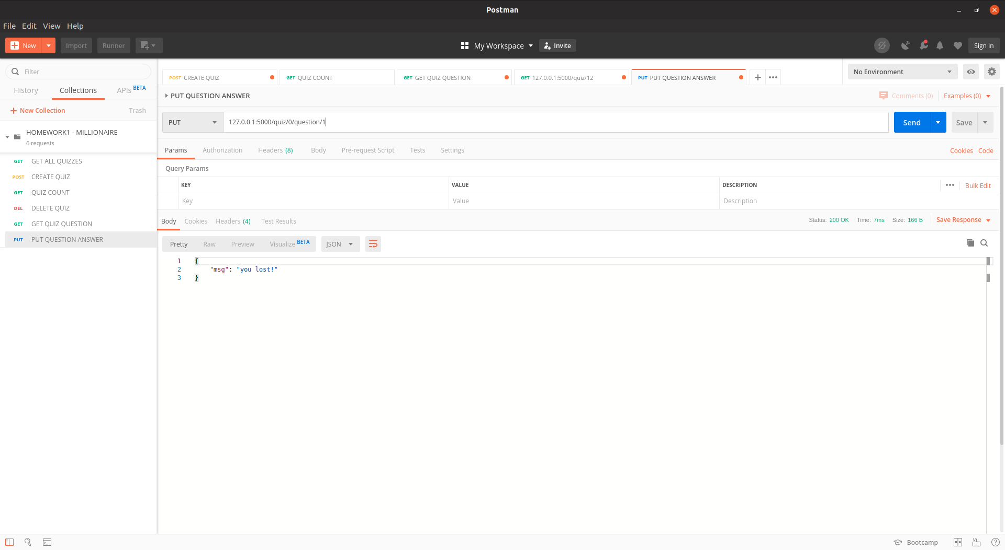Figure 19: Test18 - Wrong answer

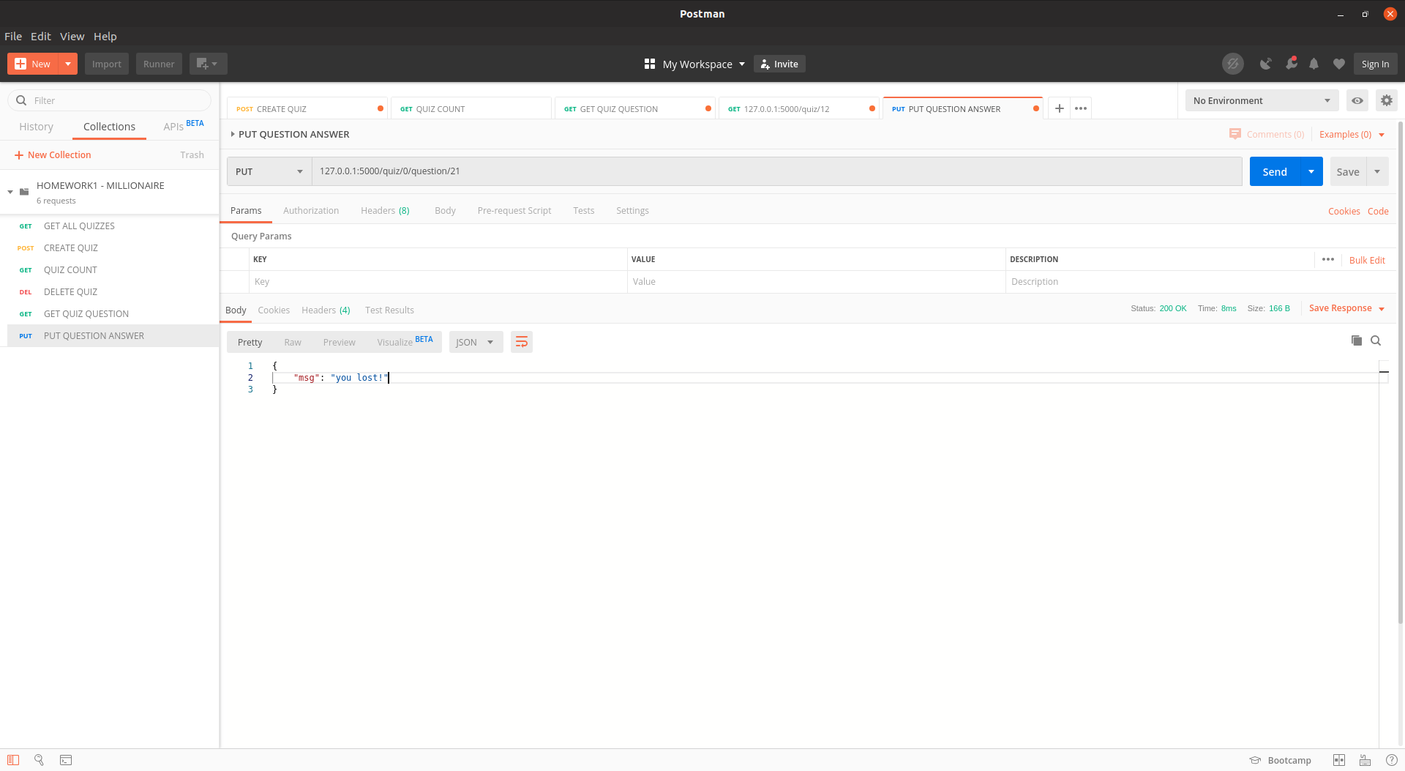Figure 20: Test19 - Double call to lost quiz
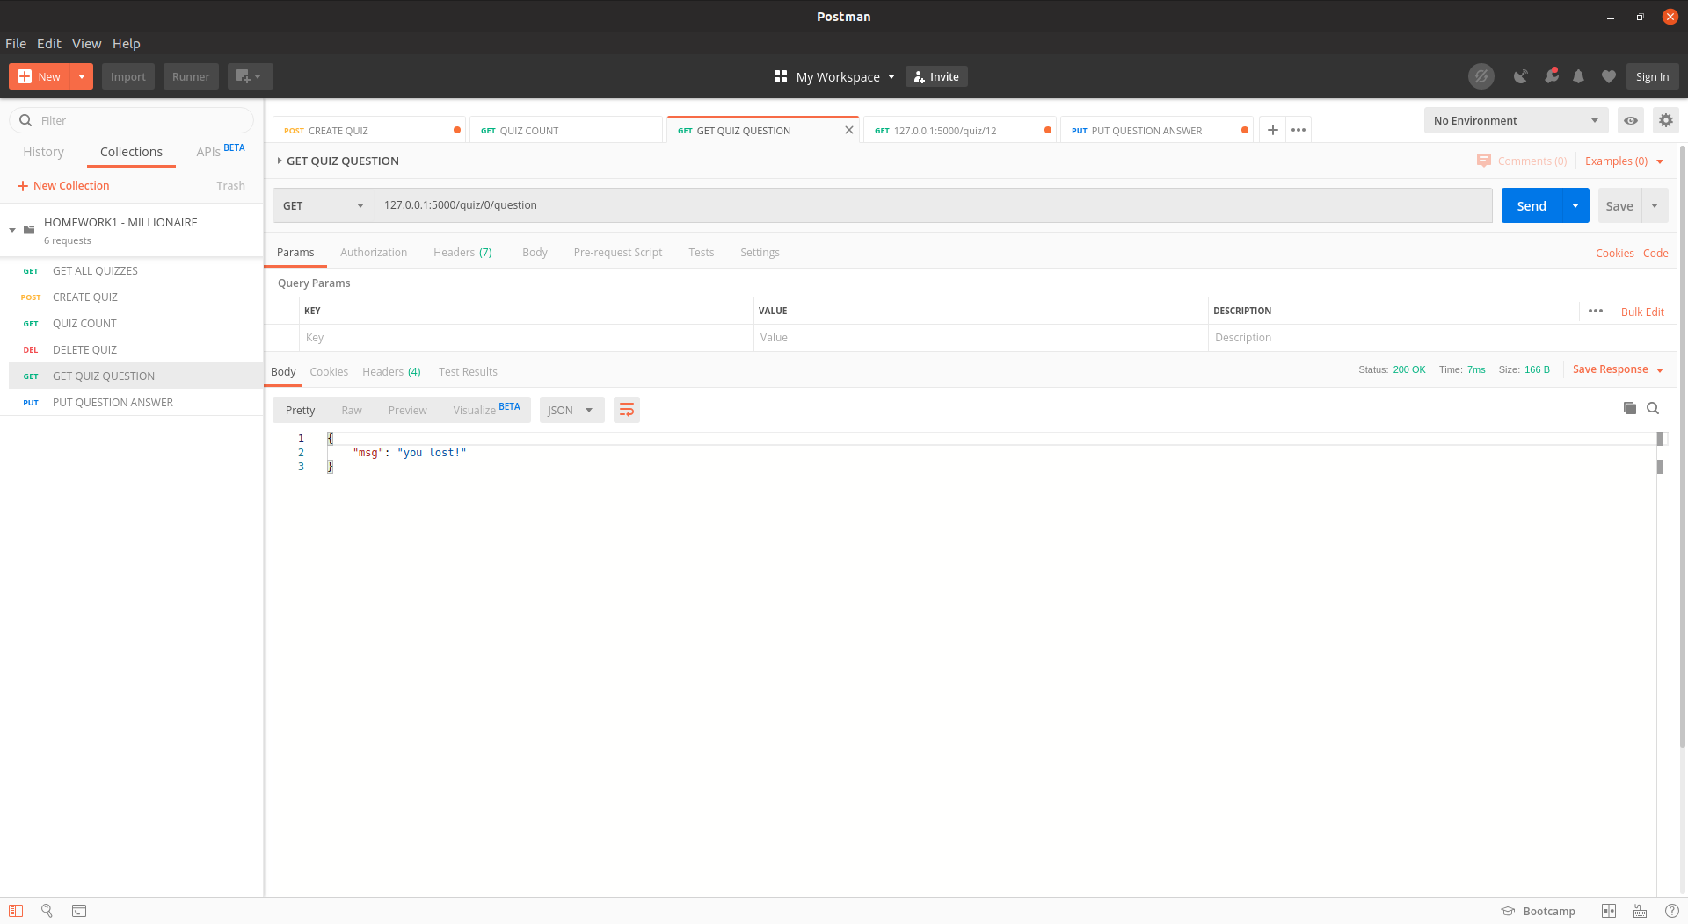Figure 21: Test20 - Triple call to lost quiz

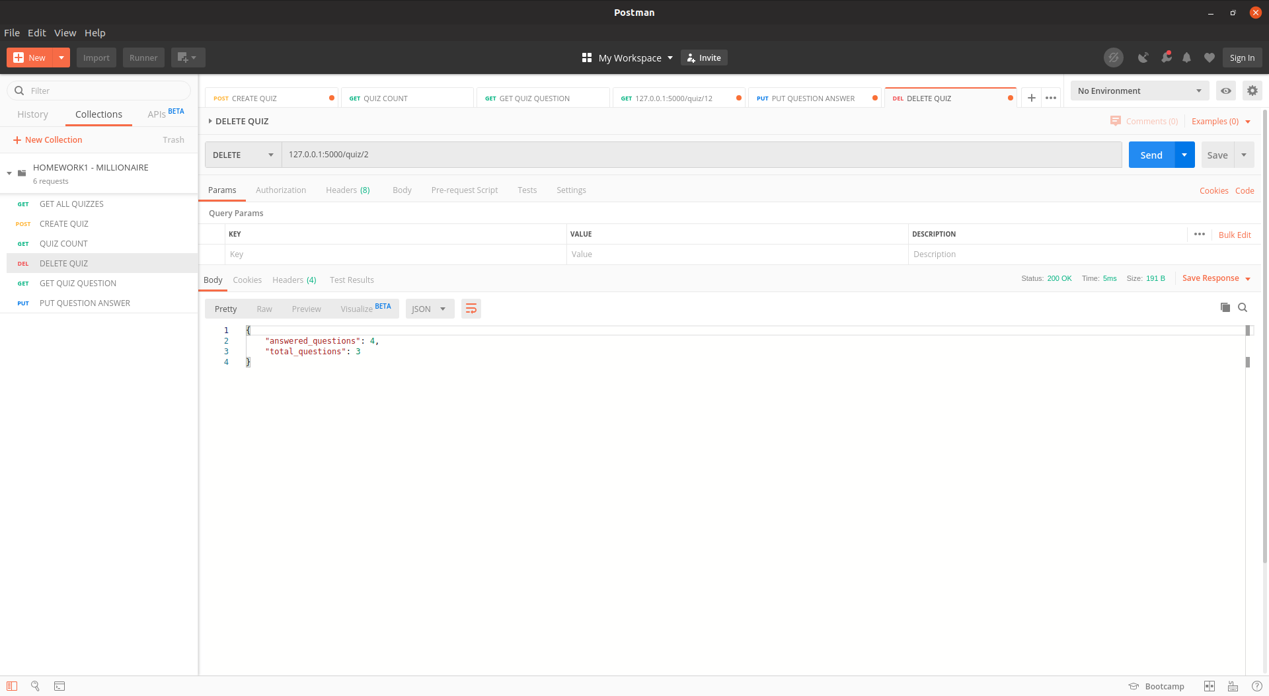Figure 22: Test21 - Delete quiz

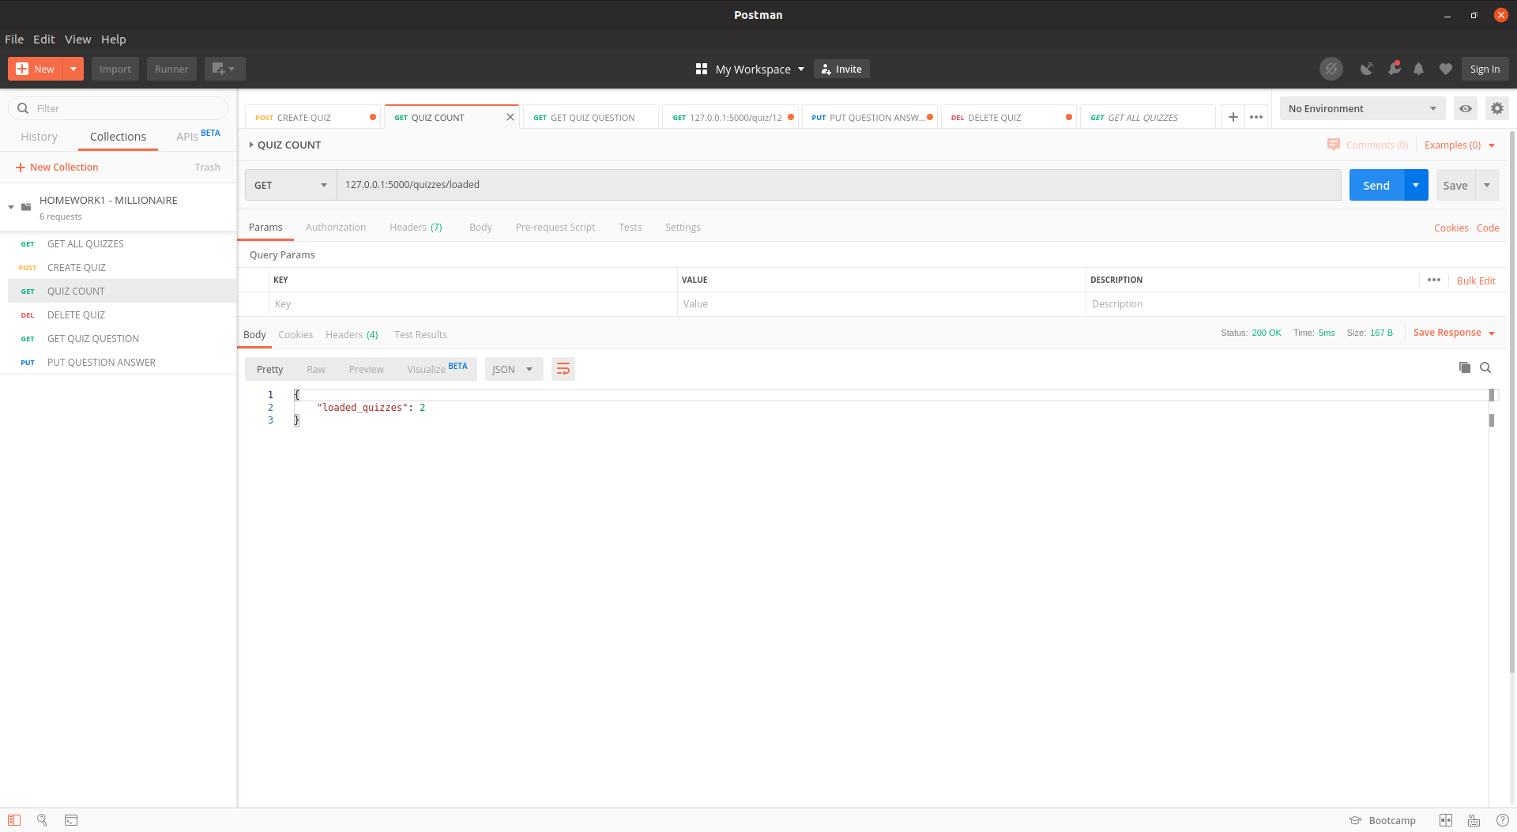Figure 23: Test22 - Two loaded quizzes

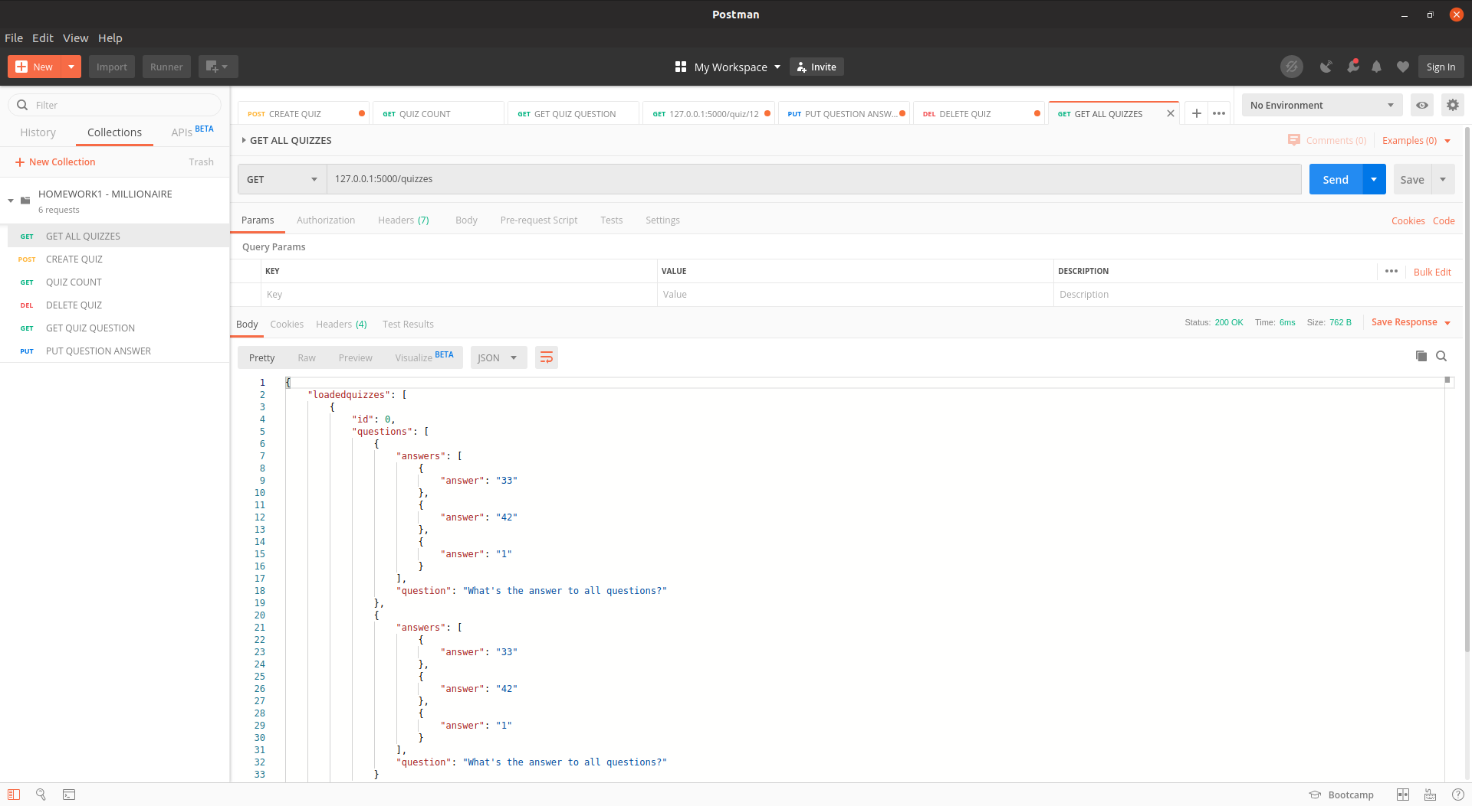Figure 24: Test23 - Get all loaded quizzes
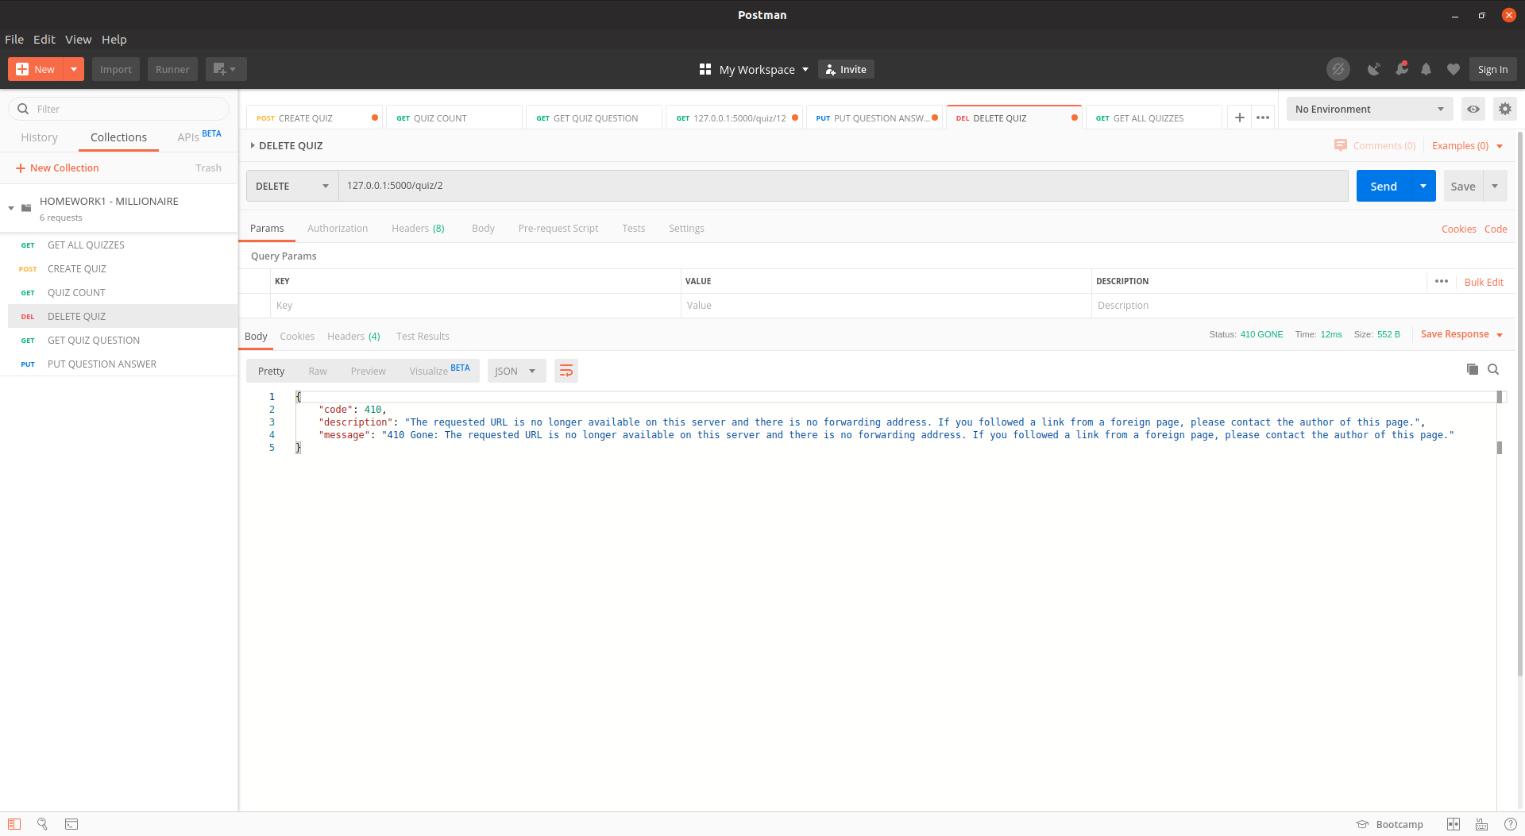Figure 25: Test24 - Delete previously deleted quiz

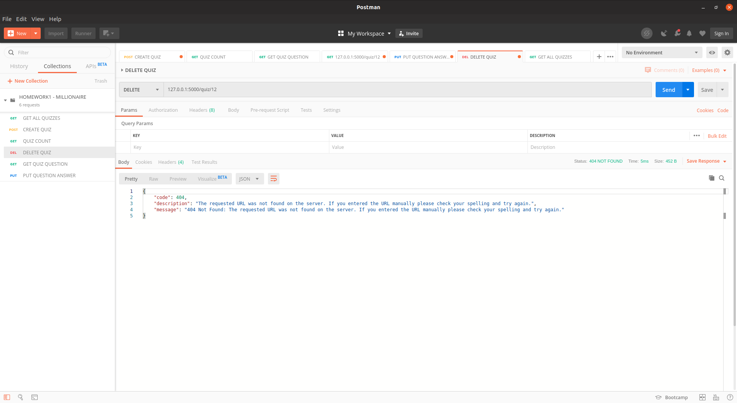Figure 26: Test25 - Delete non-existing quiz
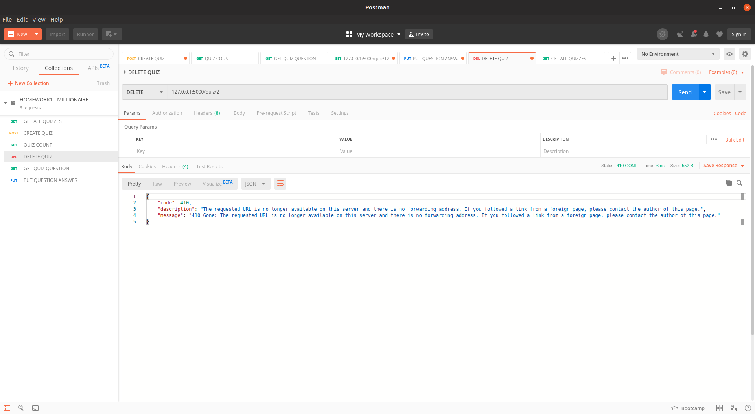Figure 27: Test26 - Get previously existing quiz

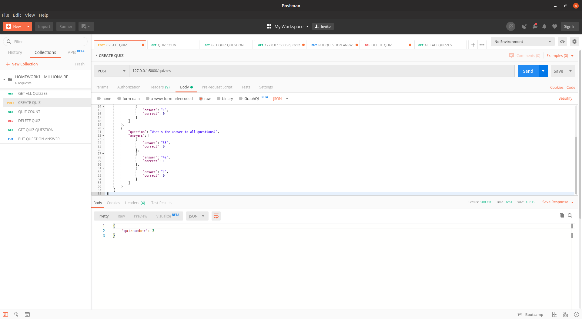Figure 28: Test27 - Create new quiz after deletion
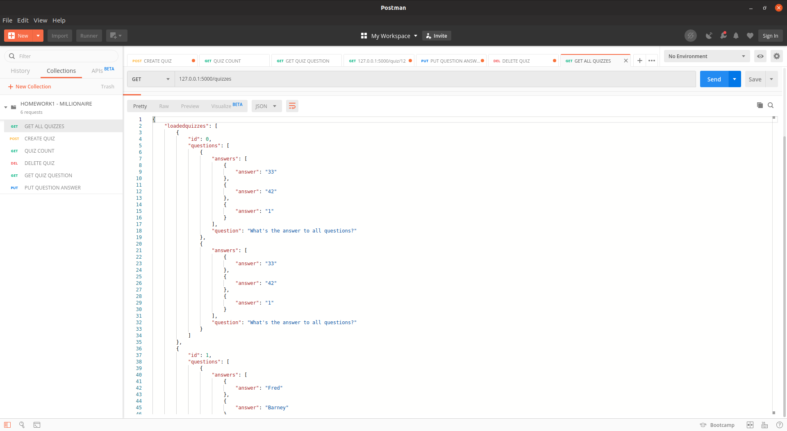Figure 29: Test28 - Get all loaded quizzes

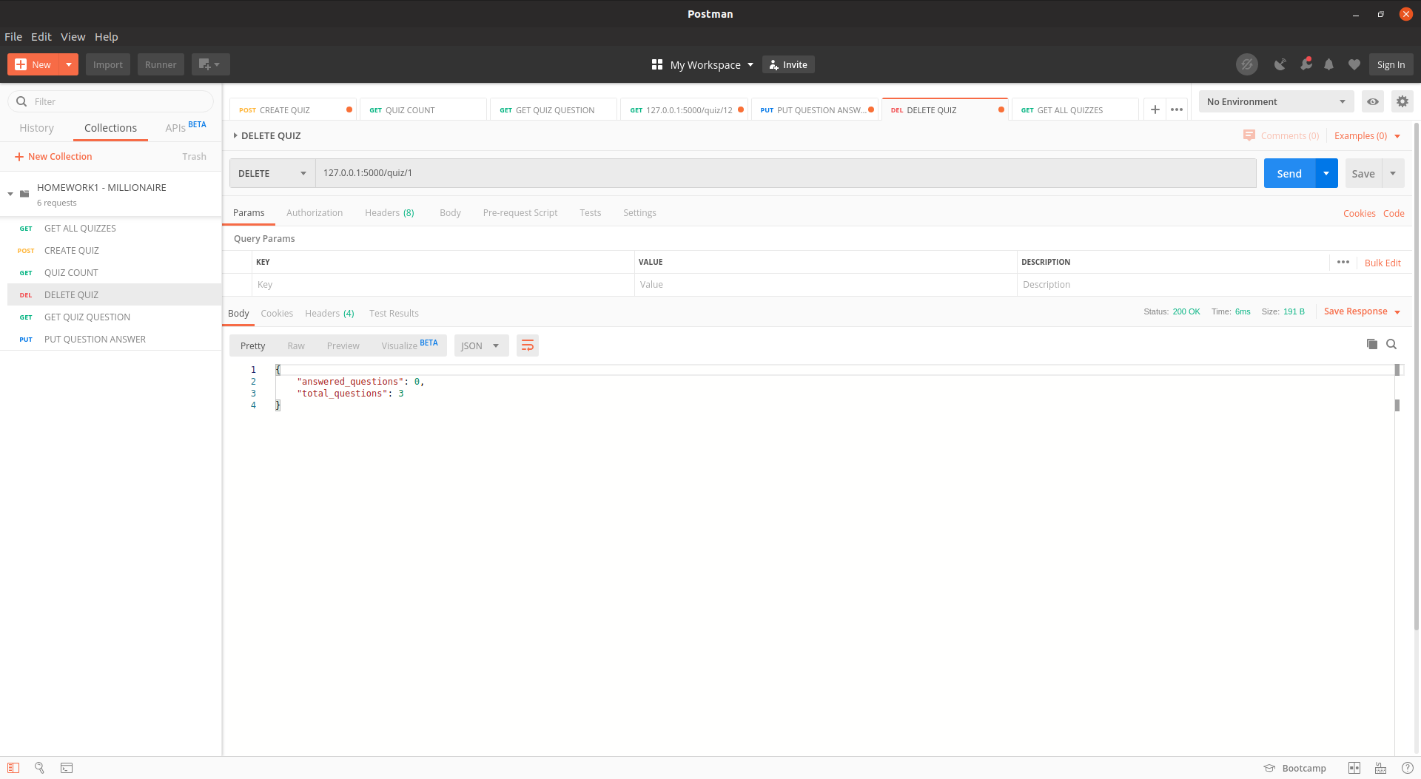Figure 30: Test29 - Delete quiz

