**FITTS’S LAW EXPERIMENT REPORT**

**SIMONE AMICO**

**Fitts’s law description**

Fitts's law is a predictive model of human movement primarily used in [human–computer interaction](https://en.wikipedia.org/wiki/Human%E2%80%93computer_interaction) and [ergonomics](https://en.wikipedia.org/wiki/Human_factors_and_ergonomics). This [scientific law](https://en.wikipedia.org/wiki/Scientific_law) predicts that the time required to rapidly move to a target area is a function of the ratio between the distance to the target and the width of the target. [1]

In order to replicate the Fitts’s Law experiment for aimed movement in graphical user interfaces (GUI) I decided to use Unity to create the design of the interface of the application and Excel in order to calculate the regression and plot the graphs.

**Data Collection**

At the beginning I tried to do all the work with Unity, but I had a lot of troubles because is not easy to plot nice graphs and do the regression. Then I tried to do the second part with Python, but in the end, I decided to go with Excel because it was easier to do.

When the Unity application starts, 9 circles disposed in circle appears and only one is highlighted with a blue color. When the user clicks on the blue circle the timer starts and another circle distant D (where D is the diameter of the “big circle” composed by all the circles) becomes blue. After each click in a blue circle, it returns grey and the timer restarts.



(fig 1)

At the beginning the user had to do 6 sessions and in each one the width (W) of the circle and the diameter (D) were randomly generated. I noticed that the ID sometimes didn’t vary too much, so I then pre-made 6 sessions with fixed values:

* 3 different Ds: 360, 560, 760
* 2 different Ws: 15 and 80

I then mixed all the possibilities in order to create the 6 sessions.

At the end of the 6th session the Unity application will output in a csv file the data for each session that will be used by Excel in the second part.

**Data Analysis**

In the Excel file I first put together the data from the 2 sessions and then I plotted all the data collected in one graph and calculated the regression in order to know the values of the empiric constants a and b. From the analysis I had a = 29,435 and b = 199,94.

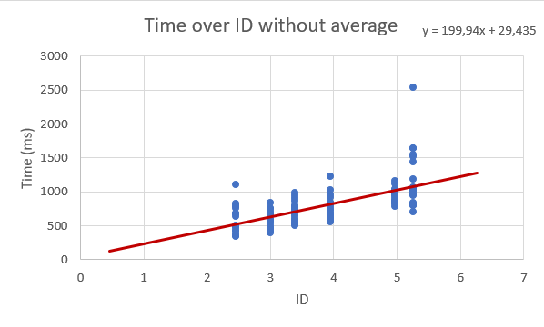

(fig 2)

Then I calculated the average of the times for each session and I plotted the ID-MT graph.

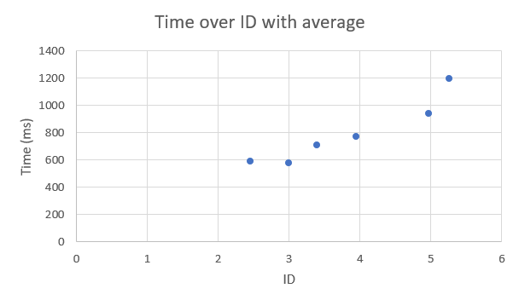

(fig 3)

Finally, I evaluated the throughput for each session dividing the average of the times (converted in seconds for better visibility) with the ID of the session.

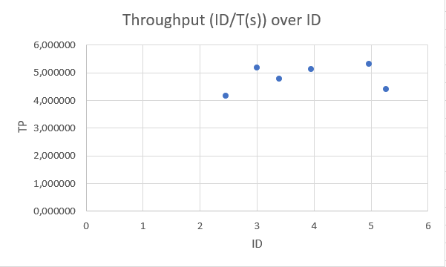

(fig 4)

**References**

[1] Wikipedia Fitts’s Law: https://en.wikipedia.org/wiki/Fitts%27s_law

[2] Github Repo: https://github.com/simoamico94/HCI_HW3