Plan

Visualise data

* Charging points existing and potential – oleg
* Demands for each year - jx
* Distance from centre – heatmap – transform axis -jx
* Number of charging points (rapid, fast, slow) for existing -
* Point of interest graph, merge excel file – Imran

Objective function

* Budget (cost of building charging station)
* Min distance from charging point to demand, constraint
* Decision var = the number of charging stations in a grid

Constraints

* Budget
* Demand
* Capacity of charging station (kW for each year)
* Traffic
* ???
* Demands, set cover, satisfy all grids?
* Points of interests (prioritise if there are more options)
* Type of chargers (mixture)

Sensitivity analysis

<https://heycar.co.uk/blog/electric-cars-statistics-and-projections>

<https://www.nextgreencar.com/electric-cars/statistics/>

<https://www.dundeecity.gov.uk/performance-indicator/percentage-of-electric-vehicles-in-the-city>

<https://www.transport.gov.scot/media/51956/electric-vehicle-charge-points-in-buildings-consultation-response.pdf>

<https://www.transport.gov.scot/publication/report-on-public-electric-vehicle-ev-infrastructure-in-scotland-opportunities-for-growth/>

<https://wattlogic.com/blog/commercial-ev-charging-stations-cost/>

Latex table generator: <https://www.tablesgenerator.com/>

Report link : https://www.overleaf.com/2333435316twqcxghyyhvm

<http://support.sas.com/rnd/app/or/papers/index.html>

Report

# Understanding and Depth of Academic Content

* achieved and showed understanding of the principal objectives of the project
* master underlying theoretical techniques and mathematical models
* correctly apply highly involved numerical algorithms
* performed rigorous statistical data analysis
* However, some errors occur where the student has missed or misunderstood some aspect of the underlying theory, models or algorithms, or has made an error in the application of an algorithm or the statistical data analysis.
* near-publishable quality, a rigorous scientific fashion

# Originality of Approach

* very creative, coming up with several ideas for different research directions or alternative solution approaches.
* made a significant contribution to the given topic, deriving considerable number of original theoretical contributions, or extensions or modifications of existing models or algorithms, or applying new statistical techniques from recent literature (outside syllabus)
* exceptional degree of originality , both in the results obtained and the route taken
* unforeseen research directions or solution approaches.

# Amount of Work Done

* All questions raised in the project description are addressed and go beyond the questions
* The report gives a detailed and complete explanation of the background material needed to understand the topic.
* Work done is evidenced through numerous theoretical contributions,
* the implementation of extensive models and algorithms,
* a substantial statistical or numerical analysis, or thorough an exhaustive and elaborate collection and cleaning of data.

# Logic of Argument

* The report CLEARLY describes all of the main steps in the mathematical, statistical, or computational argument that underlies the project,
* It is easy to follow the argument, and there are no gaps in the reasoning

# Background and References

* Great care and consistency is shown in selecting the most appropriate (comprehensive) references for embedding the project in the field of research, and for supporting scientific claims made in the report.
* References are chosen exclusively from the scientific literature.
* Reading has considerably benefited the quality of results obtained, or the strength of conclusions drawn.
* The bibliography is presented professionally.

# Validity, Analysis, and Assessment of Results

* The DISCUSSIONS OF findings are detailed and EXAMPLARY and validated in a manner that is fully supported by the results presented in the report.
* important questions for FUTURE research in the field are identified
* Conclusions drawn from the analysis are well-motivated; the embedding into the scientific context of the project is near-flawless.
* The choice of MODELS and ALGORITHMS for the analysis is appropriate.
* Where data is used, it is thoroughly verified and very informatively visualised.

# Clarity of Statement of Objective

* The rationale behind the objectives of the project is conveyed in an authoritative manner,
* with clear reference to the state of the art in the field of research.
* Specific implications for the field are discussed in some detail, and in an accessible fashion.
* ** provides compelling evidence that the objectives, would advance the field of research in a significant and highly original direction.

# Style and Clarity of Writing

* Considerable thought and exceptional attention to detail FOR the presentation of figures, tables, and mathematical formulae to communicate the key scientific points effectively.
* The writing is rigorous, flows naturally; no lapses in phrasing, grammar, or spelling.
* *** The writing shows creative flair whilst being scientifically accurate, resulting in a report that is ENJOYABLE TO READ throughout.

# Clarity and Economy of Argument

* content is accurate, articulated with care;
* the reader can follow the argument with ease, with little effort required to understand the content and the underlying concepts
* *** All aspects of the presentation are aimed at enhancing the content of the report to the highest possible degree. The only effort required by the reader is to contemplate the scientific ramifications of the argument.

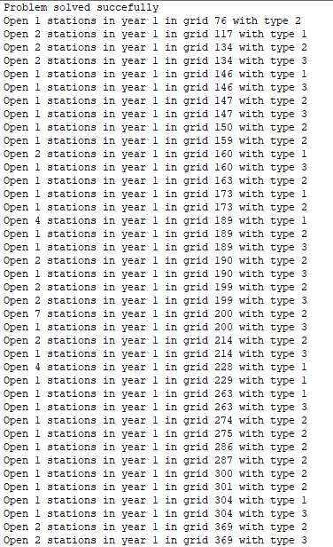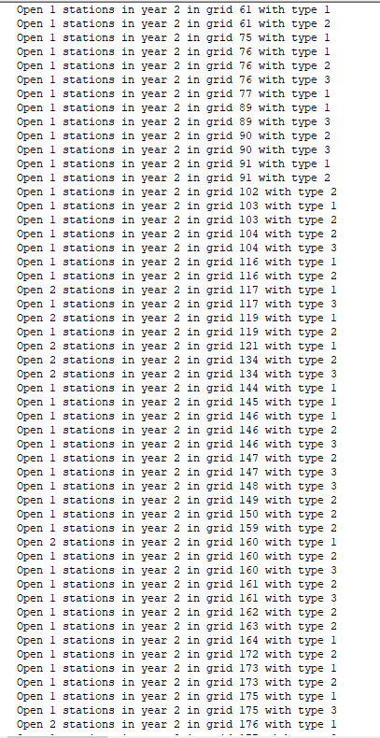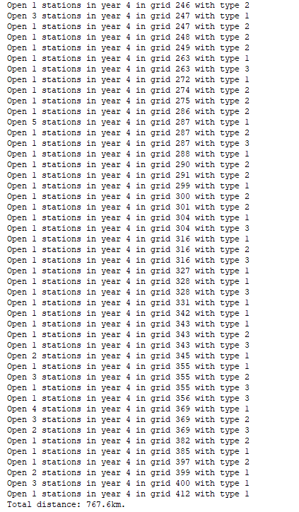

Around 365 meter per car