|  |  |
| --- | --- |
| **Architetture dei Sistemi di Elaborazione** | Delivery date:  October 22nd 2021 |
| **Laboratory**  **2** | Expected delivery of lab_02.zip must include:   * **program_2.s** and **program_3.s** * This file, filled with information and possibly compiled in a pdf format. |

Please, configure the winMIPS64 simulator with the *Base Configuration* provided in the following:

* 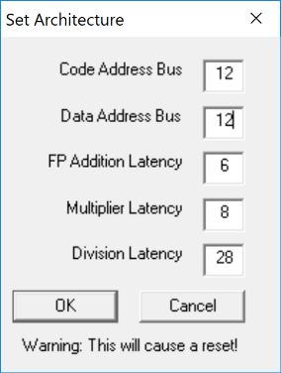Code address bus: 12
* Data address bus: 12
* Pipelined FP arithmetic unit (latency): 6 stages
* Pipelined multiplier unit (latency): 8 stages
* divider unit (latency): not pipelined unit,

24 clock cycles

* Forwarding is enabled
* Branch prediction is disabled
* Branch delay slot is disabled
* *Integer ALU: 1 clock cycle*
* *Data memory: 1 clock cycle*
* *Branch delay slot: 1 clock cycle*.

1. Write an assembly program (**program_2.s**) for the *winMIPS64* architecture described before able to implement the following piece of code described at high-level:

for (i = 0; i < 40; i++){

v5[i] = v1[i]+(v2[i] * v3[i]);

v6[i] = v5[i]*v4[i];

v7[i] = v6[i]/v2[i];

}

Assume that the vectors v1[], v2[], v3[], and v4[] are allocated previously in memory and contain 40 double precision **floating point** values; assume also that v2[] does not contain 0 values. Additionally, the vectors v5[], v6[], v7[] are empty vectors also allocated in memory.

* + 1. Using the simulator and the *Base Configuration*, disable the Forwarding option and compute how many clock cycles the program takes to execute.

|  |  |
| --- | --- |
|  | Number of clock cycles |
| program_2.S |  |

Enable one at a time the **optimization features** that were initially disabled and collect statistics to fill the following table (fill all required data in the table before exporting this file to pdf format to be delivered).

Table 1: **Program performance for different processor configurations**

|  |  |  |  |  |
| --- | --- | --- | --- | --- |
|  | Number of clock cycles | | | |
| Program | Forwarding | Branch Target Buffer | Delay Slot | Forwarding + Branch Target Buffer |
| program_2 |  |  |  |  |

1. Write an assembly program (**program_3.s**) for the winMIPS64 architecture able to compute the output (y) of a **neural computation** (see the Fig. below):

*x = $\sum_{j=0}^{K-1}{i_{j}*w_{j}+b}$*

*y = f(x)*

where, to prevent the propagation of NaN (Not a Number), the activation function *f* is defined as:

$$f\left(x\right)=\left\{\begin{aligned}0, &if the exponent part of x is equal to 0x7ff \\ x, &otherwise\end{aligned}\right.$$

Assume the vectors *i* and *w* respectively store the inputs entering the neuron and the weights of the connections. They contain *K=30* double precision **floating point** elements. Assume that *b* is a double precision **floating point** constant and is equal to *0xab*, and *y* is a double precision **floating point** value stored in memory.

Compute *y*.

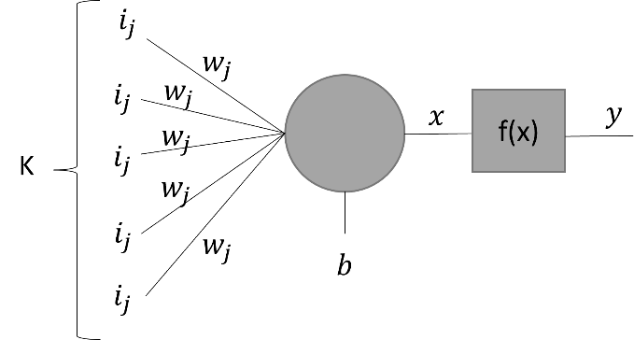

Below is reported the encoding of IEEE 754 double-precision binary floating-point format:

1. Using the WinMIPS64 simulator, validate experimentally the Amdahl’s law, defined as follows:



1. Using the program developed before: **program_2.s**
2. Modify the processor architectural parameters related with multicycle instructions (Menu🡪Configure🡪Architecture) in the following way:
   * + - 1. Configuration 1

Starting from the *Base Configuration*, change only the FP addition latency to 3

* + - * 1. Configuration 2

Starting from the *Base Configuration*, change only the Multiplier latency to 4

* + - * 1. Configuration 1

Starting from the *Base Configuration*, change only the division latency to 12

Compute by hand (using the Amdahl’s Law) and using the simulator the speed-up for any one of the previous processor configurations. Compare the obtained results and complete the following table.

Table 1: **program_2.s speed-up computed by hand and by simulation**

|  |  |  |  |  |
| --- | --- | --- | --- | --- |
| **Proc. Config.**    **Speed-up comp.** | Base config.  [c.c.] | Config. 1 | Config. 2 | Config. 3 |
| **By hand** |  |  |  |  |
| **By simulation** |  |  |  |  |