|  |  |
| --- | --- |
| **Architetture dei Sistemi di Elaborazione** | Delivery date:  26/11/2021 |
| **Laboratory**  **6** | Expected delivery of lab_06.zip must include:   * Solutions of the exercises 1, 2 and 3 * this document compiled possibly in pdf format. |

Starting from the ASM_template project (available on Portale della Didattica), solve the following exercises:



1. Write a program using the ARM assembly that performs the following operations:
   1. Sum R0 to R1 (R0+R1) and store the result in R2
   2. Subtract R4 to R3 (R3-R4) and store the result in R5
   3. Force, using the debug register window, a set of specific values to be used in the program to provoke the following flag to be updated **once at a time** (whenever possible) to 1:
      * carry
      * overflow
      * negative
      * zero
   4. Report the selected values in the table below.

Please explain the cases when it is **not** possible to force a **single** FLAG condition:

* Il flag Overflow (V) non può essere settato senza settare anche altri flag;   
  ADDS:  
  Se entrambi gli operandi sono positivi e V=1, allora anche N=1.  
  Se entrambi gli operandi sono negativi e V=1, allora anche C=1.  
  SUBS:  
  Se sottraendo +, minuendo -, e V=1, allora anche C=1  
  Se sottraendo -, minuendo +, e V=1, allora anche N=1
* Il flag Zero non è impostabile singolarmente. In complemento a due il negativo di un numero si ottiene invertendo tutti i bit e sommando 1. Ciò significa che appena si ha una somma tra 1, il carry si propagherà fino alla fine della somma. L’unico caso possibile è quello in tabella (entrambi operandi a 0).

|  |  |  |  |  |
| --- | --- | --- | --- | --- |
|  | Please, report the hexadecimal representation of the values | | | |
| Updated flag | R0 + R1 | | R3 - R4 | |
| R0 | R1 | R3 | R4 |
| Carry = 1 | 0x000000CC | 0xFFFFFF35 | 0x000000D5 | 0x000000D4 |
| Carry = 0 | 0x00000003 | 0x00000005 | 0x0000000A | 0xFFFFFFEC |
| Overflow | 0xA1111111 | 0xB5555555 | 0x7FFFFFFF | 0x80000001 |
| Negative | 0xFFFFFFFD | 0x00000002 | 0x00000002 | 0x00000014 |
| Zero | 0x00000000 | 0x00000000 | 0x00000000 | 0x00000000 |

1. Write two versions of a program that performs the following operations:
   1. Initialize registers R2 and R3 to random signed values
   2. Compare the two registers:
      * If they differ, store in the register R4 the minimum among R2 and R3
      * Otherwise, perform an arithmetic right shift of R3, sum R2 and store the result in R5

First, solve it resorting to 1) a traditional assembly programming approach using conditional branches and then compare the execution time with a 2) conditional instructions execution approach.

Report the execution time in the two cases in the table that follows: **NOTE**, report the number of clock cycles (cc) considering a cpu clock (clk) frequency of 12 MHz, as well as the simulation time in milliseconds (ms).

Notice that the processor clock frequency is setup in the menu “*Options for Target: ‘Target 1’*”.



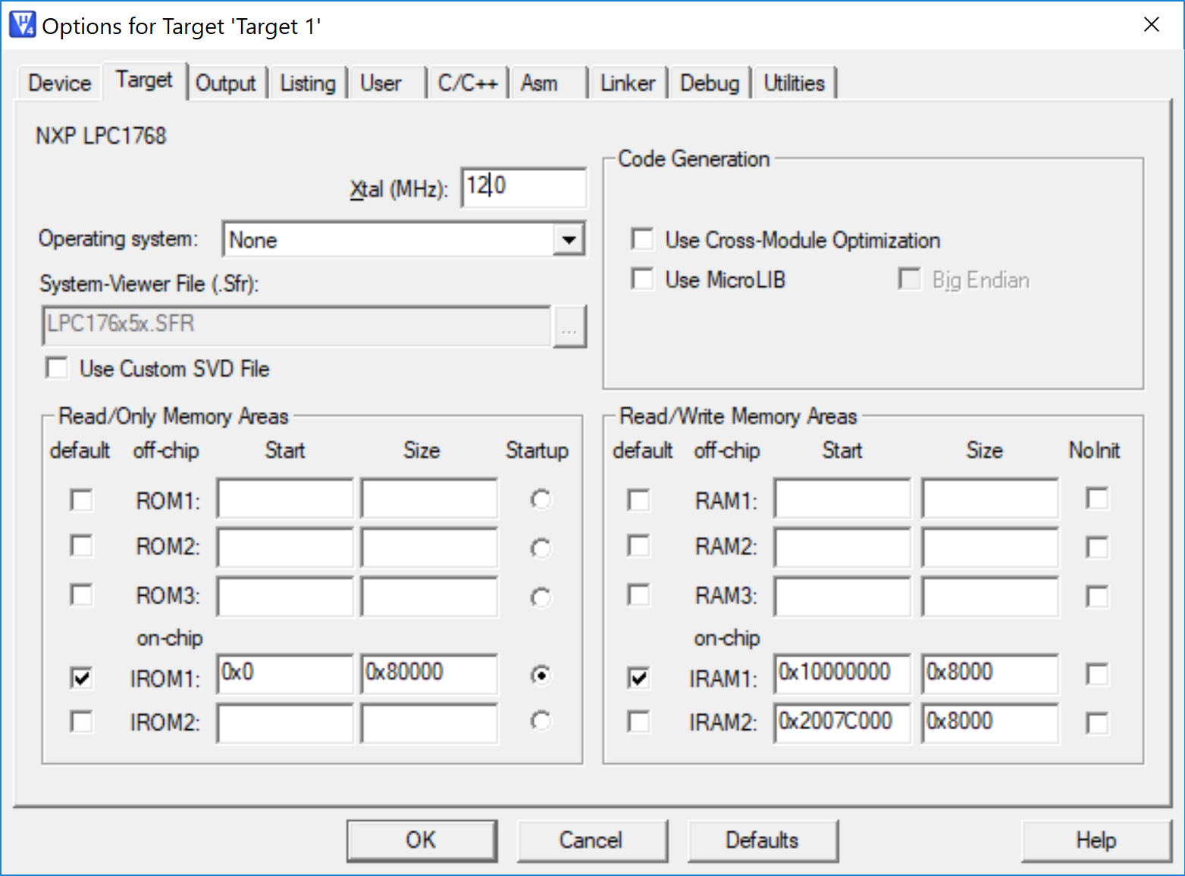

|  |  |  |  |  |
| --- | --- | --- | --- | --- |
|  | R0==R1 [cc] | R0==R1 [ms] | R0!=R1 [cc] | R0!=R1 [ms] |
| 1) Traditional | 12 cc | 0.001 ms | 12 cc | 0.001 ms |
| 2) Conditional Execution | 12 cc | 0.001 ms | 12 cc | 0.001 ms |

1. Write a program that calculates the **Hamming distance** between two values. The Hamming distance is defined as the number of positions at which the corresponding values are different: e.g., the Hamming distance between the values *0b1010101* and *0b1001001* is 3. The initial values are stored in R0 and R1, while the resulting Hamming distance must be stored in R2.

Implement the ASM code that performs the following operations:

* 1. It determines whether the content of R2 is odd or even.
  2. As a result, the values of R0 and R1 are updated as follows:
     + If R2 is even, the program clears the 11th bit of R0 and sets to 1 the 6th bit of R1 (all other bits must remain unchanged)
     + Else, the program copies in R1 the values of the flags.
  3. Report code size and execution time (with 15MHz clk) in the following table.

|  |  |  |  |
| --- | --- | --- | --- |
|  | Code size [Bytes] | Execution time  [*ms*] | |
| If R2 is even | Otherwise |
| Exercise 3) computation | 564 | 0.00327 ms | 0.00327 ms |

ANY USEFUL COMMENT YOU WOULD LIKE TO ADD ABOUT YOUR SOLUTION: