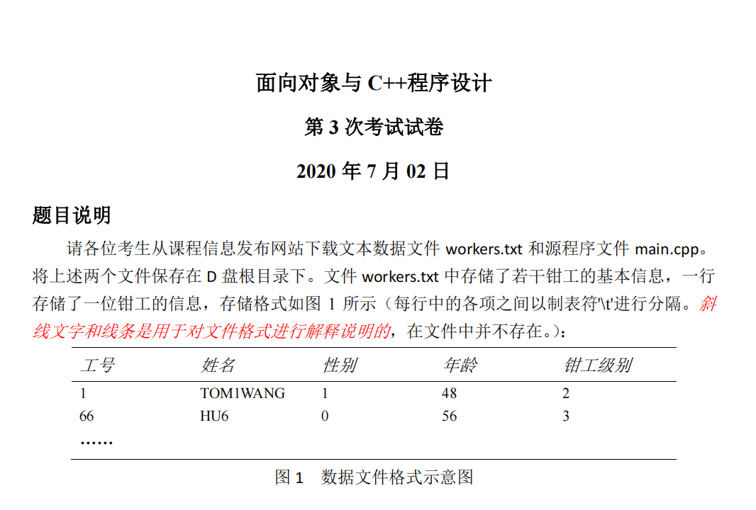

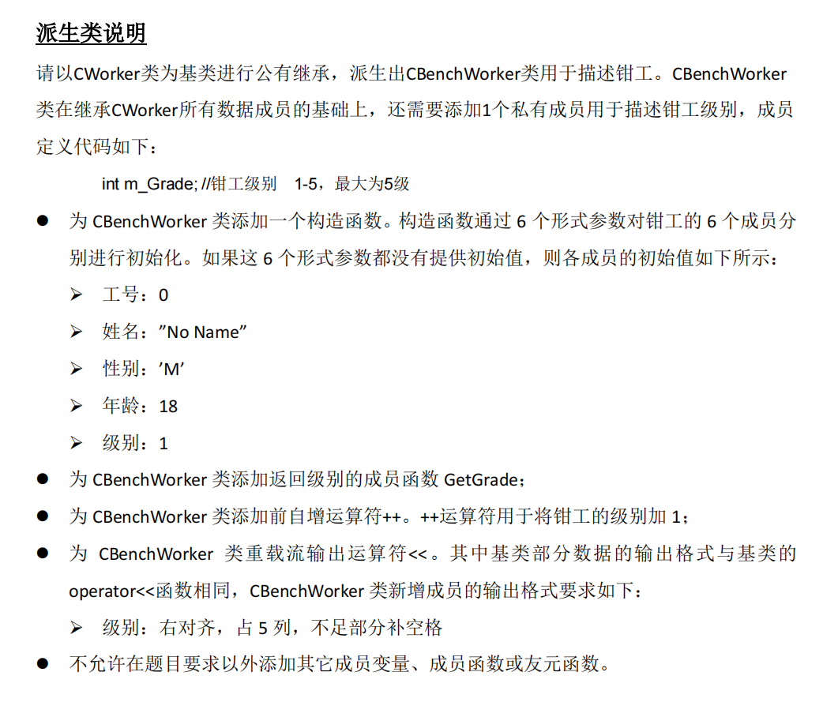

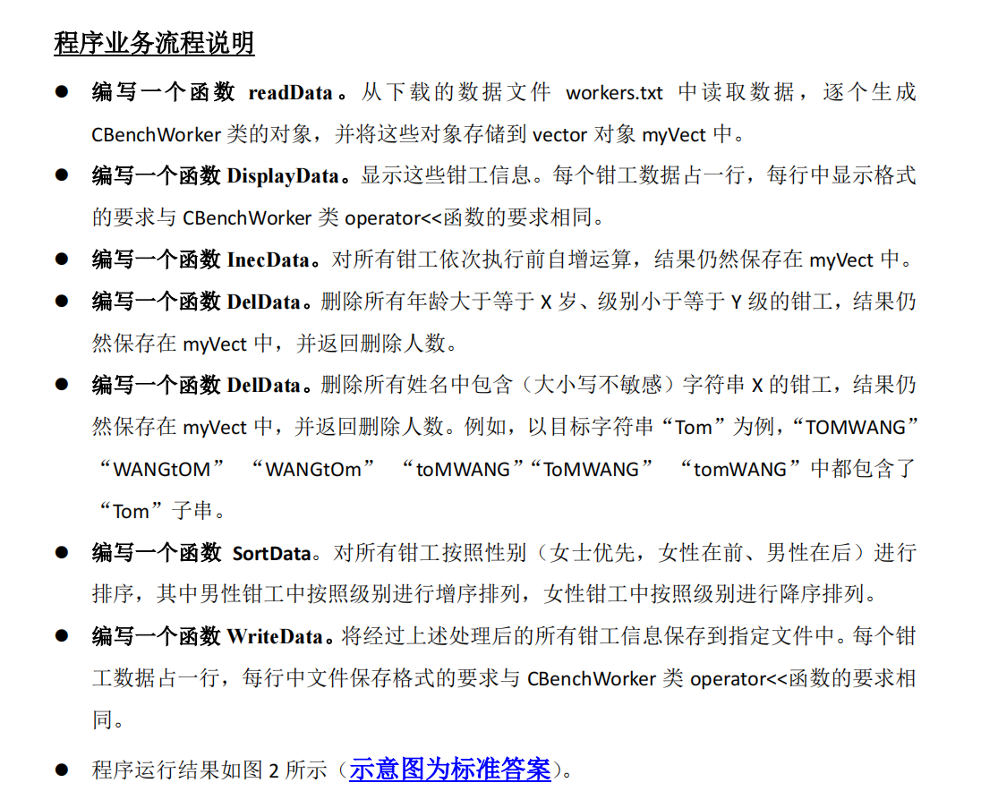

#include <iostream>
#include <cstdlib> // 包含exit()的头文件
#include <cctype> // 包含 tolower 函数
#include <fstream>
#include <vector>
#include <string>
#include <sstream>
#include <iomanip>
#include <algorithm>
using namespace std;

class CWorker
{
private:
int m_ID; //工号
string m_Name; //姓名
int m_Sex; //性别 0代表女性 1代表男性
int m_Age; //年龄
public:
CWorker(int ID, string Name, int Sex, int Age)
{
if (Sex < 0 || Sex>1)
{
cout << "性别初始值" << Sex << "不符合要求！" << endl;
exit(0);
}
if (Age <= 0)
{
cout << "年龄初始值" << Age << "不符合要求！" << endl;
exit(0);
}
m_ID = ID;
m_Name = Name;
m_Sex = Sex;
m_Age = Age;
}
string GetName()const { return m_Name; }
int GetSex()const{ return m_Sex;}
int GetAge()const{ return m_Age;}

friend ostream& operator<<(ostream& Out, const CWorker& Obj)
{
Out << right << setw(5) << Obj.m_ID;
Out << right << setw(10) << Obj.m_Name;
Out << right << setw(5) << Obj.m_Sex;
Out << right << setw(6) << Obj.m_Age;
return Out;
}
};

class CBenchWorker : public CWorker
{
private:
int m_Grade; //钳工级别 1-5，最大为5级
public:
CBenchWorker()
:CWorker(0,"No Name",0,18)
{
m_Grade = 1;
}
CBenchWorker(int ID, string Name, int Sex, int Age, int Grade)
:CWorker(ID, Name, Sex, Age)
{
m_Grade = Grade;
}
int GetGrade() const { return m_Grade; }

CBenchWorker& operator++()
{
if (m_Grade < 5)
m_Grade++;
return *this;
}

friend ostream& operator<<(ostream& Out, const CBenchWorker& Obj)
{
Out << static_cast<const CWorker&>(Obj);
Out << right << setw(5) << Obj.m_Grade;
return Out;
}
};

bool ReadData(const string& filename, vector<CBenchWorker>& a)
{
ifstream file(filename);
if (!file.is_open()) return false;
string line;
while (getline(file, line))
{
CBenchWorker temp;
istringstream ss(line);
int id, sex, age, grade;
string name;
ss >> id >> name >> sex >> age >> grade;
temp = CBenchWorker(id, name, sex, age, grade);
a.push_back(temp);
//这两句 可以写为 a.emplace_back(id, name, sex, age, grade);
}
file.close();
return true;
}

void DisplayData(const vector<CBenchWorker>& workers){
for (const auto& worker : workers)
cout << worker << endl;
}

void InecData(vector<CBenchWorker>& workers){
for (auto& worker : workers)
++worker;
}

int DelData(vector<CBenchWorker>& a, int age, int grade){
int count1=0;
for (int i = 0; i < a.size(); ){
if (a[i].GetAge() >= age && a[i].GetGrade() <= grade){
a.erase(a.begin() + i);
//cout << "Deleting worker: " << a[i].GetName() << endl;
count1++;
}
else
i++;
}
return count1;
}

string toLower(const string& s)
{
string result;
result.resize(s.size());
transform(s.begin(), s.end(), result.begin(), ::tolower);
return result;
}
int DelData(vector<CBenchWorker>& a,string s)
{
int count2 = 0;
string snew =toLower(s);
for (int i = 0; i < a.size(); )
{
string s1 = toLower(a[i].GetName());
if (s1.find(snew) != string::npos)
{
a.erase(a.begin() + i);
count2++;
}
else
i++;
}
return count2;
}

bool compare(const CBenchWorker& a, const CBenchWorker& b)
{
if (a.GetSex() != b.GetSex())
return a.GetSex() < b.GetSex();
// 女性在前，男性在后
else if (a.GetSex() == 0)
return a.GetGrade() > b.GetGrade();
// 同性别女性，按级别降序排列
else
return a.GetGrade() < b.GetGrade();
// 同性别男性，按级别升序排列
}
void SortData(vector<CBenchWorker>& a)
{
sort(a.begin(), a.end(), compare);
}

int WriteData(const string& path, vector<CBenchWorker>& a)
{
ofstream outFile(path);
if (!outFile) return 0;
for (const auto& worker : a)
{
outFile << worker << endl;
}
outFile.close();
return 1;
}

int main()
{
vector<CBenchWorker> a;
int c;

if (ReadData("d:\\workers.txt", a) == 0)
return -1;

cout << "文件读取后一共有 " << a.size() << " 条钳工数据：" << endl;
DisplayData(a);

InecData(a);

c = DelData(a, 55, 2); //第2个参数为年龄，第3个参数为等级
cout << endl << "第1次删除了" << c << "个钳工数据" << endl;

c = DelData(a, "Tom");
cout << endl << "第2次删除了" << c << "个钳工数据" << endl;
SortData(a);
cout << endl << "上述流程结束后一共有 " << a.size() << " 条钳工数据：" << endl;
DisplayData(a);

if (WriteData("d:\\res.txt", a) == 0)
return -1;
cout << endl << "文件保存成功" << endl << endl;
}

